BDA400 Assignment 2
Technical Analysis Using R – Preliminary Stage

Student: Parvaneh Rezaei
Course: BDA400
Repository: github.com/Pary2003/TechnicalAnalysis

1. GitHub Repository Setup
The TechnicalAnalysis GitHub repository was created for the BDA400 technical-analysis work. The repository uses the main branch and contains the Assignment2 folder.
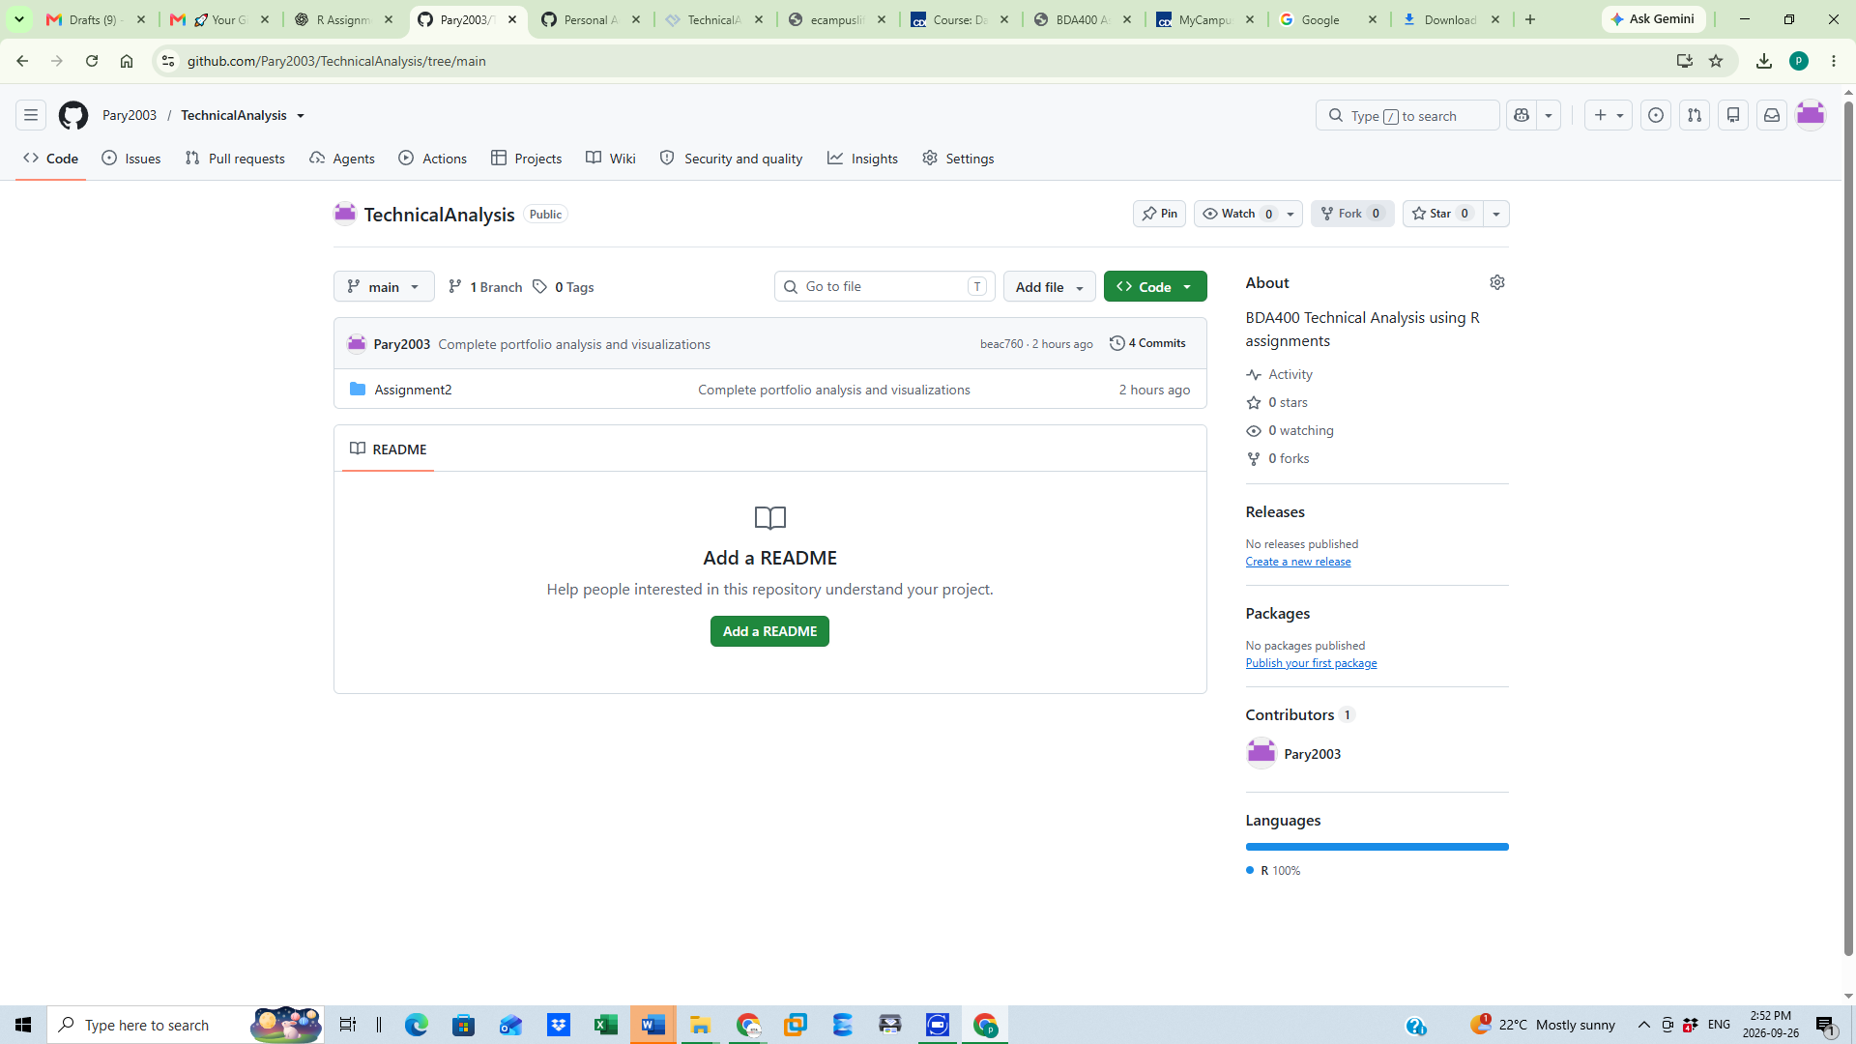
Figure 1. TechnicalAnalysis repository on GitHub showing the main branch and Assignment2 folder.

2. Portfolio File
The portfolio.txt file contains five selected stock symbols: AAPL, MSFT, GOOG, AMZN, and TSLA. These symbols are read by the R script for portfolio-wide processing.
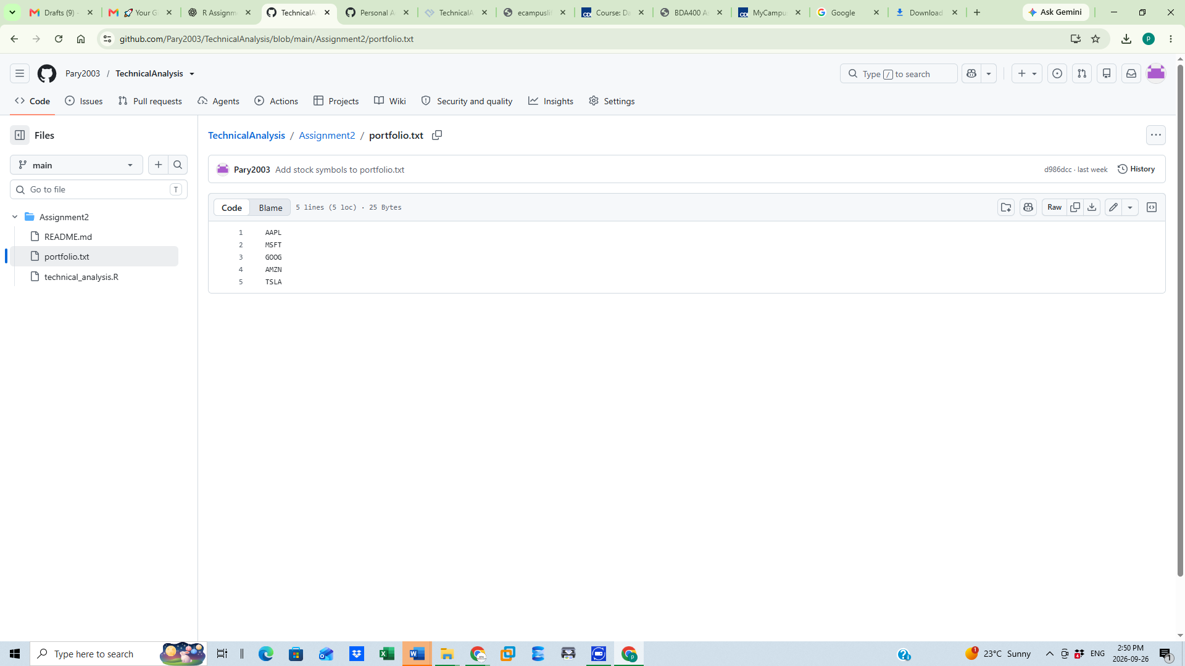
Figure 2. portfolio.txt containing the five selected stock symbols.

3. R Packages, Data Import, and Statistics
The R script loads quantmod and TTR. The import_stock_data() function retrieves historical market data from Yahoo, while calculate_statistics() begins the calculation of the 20-day simple moving average and descriptive statistics.
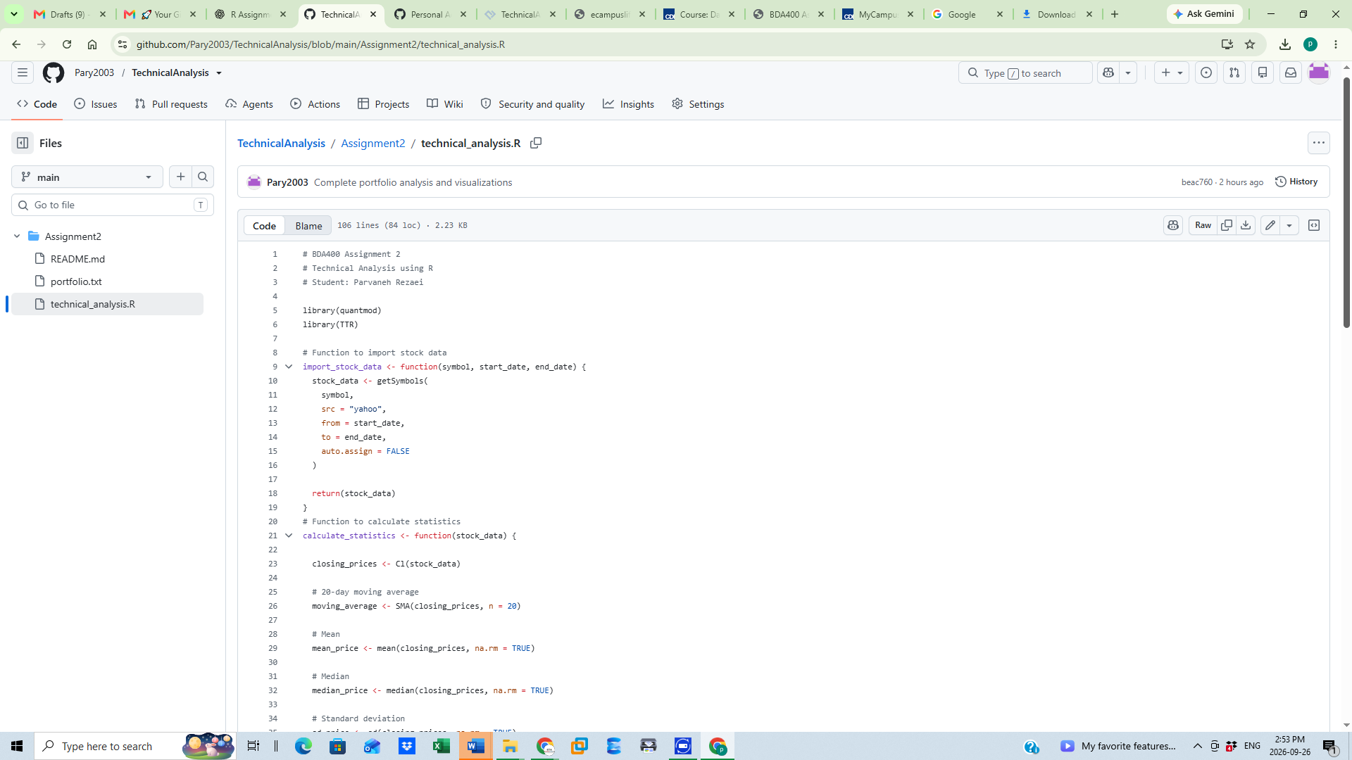
Figure 3. R packages, stock-data import function, and beginning of the statistics function.
The statistics function calculates standard deviation and mode and returns the moving average, mean, median, mode, and standard deviation. The script then imports AAPL data, displays the data, calculates statistics, and creates stock-price visualizations.
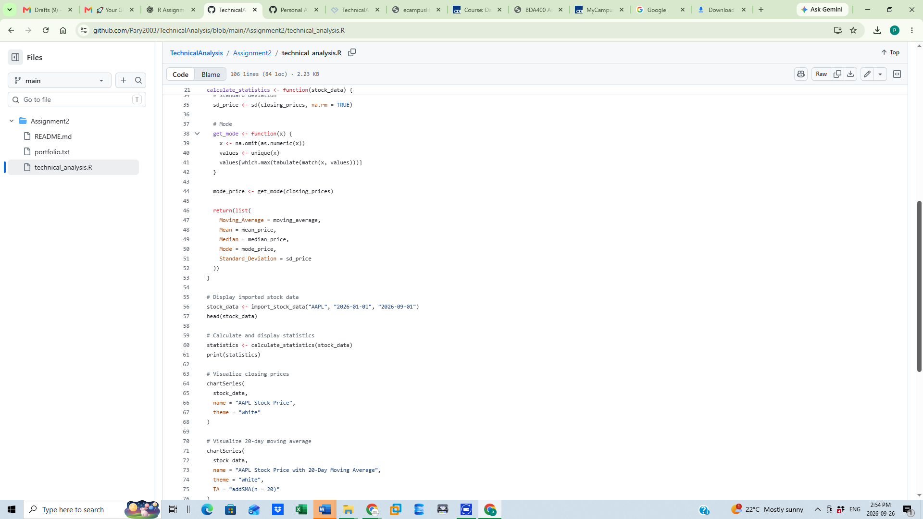
Figure 4. Completion of statistical calculations and AAPL analysis/visualization code.

4. Portfolio Processing
The script reads the symbols from Assignment2/portfolio.txt and loops through every stock. For each symbol it imports the data, prints a sample, calculates statistics, and generates a chart with a 20-day moving average.
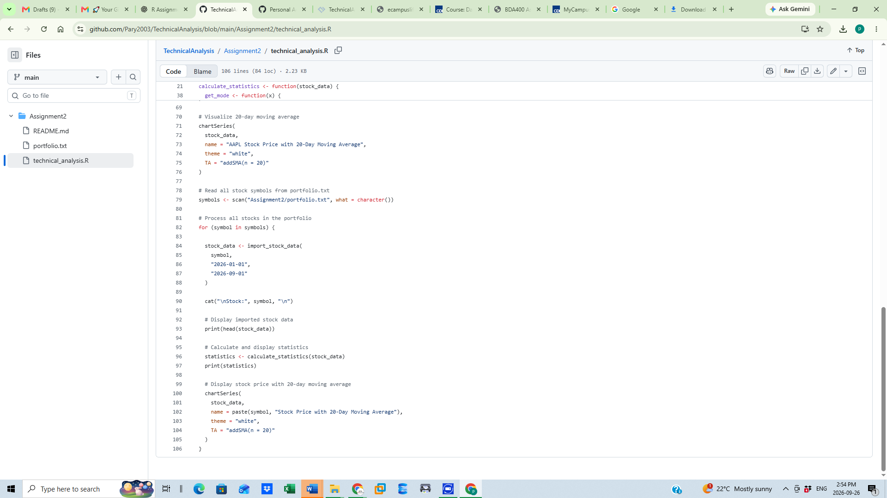
Figure 5. Portfolio loop processing all stock symbols and generating 20-day moving-average charts.

5. Analysis Output
The completed script was executed in Posit Cloud. The final displayed TSLA result shows the stock-price chart with a 20-day moving average together with the calculated statistics in the Console.
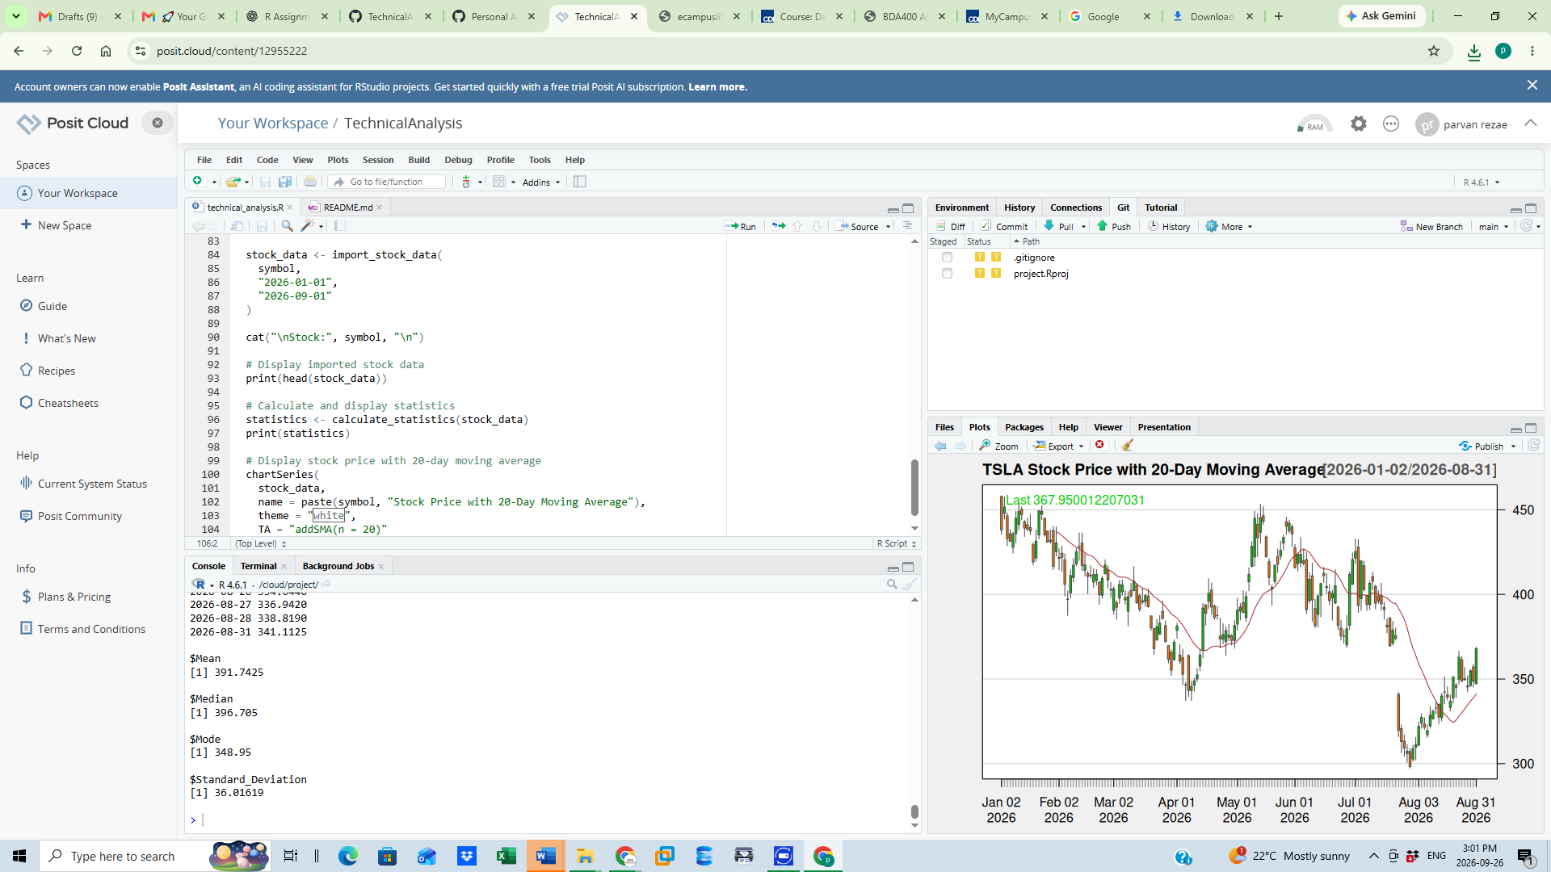
Figure 6. Posit Cloud output showing TSLA statistics and the 20-day moving-average chart.

6. Git and GitHub Synchronization
After completing the analysis, the changes were committed and pushed from Posit Cloud to the GitHub main branch.
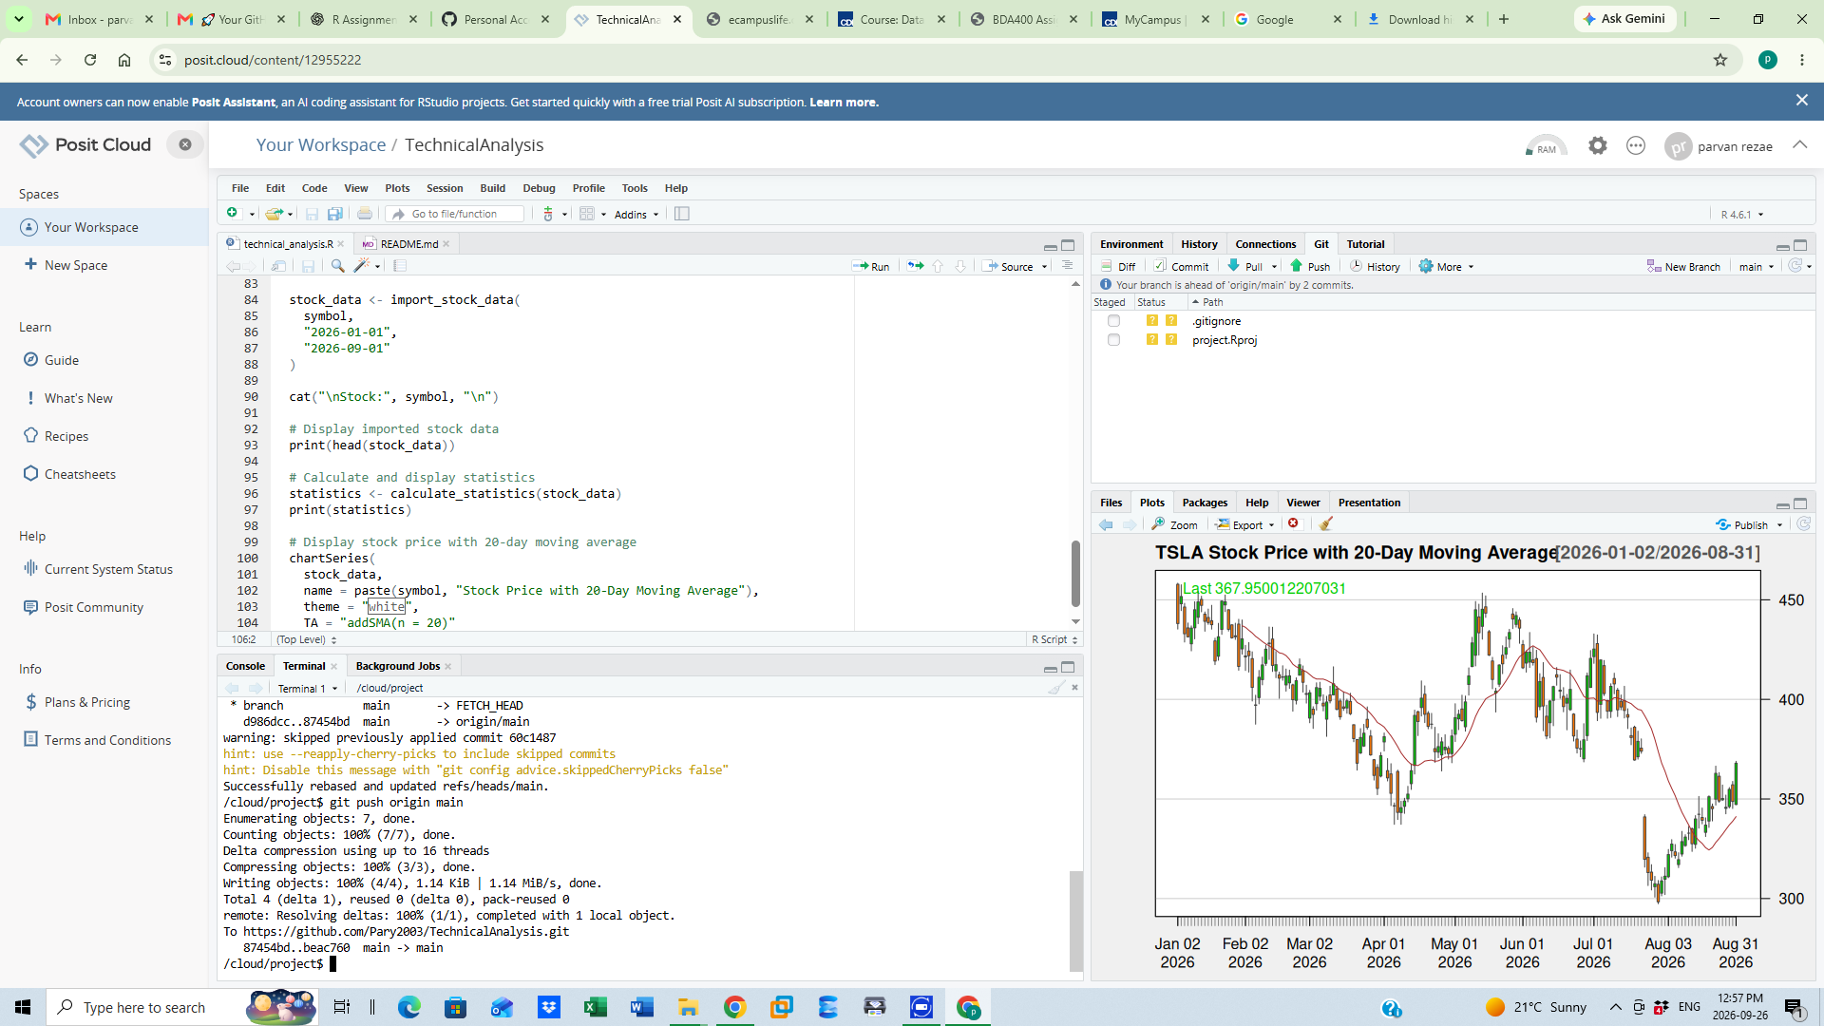
Figure 7. Successful Git push from Posit Cloud to the GitHub main branch.

7. Final GitHub Verification
The final GitHub version of technical_analysis.R contains 106 lines and shows the completed commit, confirming that the updated assignment code is available in the repository.
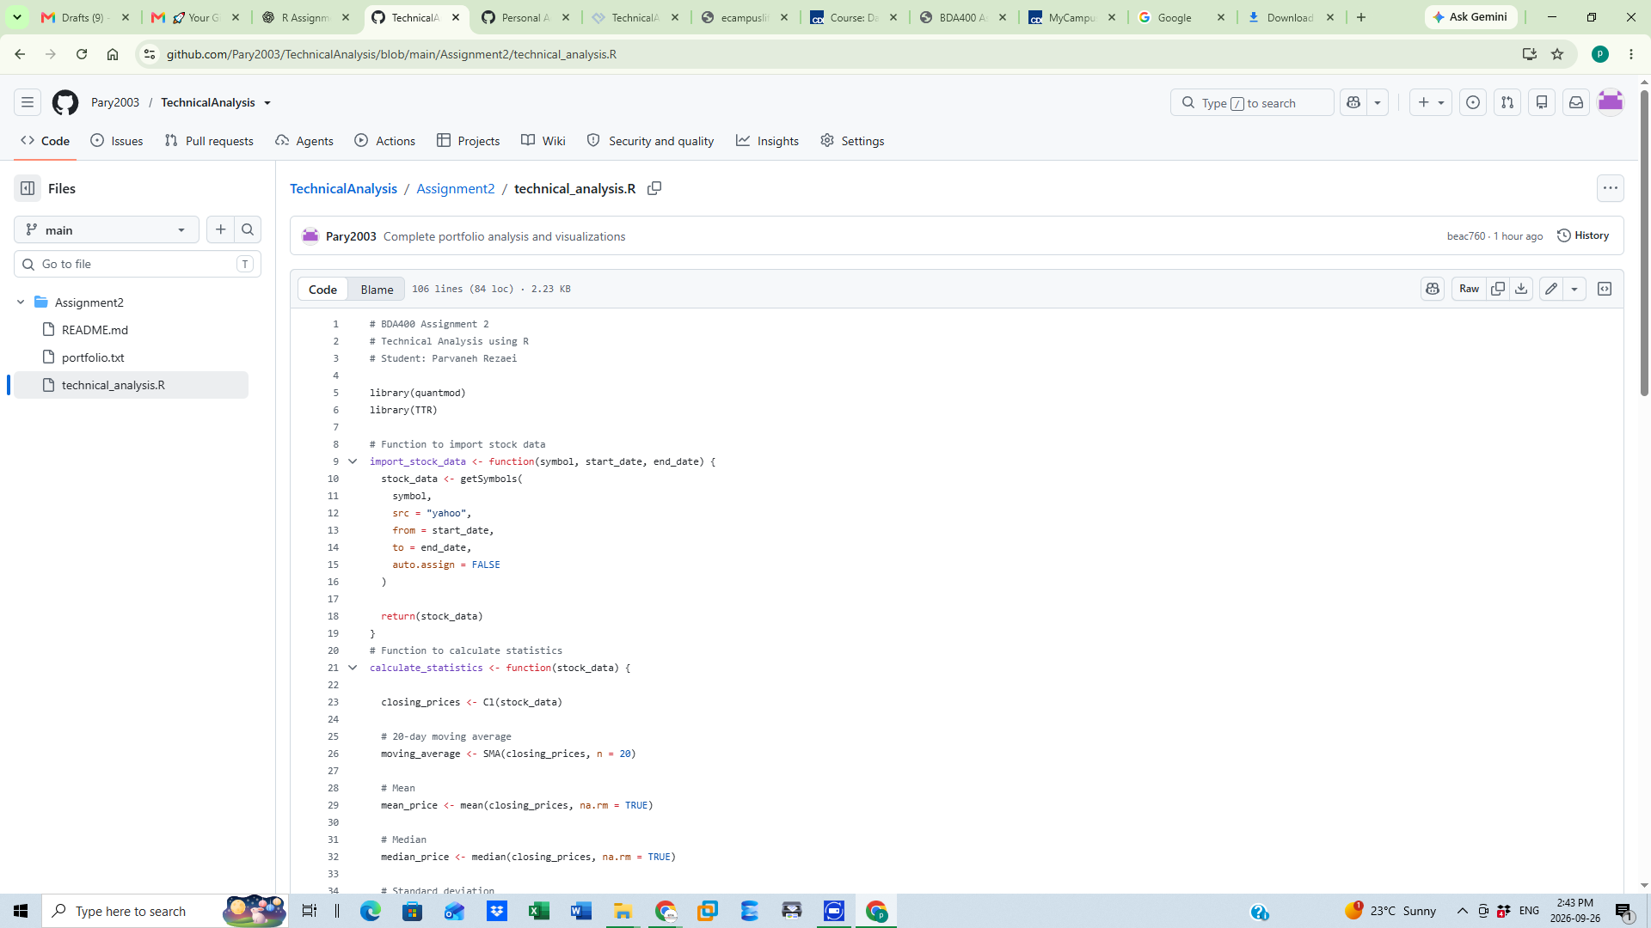
Figure 8. Final technical_analysis.R file on GitHub after the successful push.

8. Conclusion
The preliminary technical-analysis project was completed in R using Posit Cloud, Git, and GitHub. The project imports stock data, calculates descriptive statistics and a 20-day moving average, processes a five-stock portfolio, creates visualizations, and stores the completed work in the GitHub repository.

