BDA400 Assignment 3 – Prompting R Functions with AI
Student: Parvaneh Rezaei
Course: BDA400 – Data Science Tools and Techniques
Assignment: Assignment 3 – Prompting R Functions with AI
AI Assistance Declaration
AI Assistance Declaration: I used ChatGPT (GPT-5.6 Sol) for assistance with designing and refining an R function, debugging guidance, test suggestions, and writing assistance. Prompts used are documented below. I verified the outputs by running the R code in Posit Cloud/RStudio, testing it with synthetic data, comparing the result with R’s boxplot.stats() function, and performing additional edge-case tests. All final calculations and tests were performed by myself. I am responsible for the accuracy and originality of this work.
Original Task Description
Remove outliers from a numeric vector using the IQR method.
AI Prompts Used
Prompt 1:
“Write an R function that removes outliers from a numeric vector using the IQR method.”
Prompt 2:
“Revise the function to include comments, argument validation, and return a clean result.”
Prompt 3:
“Explain what each line of the R code does and how you might test if it works correctly.”
Prompt 4:
“Update the function to handle NA values.”
Prompt 5:
“Optimize the function for efficiency and readability.”
Prompt 6:
“How could you test this function with edge cases?”
Prompt 7:
“Summarize how this R function changed across revisions and highlight what improvements were human-driven vs. AI-generated.”
Short Debugging Reflection
AI helped me create the initial structure of the outlier-removal function and suggested ways to improve its validation and handling of missing values. During testing, I initially encountered an error because the function had not been completely executed in R before I called it. I corrected this by running the complete function definition and testing it again. I also improved the function to remove NA values and reject non-numeric input. Finally, I compared the results with R’s built-in boxplot.stats() function to independently verify that 999 was correctly identified as an outlier.
Final Reflection
Using AI to develop this R function showed me how important prompt design is when working with coding assistants. My first prompt produced the basic logic for removing outliers using the IQR method, while later prompts helped improve the function by adding comments, input validation, and support for missing values. During testing, I learned that even correct code must be properly executed and carefully verified before the function can be used.
I tested the function with synthetic data containing the value 999 and confirmed that it was removed as an outlier. I independently checked the result using R’s boxplot.stats() function, which also identified 999 as an outlier. I also tested data with no outliers, missing values, and non-numeric input.
This exercise showed me that AI can accelerate coding and suggest useful improvements, but human judgment remains necessary for testing, debugging, and validation. AI-generated code should not be accepted automatically because errors, incomplete logic, or unhandled cases may still occur. I learned that combining AI assistance with manual verification produces a more reliable analytics workflow.
Final Reflection
In this assignment, I used AI to help design and improve an R function that removes outliers from a numeric vector using the IQR method. My initial prompt produced a basic function, and additional prompts helped improve the code by adding comments, input validation, NA handling, and testing suggestions. I learned that creating the function is only one part of the process; testing and debugging are necessary to make sure the code behaves correctly.
During testing, I checked the function with regular numeric data, data containing an extreme value, missing values, and non-numeric input. I also compared the results with R’s built-in boxplot.stats() function. One limitation of the initial AI-assisted code was that it did not properly address all possible input conditions. I manually tested the function and verified the results before accepting the final version.
This exercise showed me that AI can be useful for generating ideas, explaining code, and suggesting improvements, but human judgment is still essential. An analyst must understand, test, verify, and take responsibility for the final code.
Testing and Verification Evidence
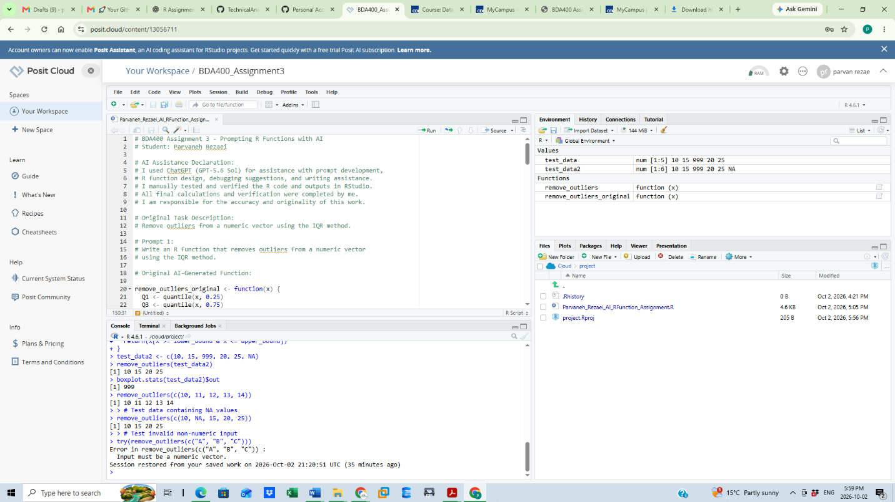

Figure 1. RStudio/Posit Cloud testing results showing outlier removal, comparison with boxplot.stats(), NA handling, edge-case testing, and input validation.

