1. The evolution of the InternSet of Things (IoT)
Home » Blog » IT Infrastructure » The evolution of the Internet of Things (IoT)
The Internet of Things is at the heart of our digital world and is fundamentally changing the way we live and work. It refers to the networking of physical devices that collect, analyze and evaluate data. From networked household appliances to industrial machines, the IoT enables automation and increased efficiency that goes far beyond conventional technologies.
The development of the IoT has not only set technological milestones, but has also created new opportunities for businesses and consumers, which we will explore in this blog post.

What is the Internet of Things?
Internet of Things refers to the networking of physical objects that can communicate with each other and with the internet. These devices, from household appliances to industrial machinery, use sensors to collect and share data, enabling automated responses.
IoT devices are networked either locally or via the internet and are designed to make our everyday lives more efficient. It therefore enables direct communication between devices (machine-to-machine), allowing them to perform tasks independently and learn from experience. It is already present in many areas, such as robot vacuum cleaners, Apple AirTags and fitness wristbands.
Key features of the IoT:
- Networked objects: Devices with sensors, actuators and software.
- Unique identification: unique identifier (UID) of the object
- Automation: simplification of everyday life through automatic processes, without user input

The history of the IoT
The term “Internet of Things” was coined by Kevin Ashton in 1999. He used the term in a presentation on RFID chips, which enable automatic and contactless identification. The invention of the World Wide Web in 1989 by Tim Berners-Lee was decisive for the IoT. It developed through the combination of wireless technologies, MEMS, microservices and the internet.
Important milestones
- 1980s: Networked Coca-Cola vending machine at Carnegie Mellon University.
- 1990: John Romkey's internet-enabled toaster.
- 1999: Kevin Ashton coins the term “Internet of Things”.
- 2000: LG's smart refrigerator.
- 2010: China's government integrates the IoT into its five-year plan.
The technologies and distribution
RFID tags and IPv6 addresses enabled the mass production of IoT devices. RFID tags track inventory in the industry. IPv6 solved the IP address problem and promoted smart home technologies. AI (artificial intelligence) is central to the IoT. Devices collect data, learn and adapt. Voice assistants store commands in the cloud and learn independently. IoT has evolved from experiments to a widespread technology and is now present in many areas of life.

How networked devices work
The IoT automates data collection, transmission and processing using networked devices with sensors. The data is often sent to the cloud and analyzed there. IoT consists of a measuring instrument, a node (gateway/hub) and a user interface. The measuring instrument collects data and sends it to the hub, which processes or forwards it. The user interface enables commands and data visualization.
Technologies enabled by the IoT:
- Connectivity: internet protocols enable easy and efficient networking of sensors with the cloud and other devices.
- Machine learning: Machine learning and cloud data analytics enable rapid insights and enhance the IoT, which in turn enhances these technologies.
- Cloud computing: Enables scaling and real-time processing of large amounts of data
- Artificial intelligence for conversational functions: Neural networks enable voice processing through IoT devices, making them attractive and affordable for home use.

Use in companies in various industries
The IoT is crucial for companies to improve performance and increase customer loyalty. Data generated by IoT helps companies to optimize their operations and develop additional digital services. At the same time, IoT is essential for increasing the competitiveness of companies through the targeted use of networked devices. The IoT offers extensive benefits for many industries, including consumer goods, retail, smart home technologies, manufacturing, healthcare, transportation and logistics, production, industry and the public sector.

Benefits
Benefits of IoT for companies
- Increased efficiency and cost reduction
- Error reduction
- Increased customer satisfaction
- Faster product development
Advantages of IoT for customers
- Flexibility and cost savings
- Reliability and efficiency
- Convenience
- Safety and security
- Faster problem solving

Challenges and disadvantages
Possible disadvantages of the IoT
- Extended attack surface: More networking means a higher risk of hacker attacks.
- Need for regular updates: Continuous security updates are essential.
- Sensitive data: Collection of personal data jeopardizes user privacy, which expects responsibility in usage.
- Data analysis complexity: Difficulties in analyzing and interpreting large amounts of data.
- Distributed implementation: High costs that increase with the number and location of devices.

2.Internet of Things (IoT) Enabling Technologies
IoT(internet of things) enabling technologies are
- Wireless Sensor Network
- Cloud Computing
- Big Data Analytics
- Communications Protocols
- Embedded System
1. Wireless Sensor Network(WSN) :
A WSN comprises distributed devices with sensors which are used to monitor the environmental and physical conditions. A wireless sensor network consists of end nodes, routers and coordinators. End nodes have several sensors attached to them where the data is passed to a coordinator with the help of routers. The coordinator also acts as the gateway that connects WSN to the internet.
Example -
- Weather monitoring system
- Indoor air quality monitoring system
- Soil moisture monitoring system
- Surveillance system
- Health monitoring system
2. Cloud Computing :
It provides us the means by which we can access applications as utilities over the internet. Cloud means something which is present in remote locations.
With Cloud computing, users can access any resources from anywhere like databases, webservers, storage, any device, and any software over the internet.
Characteristics -
- Broad network access
- On demand self-services
- Rapid scalability
- Measured service
- Pay-per-use
Provides different services, such as -
- IaaS (Infrastructure as a service)
Infrastructure as a service provides online services such as physical machines, virtual machines, servers, networking, storage and data center space on a pay per use basis. Major IaaS providers are Google Compute Engine, Amazon Web Services and Microsoft Azure etc.
Ex : Web Hosting, Virtual Machine etc.
- PaaS (Platform as a service)
Provides a cloud-based environment with a very thing required to support the complete life cycle of building and delivering West web based (cloud) applications - without the cost and complexity of buying and managing underlying hardware, software provisioning and hosting. Computing platforms such as hardware, operating systems and libraries etc. Basically, it provides a platform to develop applications.
Ex : App Cloud, Google app engine
- SaaS (Software as a service)
It is a way of delivering applications over the internet as a service. Instead of installing and maintaining software, you simply access it via the internet, freeing yourself from complex software and hardware management.
SaaS Applications are sometimes called web-based software on demand software or hosted software.
SaaS applications run on a SaaS provider’s service and they manage security availability and performance.
Ex : Google Docs, Gmail, office etc.
3. Big Data Analytics :
It refers to the method of studying massive volumes of data or big data. Collection of data whose volume, velocity or variety is simply too massive and tough to store, control, process and examine the data using traditional databases.
Big data is gathered from a variety of sources including social network videos, digital images, sensors and sales transaction records.
Several steps involved in analyzing big data -
- Data cleaning
- Munging
- Processing
- Visualization
Examples -
- Bank transactions
- Data generated by IoT systems for location and tracking of vehicles
- E-commerce and in Big-Basket
- Health and fitness data generated by IoT system such as a fitness bands
4. Communications Protocols :
They are the backbone of IoT systems and enable network connectivity and linking to applications. Communication protocols allow devices to exchange data over the network. Multiple protocols often describe different aspects of a single communication. A group of protocols designed to work together is known as a protocol suite; when implemented in software they are a protocol stack.
They are used in
- Data encoding
- Addressing schemes
5. Embedded Systems :
It is a combination of hardware and software used to perform special tasks.
It includes microcontroller and microprocessor memory, networking units (Ethernet Wi-Fi adapters), input output units (display keyword etc. ) and storage devices (flash memory).
It collects the data and sends it to the internet.
Embedded systems used in
Examples -
- Digital camera
- DVD player, music player
- Industrial robots
- Wireless Routers etc.

3. Architecture of Internet of Things (IoT)
Last Updated : 15 Jul, 2025

Internet of Things (IoT) technology has a wide range of applications and the use of the Internet of Things is growing so faster. It is the networking of physical objects that contain electronics embedded within their architecture to communicate and sense interactions amongst each other or to the external environment.
Architecture of IoT
The architecture of IoT is divided into 4 different layers i.e. Sensing Layer, Network Layer, Data processing Layer, and Application Layer.
- Sensing Layer: The sensing layer is the first layer of the Internet of Things architecture and is responsible for collecting data from different sources. This layer includes sensors and actuators that are placed in the environment to gather information about temperature, humidity, light, sound, and other physical parameters. Wired or wireless communication protocols connect these devices to the network layer.
- Network Layer: The network layer of an IoT architecture is responsible for providing communication and connectivity between devices in the IoT system. It includes protocols and technologies that enable devices to connect and communicate with each other and with the wider internet. Examples of network technologies that are commonly used in IoT include WiFi, Bluetooth, Zigbee, and cellular networks such as 4G and 5G technology. Additionally, the network layer may include gateways and routers that act as intermediaries between devices and the wider internet, and may also include security features such as encryption and authentication to protect against unauthorized access.
- Data processing Layer: The data processing layer of IoT architecture refers to the software and hardware components that are responsible for collecting, analyzing, and interpreting data from IoT devices. This layer is responsible for receiving raw data from the devices, processing it, and making it available for further analysis or action. The data processing layer includes a variety of technologies and tools, such as data management systems, analytics platforms, and machine learning algorithms. These tools are used to extract meaningful insights from the data and make decisions based on that data. Example of a technology used in the data processing layer is a data lake, which is a centralized repository for storing raw data from IoT devices.
- Application Layer: The application layer of IoT architecture is the topmost layer that interacts directly with the end-user. It is responsible for providing user-friendly interfaces and functionalities that enable users to access and control IoT devices. This layer includes various software and applications such as mobile apps, web portals, and other user interfaces that are designed to interact with the underlying IoT infrastructure. It also includes middleware services that allow different IoT devices and systems to communicate and share data seamlessly. The application layer also includes analytics and processing capabilities that allow data to be analyzed and transformed into meaningful insights. This can include machine learning algorithms, data visualization tools, and other advanced analytics capabilities.
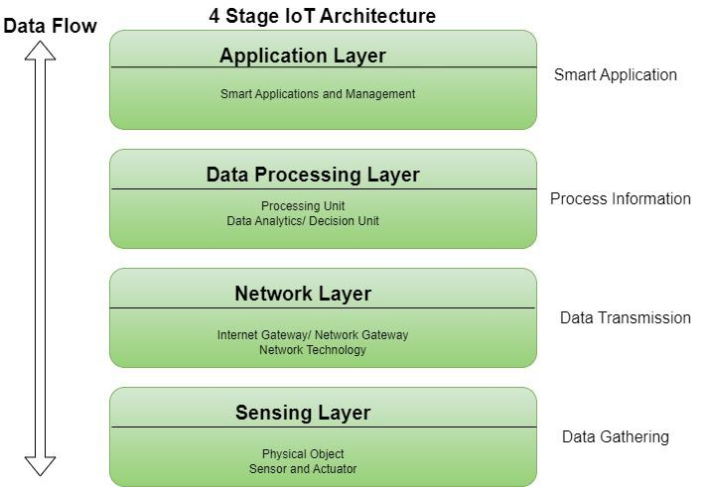Architecture of IoT
Advantages of IoT
- Execute multiple tasks at a time like a computer.
- Easiest internet connectivity
- Works on GUI (Graphical User Interface) mode because of HDMI port.
- Best suited for server-based applications i.e., can be connected via SSH–Secure Shell-to access the Rpi command line remotely and file sharing via FTP–File Transfer Protocol.
- More reliable for software applications.
Disadvantages of IoT
- Security concerns and potential for hacking or data breaches.
- Privacy issues related to the collection and use of personal data.
- Dependence on technology and potential for system failures.
- Limited standardization and interoperability among devices.
- Complexity and increased maintenance requirements.
- High initial investment costs.
- Limited battery life on some devices.
- Concerns about job displacement due to automation.
- Limited regulation and legal framework for IoT, which can lead to confusion and uncertainty.
Modern Applications of IoT
- Smart Grids and energy saving
- Smart cities
- Smart homes/Home automation
- Healthcare
- Earthquake detection
- Radiation detection/hazardous gas detection
- Smartphone detection
- Water flow monitoring
- Traffic monitoring
- Smart door lock protection system
- Robots and Drones
- Healthcare and Hospitals, Telemedicine applications
- Biochip Transponders (For animals in farms)
- Heart monitoring implants (Example Pacemaker, ECG real time tracking

4. IoT Architectures: oneM2M
The challenges and requirements of IoT systems have driven a whole new discipline of network architecture. In the past several years, architectural standards and frameworks have emerged to address the challenge of designing massive-scale IoT networks.
In effort to standardize the rapidly growing field of machine to machine (M2M) communications, the European telecommunications Standards Institute (ETSI) created the M2M Technical committee in 2008. The goal of this committee was to create a common architecture that would help accelerate the adoption of M2M applications and devices. Over the time, the scope has expanded to include the Internet of Things. Recognizing this need, in 2012 ETSI and 13 other founding members launched one M2M as a global initiative designed to promote efficient M2M communication systems and IoT.
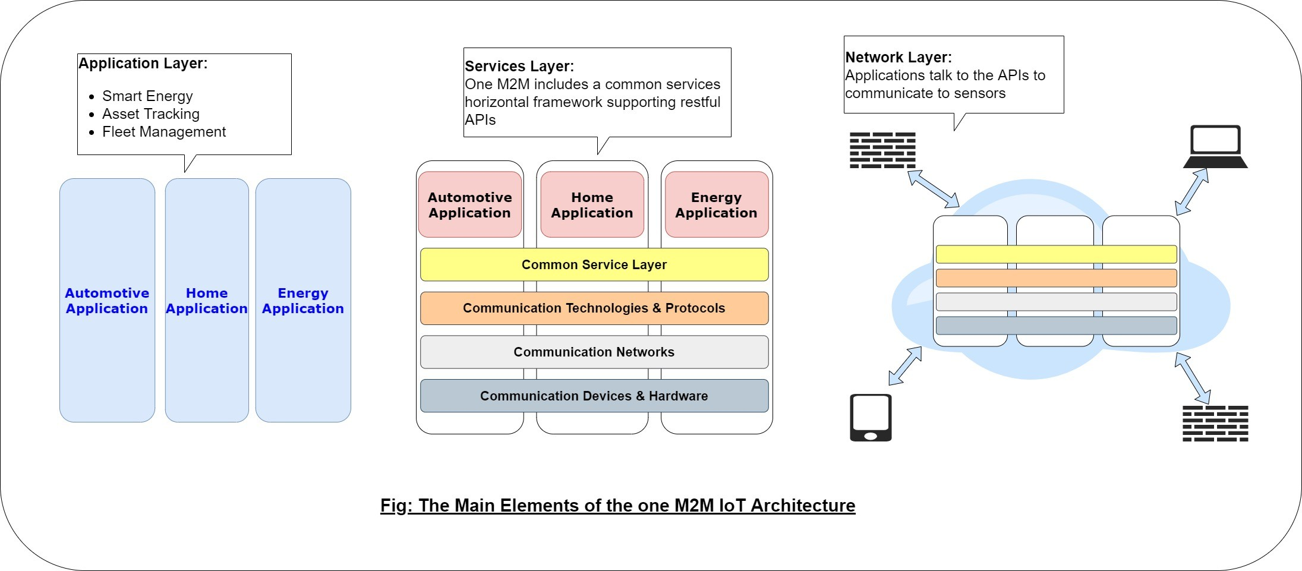
The one M2M architecture divides IoT functions into three major domains: the application layer, the services layer and the network layer. While this architecture may seem simple and somewhat generic at first glance, it is very rich and promotes interoperability through IT-friendly APIs and supports a wide range of IoT technologies. Let's examine each of these domains in turn:
- Applications Layer: The one M2M architecture gives major attention to connectivity between devices and their applications. This domain includes the application layer protocols and attempts to standardize northbound API definitions for interaction with Business Intelligence (BI) Systems. Applications tend to be industry specific and have their own sets of data models and thus they are shown as vertical entities.
- Services Layer: This layer is shown as a horizontal framework across the vertical industry applications. At this layer, horizontal modules include the physical network that the IoT applications run on, the underlying management protocols, and the hardware. Examples include backhaul communications via cellular, MPLS (Multiprotocol label switching) networks, VPNs and so on. Riding on top is the common services layer. This conceptual layer adds APIs and middleware supporting third party services and applications.
- Network Layer: This is the communication domain for the IoT devices and endpoints. It includes the devices themselves and the communication network that links them. Embodiments of this communication infrastructure includes wireless mesh technologies and wireless point to multipoint systems.
In many cases, the smart (and sometimes not so smart) devices communicate with each other. In other cases, machine-to-machine communication is not necessary, and the devices communicate through a field area network (FAN) to use case specific apps in the IoT application domain. Therefore, the device domain also includes the gateway device, which provides communications up into the core network and acts as a demarcation point between the device and network domains.

5. IoT World Forum (IoTWF) and Alternative IoT models
The IoT World Forum (IoTWF) developed a seven-layer Standardized Architecture that simplifies IoT systems by organizing them into distinct functional layers, from Physical Devices to Collaboration and Processes. This model includes layers for physical devices, connectivity, edge computing, data processing, and the application layer. Alternative IoT models include other layered architectures with different layer structures, such as the oneM2M architecture, and conceptual models like the fog computing and mist computing models, which focus on distributed processing closer to the IoT devices.
IoT World Forum (IoTWF) Standardized Architecture
The IoTWF's seven-layer model provides a structured approach to designing and understanding IoT systems:
- Physical Devices and Controllers (Things): The "things" or physical objects with embedded sensors and actuators.
- Connectivity: Focuses on protocols for communication between devices and secure data transport.
- Edge Computing: Processing and decision-making capabilities located closer to the IoT devices, reducing latency.
- Data Processing: Handles the storage, analysis, and abstraction of data collected from the edge.
- Protocol Conversion: Translates different communication protocols so that devices can communicate effectively.
- Routing: Directs data to the correct locations for processing and analysis within the network.
- Collaboration and Processes: The top layer where data and applications are used to make decisions, optimize operations, and generate value, connecting the technology to real-world outcomes.
Alternative IoT Models
Other models exist to achieve similar goals of organizing and managing IoT systems:
- oneM2M Architecture:This is another layered architecture that aims to improve interoperability and scalability for IoT deployments, though its structure and focus may differ from the IoTWF model.
- Fog Computing:Extends the cloud to the edge of the network, providing decentralized computation and data storage closer to the data sources, enabling faster responses and reduced bandwidth usage.
- Mist Computing:An extension of fog computing, this model pushes computation even further to the endpoints and devices themselves, providing the ultimate proximity for data processing and decision-making.
- Simplified Models:

6. Simplified IoT Architecture and Core IoT Functional Stack
A simplified IoT architecture comprises two parallel stacks: a Core IoT Functional Stack (Things, Communication Network, Applications/Analytics) and an IoT Data Management and Compute Stack (Edge, Fog, Cloud). The Core stack focuses on device functionality, connectivity, and data utilization, while the Data Management stack handles distributed data processing and storage. Security is an end-to-end component that integrates the two stacks, ensuring confidentiality, integrity, and availability of data across the entire system.
Core IoT Functional Stack
This stack handles the direct functionality of IoT devices and their services. It consists of three main layers:
- Things Layer (Perception/Sensor Layer): This is the physical layer where devices, sensors, and actuators are located. Sensors gather raw data (e.g., temperature, gas), and actuators provide a physical response (e.g., controlling a motor). Embedded systems, microcontrollers, and various ports are part of this layer.
- Communication Network Layer: This layer is responsible for transmitting the data collected by the "things" to other parts of the system. It includes access networks, gateways for data forwarding, backhaul for core network connection, and transport protocols for data transfer.
- Applications & Analytics Layer: This final layer processes and analyzes the collected data to generate insights and take actions. It includes business applications and a strong big data analytics component to provide visualization, automation, and new services.
IoT Data Management and Compute Stack
This parallel stack handles the processing, storage, and management of IoT data, often leveraging distributed computing models:
- Edge Computing Layer: Data is processed closer to the devices to reduce latency and bandwidth usage.
- Fog Computing Layer: An intermediate layer that provides compute and storage, acting as a bridge between the edge and the cloud.
- Cloud Computing Layer: The central platform for large-scale data storage, processing, and complex analytics, often used for long-term data retention and advanced machine learning.
Security
Security is an integrated, end-to-end component that spans both parallel stacks. It's crucial for the confidentiality, integrity, and availability of IoT data and systems, protecting devices, networks, and applications.

7. Fog, Edge and Cloud in IoT
n the context of IoT, Cloud computing is centralized, remote data processing and storage. Fog computing is a decentralized layer between the edge and cloud, bringing processing closer to data sources to reduce latency and analyze data from multiple edge devices. Edge computing processes data directly on or at the source device, enabling immediate, localized decisions and the highest speed and efficiency for time-sensitive applications.

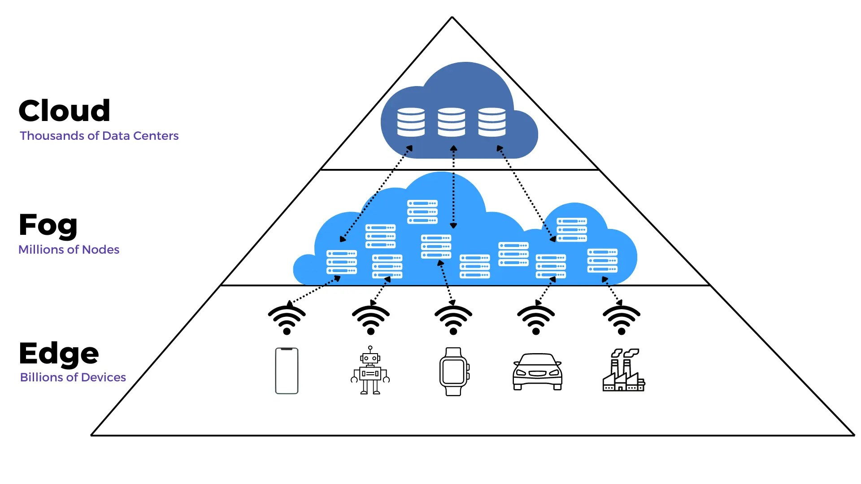

Here's a breakdown of each layer:
- Cloud Computing
  - Location: Centralized, remote data centers.
  - Functionality: Provides large-scale data storage, processing, networking, and intelligence services over the Internet.
  - Use Cases: Long-term data storage, complex analytics, big data processing, and applications that don't require real-time responses.
  - Pros: Scalability, massive storage capacity, and cost-effectiveness through economies of scale.
  - Cons: High latency, potential network congestion, and increased bandwidth costs for large data transfers.
- Fog Computing
  - Location: A layer of devices (fog nodes) located between the edge and the cloud, such as industrial controllers, routers, and gateways.
  - Functionality: Aggregates and processes data from multiple edge devices, performing localized analysis and filtering before sending relevant information to the cloud.
  - Use Cases: Localized decision-making, real-time analytics for multiple devices, and reduced network traffic to the cloud.
  - Pros: Lower latency than cloud, reduced burden on the cloud, improved security by keeping sensitive data local, and contextual awareness of nearby devices.
  - Cons: Requires more complex infrastructure than edge computing.
- Edge Computing
  - Location: Directly on or very close to the data-generating IoT devices.
  - Functionality: Processes data locally at the data source for immediate, device-specific actions.
  - Use Cases: Time-sensitive operations, applications requiring immediate responses, and autonomous device control.
  - Pros: Highest speed and lowest latency, real-time data analysis for immediate decisions, and increased operational efficiency.
  - Cons: Limited computational power and storage capabilities compared to fog or cloud, making it best for localized tasks rather than large-scale analysis.
The Relationship in an IoT System
The three concepts represent a continuum of where computation and data storage occur.
- Edge: handles immediate, device-level actions.
- Fog: aggregates data from multiple edge devices for localized, broader analysis.
- Cloud: provides the massive storage and processing power for historical data and complex, large-scale analytics.
This layered approach helps manage the dynamic nature of IoT, reducing latency, offloading network traffic, and improving overall system efficiency and reliability.

Difference Between Edge Computing and Fog Computing
S.NO. | EDGE COMPUTING | FOG COMPUTING
01. | Less scalable than fog computing. | Highly scalable when compared to edge computing.
02. | Millions of nodes are present. | Billions of nodes are present.
03. | Nodes are installed far away from the cloud. | Nodes in this computing are installed closer to the cloud(remote database where data is stored).
04. | Edge computing is a subdivision of fog computing. | Fog computing is a subdivision of cloud computing.
05. | The bandwidth requirement is very low. Because data comes from the edge nodes themselves. | The bandwidth requirement is high. Data originating from edge nodes is transferred to the cloud.
06. | Operational cost is higher. | Operational cost is comparatively lower.
07. | High privacy. Attacks on data are very low. | The probability of data attacks is higher.
08. | Edge devices are the inclusion of the IoT devices or client's network. | Fog is an extended layer of cloud.
09. | The power consumption of nodes is low. | The power consumption of nodes filter important information from the massive amount of data collected from the device and saves it in the filter high.
10. | Edge computing helps devices to get faster results by processing the data simultaneously received from the devices. | Fog computing helps in filtering important information from the massive amount of data collected from the device and saves it in the cloud by sending the filtered data.

8. Functional blocks of an IoT ecosystem

An IoT ecosystem's functional blocks include: Sensors/Actuators for data collection and actions, Processors for data processing and intelligence, Connectivity/Gateways to transmit data, Data Storage & Analytics for handling and analyzing large data sets, and Applications/User Interfaces for user interaction and delivering services. Security is also a critical functional block woven throughout the entire system.
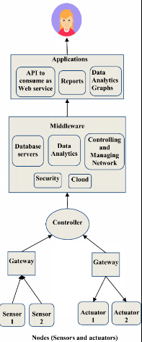
Here's a breakdown of each block:
- Sensors and Actuators
  - Sensors: are the "things" that collect data from the surrounding environment, such as temperature, moisture, or gas levels, converting physical inputs into electrical signals.
  - Actuators: perform actions in the real world based on received data or commands, like controlling a motor or a valve.
- Processors (or Microcontrollers)
  - These components are the "brain" of the IoT system, processing the raw data collected by sensors.
  - They extract valuable, intelligent insights from the data and can also handle data security tasks like encryption and decryption.
- Connectivity and Gateways
  - This block handles the communication between devices and platforms.
  - Gateways: are intermediary devices that route the processed data to its appropriate location. They facilitate data exchange over various network types.
- Data Storage and Analytics
  - A large amount of raw data is generated in an IoT system, requiring efficient storage.
  - Analytics tools are used to process, analyze, and visualize this data to gain actionable insights, often utilizing cloud computing platforms.
- Applications and User Interfaces
  - These are the user-facing components, such as web dashboards, mobile apps, or voice assistants, that provide actionable data and allow users to monitor and control the IoT system.
- Security
  - A fundamental functional block, security measures are implemented at every stage of the IoT ecosystem.
  - This includes data encryption, authentication, secure boot, and regular updates to protect against vulnerabilities and ensure system integrity.

9. Sensors, Actuators, Smart Objects and Connecting Smart Objects
Sensors collect data about the environment, while actuators affect the physical world. A smart object is a device that combines a processing unit, sensors and/or actuators, and a communication device to interact autonomously with its environment. Connecting smart objects creates networks, such as the Internet of Things (IoT), allowing data to be shared, analyzed, and used to trigger actions across multiple devices.
Sensors
- Function: Sensors are input components that detect and measure physical quantities like temperature, light, movement, or humidity from their surroundings.
- Mechanism: They convert these physical measurements into electrical signals or digital data that can be processed by intelligent devices.
- Examples: A temperature sensor in a smart thermostat or an accelerometer in a smartphone.
Actuators
- Function: Actuators are output components that produce a physical effect or change in the environment based on a control signal.
- Mechanism: They receive commands from a processing unit and convert them into action, such as motion, force, heat, or light.
- Examples: A motor in a smart lock, a valve in a smart irrigation system, or a light bulb in a smart lighting setup.
Smart Objects
- Definition: A smart object is a device with the ability to sense, process, communicate, and act.
- Key Components:
  - Processing Unit: Typically a microcontroller that analyzes sensor data and coordinates functions.
  - Sensor(s) and/or Actuator(s): For interaction with the physical world.
  - Communication Device: A wireless or wired component to connect with other objects or networks.
  - Power Source: A battery or other energy source to power the device's components.
- Purpose: To collect information from the environment and respond to it, enabling automation and data-driven decision-making.
Connecting Smart Objects
- Concept: This involves establishing a network where multiple smart objects can communicate and cooperate with each other and with higher-level systems.
- Technology: Wireless technologies like Wi-Fi, Bluetooth, and cellular networks are used for communication.
- Benefits:
  - Data Aggregation: Combining data from multiple sensors to form a more comprehensive understanding of the environment.
  - Coordinated Actions: Enabling complex actions based on the collective data and intelligence of the network.
  - System-Level Intelligence: Creating larger, more sophisticated systems (like smart farms) that can automate tasks and provide advanced services.

UNIT 02:

1. IoT Access Technologies: Physical and MAC layers
In IoT, the Physical (PHY) Layer handles the hardware-level details of data transmission, like signal encoding and physical connectors, while the Media Access Control (MAC) Layer manages access to the shared communication medium, ensuring efficient and reliable data transfer, error handling, and flow control between devices. Common PHY/MAC technologies for IoT include Bluetooth, Wi-Fi, Zigbee (based on IEEE 802.15.4), and cellular technologies like LTE-M and NB-IoT.
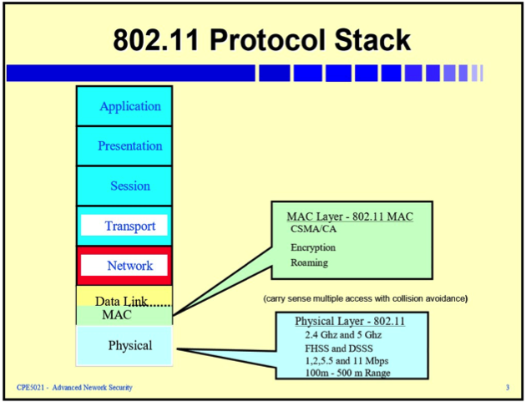

Physical (PHY) Layer Functions
The PHY layer is the lowest layer of the communication stack and deals with the physical transmission of raw data bits.
- Signal Encoding:
Defines how binary data (0s and 1s) is encoded into signals suitable for the physical medium.
- Hardware Components:
Involves physical connectors, cabling, and the modulation/demodulation of radio frequency (RF) bits.
- Transmission Medium:
Handles the actual transmission of data over physical media like radio waves, copper wire, or fiber optics.
Media Access Control (MAC) Layer Functions The MAC layer is a sublayer of the data link layer and is responsible for managing access to the shared communication medium.
- Medium Access:
Controls which device can transmit at any given time, preventing data collisions.
- Flow Control:
Regulates the flow of data between devices to prevent overwhelming the network.
- Data Integrity:
Provides error detection and retransmission mechanisms to ensure reliable data transfer and frame integrity.
Examples of IoT Access Technologies and their PHY/MAC Layers
- IEEE 802.15.4 (used by Zigbee):
Designed for low-power, low-data-rate IoT devices. It provides specific PHY and MAC layers for applications such as consumer and business markets.
- Bluetooth:
A wireless technology primarily for short-range communication, with established PHY and MAC specifications for its operation.
- Wi-Fi:
A widely used wireless standard that specifies PHY and MAC protocols to enable high-speed data transfer over local networks.
- Cellular IoT (e.g., LTE-M, NB-IoT):
These technologies use the physical and MAC layers of cellular networks to provide mobile connectivity for IoT devices like smartwatches and fitness trackers, emphasizing power efficiency.

2. Introduction of IEEE 802.15.4 Technology
IEEE 802.15.4 is a low-cost, low-data-rate wireless access technology for devices that are operated or work on batteries. This describes how low-rate wireless personal area networks (LR-WPANs) function.
IEEE 802.15.4e:
802.15.4e for industrial applications and 802.15.4g for the smart utility networks (SUN)
The 802.15.4e improves the old standard by introducing mechanisms such as time slotted access, multichannel communication and channel hopping.
- IEEE 802.15.4e introduces the following general functional enhancements:
1. Low Energy (LE): This mechanism is intended for applications that can trade latency for energy efficiency. It allows a node to operate with a very low duty cycle.
2. Information Elements (IE) It is an extensible mechanism to exchange information at the MAC sublayer.
3. Enhanced Beacons (EB): Enhanced Beacons are an extension of the 802.15.4 beacon frames and provide a greater flexibility. They allow to create application-specific frames.
4. Multipurpose Frame: This mechanism provides a flexible frame format that can address a number of MAC operations. It is based on IEs.
5. MAC Performance Metric: It is a mechanism to provide appropriate feedback on the channel quality to the networking and upper layers, so that appropriate decision can be taken.
6. Fast Association (FastA) The 802.15.4 association procedure introduces a significant delay in order to save energy. For time-critical application latency has priority over energy efficiency.
- IEEE 802.15.4e defines five new MAC behavior modes.
1. Time Slotted Channel Hopping (TSCH): It targets application domains such as industrial automation and process control, providing support for multi-hop and multichannel communications, through a TDMA approach.
2. Deterministic and Synchronous Multi-channel Extension (DSME): It is aimed to support both industrial and commercial applications.
3. Low Latency Deterministic Network (LLDN): Designed for single-hop and single channel networks
4. Radio Frequency Identification Blink (BLINK): It is intended for application domains such as item/people identification, location and tracking.
5. Asynchronous multi-channel adaptation (AMCA): It is targeted to application domains where large deployments are required, such as smart utility networks, infrastructure monitoring networks, and process control networks.
Properties:
1. Standardization and alliances: It specifies low-data-rate PHY and MAC layer requirements for wireless personal area networks (WPAN).
IEEE 802.15. Protocol Stacks include:
- ZigBee: ZigBee is a Personal Area Network task group with a low rate task group 4. It is a technology of home networking. ZigBee is a technological standard created for controlling and sensing the network. As we know that ZigBee is the Personal Area network of task group 4 so it is based on IEEE 802.15.4 and is created by Zigbee Alliance.
- 6LoWPAN: The 6LoWPAN system is used for a variety of applications including wireless sensor networks. This form of wireless sensor network sends data as packets and uses IPv6 - providing the basis for the name - IPv6 over Low power Wireless Personal Area Networks.
- ZigBee IP: Zigbee is a standards-based wireless technology that was developed for low-cost and low-power wireless machine-to-machine (M2M) and internet of things (IoT) networks.
- ISA100.11a: It is a mesh network that provides secure wireless communication to process control.
- Wireless HART: It is also a wireless sensor network technology, that makes use of time-synchronized and self-organizing architecture.
- Thread: Thread is an IPv6-based networking protocol for low-power Internet of Things devices in IEEE 802.15. 4-2006 wireless mesh network. Thread is independent.
2. Physical Layer: This standard enables a wide range of PHY options in ISM bands, ranging from 2.4 GHz to sub-GHz frequencies. IEEE 802.15.4 enables data transmission speeds of 20 kilobits per second, 40 kilobits per second, 100 kilobits per second, and 250 kilobits per second. The fundamental structure assumes a 10-meter range and a data rate of 250 kilobits per second. To further reduce power usage, even lower data rates are possible. IEEE 802.15.4 regulates the RF transceiver and channel selection, and even some energy and signal management features, at the physical layer. Based on the frequency range and data performance needed, there are now six PHYs specified. Four of them employ frequency hopping techniques known as Direct Sequence Spread Spectrum (DSSS). Both PHY data service and management service share a single packet structure so that they can maintain a common simple interface with MAC.
3. MAC layer: The MAC layer provides links to the PHY channel by determining that devices in the same region will share the assigned frequencies. The scheduling and routing of data packets are also managed at this layer. The 802.15.4 MAC layer is responsible for a number of functions like:
- Beaconing for devices that operate as controllers in a network.
- used to associate and dissociate PANs with the help of devices.
- The safety of the device.
- Consistent communication between two MAC devices that are in a peer-to-peer relationship.
Several established frame types are used by the MAC layer to accomplish these functions. In 802.15.4, there are four different types of MAC frames:
- frame of data
- Frame for a beacon
- Frame of acknowledgement
- Frame for MAC commands
4. Topology: Networks based on IEEE 802.15.4 can be developed in a star, peer-to-peer, or mesh topology. Mesh networks connect a large number of nodes. This enables nodes that would otherwise be out of range to interact with each other to use intermediate nodes to relay data.
5. Security: For data security, the IEEE 802.15.4 standard employs the Advanced Encryption Standard (AES) with a 128-bit key length as the basic encryption technique. Activating such security measures for 802.15.4 significantly alters the frame format and uses a few of the payloads. The very first phase in activating AES encryption is to use the Security Enabled field in the Frame Control part of the 802.15.4 header. For safety, this field is a single bit which is assigned to 1. When this bit is set, by taking certain bytes from its Payload field, a field known as the Auxiliary Security Header is formed following the Source Address field.
6. Competitive Technologies: The IEEE 802.15.4 PHY and MAC layers serve as a basis for a variety of networking profiles that operate in different IoT access scenarios. DASH7 is a competing radio technology with distinct PHY and MAC layers.
The architecture of LR-WPAN Device:
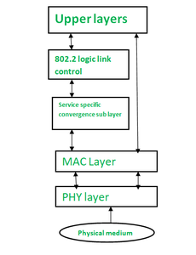
IEEE 802.15.4
Advantages of IEEE 802.15.4:
IEEE 802.15.4 has the following advantages:
- cheap cost
- long battery life,
- Quick installation
- simple
- extensible protocol stack
Disadvantages of IEEE 802.15.4:
IEEE 802.15.4's drawbacks include:
- IEEE 802.15.4 causes interference and multipath fading.
- doesn't employ a frequency-hopping approach.
- unbounded latency
- interference susceptibility
Applications of IEEE 802.15.4:
IEEE 802.15.4 Applications:
- Wireless sensor networks in the industry
- Building and home automation
- Remote controllers and interacting toys
- Automotive networks
3. topology and Security of IEEE 802.15.4, 802.15.4g, 802.15.4e, 1901.2a, 802.11ah and LoRaWAN, Network Layer: IP versions

The provided standards support star, tree, mesh, and point-to-point (1901.2a) topologies, with security features like AES encryption for IEEE 802.15.4, enhanced options in its amendments, and specialized protocols for 802.11ah and LoRaWAN. Network layer functions in these low-power IoT environments are often handled by IP versions such as IPv6, with specific implementations for constrained devices like 6LoWPAN.
Topology & Security Summary
- IEEE 802.15.4:
  - Topologies: Supports star, tree, and mesh network topologies.
  - Security: Uses the Advanced Encryption Standard (AES) for data encryption.
- IEEE 802.15.4g:
  - Topologies: Primarily uses mesh topologies for industrial and smart city applications.
  - Security: Builds on 802.15.4's security with enhancements for specific applications.
- IEEE 802.15.4e:
  - Topologies: Also utilizes mesh topologies, often incorporating features for reliability.
  - Security: Adds features like security fields to the MAC layer for improved protection.
- IEEE 1901.2a:
  - Topologies: This standard focuses on power line communication, supporting point-to-point, star, and mesh-like configurations.
  - Security: Details include security features for the power line communication channel.
- IEEE 802.11ah:
  - Topologies: Supports star, tree, and mesh topologies, similar to other Wi-Fi standards but optimized for long-range, low-power communication.
  - Security: Includes industry-standard security features like WPA2 and, in some cases, WPA3, adapted for the low-power requirements of IoT.
- LoRaWAN:
  - Topologies: Employs a star-of-stars topology, where end nodes communicate directly with gateways, which then forward to a network server.
  - Security: Incorporates its own security framework, with unique key management for encryption and message integrity.
Network Layer: IP Versions
- IPv6:The dominant IP version for IoT networks, especially for devices with sufficient resources.
- IPv4:Still used, particularly in scenarios with a higher data rate or legacy devices, but less scalable for the growing number of IoT devices.
- 6LoWPAN:This adaptation layer enables IPv6 to be used in low-power and lossy networks (LLNs), including IEEE 802.15.4-based networks, by fragmenting and compressing IPv6 packets.
4. Constrained Nodes and Constrained Networks
Constrained nodes are devices, typically in IoT systems, that have limited processing power, memory, and energy, often relying on batteries. A constrained network is one where a significant portion of the nodes are these constrained devices, resulting in characteristics like low bandwidth, unreliable links, limited packet sizes, and high latency. Examples include smart agricultural sensors or building automation devices, which must operate under strict power and resource limits.
Characteristics of Constrained Nodes
- Limited Resources: They have small CPUs, minimal memory, and low-power consumption, often necessitating battery operation.
- Physical Constraints: Their size, weight, and power usage are often limited by cost or physical deployment conditions.
- Duty Cycling: To conserve power, these nodes may enter sleep states or "duty cycles".
Characteristics of Constrained Networks
- Low Data Rates: Communication channels are typically slow, often operating at kilobits per second.
- Unreliable Links: The network may experience high packet loss, unpredictable errors, and connectivity issues.
- Small Packet Sizes: Constrained networks often support only limited packet sizes.
- No Standard Stacks: Because of their resource limitations, they cannot use conventional network stacks like TCP/IP and require specialized, lightweight protocols like CoAP.
How They Relate
- A constrained network is caused by the presence of many constrained nodes within it.
- The limitations of the nodes directly influence the characteristics of the network, creating challenges for data transfer and communication.
- Constrained-node networks are often deployed in the "edge" of an Internet of Things (IoT) system, connecting sensors and actuators to more traditional networks or servers.
5. Optimizing IP for IoT: From 6LoWPAN to 6Lo
Optimizing IP for IoT involves using 6LoWPAN for constrained wireless networks and 6Lo (6LoWPAN) to expand IPv6 support to new technologies. 6LoWPAN achieves optimization through header compression, fragmentation, and mesh addressing, making IPv6 usable on low-power devices and networks like IEEE 802.15.4. The subsequent 6Lo working group built on this by applying these optimizations to a wider range of link layers, including Bluetooth LE, expanding IPv6's reach and enabling more devices to become part of the IoT by addressing their resource and network constraints.
1. Why Optimization is Needed
Standard IP isn't suitable for the IoT due to:
- Resource Constraints: IoT devices often have limited processing power, memory, and battery life.
- Network Constraints: IoT networks use low-power, low-bandwidth, and potentially unreliable wireless technologies, which cannot handle large IP packets.
2. The Role of 6LoWPAN
6LoWPAN (IPv6 over Low-power Wireless Personal Area Networks) was the initial optimization for resource-constrained networks, primarily IEEE 802.15.4:
- Header Compression: Reduces the size of IPv6 and UDP headers, lowering transmission overhead.
- Fragmentation and Reassembly: Breaks down large IP packets into smaller fragments that fit on the limited MTU of low-power wireless links and reassembles them at the destination.
- Mesh Addressing: Manages addressing efficiently in mesh networks where data may be routed through multiple hops, ensuring scalability.
3. The Evolution to 6Lo
The 6Lo working group builds upon the foundation of 6LoWPAN to extend IPv6 support to a broader universe of technologies beyond IEEE 802.15.4.
- Broader Technology Support:
Instead of being tied to a single network type, 6Lo provides adaptation layers for various low-power technologies like Bluetooth LE, ITU-T G.9959, and others.
- Standardization of Adaptation:
It standardizes the adaptation layer to ensure IPv6 can be efficiently transmitted over these diverse new link layer technologies.
- Global Compatibility:
By defining adaptation layers for these newer technologies, 6Lo enhances the global compatibility of IPv6 in the IoT landscape.
6. Routing over Low Power and Lossy Networks
What is RPL (IPv6 Routing protocol)?
RPL stands for Routing Protocol for Low Power and Lossy Networks for heterogeneous traffic networks. It is a routing protocol for Wireless Networks. This protocol is based on the same standard as by Zigbee and 6 Lowpan is IEEE 802.15.4 It holds both many-to-one and one-to-one communication.
It is a Distance Vector Routing Protocol that creates a tree-like routing topology called the Destination Oriented Directed Acyclic Graph (DODAG), rooted towards one or more nodes called the root node or sink node.
The Directed Acyclic Graphs (DAGs) are created based on user-specified specific Objective Function (OF). The OF defines the method to find the best-optimized route among the number of sensor devices.
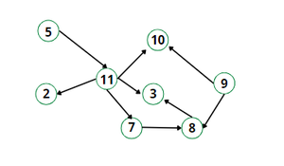Directed Acyclic Graph
The IETF chartered the ROLL (Routing Over Low power and Lossy networks) working group to evaluate all three routing protocols and determine the needs and requirements for developing a routing solution for IP smart objects. After the study of various use cases and a survey of existing protocols, the consensus was that a new routing protocol should be developed for IP smart objects, given the characteristics and requirements of the constrained network. This new Distance Vector Routing Protocol was named the IPv6 Routing Protocol for Low power and Lossy networks(RPL). The RPL specification was published as RFC 6550 by the ROLL working group.
In an RPL Network, each node acts as a router and becomes part of a mesh network. Routing is performed at the IP Layer. Each node examines every received IPv6 packet and determines the next-hop destination based on the information contained in the IPv6 header. No information from the MAC layer header is needed to perform the next determination.
Modes of RPL:
This protocol defines two modes:
1. Storing mode
All modes contain the entire routing table of the RPL domain. Every node knows how to reach every other node directly.
2. Non-Storing mode
Only the border router(s) of the RPL domain contain(s) the full routing table. All other nodes in the domain maintain their list of parents only and use this as a list of default routes towards the border router. The abbreviated routing table saves memory space and CPU. When communicating in non-storing mode, a node always forwards its packet to the border router, which knows how to ultimately reach the final destination.
RPL is based on the concept of a Directed Acyclic Graph (DAG). A DAG is Directed Graph where no cycle exists. This means that from any vertex or point in the graph, we cannot follow an edge or a line back to this same point. All of the edges are arranged in a path oriented toward and terminating at one or more root nodes.
A basic RPL process involves building a Destination Oriented Directed Acyclic Graph (DODAG). A DODAG is a DAG rooted in one destination. In RPL this destination occurs at a border router known as the DODAG root. In a DODAG, three parents maximum are maintained by each node that provides a path to the root. Typically one of these parents is the preferred parent, which means it is the preferred next hop for upward roots towards the root. The routing graph created by the set of DODAG parents across all nodes defines the full set of upwards roots. RPL protocol information should ensure that routes are loop-free by disallowing nodes from selected DODAG parents positioned further away from a border router.
Implementation of RPL Protocol
The RPL protocol is implemented using the Contiki Operating system. This Operating System majorly focuses on IoT devices, more specifically Low Power Wireless IoT devices. It is an Open source Model and was first bought into the picture by Adam Dunkels.
The RPL protocol mostly occurs in wireless sensors and networks. Other similar Operating Systems include T-Kernel, EyeOS, LiteOS, etc.
Main Features and Advantages of RPL
The IPv6 Routing Protocol for RPL, is an efficient and effective protocol for data routing in resource-constrained scenarios, such Internet of Things devices as per requirement. Its many essential features include the below points:
- Scalability: The protocol can accommodate such type of big networks with low power and lossy connectivity, which makes it appropriate for a range of Internet of Things applications.
- Multipoint-to-point traffic generation: RPL offers a way to send data to a single destination point from several devices within the LLN as per requirement.
- Quality of Service (QoS) - The protocol guarantees QoS by offering various types of methods for reliable packet delivery system and congestion control systetm.
- Adaptive – RPL modifies the required routes in response to link quality and energy availability changes in the network environment or system.
- Security system: To guarantee various types of secure communication within the LLN as per requirement, RPL incorporates techniques for integrity protection, authentication, confidentiality, and encryption for better performance.
7. Application Transport Methods: Supervisory Control and Data Acquisition
SCADA systems use transport methods like serial links, IP networks, and specialized protocols such as Modbus and DNP3 to transmit data for remote monitoring and control of industrial processes. Protocols like Modbus and DNP3 can now utilize TCP/UDP directly for the transport layer, while older serial data can be encapsulated within TCP/UDP packets using tunneling to operate over IP networks.
Transport Methods for SCADA
- Serial Communication:Historically, SCADA systems relied on serial communication protocols like Modbus over serial links (e.g., RS-232 or RS-485) to transfer data between remote devices and the central control station.
- IP Networks (TCP/UDP):With the rise of the internet, SCADA protocols have been adapted to run over IP networks, leveraging TCP (Transmission Control Protocol) or UDP (User Datagram Protocol) as the underlying transport layers.
- Protocol Tunneling:To integrate legacy serial communication systems into modern IP networks, data from serial devices can be encapsulated within TCP or UDP packets. This process, known as tunneling, allows the data to be sent across an IP network and then de-encapsulated at the receiving end for processing.
- Specialized SCADA Protocols:
  - Modbus: A widely adopted protocol that can operate over serial or IP-based networks.
  - DNP3 (Distributed Network Protocol 3): A robust communication protocol designed for distributed automation and control systems, also capable of running over serial and IP networks.
How SCADA Applications Use These Methods
- Data Acquisition: Remote Terminal Units (RTUs) and Programmable Logic Controllers (PLCs) at remote locations gather data from sensors, pumps, valves, and other equipment.
- Transmission to Control Center: The acquired data is then transmitted to a central SCADA host or Human-Machine Interface (HMI) using the transport methods described above.
- Data Processing and Display: The SCADA software processes this data, displaying it in an understandable format for operators to monitor the status of the system.
- Supervisory Control: Operators can then use the HMI to send control commands back to the RTUs/PLCs via the same communication infrastructure to adjust processes, change setpoints, and control equipment.

7. Application Layer Protocols: CoAP and MQTT.
CoAP is a request/response, UDP-based protocol for constrained IoT devices, designed for resource interaction, while MQTT is a more mature TCP-based publish/subscribe protocol using a broker for decoupling and reliable communication. CoAP is lightweight and energy-efficient, suitable for low-power sensors, whereas MQTT offers higher reliability and is better for high-throughput, broadcast-style communication. The choice between them depends on the application's needs for data volume, reliability, and the capabilities of the devices involved.
CoAP (Constrained Application Protocol)
- Transport: Uses UDP (User Datagram Protocol), which is connectionless and lightweight, making it ideal for devices with limited power and network resources.
- Communication Model: Follows a client/server request/response model, similar to HTTP, allowing direct interaction with resources using methods like GET, PUT, and DELETE.
- Key Features:
  - Resource Discovery: Supports discovering resources available on a server.
  - Observe Functionality: Allows clients to observe resources and receive notifications when their state changes.
  - Lightweight: Has small headers and is designed for efficiency in constrained environments.
- Use Cases: Best suited for battery-powered wearables, sensor networks, and scenarios where direct resource manipulation is needed.
MQTT (Message Queuing Telemetry Transport)
- Transport: Typically runs over TCP (Transmission Control Protocol), providing a reliable, connection-oriented channel.
- Communication Model: Implements a publish/subscribe model, where devices (publishers) send messages to a central broker based on topics, and other devices (subscribers) receive messages they have subscribed to.
- Key Features:
  - Decoupling: The broker decouples publishers and subscribers, making it easier to manage complex interactions.
  - Reliability: Offers different levels of Quality of Service (QoS) to ensure messages are delivered, even in unreliable network conditions.
  - Asynchronous Messaging: Publishers don't need to wait for subscribers to consume data, enabling scalable communication.
- Use Cases: Ideal for large-scale deployments, high-throughput applications, and scenarios requiring reliable message delivery between many devices, such as in cloud-based IoT platforms.
Key Differences at a Glance
Feature | CoAP | MQTT
Transport | UDP | TCP
Model | Request/Response | Publish/Subscribe
Architecture | Client/Server | Publisher/Subscriber with a Broker
Best For | Constrained devices, low-power sensors | High-throughput, reliable messaging
Overhead | Lower | Higher (due to TCP)

UNIT:04

1. Structured Vs Unstructured Data and Data in Motion Vs Data in Rest
In IoT, structured data (e.g., sensor readings) is organized in predefined formats, making it easier to manage with traditional tools, while unstructured data (e.g., video feeds) is diverse and requires advanced techniques like NLP. Data in motion is data actively moving across networks, posing interception risks, whereas data at rest is stored on devices, needing different security measures like encryption. Both data types and states require appropriate tools and security for effective IoT data management and analysis.
Structured vs. Unstructured Data in IoT
- Structured Data:
  - Definition: Data with a well-defined structure, fitting into a predefined format like a table.
  - IoT Examples: Sensor readings (temperature, pressure, humidity), GPS coordinates, and data from point-of-sale (POS) systems.
  - Characteristics: Easy to search, manipulate, and analyze using standard tools and languages like SQL.
  - Management: Stored in relational databases or data warehouses with rigid schemas.
- Unstructured Data:
  - Definition: Data that doesn't fit a predefined model and exists in its native, varied format.
  - IoT Examples: Audio and video feeds from cameras, social media posts from users interacting with IoT devices, emails, and large text documents.
  - Characteristics: Difficult to categorize or search with standard methods, but rich in potential insights.
  - Management: Stored in data lakes or non-relational (NoSQL) databases and requires advanced analytics techniques like Natural Language Processing (NLP).
Data in Motion vs. Data in Rest in IoT
- Data in Motion (or "in flight"):
  - Definition: Data that is actively being transferred or moved from one location to another across networks.
  - IoT Examples: Data moving from an IoT sensor to the cloud, data being transmitted between different applications or cloud services.
  - Vulnerabilities: More susceptible to threats like interception, corruption, and data breaches because it's exposed during transit.
  - Security: Requires protocols like TLS/SSL for HTTPS and IPsec for VPN tunnels to encrypt and secure the data during transmission.
- Data at Rest:
  - Definition: Data that is stored on a device or system and is not actively being moved or processed.
  - IoT Examples: Data stored on an IoT device's internal storage, data in a cloud database or a device's memory.
  - Vulnerabilities: Susceptible to physical theft of devices or unauthorized access to the storage medium.
  - Security: Requires encryption and access controls to protect the stored information from being accessed by unauthorized individuals.

Difference between structured data and unstructured data
Parameters | Structured data | Unstructured data
Format | Organized, typically in tables or databases | No predefined format lacks structure
Schema | Follows a predefined schema | No fixed schema, flexible
Storage | Easily stored in databases or spreadsheets | Requires specialized storage solutions
Retrieval | Simple and straightforward | Often requires advanced search algorithms
Analysis | Well-suited for quantitative analysis | Requires specialized techniques (NLP, etc.)
Processing | Easily processed using traditional methods | Requires advanced processing techniques
Complexity | Low complexity due to structured format | High complexity due to lack of structure
Size | Typically smaller in size | Can be larger due to multimedia content
Insights Extraction | Straightforward extraction of insights | Requires sophisticated analysis methods
Database Management | Easily managed with traditional DBMS | May require NoSQL or other specialized DBMS
Searchability | Highly searchable using SQL queries | Less searchable, often relies on metadata
Examples | Databases, spreadsheets, CSV files | Text documents, emails, images, videos

2. Role of Machine Learning,
Machine learning (ML) empowers Internet of Things (IoT) systems by enabling them to analyze data, identify patterns, and make intelligent, autonomous decisions without constant human intervention. Its role is to extract insights from the massive data generated by IoT devices, leading to improved operational efficiency, enhanced security through anomaly detection, predictive maintenance, resource optimization, and better overall decision-making in various applications.
Key Roles of Machine Learning in IoT
- Intelligent Decision-Making:
ML algorithms learn from data patterns to make informed, real-time decisions, automating tasks and improving performance without human oversight.
- Predictive Analytics:
ML can predict future events and trends based on historical IoT data, enabling proactive measures in areas like predictive maintenance or energy demand forecasting.
- Anomaly Detection & Security:
By continuously monitoring data for unusual patterns, ML can detect potential security threats, breaches, and malware, bolstering the security of IoT networks.
- Resource Optimization:
In industries like manufacturing or smart grids, ML optimizes the use of resources such as energy and materials, leading to cost savings and increased sustainability.
- Enhanced User Experience:
ML enables personalized recommendations and automated actions, improving the user experience by tailoring services to individual preferences.
- Improved Efficiency:
By automating complex processes and enhancing operational efficiency through data-driven insights, ML helps organizations achieve their goals more effectively.
- Automation:
ML automates a wide range of tasks and processes within an IoT system, reducing manual intervention and improving reliability.
How it Works
- Data Collection:
IoT devices gather vast amounts of data from their environment.
- Data Analysis:
This data is then processed by ML algorithms, which identify hidden patterns, anomalies, and correlations.
- Model Building:
ML models are built and refined based on this analysis to predict future behaviors and events.
- Intelligent Action:
The insights gained are used to guide IoT devices to perform actions, optimize processes, or trigger alerts autonomously.

3. No SQL Databases IN IOT
NoSQL databases are frequently chosen for Internet of Things (IoT) applications due to their ability to handle the unique demands of IoT data. Unlike traditional relational databases (SQL), NoSQL databases offer flexibility, scalability, and performance optimized for large volumes of unstructured or semi-structured data, which is common in IoT environments.
Here's why NoSQL databases are well-suited for IoT:
- Handling Unstructured and Semi-structured Data:
IoT devices generate diverse data types (sensor readings, logs, events) that often lack a rigid schema. NoSQL databases, with their flexible schema models (document, key-value, column-family, graph), can easily accommodate this variety.
- Scalability for High Data Ingestion:
IoT deployments can involve millions of devices generating data continuously. NoSQL databases are designed for horizontal scalability, allowing them to distribute data across multiple servers and handle massive write operations without performance degradation.
- Real-time Data Processing:
Many IoT applications require real-time analysis and action based on incoming data. NoSQL databases often provide faster read and write performance compared to relational databases, enabling quicker data processing and responsiveness.
- Flexibility and Agility:
The nature of IoT applications can evolve rapidly, requiring changes to data models. NoSQL's flexible schema allows for easier adaptation and iteration without complex migration processes.
- Edge Computing and Offline Capabilities:
Some NoSQL databases are designed with features like cloud-to-edge synchronization, enabling data storage and processing closer to the source (edge devices) and ensuring data consistency even with intermittent connectivity.
Examples of NoSQL databases used in IoT:
- MongoDB:
A document-oriented database known for its flexibility and scalability, suitable for storing device data and application logs.
- Cassandra:
A wide-column store offering high availability and linear scalability, ideal for time-series data and large-scale data ingestion.
- InfluxDB:
A time-series database specifically optimized for storing and querying time-stamped data, a common requirement in IoT.
- Redis:
An in-memory key-value store providing extremely fast data access, often used for caching and real-time data processing in IoT.
- Firebase/Firestore:
Cloud-based NoSQL databases offering real-time data synchronization and ease of integration with mobile and web applications, often used for IoT device management and data visualization.
4. Hadoop Ecosystem IN IOT
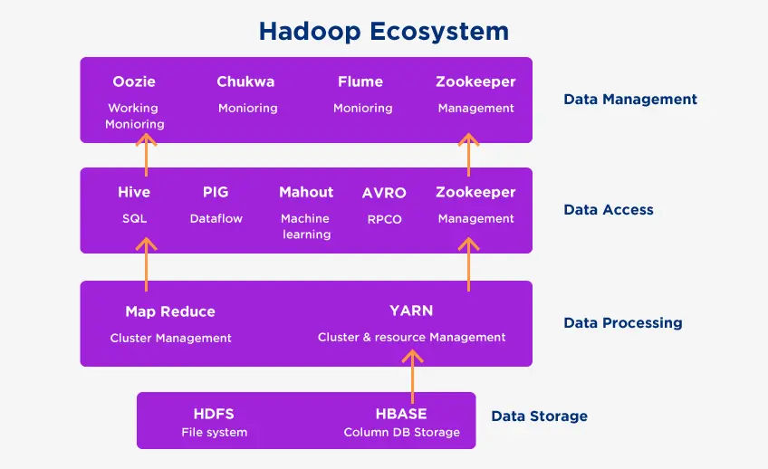
The Hadoop ecosystem is a collection of Apache open-source tools that handle Big Data from diverse sources, including IoT devices, by providing distributed storage (HDFS), processing (MapReduce, Spark), resource management (YARN), and data integration (Kafka, Flume). In IoT, these components are vital for ingesting the massive, real-time data generated by sensors, performing analytics like predictive modeling, and deriving insights for various applications, such as smart environments or predictive maintenance.
Key Components of the Hadoop Ecosystem in IoT
- Hadoop Distributed File System (HDFS): Stores the vast amounts of data generated by IoT devices in a distributed, fault-tolerant manner across multiple nodes.
- Yet Another Resource Negotiator (YARN): Manages and allocates cluster resources, enabling various processing engines to run efficiently for IoT data.
- MapReduce/Spark: Provides frameworks for parallel data processing. Spark is often preferred for its faster, real-time processing capabilities, which are crucial for IoT data streams.
- Apache Kafka: A distributed event streaming platform that ingests, processes, and distributes real-time data feeds from IoT devices.
- Apache Flume/Sqoop: Used for data ingestion. Flume helps collect streaming data from IoT sources, while Sqoop facilitates moving data between Hadoop and structured databases.
- Apache Hive/HBase: Hive provides SQL-like querying for data stored in HDFS, and HBase offers a NoSQL database for fast, random read/write access to large datasets, suitable for IoT data analysis.
How the Ecosystem Supports IoT
- Data Ingestion: Tools like Flume and Kafka collect and stream data from numerous IoT devices into the Hadoop ecosystem.
- Data Storage: HDFS provides a scalable and reliable platform for storing the continuous, high-volume data from IoT devices.
- Real-time Processing: Spark and Kafka enable real-time analytics on incoming data, allowing for immediate detection of anomalies or trends in IoT sensor readings.
- Batch Analytics: MapReduce and Hive allow for complex, large-scale batch processing to derive historical insights from IoT data for applications like predictive maintenance.
- Advanced Analytics & Machine Learning: The ecosystem supports machine learning and predictive analytics to build models that can forecast equipment failures, optimize energy consumption, or improve smart city services.

5. Apache Kafka IN IOT
Apache Kafka is used in IoT to handle massive real-time data streams from connected devices, providing high throughput, scalability, and fault tolerance for applications like smart homes, industrial IoT, and smart cities. It acts as a central "data backbone" or intermediary, allowing devices to publish events, which are then subscribed to, stored, and processed in real-time for various analytics and automation tasks.
Key Capabilities of Kafka for IoT
- High Throughput:
Kafka can manage billions of events per day, which is crucial for the high-volume data generated by IoT devices.
- Real-time Processing:
It enables near-instantaneous handling of data, allowing for rapid responses in applications like fleet management or connected car systems.
- Scalability:
Kafka's distributed nature allows it to easily scale to handle increasing numbers of connected devices and growing data volumes without performance degradation.
- Fault Tolerance:
Its distributed architecture and data replication ensure that data streams are not lost even if some parts of the system fail.
- Durability:
Kafka persists data, storing it safely and reliably for later use, which is important for data analysis and historical record-keeping.
Common IoT Use Cases
- Smart Home Systems:
Aggregating data from smart devices (like thermostats and security systems) for monitoring and automated actions.
- Industrial IoT (IIoT):
Real-time monitoring of industrial equipment, predictive maintenance, and optimization of production lines using sensor data.
- Connected Vehicles:
Collecting and analyzing vehicle telematics data for fleet management, driver behavior analysis, and traffic management.
- Smart Cities:
Monitoring urban infrastructure, managing traffic flow, and optimizing energy consumption by collecting data from city-wide sensors.
- Healthcare:
Facilitating real-time patient monitoring and data analysis from medical devices to improve patient outcomes.
How Kafka Works with IoT
- Data Ingestion:
IoT devices (producers) publish streams of data (events) to specific Kafka topics.
- Data Processing:
Kafka's distributed nature allows for parallel processing of these data streams by various applications (consumers).
- Integration with Other Protocols:
Kafka often works with other IoT protocols like MQTT for device-to-cloud communication.
- Data Storage & Analytics:
The processed data is stored durably and can be used for real-time analytics, enabling insights and intelligent decision-making.
6. Apache Spark IN IOT
Apache Spark is a powerful and versatile open-source framework that plays a crucial role in processing and analyzing the massive amounts of data generated by Internet of Things (IoT) devices. Its capabilities make it an ideal solution for various IoT applications.
Key ways Apache Spark is utilized in IoT:
- Real-time Data Processing and Analytics:
  - Spark Streaming: Enables the processing of live data streams from IoT sensors and devices, crucial for applications requiring immediate insights, such as anomaly detection in industrial equipment, real-time traffic management, or smart home automation.
  - Low-latency in-memory processing: Spark's in-memory computing significantly speeds up data analysis, allowing for quick decision-making and rapid responses to events in IoT environments.
- Scalability and Distributed Computing:
  - Distributed Architecture: Spark's ability to distribute processing across a cluster of machines allows it to handle the immense data volumes generated by large-scale IoT deployments, like smart cities or extensive sensor networks.
- Machine Learning and Predictive Analytics:
  - MLlib: Spark's machine learning library can be used to build and train models on IoT data for tasks such as predictive maintenance, anomaly detection, forecasting, and personalized recommendations in smart environments.
- Data Integration and Flexibility:
  - Diverse Data Sources: Spark can integrate with various data sources, including databases, file systems (like HDFS), and streaming platforms, allowing for a comprehensive view of IoT data.
  - Multi-language Support: With APIs in Java, Scala, Python, and R, Spark offers flexibility for developers working on IoT solutions.
- Use Cases:
  - Smart Cities: Analyzing traffic sensor data for congestion prediction and dynamic signal adjustments.
  - Industrial IoT (IIoT): Monitoring equipment performance, detecting anomalies, and predicting failures for preventative maintenance.
  - Connected Vehicles: Processing real-time vehicle data for navigation, safety features, and fleet management.
  - Smart Homes: Analyzing sensor data for automation, energy efficiency, and security.
In essence, Apache Spark provides the necessary speed, scalability, and analytical power to transform raw IoT data into actionable insights, driving intelligence and automation across a wide range of IoT applications.
7. Edge Streaming Analytics and Network Analytics
Edge Streaming Analytics processes data in real-time directly at its source, like IoT devices, to enable immediate insights and actions, reducing the need to send large data volumes to a central cloud. Network Analytics, in contrast, is a broader process focused specifically on collecting and analyzing data from the network itself to improve its performance, security, and reliability. While edge analytics can incorporate network data at the edge, network analytics' primary focus is the network infrastructure itself, whereas edge analytics focuses on data generated by the devices connected to that network.
Edge Streaming Analytics
- What it is: A specific application of edge analytics that handles data as it's generated and in constant motion (streaming).
- Where it happens: At or near the data source (e.g., sensors, machines, IoT devices).
- Why it's used: To enable real-time decision-making, reduce bandwidth by sending only processed insights, and decrease latency.
- Key actions: Filtering, transforming, correlating, and pattern matching on streaming data.
- Examples: Predictive maintenance for machinery, autonomous vehicle operations, or in-hospital patient monitoring systems that provide immediate alerts.
Network Analytics
- What it is: The process of analyzing data related to network traffic and infrastructure.
- Where it happens: Across the network, potentially in a centralized location, or in conjunction with edge devices.
- Why it's used: To monitor network health, detect security threats, optimize network performance, and ensure reliability.
- Key actions: Data collection from various network points, performance monitoring, traffic analysis, and security log analysis.
- Examples: Identifying a sudden surge in network traffic that indicates a security breach or analyzing network congestion to improve resource allocation.
How They Relate
- Complementary: Edge streaming analytics can use network analytics to understand the local network environment at the edge, and network analytics can gain insights from the data being processed at edge devices.
- Different Focus: Edge streaming analytics is about what the edge devices are doing and the data they generate, while network analytics is about the health and performance of the network infrastructure connecting them.
8. Xively Cloud for IoT, Python Web Application Framework
Xively Cloud was a commercial Platform-as-a-Service (PaaS) specifically designed for Internet of Things (IoT) applications. It aimed to provide a comprehensive suite of tools and services to help developers build, manage, and derive value from connected products.
Key Features of Xively Cloud for IoT:
- Device Management:
Facilitated the onboarding, authentication, and management of IoT devices, including features like device registration, secure authentication (using protocols like OAuth and TLS), and Over-the-Air (OTA) firmware updates.
- Data Collection and Processing:
Simplified the collection and processing of data generated by IoT devices, offering real-time data streaming, data aggregation, and basic data filtering and transformation capabilities.
- Messaging:
Built on the publish-subscribe protocol MQTT, supporting real-time message management between devices and the cloud.
- APIs and SDKs:
Exposed its services via RESTful APIs and supported MQTT-based messaging, providing SDKs for various platforms to integrate with the cloud.
- Security:
Included a "trust engine" for security, ensuring secure communication and authentication of devices.
Python Web Application Frameworks in the Context of IoT:
While Xively provided the cloud infrastructure for IoT, Python web application frameworks like Flask or Django could be used to build the front-end and back-end applications that interact with the Xively platform.
- Integration with Xively APIs:
Python applications could utilize Xively's RESTful APIs or MQTT-based messaging to send commands to devices, retrieve sensor data, and manage device configurations.
- Data Visualization and Analysis:
Frameworks like Flask or Django could be used to create web interfaces for visualizing the data collected from IoT devices, performing further analysis, and generating reports.
- User Interface Development:
Developers could build dashboards and control panels using Python web frameworks to allow users to monitor and interact with their connected devices.
In essence, Xively handled the core IoT cloud services, while Python web application frameworks could be employed to build the user-facing applications and logic that leveraged Xively's capabilities.
9. Django, AWS for IoT – System Management with NETCONF, YANG.
Integrating Django with AWS for IoT system management using NETCONF and YANG involves leveraging these technologies for robust and standardized device configuration and monitoring.
1. NETCONF and YANG for IoT Device Management:
- YANG (Yet Another Next Generation):
This data modeling language defines the structure and hierarchy of configuration and state data for network devices, including IoT devices. It provides a standardized way to describe device capabilities, configuration parameters, and operational state.
- NETCONF (Network Configuration Protocol):
This protocol uses YANG models to retrieve and manipulate configuration and state data on network devices. It operates over secure transport protocols like SSH and provides features like transactional configuration, error handling, and notifications.
2. Django as the Management Application Framework:
- Web Interface:
Django can power a web-based interface for operators to interact with the IoT system. This interface can allow users to view device status, configure settings, and receive alerts.
- API Development:
Django's REST framework can be used to build APIs that interact with the NETCONF clients and the AWS IoT platform. These APIs would facilitate communication between the web interface, the NETCONF clients, and the cloud.
- Data Storage:
Django's ORM and database capabilities can store information about registered IoT devices, their configurations, and historical operational data.
3. AWS IoT for Cloud Connectivity and Services:
- Device Connectivity:
AWS IoT Core provides secure and scalable connectivity for IoT devices to the cloud, allowing them to send telemetry data and receive commands.
- Device Shadow:
AWS IoT Device Shadow service can maintain a virtual representation of each device's state in the cloud, enabling applications to interact with devices even when they are offline.
- Rules Engine:
The AWS IoT Rules Engine can process data from devices, trigger actions (e.g., sending alerts, updating databases), and route data to other AWS services.
- Security:
AWS IoT offers robust security features, including authentication, authorization, and encryption, to protect device-to-cloud communication.
4. Integration Workflow:
- Device Onboarding:
IoT devices are registered with AWS IoT Core.
- YANG Model Deployment:
YANG models describing the device's capabilities are made available to the management system.
- Django Application:
A Django application provides a user interface and APIs for managing devices.
- NETCONF Client:
The Django application or a separate service uses a NETCONF client to send configuration commands (based on YANG models) to the IoT devices.
- AWS IoT Integration:
The Django application can interact with AWS IoT Core to monitor device status, receive data from devices, and potentially trigger actions based on device events.
- Data Flow:
Device telemetry flows through AWS IoT Core, where it can be processed by the Rules Engine and stored in databases managed by Django. Configuration changes initiated via Django are pushed to devices using NETCONF.
This integrated approach provides a robust, scalable, and standardized solution for managing IoT systems, combining the power of Django for application development, AWS IoT for cloud services, and NETCONF/YANG for device configuration and management.

