Team Group Name: Team D

Team Members: Gabriel Vance, Ashlee Correll, Daniel Coleman

Team Captain: Daniel Coleman



Bio: We are first year web developer students at Bellevue University currently learning HTML, JavaScript, and CSS. This is our first group web development project. By utilizing Google Hangouts, GitHub and Google Docs, we will be conducting the development of our application despite the distance gap.

Ashlee Correll lives in Bellevue NE and has been studying web development for six months. When she graduates she hopes to travel and work remotely along the way.

Gabriel Vance lives in Bellevue, NE and this is his third set of web development classes. He is currently studying how to use JavaScript and Node.js. He plans to learn additional aspects of web development and coding to become a full stack web developer.

Daniel Coleman currently resides in Fayetteville Arkansas. Where he works full-time as a motion graphics artist. Attending his first year through Bellevue University, his goal is to earn his Bachelors in Web Development so that he can build and design custom web applications and sites for current and future clients.

Application: JavaScript Trivia

We will create a JavaScript application using Knockout.js that will test the user on trivia from our previous web development classes. There will be 10 questions. The user will be able to move backward and forward for the questions. After all 10 questions are answered and the user submits their test, they will receive their score. The questions will all be multiple choice with four possible answers each. The test will be graded on a scale from 1-10 and a rank will be given depending on the score.

Proposed Prototype - 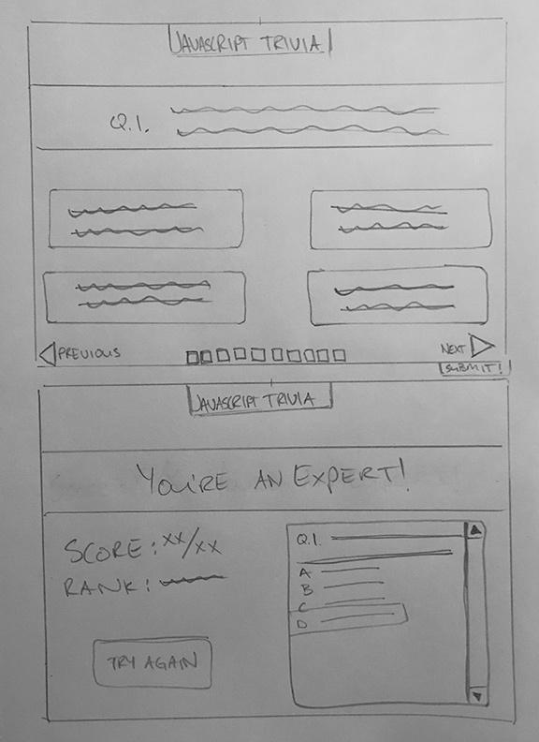

**Single Page Application (Javascript Trivia) -**   
Question within the header area, rotates out after selecting navigation buttons (next, previous)

Possible answers will be in boxes below, and will change background color upon selection and hover.

Progress bar will show level of progress during the quiz.

On the final question, the next button will swap out with a submit button.

**End frame -**

Headline with comment of rank will display in header area.

Score and final rank will display left of the questions recap scroll box.

Try again button will all users to start the quiz over.