Assignment 9.4 - Client-side Debugging

1. How to set Breakpoints while using Google Chrome.

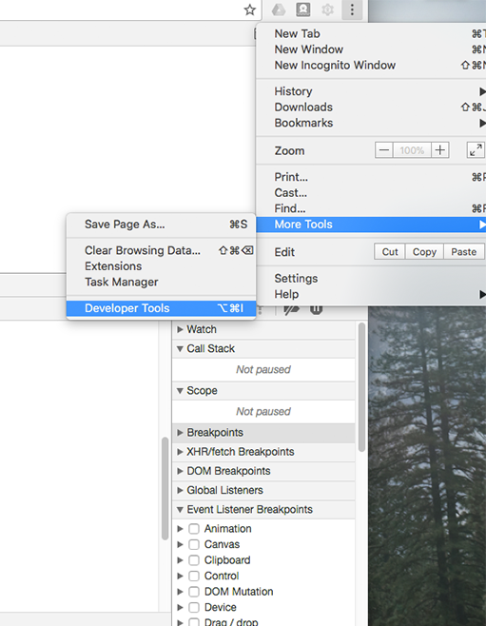

Begin by opening your chrome browser. There will be three stacked dots, click this to open the menu list. Then select ‘More Tools’ and then ‘Developer tools’. Or just press CMD+OPT+J­­­­

(Three stacked dots)

From the different tabs, select ‘Sources’, and drag a folder or open a file by pressing CMD+P

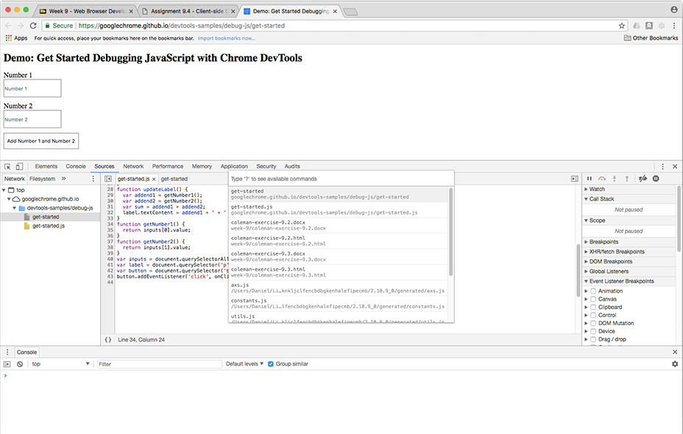

On the far right there should be a panel dedicated to debugging. Scroll down the list and open the Event Listeners Breakpoints. Then select the mouse folder, and then check the box by ‘click.’

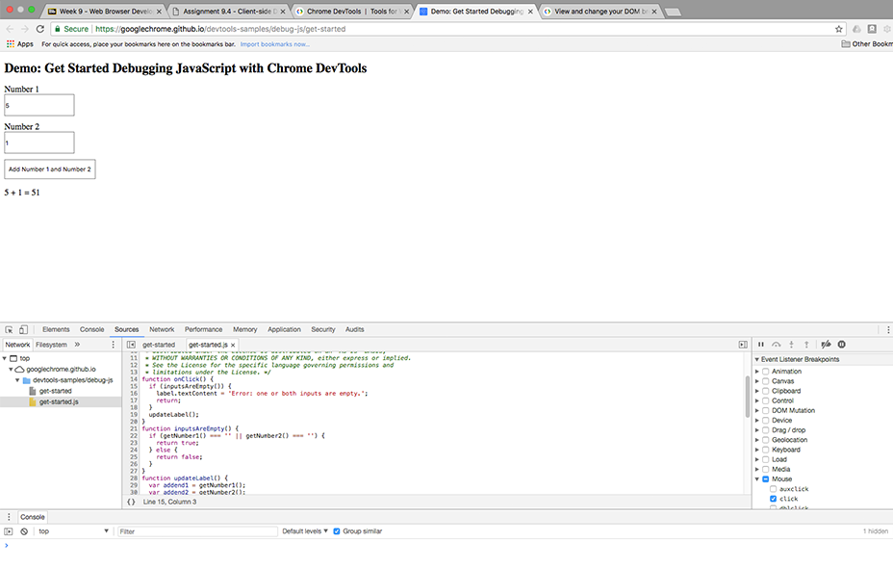

Running your code again will activates your breakpoint and it should select the line of code that is linked to that action.

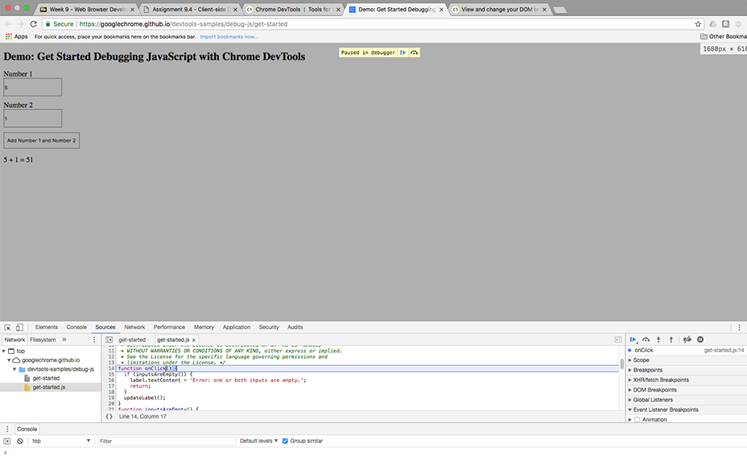

From here we can go line by line to make sure each section of code is correct and there aren’t any errors. We do this by selecting ‘Step into next function call’ (the Arrow Down over a dot icon)

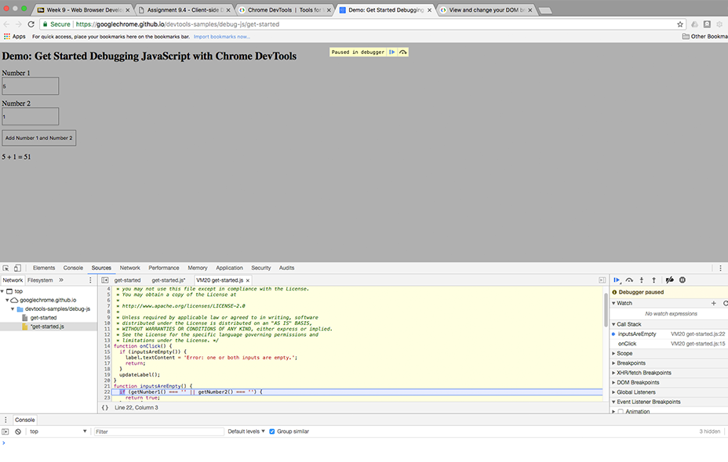

1. How to view, log, and read messages via the Javascript Console while using Google Chrome.

Start by selecting the console tab from the DevTools window, this is where you will be able to access the messages

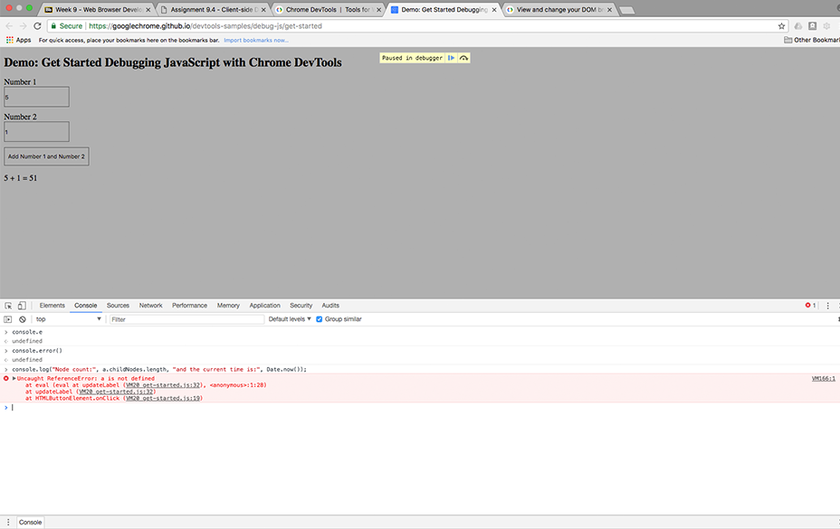

1. How to select HTML elements while in the Javascript Console window.

Start by selecting the <div> tag you are trying to select from within the Elements tab. Then return to the Console tab.

Use the ID from the <div> tag to enter into the replacing “ID” placeholder.

Document.getElementById(“ID”)

1. How to simulate CSS states; hover and focus

Find the element that you would like to edit

Right click that element and select Force State / or select it from the styles tab

