Start by opening your HTML file within a Chrome browser. To open the Browsers DevTools window(on a mac) start by pressing: CMD+Option+J on the keyboard. Then select the first Elements Tab.

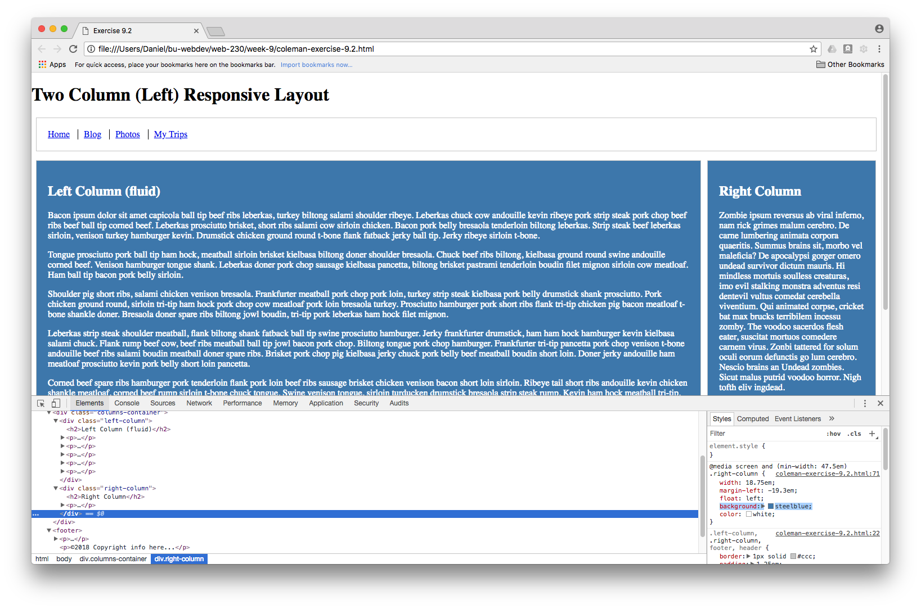

Then you can locate the areas you need to change by hover over the sections of code in the DevTools window, it will highlight the different parts of the site as you scroll over them.

Find the sections you need to edit, here they are marked as ‘left column’ and ‘right column’ so they are easy to find since the main sections are outlined in green.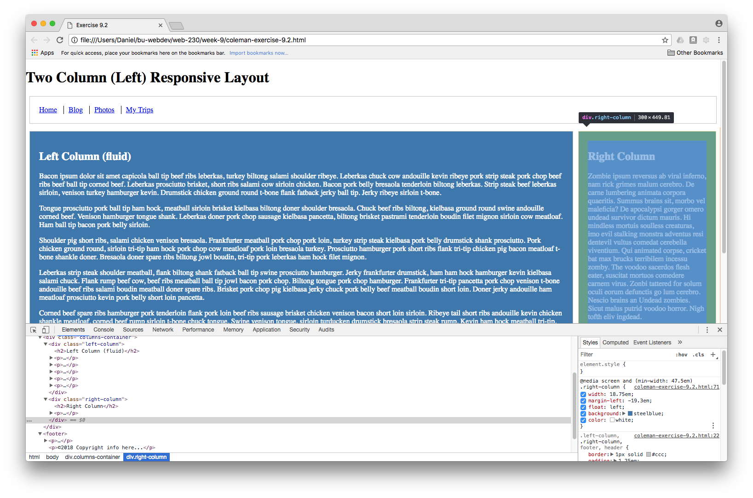

Follow this step by editing the css elements in the window the bottom right and adding background and color tags. Repeat this step for the remaining column.