Embedded System Design Project

# Project Group Members:

1) Ananyo Chattopadhyay (2023H1400123P)

2) Akash K (2023H1400122P)

3) Panjagalla Deepika (2023H1400222P)

4) Anjaney Asreet Rout (2018HD400729P)

Project Title**:** Smart Waste Water Irrigation System

# Objectives:

**1.** Diverting waste water from Aqua-guard unit to garden and trees

**2.** During rainy season, the relay is used to turn off the input supply of the purifier.

# Resources used:

1. STM32F4 Discovery Boards x 2

2. Soil Moisture Sensor x 2

3. LEDs

4. XBee UART Modules x 2

5. Submersible 5V motors x 2

6. Ultrasonic Sensor (HC-SRO4)

7. 5V optocoupler relay x 2

8. Power Bank x 2

# Working of Project:

1. Waste water is released by Aqua-guard during water purification. The water is collected in a container, where water level is measured using an ultrasonic sensor.

2. There will be two case:

(i) If the water level exceeds a threshold level in tank then we check the moisture levels of both plants and trees using the sensors

(ii) If there is very less or no water then both of the motors will remain inactive

3. After the previous step we encounter four cases:

(i) Less plants moisture and high trees moisture- we use XBee UART to send signal to the second microcontroller using a relay to activate the 1st motor.

(ii) High plants moisture and low tree moisture- we use XBee UART to send signal to the second microcontroller using a relay to activate the 2nd motor.

(iii) Both plants and trees have low moisture- we use XBee UART to activate the 1st motor to water the plants.

(iv) Both plants and trees have high moisture- Both of the motors are deactivated and Aqua-guard water supply is closed.

4. In the case of the rainy season, the moisture level will be suitable for all the situations based on the sensor values, so we cannot supply water to the plants and trees since it would lead to a waste of water, so we use the relay to turn-off the Aqua-guard water supply.

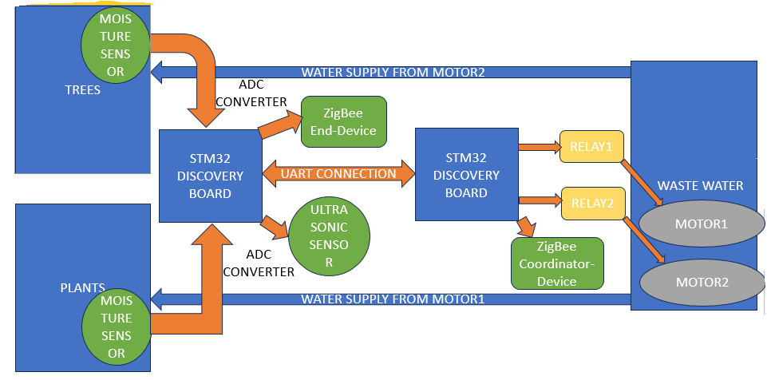

Overview of our Project

# Outcomes:

1. By implementing this project, we demonstrated a water irrigation system that takes the refuse of our water purification unit and diverts it to the garden or, the trees, or neither; based on the situation.

2. We learned how to interface various sensors as part of this project.

3. We also learned how to use multiple microcontrollers and inter-communicate between them.