

**ASSIGNMENT COVERSHEET FOR INDIVIDUAL WORK**

**Faculty of Design and Creative Technologies**

|  |  |  |  |  |  |  |
| --- | --- | --- | --- | --- | --- | --- |
| **First Name** | Robin | | **Family Name** | Nowlan | **Student ID No** | 21141049 |
| **Paper Name** | Embedded Systems Design | | **Paper Code:** | ENEL712 | **Assignment Due Date** |  |
| **Lecturer:** | Professor Jack Li | | **Tutorial Day** |  | **Date Submitted** |  |
| **Tutor:** |  | | **Tutorial Time** |  | **No.Words/Pages** |  |
| In order to ensure fair and honest assessment results for all students, it is a requirement that the work that you hand in for assessment is your own work. If you are uncertain about any of these matters then please discuss them with your lecturer.  Plagiarism and Dishonesty are methods of cheating for the purposes of General Academic Regulations (GAR) | | | | | | |
| <http://www.aut.ac.nz/calendar> | |  | | | | |
| **Assignments will not be accepted if this section is not completed and signed.**  Please read the following and **tick** ☑ to indicate your understanding:   1. I understand it is my responsibility to keep a copy of my assignment.  **Yes**  **No** 2. I have signed and read the **Student's Statement below**.  **Yes**   **No** 3. I understand that a software programme (Turnitin) that detects plagiarism  **Yes**  **No**   and copying may be used on my assignment. | | | | | | |
| **Student's Statement:**  This assessment is entirely my own work and has not been submitted in any other course of study. I have submitted a copy of this assessment to Turnitin, if required.  In this assessment I have acknowledged, to the best of my ability:   * The source of direct quotes from the work of others. * The ideas of others (includes work from private or professional services, past assessments, other students, books, journals, cut/paste from internet sites and/or other materials) * The source of diagrams or visual images.   **Student's Signature: Date:**  The information on this form is collected for the primary purpose of submitting your assignment for assessment. Other purposes of collection include receiving your acknowledgement of plagiarism polices and attending to administrative matters. If you choose not to complete all questions on this form, it may not be possible for the Faculty of Design and Creative Technologies to accept your  assignment. | | | | | | |

Author: Academic Office, Faculty of Design and Creative Technologies Page 1 of 1 Subject: Individual Assignment Cover sheet

Version 2.0 Issue Date: 01/01/2009 Last Updated: 20/07/2009

Auckland University of Technology



School of Engineering, Computer and Mathematical Science

**ENEL712 Embedded Systems Design**

**Project Report**

Submitted by: Robin Nowlan

Student ID: 21141049

2 September 2023

**Table of Contents**

1 Introduction (Use style Heading 1) 3

1.1 Background (Use style Heading 2) 3

1.2 Introduction to Microcontroller 3

2 Objectives (Use style Heading 1) 4

3 Methodologies 4

3.1 Design of Flowchart 4

3.1.1 Flowchart Components 4

4 Results 5

4.1 Simulation Results 5

4.2 Experimental Results 5

4.3 Comparison of Results 5

5 Discussions 5

6 Conclusion 5

7 References 5

8 Appendix 5

# Introduction (Use style Heading 1)

This template serves as an example for report writing and assignment submission in digital format [1].

## Background (Use style Heading 2)

For equations, please numerate them according their appearance in the report.

$A=πr^{2}$ (1)

${\left(x+a\right)}^{n}=\sum_{k=0}^{n}{\left({n \atop k}\right)x^{k}a^{n-k}}$ (2)

## Introduction to Microcontroller

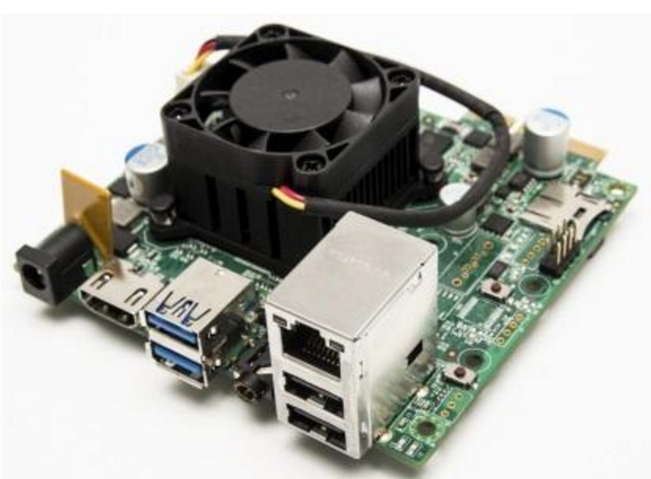

Figure 1. A sample of Embedded Digital System (using Figure Caption)

# Objectives (Use style Heading 1)

Table 1. List of Available Microcontrollers (using Table Caption)

|  |  |  |  |  |
| --- | --- | --- | --- | --- |
| S/N | Brand | Model | I/O Type |  |
| 1 | Amtel | AT90USB1287 |  |  |
| 2 | TI |  |  |  |
| 3 | Microchip |  |  |  |

# Methodologies

## Design of Flowchart

### Flowchart Components

# Results

## Simulation Results

## Experimental Results

## Comparison of Results

# Discussions

# Conclusion

# References

[1] I. Grant, *How to speak well in public and in private!*, 302.2GRA ed.: Random House New Zealand, 2007.

# Appendix