**PasaBuy.App**

Video Teaser

**Preferred Duration:** 15 sec – 20 sec

**Primary Theme Color**: Yellow / Gradient: {Yellow-Orange} -> Dark Gray {#2d2d2d}

Note: Script reading or just energetic sound effect

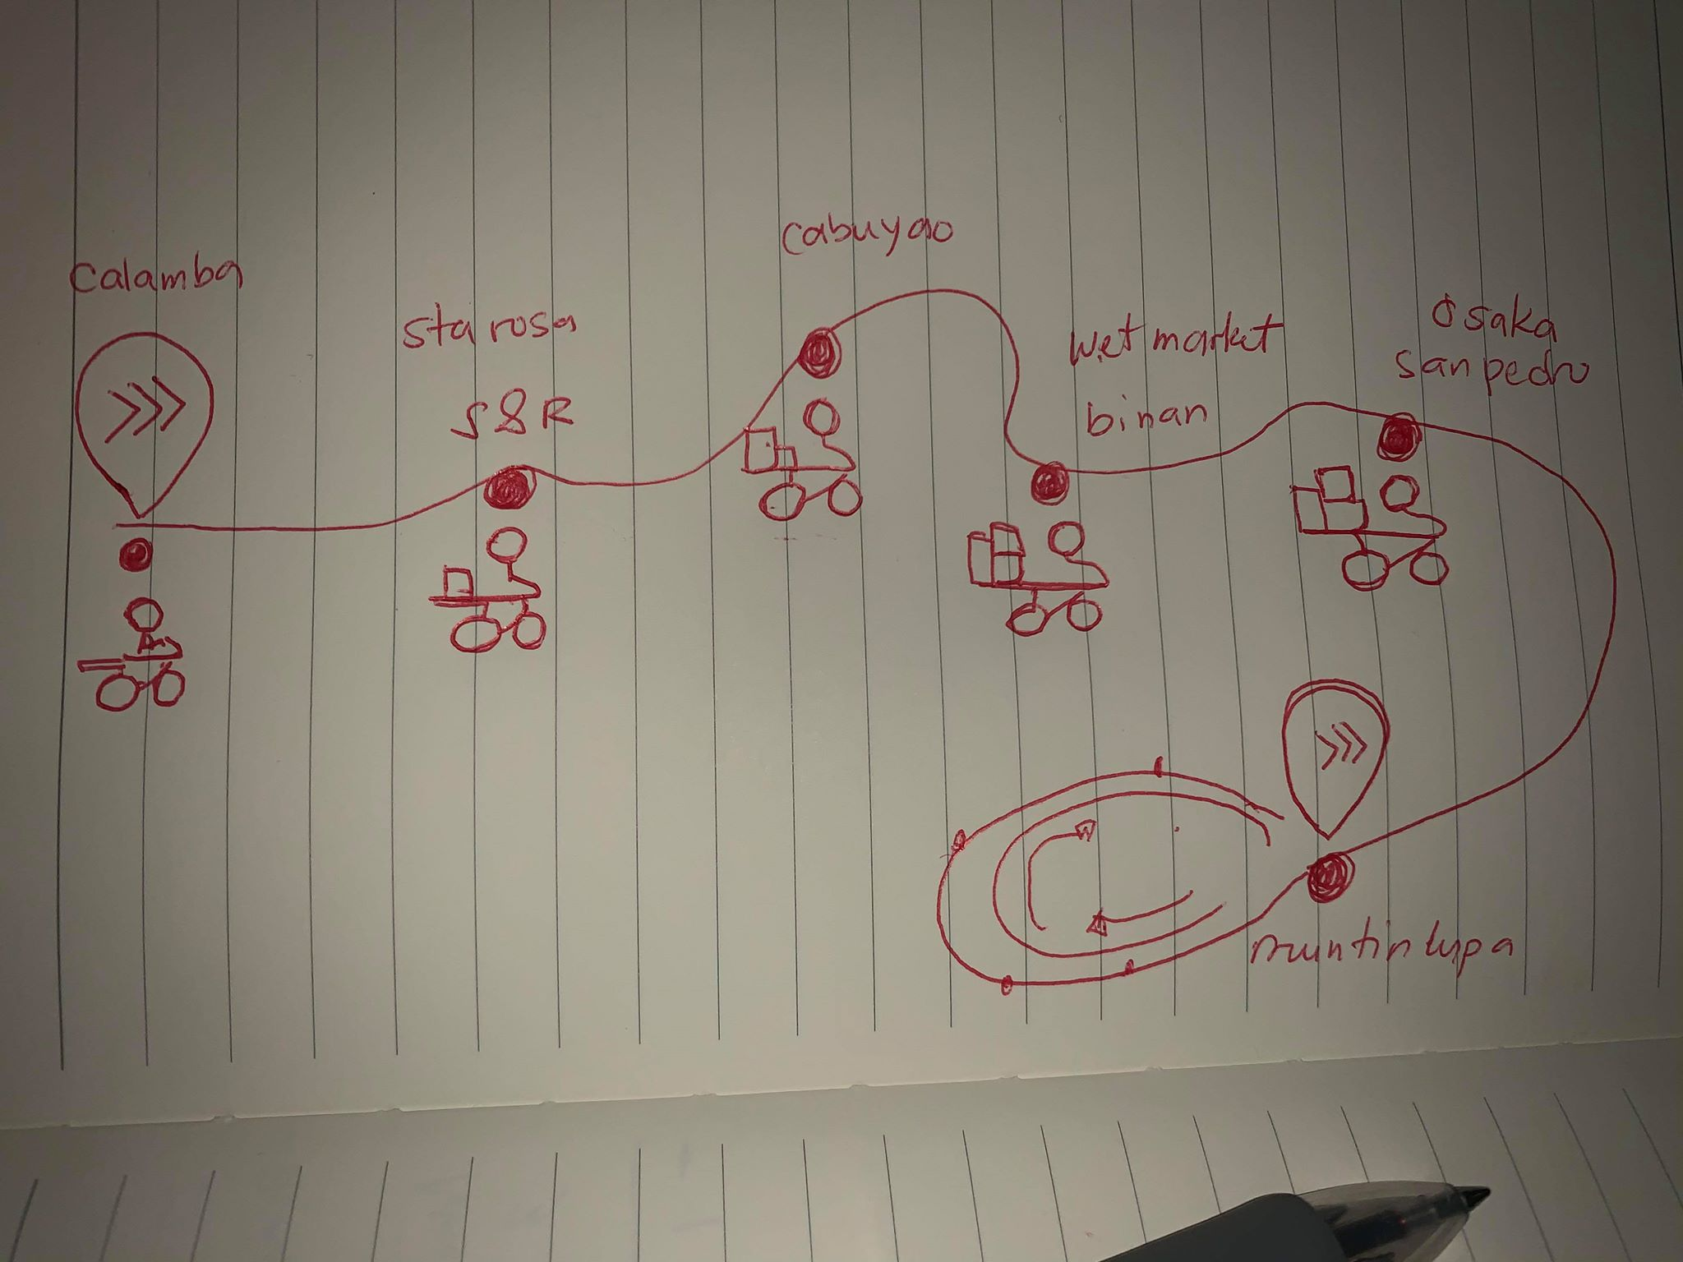

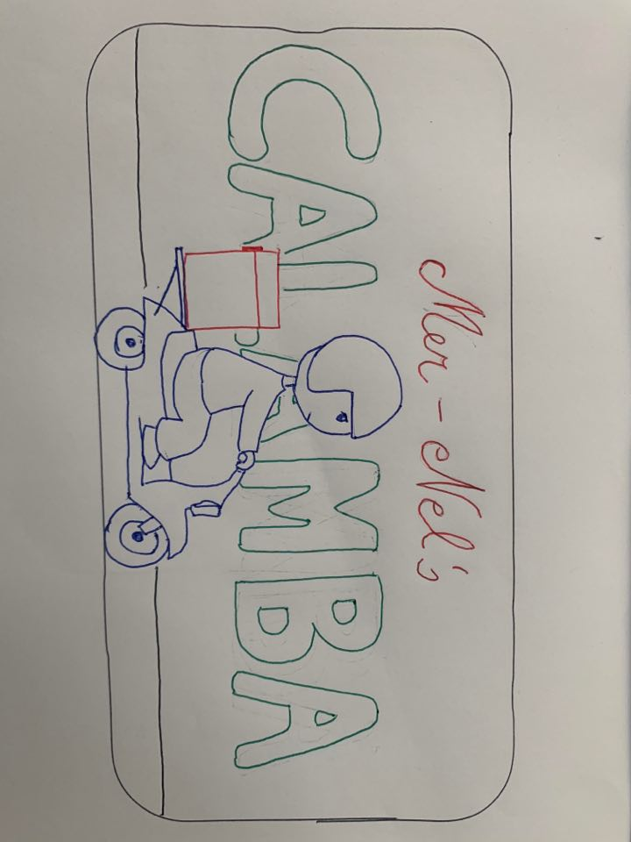

**Frame Group 1**

* Background: Radial Gradient of Yellow.
* 3 Arrows racing to the right and the red one brakes near at the middle. Put an overlapping momentum effect. Next Orange, next yellow.
* Overlay with shape of navigation icon to block and minified this logo.
* Going to mobile view zoom out.

Form Group 2

* User will swipe to navigation window then zoom in to FG3.

Frame Group 3

* Rider will be on the start line animating then…
* Multiple location icon for every store will popup to some of the store.
* Rider will now travel to each and every tagged location.

Frame Group 4

* Rider Driving with loopable background.
* On every stop, will show landmark of the city.

Frame Group 5

* Rider came out from the phone.
* Rider pass our parcel to client.
* Success delivery motion

Frame Group 6

* Back to logo animation
* Emphasizing Sure, We Will.

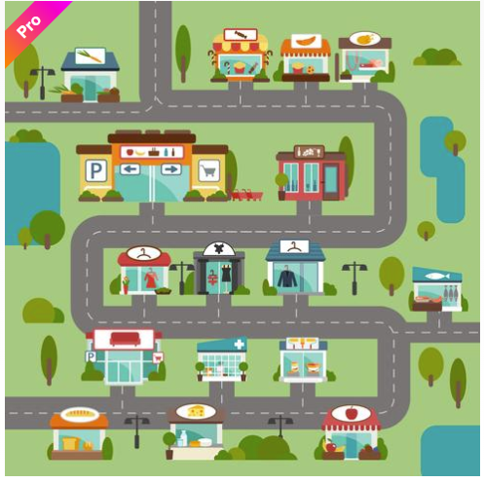

**PasaBuy.App**

Video Demo

**Preferred Duration:** 3 min – 7 min

**Primary Theme Color**: Yellow / Gradient: {Yellow-Orange} -> Dark Gray {#2d2d2d}

**Note:** More on talking to investor like clients.

Note: Keep the url to credits for each vector.

* Welcome to the Future
* Countdown 3-2-1
* Internet
* Tech Advances
* Web App

1. Facebook
2. Amazon
3. Netflix
4. Google
5. Uber

* Solve Problems
* Show Application Previews
* Imagine being the world’s biggest social media on-demand delivery company without actual drivers and vehicle.