

INFORMATICS INSTITUTE OF TECHNOLOGY

In Collaboration with

UNIVERSITY OF WESTMINSTER

**6SENG005C Formal Methods**

**Module Leader: Dr. Thilini Piyathilaka**

**Student Name: Pasan Kottearachchi**

**IIT Student Number: 2018315**

**UOW Student Number: W1761885**

Contents

**Structure Diagram** 3

**Plain English Explanation of State Invariants** 4

Table of Figures

Figure 1: Structure Diagram 3

# **Structure Diagram**

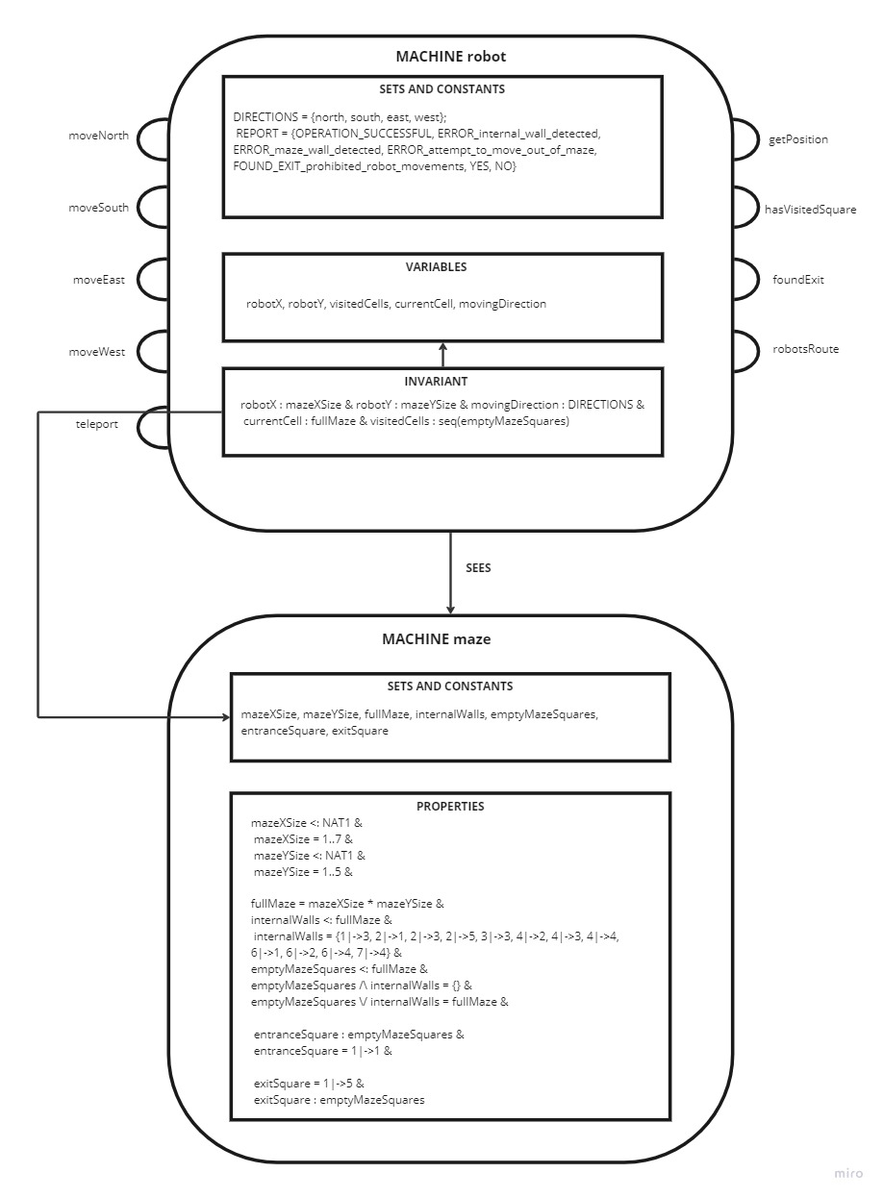

Figure 1: Structure Diagram

# **Plain English Explanation of State Invariants**

**robotX** : The current x position of the robot. The x position of the robot should stay within the range of the maze x axis and cannot go outside the given range

**robotY** : The current y position of the robot. The y position of the robot should stay within the range of the maze y axis and cannot go outside the given range

**movingDirection** : The moving direction of the robot should belong to the set DIRECTIONS which includes north, south, east and west

**currentCell** : The current x and the current y position of the robot. The coordinates should stay with in the maze range.

**visitedCells** : The whole movement history of the robot. The robot should only move within the maze range and also within the empty squares of the maze that are not occupied by a wall