PROJECT DOCUMENTATION
Flutter Login & Registration Module
A complete, beginner-friendly guide to the Keyo app: architecture, every source file, important functions, application flows and interview preparation.
Project: Flutter Associate Developer technical assignment
Technologies: Flutter 3.32, Dart 3.8, Provider, Material 3
Author: Pasan Sasmika
Repository: github.com/PasanSasmika/Flutter-Login-Registration-Module
Date: 2 November 2026

Table of Contents
1. How to Use This Document 1
2. Project Overview 2
2.1 What the application does 2
2.2 Why it was developed 2
2.3 Technologies used 2
2.4 The roles of Flutter and Dart 2
2.5 Why Provider is used 3
2.6 What the mock authentication service does 3
2.7 How the parts communicate 3
3. Project Folder Structure 5
3.1 Purpose of each folder 6
4. File-by-File Explanation 8
4.1 Entry point and app setup 8
4.2 Core: constants, theme, validators and exceptions 9
4.3 Models 12
4.4 Services 13
4.5 Providers 14
4.6 Screens 16
4.7 Reusable widgets 19
4.8 Supporting files 22
5. Application Flows 23
5.1 Successful login flow 23
5.2 Invalid login flow 24
5.3 Registration flow 24
5.4 Forgot password flow 25
5.5 Loading state flow 25
6. Important Functions in Detail 27
6.1 Login — _LoginScreenState._submit() 27
6.2 Login — LoginProvider.login() and AuthProvider.login() 27
6.3 Registration — RegisterScreen._submit() and MockAuthService.register() 28
6.4 Password visibility toggle 29
6.5 Form validation — FormState.validate() 30
6.6 Email validation — Validators.email() 30
6.7 Mobile number validation — Validators.mobile() and emailOrMobile() 31
6.8 Password and confirmation validation 31
6.9 Loading, error and success handling — FormProvider.submit() 32
6.10 notifyListeners() and safe disposal 33
6.11 Forgot password — sendResetLink() and forgotPassword() 33
6.12 Simulating the API — _simulateRequest() and _findAccount() 34
6.13 Remember me — loadRememberedIdentifier() and _saveRememberedIdentifier() 34
6.14 Success and error messages — showSuccessSnackBar() / showErrorSnackBar() 35
6.15 Navigation functions 35
7. Provider State Management 37
7.1 What Provider is 37
7.2 Why we use it 37
7.3 ChangeNotifier and notifyListeners() 37
7.4 How screens access a provider 37
7.5 How the UI reacts to state changes 38
7.6 Two kinds of providers in this project 38
8. Application Screenshots 39
Native splash screen 39
Animated splash screen 40
Login screen 41
Login validation errors 42
Loading state 43
Invalid login error 44
Registration screen 45
Registration validation errors 46
Password strength meter 47
Successful registration 48
Successful login 49
Forgot password screen 50
Reset link sent 51
9. Dependencies and pubspec.yaml 52
9.1 What pubspec.yaml does 52
9.2 Package details 52
10. Interview Preparation 54
11. Final Project Summary 57
11.1 What we implemented 57
11.2 Main technical concepts learned 57
11.3 Important architectural decisions 57
11.4 Current limitations 58
11.5 Possible future improvements 58

If page numbers are missing, right-click the table above and choose Update Field.

1. How to Use This Document
This document explains the Flutter Login & Registration project from beginning to end. It is written for learning and interview preparation, so the language is simple and every explanation is based on the real source code in the repository.
A good way to read it:
- Read Section 2 (overview) and Section 3 (folder structure) to get the big picture.
- Read Section 5 (application flows). These show how the files work together.
- Use Section 4 (file-by-file) and Section 6 (functions) as a reference while you open the code.
- Practise with Section 10 (interview questions) out loud.
Tip: every code example in this document was copied automatically from the project source code when the document was generated, so it matches what you will see when you open the files.

2. Project Overview

2.1 What the application does
The app (working name Keyo) is a complete login and registration module for a mobile app. A user can:
- Sign in with an email address or mobile number and a password.
- Show or hide the password, tick Remember me, and open Forgot password.
- Create a new account with full name, email, mobile number, password and password confirmation.
- Request a password reset link.
- See a home screen with their details after signing in, and sign out.
Every form is validated before it is sent, buttons show a loading spinner while a request runs, and the user sees a clear success or error message for every outcome.

2.2 Why it was developed
It was built as the technical assignment for a Flutter Associate Developer position. The assignment asked for a functional, responsive and polished login and registration module that uses Provider for state management, keeps business logic out of the UI, and uses a mock API that can later be replaced by a real backend.

2.3 Technologies used
Technology | Role in this project
Flutter 3.32 | The UI framework. Everything you see on screen is a Flutter widget.
Dart 3.8 | The programming language. All logic, models, services and widgets are written in Dart.
Material 3 | Google's design system. The app theme (AppTheme.light) turns on useMaterial3: true and customises colours, fields and buttons.
Provider | State management. Shares the signed-in user and each form's loading/error state with the screens.
shared_preferences | Small key-value storage on the device. Used only for Remember me (saves the email or mobile number, never the password).
flutter_test | Unit tests and widget tests (49 tests in the test folder).
flutter_launcher_icons, flutter_native_splash | Development tools that generate the app icon and native splash screen from the logo images.

2.4 The roles of Flutter and Dart
Dart is the language: it gives us classes, async/await, null safety and type checking. Flutter is the toolkit written in Dart: it draws the screens, handles touches and keyboard input, and runs the same code on Android, iOS and the web. In this project, Dart classes such as MockAuthService and Validators hold logic, and Flutter widgets such as LoginScreen and CustomTextField build the UI.

2.5 Why Provider is used
The assignment required Provider, and it is also a good fit: it is simple, officially recommended in the Flutter docs, and easy to explain. Provider lets a screen listen to an object (a ChangeNotifier). When the object changes and calls notifyListeners(), the screen rebuilds automatically. This keeps logic such as "am I loading?" or "what was the error?" out of the widgets. Section 7 explains Provider in detail.

2.6 What the mock authentication service does
There is no real backend, so MockAuthService pretends to be one. It keeps a list of accounts in memory, waits 1.2 seconds for every request (like a real network call), and then either returns a success response or throws an error. It supports login, registration (with duplicate email and mobile checks) and forgot password. Two special emails simulate failures:
Input | What happens
demo@example.com / 0771234567 with password Demo@1234 | Successful login as "Demo User".
Wrong password or unknown user | InvalidCredentialsException → "Incorrect email/mobile number or password."
Registering an email or mobile that already exists | ValidationException with an error for that field.
network@example.com | NetworkException → "Unable to connect…"
crash@example.com | A StateError (an unexpected bug) → "Something went wrong. Please try again."

Because the screens only depend on the abstract AuthService class, the mock can be replaced with a real REST API by changing one line in main.dart.

2.7 How the parts communicate
The project uses a simple layered design. Each layer only talks to the layer next to it:
Screen (UI)
LoginScreen, RegisterScreen, ForgotPasswordScreen — draw the form and react to state
▼
Form provider
LoginProvider, RegisterProvider, ForgotPasswordProvider — loading, errors, success
▼
AuthProvider
App-wide session: who is signed in
▼
AuthService (interface)
The contract: login, register, forgotPassword
▼
MockAuthService
Pretend backend today; a real API client later

Data goes down as method calls (for example provider.login(...)). Results come back up as return values (AuthResponseModel) or as exceptions (AppException). Providers then call notifyListeners() so the screens rebuild.

3. Project Folder Structure
The screenshots below are real captures of a Windows console window running tree lib /F /A inside the project folder. The output was too long for one window, so it is shown in three overlapping parts.
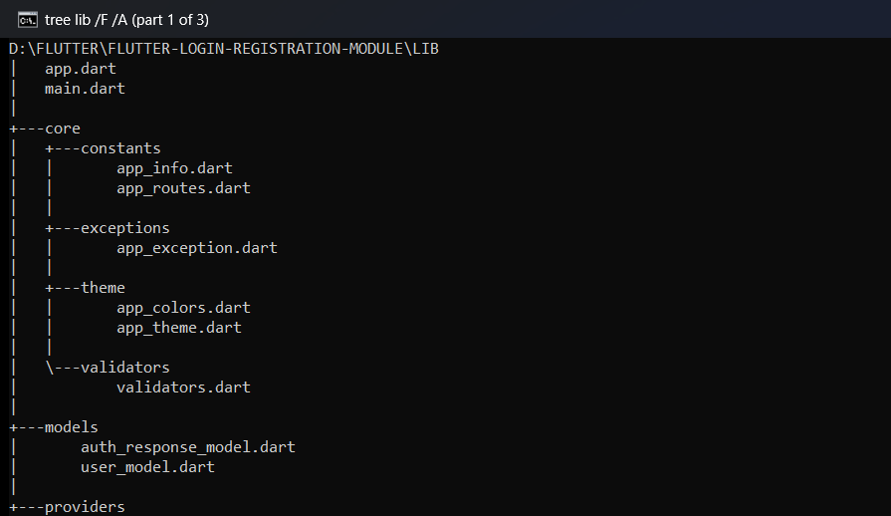
Figure 1. Real folder structure of lib (part 1 of 3): root files, core and models.
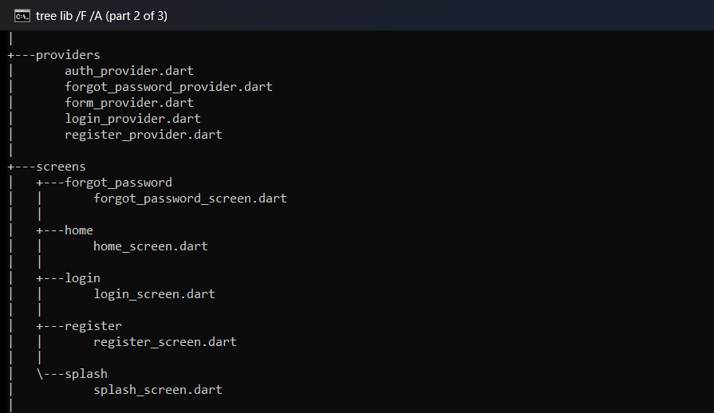
Figure 2. Real folder structure of lib (part 2 of 3): providers and screens.
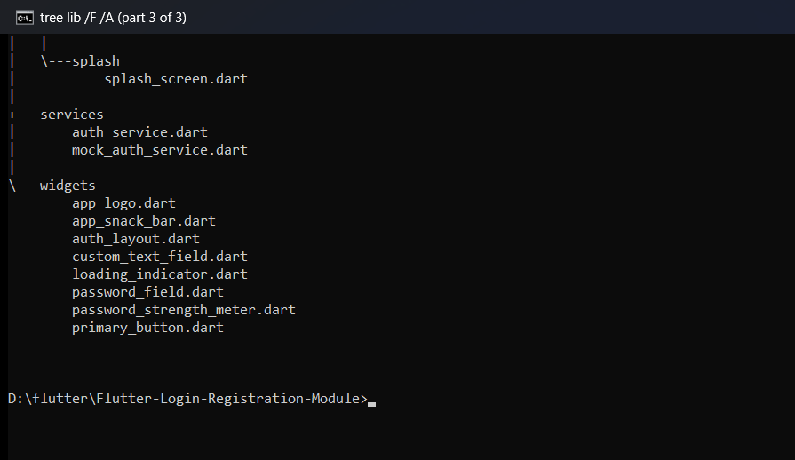
Figure 3. Real folder structure of lib (part 3 of 3): services and widgets.

3.1 Purpose of each folder
Folder | Purpose
lib/ | All Dart source code for the app. main.dart starts the app and app.dart sets up the theme, routes and providers.
lib/core/constants/ | Fixed values used across the app: route names (AppRoutes) and the app name and tagline (AppInfo).
lib/core/exceptions/ | Custom error types (AppException and its subclasses) that the service layer throws.
lib/core/theme/ | Colours (AppColors) and the Material 3 theme (AppTheme). Changing the look of the app starts here.
lib/core/validators/ | Form validation rules for names, emails, mobile numbers and passwords.
lib/models/ | Plain data classes: UserModel and AuthResponseModel. They can be created from JSON.
lib/services/ | Talking to the "backend": the AuthService contract and the MockAuthService implementation.
lib/providers/ | State management with Provider: the session (AuthProvider) and one provider per form.
lib/screens/ | One folder per screen: splash, login, register, forgot_password and home.
lib/widgets/ | Reusable UI pieces: text fields, password field, buttons, layout, logo, snack bars, strength meter.
test/ | Automated tests: validators, mock service and full screen flows (49 tests).
tool/ | A helper script that draws the logo images used for the app icon and splash screen.
assets/ | Fonts (Plus Jakarta Sans) and brand images (icon and splash logo).
android/, ios/, web/ | Platform projects generated by Flutter. They hold the app name, icons and native splash screen.

4. File-by-File Explanation
This section explains every Dart source file in lib/, plus the most important supporting files. Each file has a card with the same eight points so it is easy to compare files.

4.1 Entry point and app setup

main.dart
Location | lib/main.dart
Why it exists | Every Flutter app needs a main() function. This is where the app starts.
Main responsibility | Starts the app and chooses which AuthService implementation to use.
Important classes / methods | main()
Data it handles | None directly. It creates a MockAuthService object.
Talks to | app.dart (creates App), services/mock_auth_service.dart.
How it works | runApp() attaches the widget tree to the screen. The service is passed into App, so the rest of the app never creates its own service. This is a simple form of dependency injection.
Example of use | To use a real backend, you would only change MockAuthService() to your real class here.

lib/main.dart
void main() {
// Replace MockAuthService with a real AuthService to use a live API.
runApp(App(authService: MockAuthService()));
}

app.dart
Location | lib/app.dart
Why it exists | Keeps the app-level setup (theme, routes, providers) in one place instead of inside main.dart.
Main responsibility | Builds the MaterialApp, registers all named routes and creates the providers.
Important classes / methods | App (StatelessWidget) with a required authService.
Data it handles | The AuthService passed from main.dart.
Talks to | All screens, all providers, AppTheme, AppRoutes, AppInfo.
How it works | ChangeNotifierProvider creates one AuthProvider for the whole app. Each route also wraps its screen in its own ChangeNotifierProvider (for example LoginProvider), so form state is fresh every time a screen opens. There is no initialRoute, so the app starts at /, which is the splash screen.
Example of use | When LoginScreen calls Navigator.pushNamed(context, AppRoutes.register), Flutter looks up /register in this routes map and builds RegisterScreen with a new RegisterProvider.

lib/app.dart — providers and routes
return ChangeNotifierProvider(
create: (_) => AuthProvider(authService),
child: MaterialApp(
title: AppInfo.name,
debugShowCheckedModeBanner: false,
theme: AppTheme.light,
// Form providers are created per route, so their state is reset
// whenever the user leaves a screen.
routes: {
AppRoutes.splash: (_) => const SplashScreen(),
AppRoutes.login: (_) => ChangeNotifierProvider(
create: (context) => LoginProvider(context.read<AuthProvider>()),
child: const LoginScreen(),
),
AppRoutes.register: (_) => ChangeNotifierProvider(
create: (context) => RegisterProvider(context.read<AuthProvider>()),
child: const RegisterScreen(),
),
AppRoutes.forgotPassword: (_) => ChangeNotifierProvider(
create: (context) =>
ForgotPasswordProvider(context.read<AuthProvider>()),
child: const ForgotPasswordScreen(),
),
AppRoutes.home: (_) => const HomeScreen(),
},
),
);

4.2 Core: constants, theme, validators and exceptions

app_routes.dart
Location | lib/core/constants/app_routes.dart
Why it exists | Route names are used in many files. Constants prevent typing mistakes such as /regster.
Main responsibility | Holds the named routes.
Important classes / methods | AppRoutes.splash (/), login (/login), register, forgotPassword, home.
Data it handles | Strings only.
Talks to | Used by app.dart and every screen that navigates.
How it works | A class with a private constructor (AppRoutes._()) and static const fields, so it can't be instantiated by mistake.
Example of use | Navigator.pushNamed(context, AppRoutes.forgotPassword) in LoginScreen.

class AppRoutes {
const AppRoutes._();

static const splash = '/';
static const login = '/login';
static const register = '/register';
static const forgotPassword = '/forgot-password';
static const home = '/home';
}

app_info.dart
Location | lib/core/constants/app_info.dart
Why it exists | The app name appears on several screens. Keeping it in one constant makes renaming easy.
Main responsibility | Holds AppInfo.name ("Keyo") and AppInfo.tagline.
Important classes / methods | AppInfo.name, AppInfo.tagline
Data it handles | Strings.
Talks to | app.dart (window title), SplashScreen, AuthLayout brand row.
How it works | Same pattern as AppRoutes: static constants only.
Example of use | The splash screen shows AppInfo.name under the logo.

app_colors.dart
Location | lib/core/theme/app_colors.dart
Why it exists | Using named colours keeps the design consistent and avoids repeating hex codes.
Main responsibility | Defines the colour palette: primary indigo, hero gradient colours, text, border, success, warning, info and error.
Important classes / methods | AppColors.primary, heroStart, heroEnd, textPrimary, textSecondary, border, fieldFill, success, warning, info, error.
Data it handles | Flutter Color values.
Talks to | Used by AppTheme and most widgets.
How it works | Static const Color fields.
Example of use | PasswordStrengthMeter uses AppColors.success for "Strong" and AppColors.error for "Weak".

app_theme.dart
Location | lib/core/theme/app_theme.dart
Why it exists | A central theme means screens don't need to style every widget themselves.
Main responsibility | Builds the Material 3 ThemeData: font, text sizes, input field style, button styles, checkbox and snack bar style.
Important classes / methods | AppTheme.light (getter), AppTheme.radius (16).
Data it handles | Theme values only.
Talks to | AppColors; used by app.dart.
How it works | Creates a ColorScheme.fromSeed() from the primary colour, then overrides inputDecorationTheme, filledButtonTheme, outlinedButtonTheme and textButtonTheme. Button text styles repeat the font family because a button style replaces the theme text style.
Example of use | Every TextFormField automatically gets the rounded grey fill and indigo focus border from inputDecorationTheme.

validators.dart
Location | lib/core/validators/validators.dart
Why it exists | Validation rules are business rules. Keeping them in one class means they are reusable and easy to unit test.
Main responsibility | Checks names, emails, mobile numbers and passwords, and returns an error message or null.
Important classes / methods | fullName, email, mobile, emailOrMobile, requiredPassword, newPassword, passwordStrength, confirmPassword, normalizeMobile, looksLikeMobile.
Data it handles | The text the user typed.
Talks to | Used by the three form screens, PasswordStrengthMeter and MockAuthService (normalizeMobile).
How it works | Each validator matches the FormFieldValidator<String> signature: it takes String? and returns String?. Flutter shows the returned text under the field; null means valid.
Example of use | validator: Validators.email on the registration email field.

app_exception.dart
Location | lib/core/exceptions/app_exception.dart
Why it exists | Using our own exception types lets the UI show a different message for each kind of failure.
Main responsibility | Defines the errors the service layer can throw.
Important classes / methods | AppException (base, has message), InvalidCredentialsException, ValidationException (has fieldErrors), NetworkException.
Data it handles | An error message, and for validation errors a map such as {'email': 'This email is already registered'}.
Talks to | Thrown by MockAuthService; caught by FormProvider.submit.
How it works | Subclasses call super('message'). Anything that is not an AppException is treated as an unexpected error.
Example of use | A wrong password throws InvalidCredentialsException, so the login screen shows "Incorrect email/mobile number or password."

class ValidationException extends AppException {
const ValidationException(this.fieldErrors)
: super('Please check the highlighted fields.');

final Map<String, String> fieldErrors;
}

4.3 Models

user_model.dart
Location | lib/models/user_model.dart
Why it exists | A model gives user data a clear, typed shape instead of passing loose maps around.
Main responsibility | Represents a signed-in user.
Important classes / methods | UserModel with id, fullName, email, mobile; UserModel.fromJson(); getters firstName and initials.
Data it handles | User details. The password is never part of this model.
Talks to | Created by AuthResponseModel.fromJson; stored in AuthProvider; shown on HomeScreen.
How it works | fromJson reads a Map<String, dynamic> (what a JSON API returns) and builds the object. initials takes the first letters of the first and last names.
Example of use | The home screen shows Hello, ${user.firstName} and an avatar with user.initials ("DU" for Demo User).

factory UserModel.fromJson(Map<String, dynamic> json) {
return UserModel(
id: json['id'] as String,
fullName: json['fullName'] as String,
email: json['email'] as String,
mobile: json['mobile'] as String,
);
}

auth_response_model.dart
Location | lib/models/auth_response_model.dart
Why it exists | Every auth request returns the same kind of answer: a message, and sometimes a user and token.
Main responsibility | Represents a successful auth response.
Important classes / methods | AuthResponseModel with message, user (nullable), token (nullable); AuthResponseModel.fromJson().
Data it handles | Message text, optional UserModel, optional token.
Talks to | MockAuthService builds it; AuthProvider and the form providers read it.
How it works | Failures are not stored here; they are thrown as exceptions. So if you have an AuthResponseModel, the request succeeded.
Example of use | After login, AuthProvider saves response.user and response.token, and LoginProvider returns response.message ("Welcome back, Demo User!").

4.4 Services

auth_service.dart
Location | lib/services/auth_service.dart
Why it exists | Defines what the backend can do without saying how. This is what makes the mock replaceable.
Main responsibility | An abstract class (the contract) with three methods.
Important classes / methods | login({identifier, password}), register({fullName, email, mobile, password}), forgotPassword({email}) — all return Future<AuthResponseModel>.
Data it handles | Method parameters and AuthResponseModel results.
Talks to | Implemented by MockAuthService; used by AuthProvider.
How it works | Dart abstract classes cannot be created directly; a class must implements AuthService and provide every method.
Example of use | A future ApiAuthService implements AuthService would send HTTP requests and could be passed to App in main.dart.

abstract class AuthService {
/// [identifier] is an email address or mobile number.
Future<AuthResponseModel> login({
required String identifier,
required String password,
});

Future<AuthResponseModel> register({
required String fullName,
required String email,
required String mobile,
required String password,
});

Future<AuthResponseModel> forgotPassword({required String email});
}

mock_auth_service.dart
Location | lib/services/mock_auth_service.dart
Why it exists | There is no real backend for the assignment, but the app must still behave realistically.
Main responsibility | Simulates the backend: delay, accounts, success and error responses.
Important classes / methods | login, register, forgotPassword, private helpers _simulateRequest, _findAccount, _authResponse; constants networkErrorEmail, unexpectedErrorEmail; delay (default 1200 ms).
Data it handles | An in-memory list of accounts (_accounts). The demo account is added at start-up; new registrations are added while the app runs.
Talks to | Implements AuthService; throws exceptions from app_exception.dart; uses Validators.normalizeMobile; returns AuthResponseModel.
How it works | Every method first calls _simulateRequest, which waits and can throw a network or unexpected error. Then it checks the data and either returns a response built with AuthResponseModel.fromJson or throws an AppException.
Example of use | Registering with demo@example.com throws ValidationException({'email': 'This email is already registered'}).

4.5 Providers

auth_provider.dart
Location | lib/providers/auth_provider.dart
Why it exists | The signed-in user is needed by more than one screen, so it lives in an app-wide provider.
Main responsibility | Holds the session (user and token) and forwards auth calls to the service.
Important classes / methods | AuthProvider(AuthService); getters user, token, isLoggedIn; methods login, register, forgotPassword, logout.
Data it handles | UserModel? _user, String? _token.
Talks to | AuthService below it; the form providers and HomeScreen above it.
How it works | Extends ChangeNotifier. After a successful login it stores the user and token and calls notifyListeners(). logout() clears them and notifies again.
Example of use | HomeScreen reads context.watch<AuthProvider>().user to show the user's details.

AuthProvider.login
Future<AuthResponseModel> login({
required String identifier,
required String password,
}) async {
final response = await _authService.login(
identifier: identifier,
password: password,
);
_user = response.user;
_token = response.token;
notifyListeners();
return response;
}

form_provider.dart
Location | lib/providers/form_provider.dart
Why it exists | Login, registration and forgot password all need the same loading, error and success logic. One base class avoids writing it three times.
Main responsibility | Shared state for forms: isLoading, errorMessage, successMessage, field errors, duplicate-submit protection and error handling.
Important classes / methods | submit(request) (protected), fieldError(field), clearFieldError(field), hasFieldErrors; overrides notifyListeners and dispose.
Data it handles | Loading flag, messages and a map of field errors from the server.
Talks to | Extended by LoginProvider, RegisterProvider, ForgotPasswordProvider; catches exceptions from app_exception.dart.
How it works | See Section 6.10 for a line-by-line explanation of submit.
Example of use | When a login request starts, submit sets isLoading = true; the Sign in button shows a spinner and ignores taps.

login_provider.dart
Location | lib/providers/login_provider.dart
Why it exists | Holds the login screen's own state: the Remember me tick and the login request.
Main responsibility | Logs in through AuthProvider and saves or clears the remembered identifier.
Important classes / methods | rememberMe, setRememberMe(bool), loadRememberedIdentifier(), login({identifier, password}), private _saveRememberedIdentifier.
Data it handles | _rememberMe and the saved key remembered_identifier in shared_preferences.
Talks to | AuthProvider, FormProvider (base), shared_preferences; used by LoginScreen.
How it works | login wraps the call in submit(...), so loading and errors are handled by the base class. After success it saves the identifier only if Remember me is ticked.
Example of use | Tick Remember me, sign in, restart the app: the email field is filled in again.

register_provider.dart
Location | lib/providers/register_provider.dart
Why it exists | Holds the registration form's state.
Main responsibility | Calls AuthProvider.register inside submit.
Important classes / methods | register({fullName, email, mobile, password}) returns Future<bool>.
Data it handles | Inherits loading, messages and field errors (for example duplicate email).
Talks to | AuthProvider, FormProvider; used by RegisterScreen.
How it works | A very small class: all the hard work is in FormProvider.submit.
Example of use | A duplicate email makes fieldError('email') return "This email is already registered", which the email field shows.

forgot_password_provider.dart
Location | lib/providers/forgot_password_provider.dart
Why it exists | Holds the forgot password form's state.
Main responsibility | Calls AuthProvider.forgotPassword inside submit.
Important classes / methods | sendResetLink(String email) returns Future<bool>.
Data it handles | Inherits successMessage, which the screen uses to switch to the confirmation view.
Talks to | AuthProvider, FormProvider; used by ForgotPasswordScreen.
How it works | Same pattern as RegisterProvider.
Example of use | After success, successMessage is "If an account exists, a reset link has been sent." and the screen shows it in a green box.

4.6 Screens

splash_screen.dart
Location | lib/screens/splash/splash_screen.dart
Why it exists | Gives the app a branded start and a smooth hand-over from the native splash screen.
Main responsibility | Animates the logo and name, then opens the login screen.
Important classes / methods | SplashScreen (StatefulWidget) with SingleTickerProviderStateMixin; AnimationController (1.9 s), _logoScale, _textOpacity.
Data it handles | Animation values only.
Talks to | AppLogo, HeroBackground, AppInfo, AppRoutes.
How it works | The animation starts after the first frame is drawn (addPostFrameCallback). A status listener waits for AnimationStatus.completed and calls Navigator.pushReplacementNamed(context, AppRoutes.login), so the user can't go back to the splash.
Example of use | Every app launch: native splash → animated splash → login.

void initState() {
super.initState();
_controller.addStatusListener((status) {
if (status == AnimationStatus.completed && mounted) {
Navigator.pushReplacementNamed(context, AppRoutes.login);
}
});
// Start after the first frame, so a slow launch can't skip the animation.
WidgetsBinding.instance.addPostFrameCallback((_) {
if (mounted) _controller.forward();
});
}

login_screen.dart
Location | lib/screens/login/login_screen.dart
Why it exists | The main entry screen for existing users.
Main responsibility | Shows the login form, validates it, calls LoginProvider, and shows success/error feedback and navigation.
Important classes / methods | LoginScreen, _LoginScreenState with _submit(), _openRegister(), _fillRememberedIdentifier(); two TextEditingControllers and a GlobalKey<FormState>.
Data it handles | The typed identifier and password; _autovalidateMode.
Talks to | LoginProvider, Validators, CustomTextField, PasswordField, PrimaryButton, AuthLayout, AuthFooterLink, snack bar helpers, AppRoutes.
How it works | build uses context.watch<LoginProvider>() so it rebuilds when loading or Remember me changes. Fields are disabled while loading. _submit validates, calls the provider and reacts to the bool result.
Example of use | Tapping Sign in with empty fields shows "Email or mobile number is required" and "Password is required".

register_screen.dart
Location | lib/screens/register/register_screen.dart
Why it exists | Lets new users create an account.
Main responsibility | Shows five fields, validates them, calls RegisterProvider, and returns to login on success.
Important classes / methods | RegisterScreen, _RegisterScreenState._submit(); five controllers.
Data it handles | Name, email, mobile, password, confirm password.
Talks to | RegisterProvider, Validators, PasswordStrengthMeter, shared widgets.
How it works | Server field errors are shown with errorText: provider.fieldError('email') and cleared with onChanged: (_) => provider.clearFieldError('email'). canPop: !isLoading stops the user leaving while the account is being created.
Example of use | On success it calls Navigator.pop(context, email), so the login screen can fill in the new email.

forgot_password_screen.dart
Location | lib/screens/forgot_password/forgot_password_screen.dart
Why it exists | Lets users ask for a password reset.
Main responsibility | Shows an email form, then a confirmation view after success.
Important classes / methods | _submit(), _buildForm(isLoading), _buildConfirmation(message).
Data it handles | The email and the provider's successMessage.
Talks to | ForgotPasswordProvider, Validators.email, shared widgets.
How it works | An AnimatedSwitcher swaps the form for the confirmation when successMessage is not null. The title also changes to "Check your email".
Example of use | Enter demo@example.com, tap Send reset link, then tap Back to sign in.

home_screen.dart
Location | lib/screens/home/home_screen.dart
Why it exists | Proves that login worked and gives the user a way to sign out.
Main responsibility | Shows the user's name, email and mobile; signs out.
Important classes / methods | HomeScreen, _logout(context), private _DetailTile.
Data it handles | AuthProvider.user.
Talks to | AuthProvider, AuthLayout, AppRoutes.
How it works | _logout navigates to login and removes every previous route (pushNamedAndRemoveUntil), then calls authProvider.logout().
Example of use | After signing in as Demo User you see "Hello, Demo" and the details card.

void _logout(BuildContext context) {
final authProvider = context.read<AuthProvider>();
Navigator.pushNamedAndRemoveUntil(
context,
AppRoutes.login,
(route) => false,
);
authProvider.logout();
}

4.7 Reusable widgets

custom_text_field.dart
Location | lib/widgets/custom_text_field.dart
Why it exists | All forms use the same field design. One widget avoids repeating the label, icon and decoration code.
Main responsibility | A label above a TextFormField with an optional icon, suffix, validator, server error and helper text.
Important classes / methods | CustomTextField (StatelessWidget). Key parameters: label, controller, hint, icon, suffix, validator, errorText, keyboardType, textInputAction, obscureText, enabled, onChanged, onSubmitted.
Data it handles | Text through the controller.
Talks to | Used by every form screen and by PasswordField.
How it works | errorText is passed to forceErrorText, which shows a server error (such as a duplicate email) even when the local validator passes.
Example of use | The registration mobile field uses keyboardType: TextInputType.phone so a number pad opens.

password_field.dart
Location | lib/widgets/password_field.dart
Why it exists | Password fields need a show/hide button. This widget adds it once for every password field.
Main responsibility | Wraps CustomTextField and toggles obscureText.
Important classes / methods | PasswordField (StatefulWidget), _PasswordFieldState._isHidden.
Data it handles | Whether the password is hidden. This is UI-only state, so it uses setState instead of Provider.
Talks to | CustomTextField; used by login and registration.
How it works | The eye icon's onPressed calls setState(() => _isHidden = !_isHidden). See Section 6.4.
Example of use | Tap the eye icon to check what you typed.

primary_button.dart
Location | lib/widgets/primary_button.dart
Why it exists | Every form has one main action with the same loading behaviour.
Main responsibility | A full-width FilledButton that shows a spinner and is disabled while loading.
Important classes / methods | PrimaryButton(label, onPressed, isLoading).
Data it handles | The isLoading flag from a provider.
Talks to | LoadingIndicator; used by all forms.
How it works | onPressed: isLoading ? null : onPressed. In Flutter, a button with a null onPressed is disabled, which is how double taps are blocked in the UI.
Example of use | PrimaryButton(label: 'Sign in', isLoading: isLoading, onPressed: _submit)

child: FilledButton(
onPressed: isLoading ? null : onPressed,
child: AnimatedSwitcher(
duration: const Duration(milliseconds: 180),
child: isLoading
? const LoadingIndicator(color: Colors.white)
: Text(label),
),
),

loading_indicator.dart
Location | lib/widgets/loading_indicator.dart
Why it exists | A consistent small spinner.
Main responsibility | A sized CircularProgressIndicator.
Important classes / methods | LoadingIndicator({size, color})
Data it handles | None.
Talks to | Used by PrimaryButton.
How it works | A SizedBox.square around the indicator so it fits inside a button.
Example of use | The white spinner inside the Sign in button.

app_snack_bar.dart
Location | lib/widgets/app_snack_bar.dart
Why it exists | Success and error messages should look the same everywhere.
Main responsibility | Shows a green success or red error snack bar with an icon.
Important classes / methods | showSuccessSnackBar(context, message), showErrorSnackBar(context, message), private _show.
Data it handles | The message text.
Talks to | Called by the three form screens.
How it works | ScaffoldMessenger.of(context)..hideCurrentSnackBar()..showSnackBar(...). Hiding first stops messages piling up.
Example of use | Wrong password → red "Incorrect email/mobile number or password."

auth_layout.dart
Location | lib/widgets/auth_layout.dart
Why it exists | All screens share the same branded layout. Putting it in one widget keeps them consistent.
Main responsibility | Page layout: indigo header with title, white rounded sheet for content, centred card on wide screens, pinned brand row with back button.
Important classes / methods | AuthLayout(title, subtitle, child, leading, showBackButton, canPop); also HeroBackground and AuthFooterLink; private _SheetLayout, _CardLayout, _BrandRow, _Reveal.
Data it handles | Layout values only.
Talks to | Used by login, register, forgot password and home; uses AppLogo.
How it works | If the screen is 600 px wide or more, it uses the card layout; otherwise the sheet layout. PopScope(canPop: canPop) blocks the back gesture while a request runs. _Reveal fades and slides content in.
Example of use | The same login screen looks like a phone app on a phone and like a centred card on a tablet or browser.

password_strength_meter.dart
Location | lib/widgets/password_strength_meter.dart
Why it exists | Helps users create a strong password before they submit.
Main responsibility | Shows four coloured bars and a label (Weak, Fair, Good or Strong).
Important classes / methods | PasswordStrengthMeter(controller), _levelFor(rulesMet).
Data it handles | The password text, through the controller.
Talks to | Validators.passwordStrength; used by RegisterScreen.
How it works | A ValueListenableBuilder listens to the TextEditingController, so only the meter rebuilds as the user types.
Example of use | Secret@123 meets all five rules → four green bars, "Strong".

app_logo.dart
Location | lib/widgets/app_logo.dart
Why it exists | The brand logo is drawn in code so it is sharp at any size and identical everywhere.
Main responsibility | Draws a shield with a tick on a white tile.
Important classes / methods | AppLogo({size}), ShieldMark, private _ShieldPainter (a CustomPainter).
Data it handles | Colours and size.
Talks to | Used by AuthLayout, SplashScreen and tool/generate_brand_assets.dart.
How it works | _ShieldPainter.paint draws a Path for the shield and a thick stroked path for the tick.
Example of use | The logo in the top-left of every screen.

4.8 Supporting files
File | What it is for
pubspec.yaml | Project settings: name, Dart SDK version, dependencies, fonts, assets and icon/splash configuration. See Section 9.
analysis_options.yaml | Turns on the recommended flutter_lints rules used by flutter analyze.
test/validators_test.dart | Unit tests for every validator, such as invalid emails and password rules.
test/mock_auth_service_test.dart | Unit tests for the mock backend: login, duplicates, forgot password, simulated errors and delay.
test/auth_flow_test.dart | Widget tests that drive the real screens: empty forms, invalid input, loading, double taps, remember me, registration, forgot password and layouts on five screen sizes.
tool/generate_brand_assets.dart | Renders the logo widget to PNG files for the launcher icon and native splash.
assets/fonts/ | The Plus Jakarta Sans font files and their licence (OFL.txt).
android/app/build.gradle.kts | Android build settings. The NDK version is pinned because one local NDK install was incomplete.
README.md | Setup instructions, mock credentials and screenshots for GitHub.

5. Application Flows

5.1 Successful login flow
User enters email/mobile and password
LoginScreen — two TextEditingControllers hold the text
▼
User taps Sign in
PrimaryButton calls _submit()
▼
Form validation
_formKey.currentState!.validate() runs Validators.emailOrMobile and requiredPassword
▼
LoginScreen calls LoginProvider.login()
context.read<LoginProvider>()
▼
FormProvider.submit() starts
isLoading = true → notifyListeners() → button shows spinner
▼
LoginProvider calls AuthProvider.login()
▼
AuthProvider calls AuthService.login()
Here: MockAuthService waits 1.2 s and checks the account
▼
AuthResponseModel is returned
Message, UserModel and token
▼
AuthProvider stores user + token
notifyListeners()
▼
Remember me is saved or cleared
shared_preferences
▼
submit() returns true
isLoading = false → notifyListeners()
▼
UI shows success
Green snack bar "Welcome back, Demo User!" → pushReplacementNamed(home)

Step by step in plain words: the screen first checks the form locally, so no request is sent with empty or badly formatted values. Then the screen asks its provider to log in. The provider switches on the loading state, which disables the fields and turns the button into a spinner. The request passes through AuthProvider to the service. When the service answers, AuthProvider remembers who signed in, LoginProvider saves the Remember me choice, the loading state switches off, and the screen shows a success message and replaces itself with the home screen (so Back does not return to login).

5.2 Invalid login flow
User enters a wrong password
▼
Validation passes
The format is fine, so the request is sent
▼
MockAuthService finds no matching account/password
throws InvalidCredentialsException
▼
Exception passes up through AuthProvider
AuthProvider does not catch it, so the session is unchanged
▼
FormProvider.submit() catches AppException
errorMessage = "Incorrect email/mobile number or password."
▼
submit() returns false
isLoading = false → notifyListeners()
▼
LoginScreen shows red snack bar
User stays on the login screen and can try again

5.3 Registration flow
User opens Create account
LoginScreen._openRegister() → pushNamed(register)
▼
User fills five fields
PasswordStrengthMeter updates while typing
▼
Form validation
fullName, email, mobile, newPassword, confirmPassword
▼
RegisterProvider.register() → submit()
Loading on; back navigation blocked (canPop: false)
▼
MockAuthService.register()
Checks duplicate email and mobile
▼
Success: account added to the in-memory list
Returns "Account created. Please sign in."
▼
RegisterScreen shows success and pops with the email
Navigator.pop(context, email)
▼
LoginScreen fills in the email
User enters the password and signs in

If the email or mobile already exists, the service throws ValidationException with a map of field errors. FormProvider stores them, the screen shows them under the matching fields (errorText), and each error disappears as soon as the user edits that field (clearFieldError).

5.4 Forgot password flow
User taps Forgot password?
pushNamed(forgotPassword)
▼
User enters email and taps Send reset link
Validators.email
▼
ForgotPasswordProvider.sendResetLink() → submit()
▼
MockAuthService.forgotPassword()
Same answer whether the account exists or not
▼
successMessage is set
AnimatedSwitcher shows the green confirmation box
▼
User taps Back to sign in
Navigator.pop(context)

The reply is deliberately the same for every email. If it said "no account found", someone could use the form to discover which emails are registered. This is a common security practice.

5.5 Loading state flow
submit() is called
If isLoading is already true, it returns false immediately (duplicate tap ignored)
▼
isLoading = true; old messages cleared
notifyListeners()
▼
Screens rebuild (context.watch)
Fields disabled, button disabled with spinner, links disabled
▼
Request finishes (success or any error)
▼
isLoading = false
notifyListeners() → normal UI returns

There are two layers of protection against double submission: the disabled button in the UI, and the if (_isLoading) return false; guard in FormProvider.submit. The second one also protects against pressing Enter on the keyboard while a request is running.

6. Important Functions in Detail
Every function below exists in the project. The code shown is copied from the source files.

6.1 Login — _LoginScreenState._submit()
Function | _submit()
File | lib/screens/login/login_screen.dart
Purpose | Handles the Sign in button: validate, log in, then show feedback and navigate.
Parameters | None (reads the text controllers).
Return type | Future<void>
What happens inside | 1. Hides the keyboard.  2. Validates the form; if invalid, turns on live validation and stops.  3. Calls provider.login(...) and waits for a bool.  4. Checks mounted (the screen might have closed while waiting).  5. Success: green snack bar and go to home. Failure: red snack bar with errorMessage.
Called by | The Sign in PrimaryButton, and pressing Done on the keyboard in the password field (onSubmitted).

login_screen.dart
Future<void> _submit() async {
FocusScope.of(context).unfocus();
if (!_formKey.currentState!.validate()) {
// Errors update live from now on, as the user fixes them.
setState(() => _autovalidateMode = AutovalidateMode.onUserInteraction);
return;
}

final provider = context.read<LoginProvider>();
final succeeded = await provider.login(
identifier: _identifierController.text.trim(),
password: _passwordController.text,
);
if (!mounted) return;

if (succeeded) {
showSuccessSnackBar(context, provider.successMessage!);
Navigator.pushReplacementNamed(context, AppRoutes.home);
} else {
showErrorSnackBar(context, provider.errorMessage!);
}
}

6.2 Login — LoginProvider.login() and AuthProvider.login()
Function | LoginProvider.login({identifier, password}) and AuthProvider.login({identifier, password})
File | lib/providers/login_provider.dart, lib/providers/auth_provider.dart
Purpose | LoginProvider.login manages the screen state; AuthProvider.login talks to the service and stores the session.
Parameters | identifier (email or mobile) and password, both String.
Return type | LoginProvider.login → Future<bool>; AuthProvider.login → Future<AuthResponseModel>.
What happens inside | LoginProvider.login runs a function inside submit(...). That function calls AuthProvider.login, saves the Remember me choice and returns the success message. AuthProvider.login calls the service, saves user and token, and calls notifyListeners().
Called by | _LoginScreenState._submit() calls LoginProvider.login, which calls AuthProvider.login.

login_provider.dart
Future<bool> login({required String identifier, required String password}) {
return submit(() async {
final response = await _authProvider.login(
identifier: identifier,
password: password,
);
await _saveRememberedIdentifier(identifier);
return response.message;
});
}

6.3 Registration — RegisterScreen._submit() and MockAuthService.register()
Function | _RegisterScreenState._submit(), RegisterProvider.register(...), MockAuthService.register(...)
File | lib/screens/register/register_screen.dart, lib/providers/register_provider.dart, lib/services/mock_auth_service.dart
Purpose | Create a new account and handle duplicates.
Parameters | fullName, email, mobile, password (all String).
Return type | Screen: Future<void>; provider: Future<bool>; service: Future<AuthResponseModel>.
What happens inside | The service normalises the email (lower case) and mobile (removes spaces and dashes), collects duplicate errors into a map, throws ValidationException if the map is not empty, otherwise adds the account and returns a success response.
Called by | The Create account button → _submit() → RegisterProvider.register → AuthProvider.register → AuthService.register.

mock_auth_service.dart — register
Future<AuthResponseModel> register({
required String fullName,
required String email,
required String mobile,
required String password,
}) async {
await _simulateRequest(email);

final normalizedEmail = email.trim().toLowerCase();
final normalizedMobile = Validators.normalizeMobile(mobile);

final fieldErrors = <String, String>{};
if (_accounts.any((a) => a['email'] == normalizedEmail)) {
fieldErrors['email'] = 'This email is already registered';
}
if (_accounts.any((a) => a['mobile'] == normalizedMobile)) {
fieldErrors['mobile'] = 'This mobile number is already registered';
}
if (fieldErrors.isNotEmpty) throw ValidationException(fieldErrors);

final account = {
'id': '${_accounts.length + 1}',
'fullName': fullName.trim(),
'email': normalizedEmail,
'mobile': normalizedMobile,
'password': password,
};
_accounts.add(account);
return _authResponse(account, 'Account created. Please sign in.');
}

6.4 Password visibility toggle
Function | The eye IconButton's onPressed in _PasswordFieldState.build
File | lib/widgets/password_field.dart
Purpose | Show or hide the password text.
Parameters | None.
Return type | void
What happens inside | setState flips _isHidden. Flutter rebuilds the field with obscureText: _isHidden, and the icon and tooltip switch between "Show password" and "Hide password".
Called by | The user tapping the eye icon.

password_field.dart
suffix: IconButton(
tooltip: _isHidden ? 'Show password' : 'Hide password',
icon: Icon(
_isHidden ? Icons.visibility_outlined : Icons.visibility_off_outlined,
size: 20,
),
onPressed: () => setState(() => _isHidden = !_isHidden),
),

This uses setState instead of Provider because the value only matters to this one widget. Using Provider here would be overengineering.

6.5 Form validation — FormState.validate()
Function | _formKey.currentState!.validate()
File | All three form screens
Purpose | Run every field's validator before sending anything.
Parameters | None.
Return type | bool — true if every validator returned null.
What happens inside | The Form widget finds all TextFormFields inside it and calls each one's validator. Any returned message is shown under the field. The screen then sets _autovalidateMode to AutovalidateMode.onUserInteraction, so errors update live while the user fixes them.
Called by | _submit() in each form screen.

register_screen.dart
if (!_formKey.currentState!.validate()) {
// Errors update live from now on, as the user fixes them.
setState(() => _autovalidateMode = AutovalidateMode.onUserInteraction);
return;
}

6.6 Email validation — Validators.email()
Function | Validators.email(String? value)
File | lib/core/validators/validators.dart
Purpose | Check that an email is present and well formed.
Parameters | value — the typed text (can be null).
Return type | String? — an error message, or null if valid.
What happens inside | Trims spaces, returns "Email is required" if empty, then tests a regular expression: some characters, @, a domain, a dot and at least two letters.
Called by | Registration and forgot password email fields; emailOrMobile on login.

validators.dart
static final _emailPattern = RegExp(
r'^[\w.+-]+@[A-Za-z0-9-]+(\.[A-Za-z0-9-]+)*\.[A-Za-z]{2,}$',
);

static String? email(String? value) {
final email = value?.trim() ?? '';
if (email.isEmpty) return 'Email is required';
if (!_emailPattern.hasMatch(email)) return 'Enter a valid email address';
return null;
}

6.7 Mobile number validation — Validators.mobile() and emailOrMobile()
Function | Validators.mobile(String? value), Validators.emailOrMobile(String? value), normalizeMobile, looksLikeMobile
File | lib/core/validators/validators.dart
Purpose | Check mobile numbers, and on login decide whether the user typed an email or a mobile number.
Parameters | value — the typed text.
Return type | String?
What happens inside | normalizeMobile removes spaces, dashes and brackets. The pattern allows an optional + followed by 9 to 15 digits (the international maximum). emailOrMobile uses looksLikeMobile (only digits and phone symbols) to choose which check to run, so the user gets the right error message.
Called by | Registration mobile field (mobile); login identifier field (emailOrMobile).

validators.dart
static String? emailOrMobile(String? value) {
final input = value?.trim() ?? '';
if (input.isEmpty) return 'Email or mobile number is required';
return looksLikeMobile(input) ? mobile(input) : email(input);
}

6.8 Password and confirmation validation
Function | Validators.newPassword, Validators.confirmPassword, Validators.passwordStrength
File | lib/core/validators/validators.dart
Purpose | Enforce password rules and make sure both passwords match.
Parameters | newPassword(String? value); confirmPassword(String? value, String password); passwordStrength(String password).
Return type | String? for the validators; int (0–5) for passwordStrength.
What happens inside | Rules: at least 8 characters, one uppercase letter, one lowercase letter, one number and one special character. confirmPassword compares with the current text of the password controller. passwordStrength counts how many rules are met, for the strength meter.
Called by | Registration password fields; PasswordStrengthMeter.

validators.dart — confirmPassword
static String? confirmPassword(String? value, String password) {
if (value == null || value.isEmpty) return 'Please confirm your password';
if (value != password) return 'Passwords do not match';
return null;
}

On the registration screen the call is validator: (value) => Validators.confirmPassword(value, _passwordController.text), so it always compares with the latest password.

6.9 Loading, error and success handling — FormProvider.submit()
Function | submit(Future<String> Function() request)
File | lib/providers/form_provider.dart
Purpose | One place that manages loading, success and every kind of error for all forms.
Parameters | request — a function that performs the work and returns a success message.
Return type | Future<bool> — true on success.
What happens inside | 1. If already loading, return false (duplicate submit blocked).  2. Set loading, clear old messages, notifyListeners().  3. await request() and store the success message.  4. Catch ValidationException → field errors; AppException → its message; anything else → a friendly generic message (and print details for developers).  5. Turn loading off, notifyListeners(), return the result.
Called by | LoginProvider.login, RegisterProvider.register, ForgotPasswordProvider.sendResetLink.

form_provider.dart
Future<bool> submit(Future<String> Function() request) async {
if (_isLoading) return false;

_isLoading = true;
_errorMessage = null;
_successMessage = null;
_fieldErrors = {};
notifyListeners();

var succeeded = false;
try {
_successMessage = await request();
succeeded = true;
} on ValidationException catch (e) {
_fieldErrors = Map.of(e.fieldErrors);
_errorMessage = e.message;
} on AppException catch (e) {
_errorMessage = e.message;
} catch (e, stackTrace) {
debugPrint('Unexpected error: $e\n$stackTrace');
_errorMessage = 'Something went wrong. Please try again.';
}

_isLoading = false;
notifyListeners();
return succeeded;
}

The order of the catch blocks matters: ValidationException must come before AppException because it is a subclass. The final catch (e, stackTrace) catches anything unexpected, so the app never crashes and the button never stays stuck in loading.

6.10 notifyListeners() and safe disposal
Function | notifyListeners() (overridden) and dispose()
File | lib/providers/form_provider.dart
Purpose | Tell listening widgets to rebuild, but never after the provider has been disposed.
Parameters | None.
Return type | void
What happens inside | A user can leave a screen while its request is still running. The screen's provider is then disposed. When the request finishes, calling notifyListeners() on a disposed ChangeNotifier would throw an error. The override checks _isDisposed first.
Called by | Every state change in the form providers.

form_provider.dart
void notifyListeners() {
if (!_isDisposed) super.notifyListeners();
}

6.11 Forgot password — sendResetLink() and forgotPassword()
Function | ForgotPasswordProvider.sendResetLink(String email), MockAuthService.forgotPassword({email})
File | lib/providers/forgot_password_provider.dart, lib/services/mock_auth_service.dart
Purpose | Request a password reset link.
Parameters | email
Return type | Future<bool> / Future<AuthResponseModel>
What happens inside | The provider runs the call inside submit. The mock waits, may throw a simulated error, and otherwise returns the same message for every email.
Called by | _ForgotPasswordScreenState._submit().

mock_auth_service.dart
Future<AuthResponseModel> forgotPassword({required String email}) async {
await _simulateRequest(email);

// The reply is the same whether or not the account exists, so this form
// can't be used to find out who has registered.
return AuthResponseModel.fromJson({
'message': 'If an account exists, a reset link has been sent.',
});
}

6.12 Simulating the API — _simulateRequest() and _findAccount()
Function | _simulateRequest(String input), _findAccount(String identifier)
File | lib/services/mock_auth_service.dart
Purpose | Make the mock behave like a real server.
Parameters | The email or identifier.
Return type | Future<void> / Map<String, String>?
What happens inside | _simulateRequest waits for delay with Future.delayed, then throws NetworkException or a StateError for the two special emails. _findAccount matches an account by lower-case email or normalised mobile number.
Called by | All three public mock methods.

mock_auth_service.dart
Future<void> _simulateRequest(String input) async {
await Future<void>.delayed(delay);

final email = input.trim().toLowerCase();
if (email == networkErrorEmail) throw const NetworkException();
if (email == unexpectedErrorEmail) {
throw StateError('Simulated server failure');
}
}

6.13 Remember me — loadRememberedIdentifier() and _saveRememberedIdentifier()
Function | loadRememberedIdentifier(), _saveRememberedIdentifier(String identifier), setRememberMe(bool)
File | lib/providers/login_provider.dart
Purpose | Save the email or mobile number on the device so it is filled in next time.
Parameters | The identifier / the tick value.
Return type | Future<String?>, Future<void>, void
What happens inside | Uses SharedPreferences with the key remembered_identifier. The value is saved only after a successful login with the box ticked, and removed after a successful login with the box unticked. The password is never stored.
Called by | LoginScreen.initState (load) and LoginProvider.login (save).

login_provider.dart
Future<void> _saveRememberedIdentifier(String identifier) async {
final prefs = await SharedPreferences.getInstance();
if (_rememberMe) {
await prefs.setString(_rememberedIdentifierKey, identifier);
} else {
await prefs.remove(_rememberedIdentifierKey);
}
}

6.14 Success and error messages — showSuccessSnackBar() / showErrorSnackBar()
Function | showSuccessSnackBar(context, message), showErrorSnackBar(context, message)
File | lib/widgets/app_snack_bar.dart
Purpose | Show feedback in a consistent style.
Parameters | BuildContext context, String message.
Return type | void
What happens inside | Both call the private _show with a colour and icon. _show hides any current snack bar, then shows a floating one.
Called by | The three form screens after a request finishes.

app_snack_bar.dart
void _show(BuildContext context, String message, Color color, IconData icon) {
ScaffoldMessenger.of(context)
..hideCurrentSnackBar()
..showSnackBar(
SnackBar(
backgroundColor: color,
content: Row(
children: [
Icon(icon, color: Colors.white, size: 20),
const SizedBox(width: 10),
Expanded(
child: Text(message, style: const TextStyle(color: Colors.white)),
),
],
),
),
);
}

6.15 Navigation functions
Function | _openRegister(), Navigator.pushReplacementNamed, Navigator.pop(context, email), HomeScreen._logout(), splash status listener
File | Login, register, home and splash screens
Purpose | Move between screens correctly.
Parameters | Route names from AppRoutes; an optional result for pop.
Return type | pushNamed returns a Future that completes with the value given to pop.
What happens inside | pushNamed adds a screen on top (Back returns). pushReplacementNamed replaces the current screen (used after splash and after login). pushNamedAndRemoveUntil(..., (route) => false) clears the whole history (used for sign out). pop(context, email) closes registration and sends the email back to login.
Called by | Buttons, links and the splash animation.

login_screen.dart — waiting for the registration result
Future<void> _openRegister() async {
final result = await Navigator.pushNamed(context, AppRoutes.register);
if (result is String) {
_identifierController.text = result;
_passwordController.clear();
}
}

result is String is used instead of pushNamed<String> because routes from a routes: map are MaterialPageRoute<dynamic>. A typed push caused a real crash during development, which the widget tests caught.

7. Provider State Management

7.1 What Provider is
Provider is a package that makes an object available to every widget below it in the widget tree, and rebuilds those widgets when the object changes. Think of it as a noticeboard: the provider pins up the latest state, and any screen that is "watching" the board updates when the notice changes.

7.2 Why we use it
- It was required by the assignment.
- It keeps logic (loading, errors, API calls) out of widgets, so screens stay small and readable.
- It is simple and officially recommended, which makes it easy to explain and maintain.
- Providers can be tested without building any UI.

7.3 ChangeNotifier and notifyListeners()
ChangeNotifier is a Flutter class that keeps a list of listeners. All providers in this project extend it (directly or through FormProvider). When the state changes, the provider calls notifyListeners(), which tells every listener to update. In Provider, the listeners are the widgets that called context.watch.
auth_provider.dart — clear the session, then notify
void logout() {
_user = null;
_token = null;
notifyListeners();
}

7.4 How screens access a provider
Code | Meaning | Example in this project
context.watch<T>() | Read the provider and rebuild when it changes. Use inside build. | final provider = context.watch<LoginProvider>(); in LoginScreen.build
context.read<T>() | Read the provider once, without listening. Use in callbacks and initState. | context.read<LoginProvider>().login(...) in _submit
ChangeNotifierProvider(create: ...) | Creates the provider and disposes it automatically when its part of the tree is removed. | In app.dart, for AuthProvider and each form provider

7.5 How the UI reacts to state changes
In LoginScreen.build, the screen watches LoginProvider and passes isLoading to its widgets:
Simplified from login_screen.dart
final provider = context.watch<LoginProvider>();
final isLoading = provider.isLoading;
...
CustomTextField(..., enabled: !isLoading),
PrimaryButton(label: 'Sign in', isLoading: isLoading, onPressed: _submit),

When submit() sets _isLoading = true and calls notifyListeners(), Flutter calls build again. The fields become disabled and the button shows a spinner. When the request ends, the same thing happens in reverse. The screen never sets the loading state itself; it only displays what the provider says.

7.6 Two kinds of providers in this project
Provider | Lifetime | Holds
AuthProvider | Whole app (created above MaterialApp). | The signed-in user and token.
LoginProvider, RegisterProvider, ForgotPasswordProvider | One screen (created in that route). Disposed when the screen closes. | Loading, messages, field errors, Remember me.

Creating form providers per route means you never see an old error message when you reopen a screen, and their memory is released automatically.

8. Application Screenshots
These screenshots were captured from the real app running on an Android emulator (1080 × 1920 screen, Android 16 / API 36) using adb exec-out screencap. Nothing was drawn or edited.
Note: a thin green line appears along the screen edge in some captures. It is drawn by the emulator, not by the app. The login and registration captures were taken with the demo accounts listed in Section 2.6.

Native splash screen
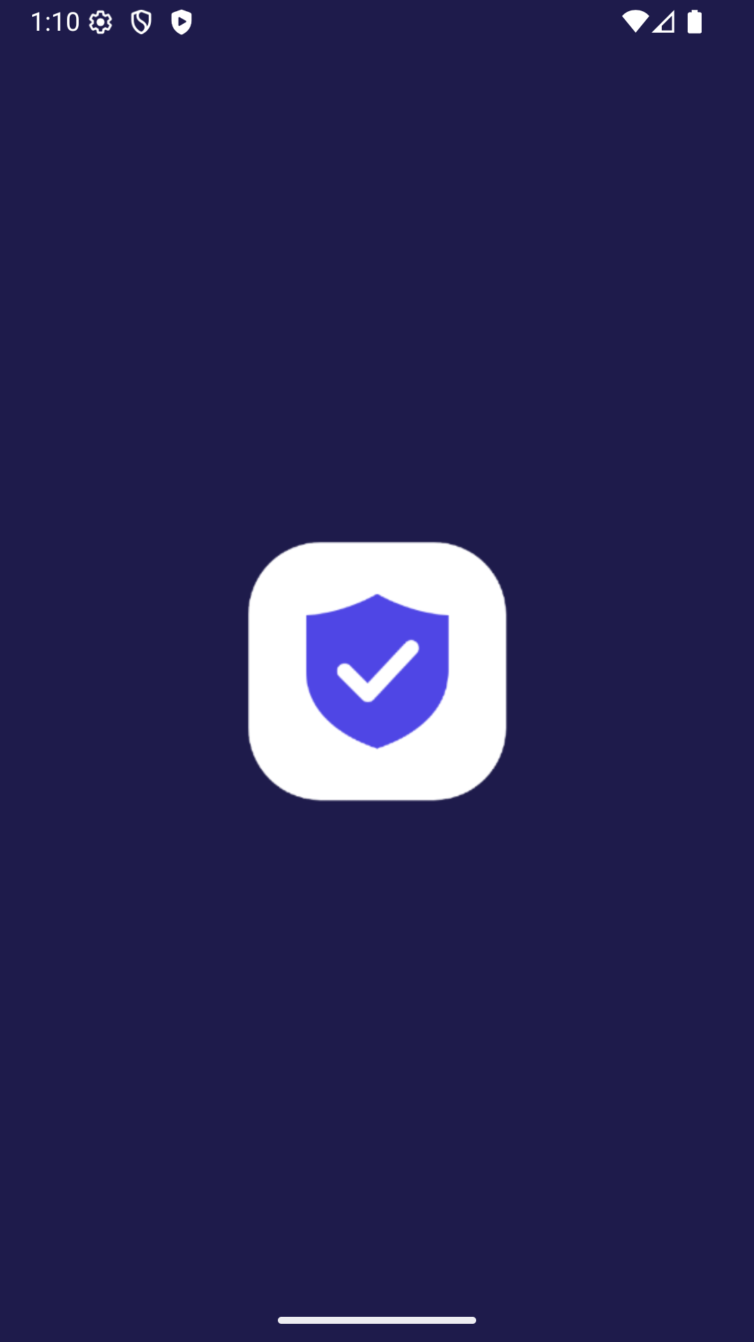
Figure 4. Native splash screen (real emulator screenshot).
What the user sees: Shown by Android while Flutter starts. It uses the same logo and colour as the animated splash, so the change is smooth.
Functionality shown: Native splash generated by flutter_native_splash.

Animated splash screen
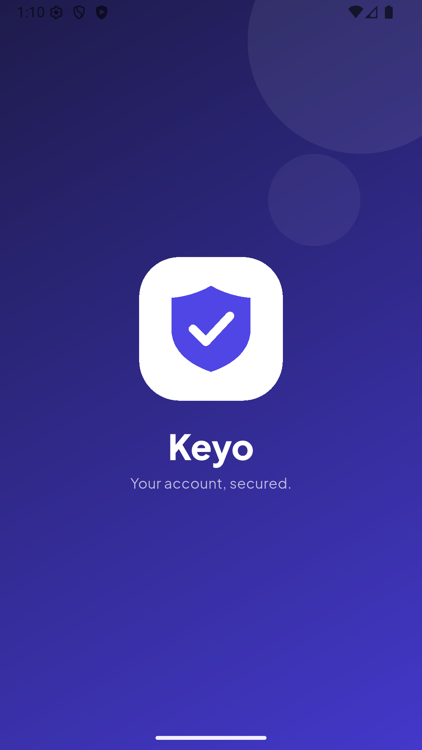
Figure 5. Animated splash screen (real emulator screenshot).
What the user sees: The logo scales in and the name and tagline fade in. After 1.9 seconds the app moves to login.
Functionality shown: SplashScreen with an AnimationController.

Login screen
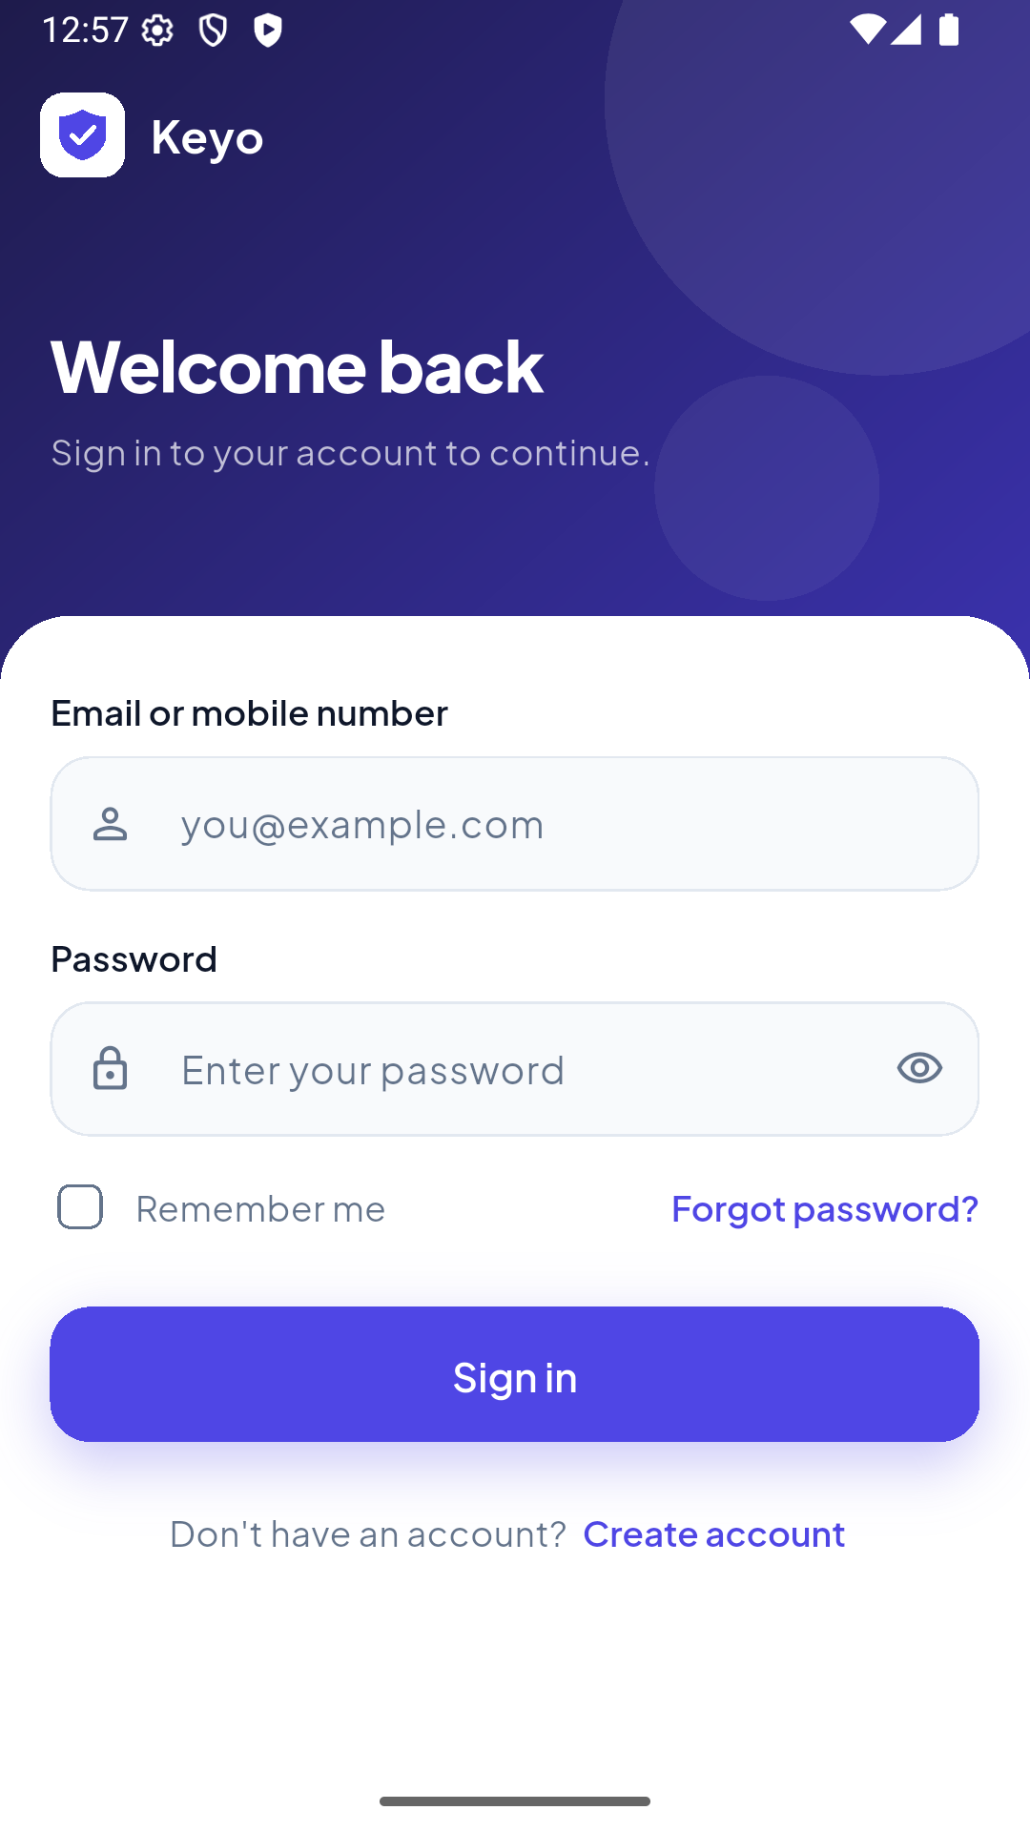
Figure 6. Login screen (real emulator screenshot).
What the user sees: The branded header, email/mobile and password fields, Remember me, Forgot password and Create account.
Functionality shown: Reusable CustomTextField, PasswordField, PrimaryButton, AuthLayout.

Login validation errors
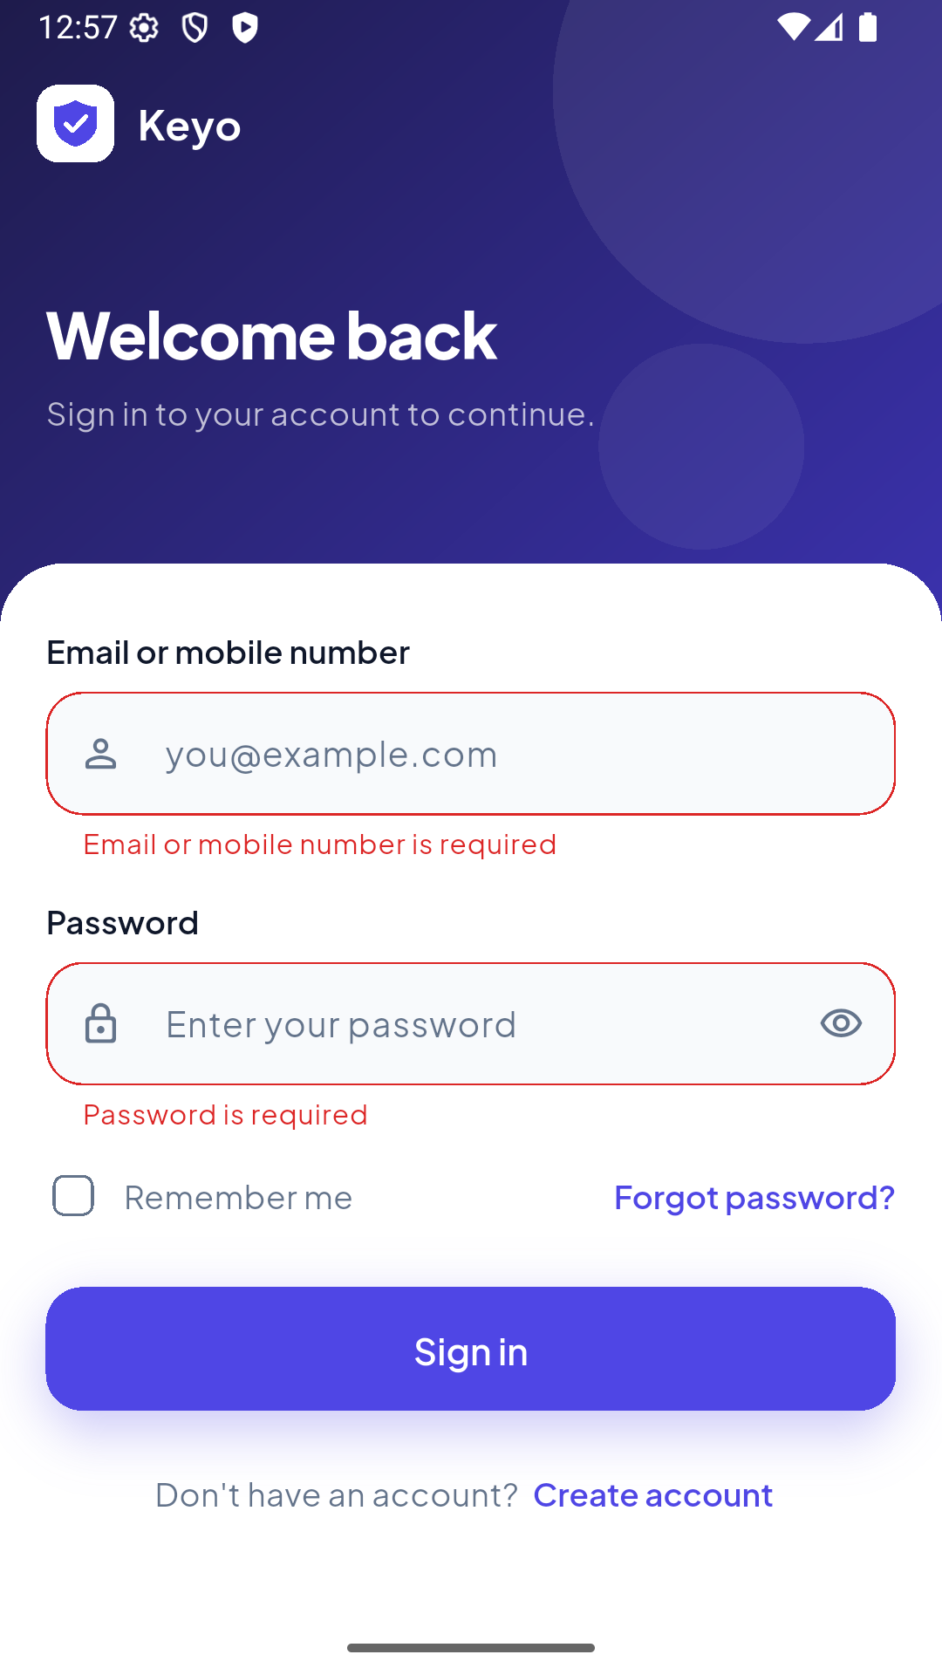
Figure 7. Login validation errors (real emulator screenshot).
What the user sees: Sign in was tapped with empty fields. Each field shows its own message and nothing is sent.
Functionality shown: Form.validate() with Validators.emailOrMobile and requiredPassword.

Loading state
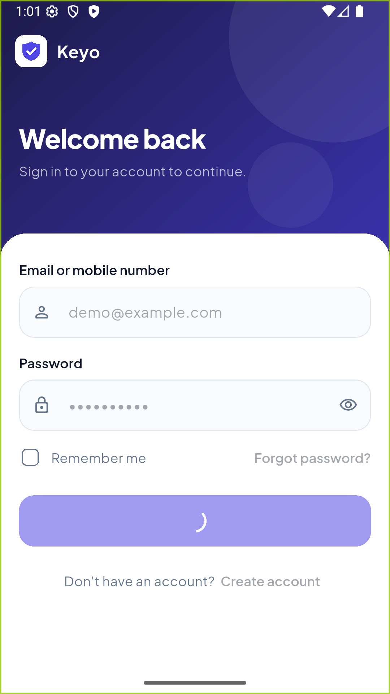
Figure 8. Loading state (real emulator screenshot).
What the user sees: While the request runs, the fields and links are disabled and the button shows a spinner.
Functionality shown: FormProvider.isLoading → PrimaryButton(isLoading: true).

Invalid login error
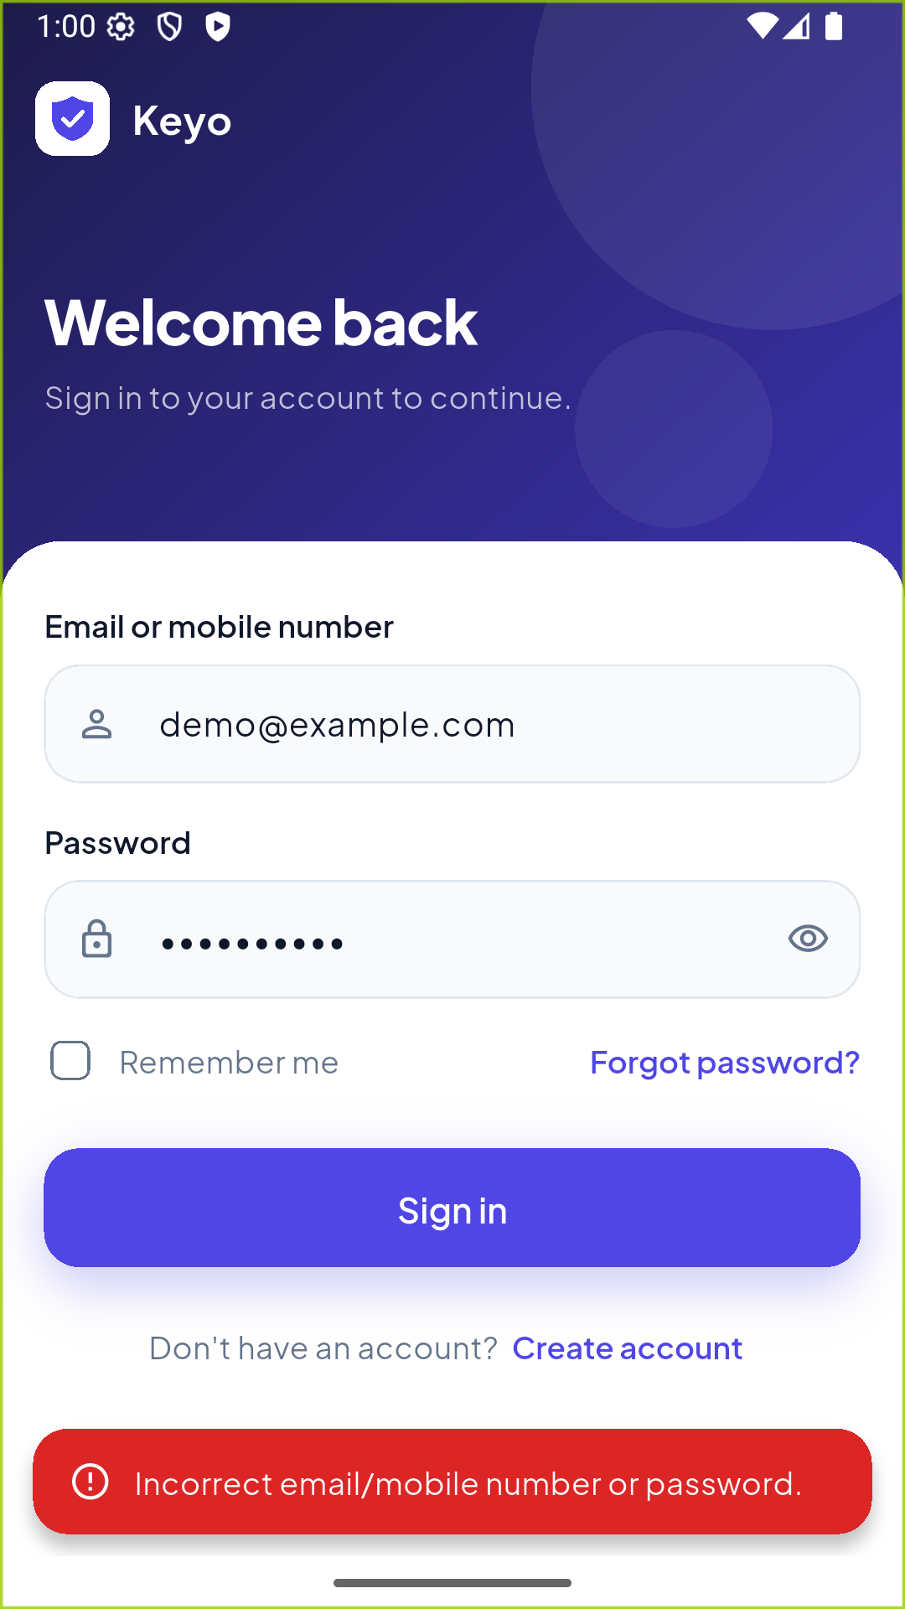
Figure 9. Invalid login error (real emulator screenshot).
What the user sees: A wrong password shows a red snack bar. The user stays on the screen.
Functionality shown: InvalidCredentialsException caught in FormProvider.submit.

Registration screen
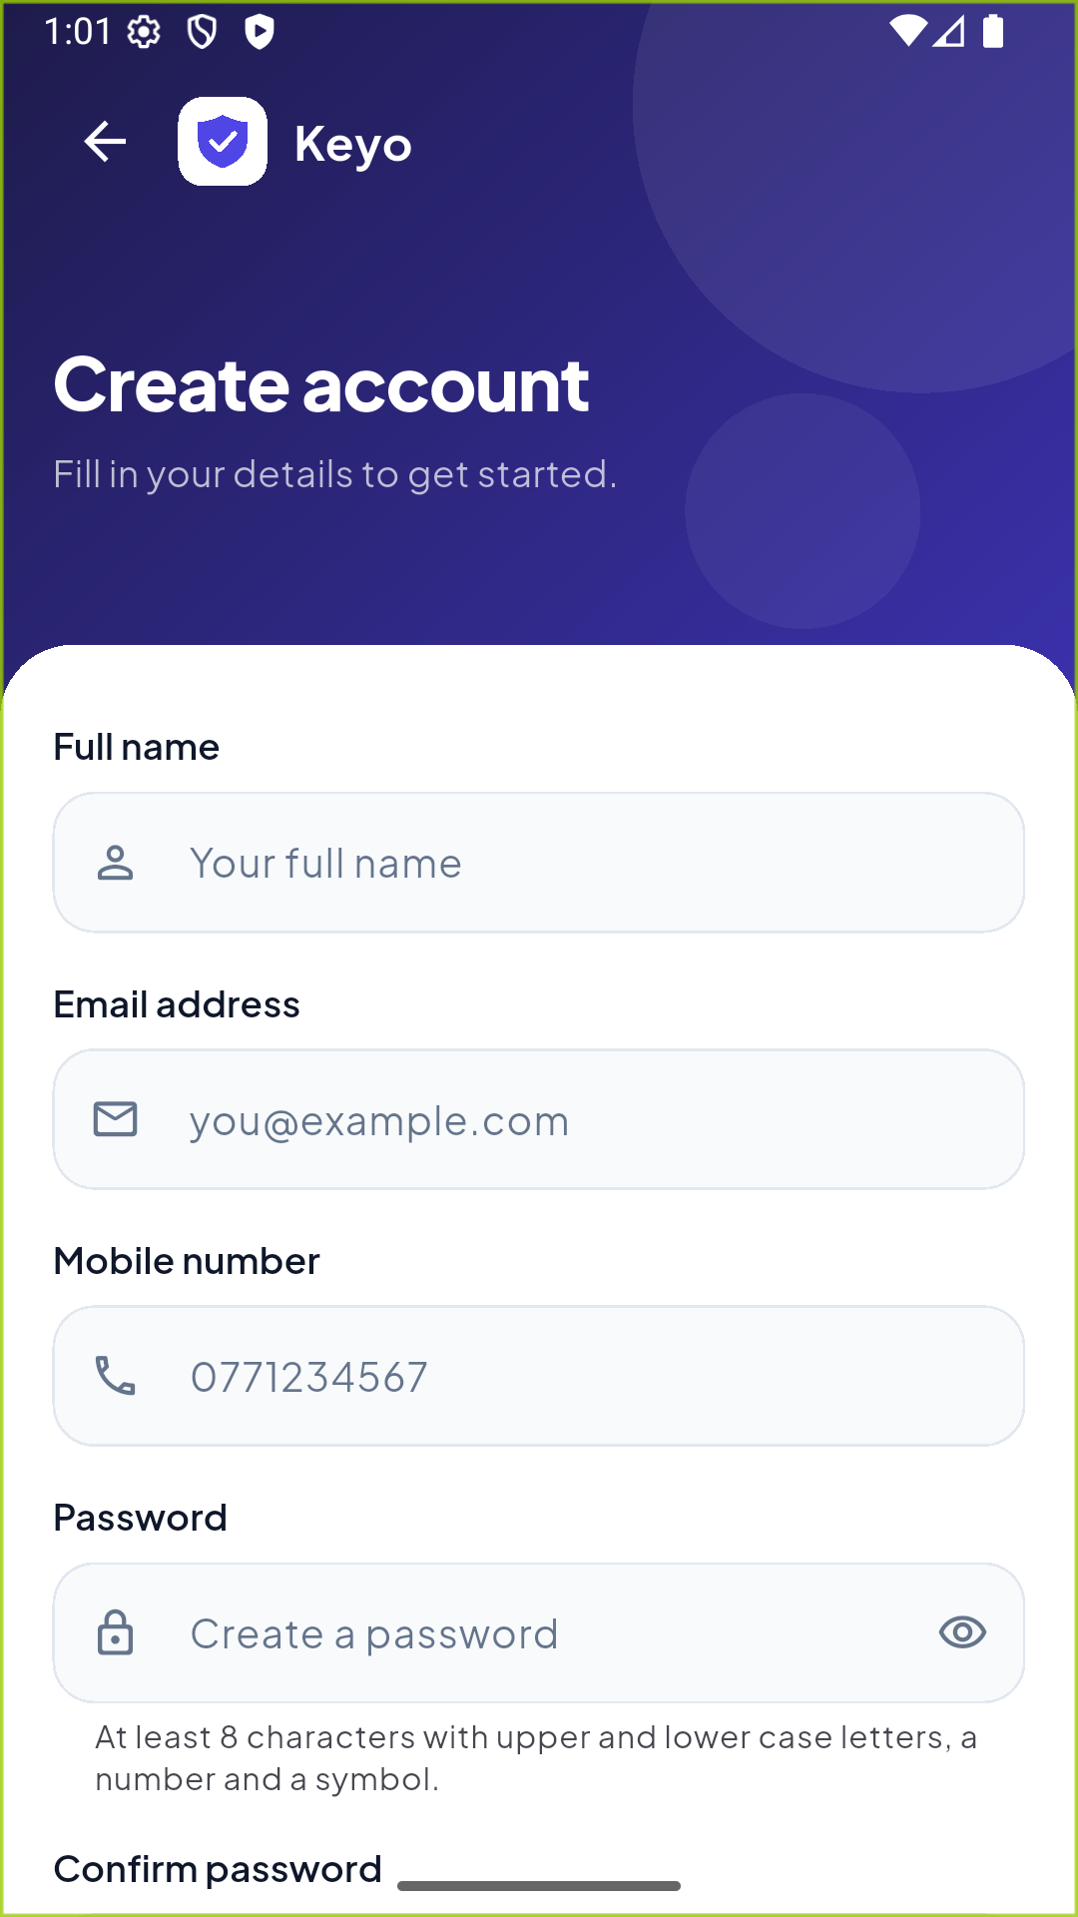
Figure 10. Registration screen (real emulator screenshot).
What the user sees: Five fields with suitable keyboards, a back button and a link back to sign in.
Functionality shown: RegisterScreen.

Registration validation errors
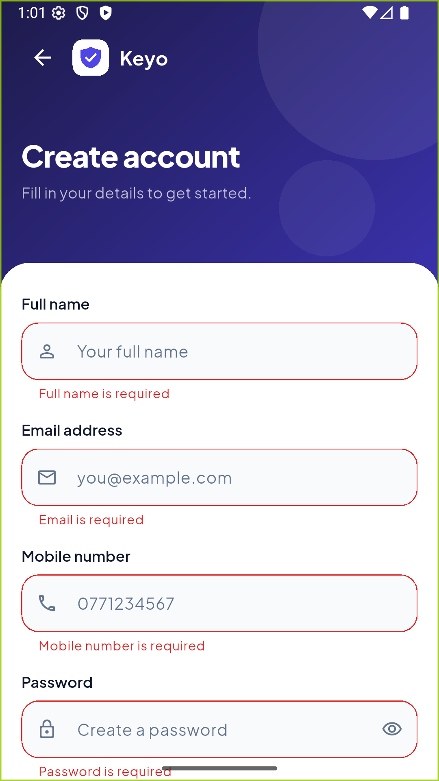
Figure 11. Registration validation errors (real emulator screenshot).
What the user sees: Every empty field shows a specific message.
Functionality shown: Validators for name, email, mobile, password and confirmation.

Password strength meter
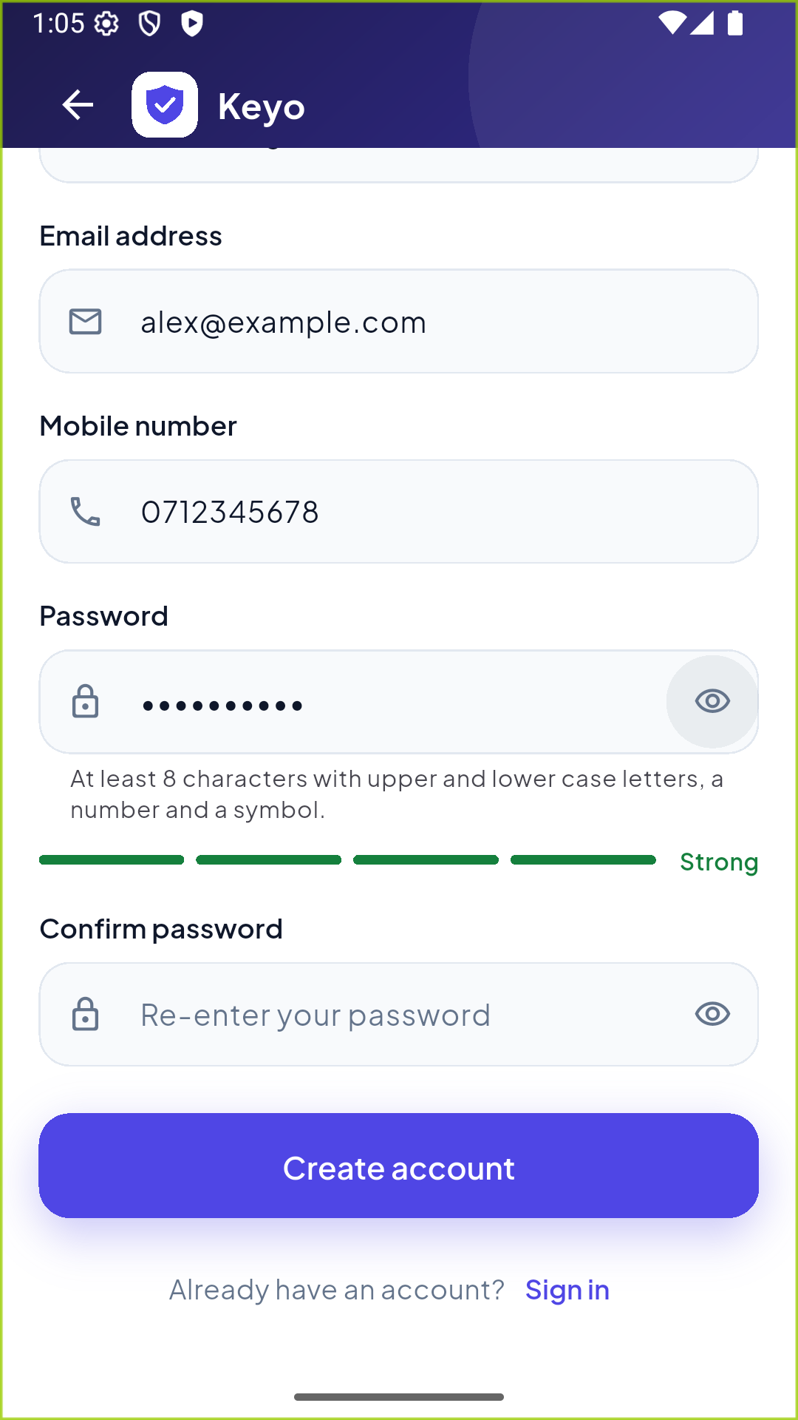
Figure 12. Password strength meter (real emulator screenshot).
What the user sees: The password Secret@123 meets all five rules, so the meter shows four green bars and "Strong". (Confirm password is still empty in this capture.)
Functionality shown: PasswordStrengthMeter + Validators.passwordStrength.

Successful registration
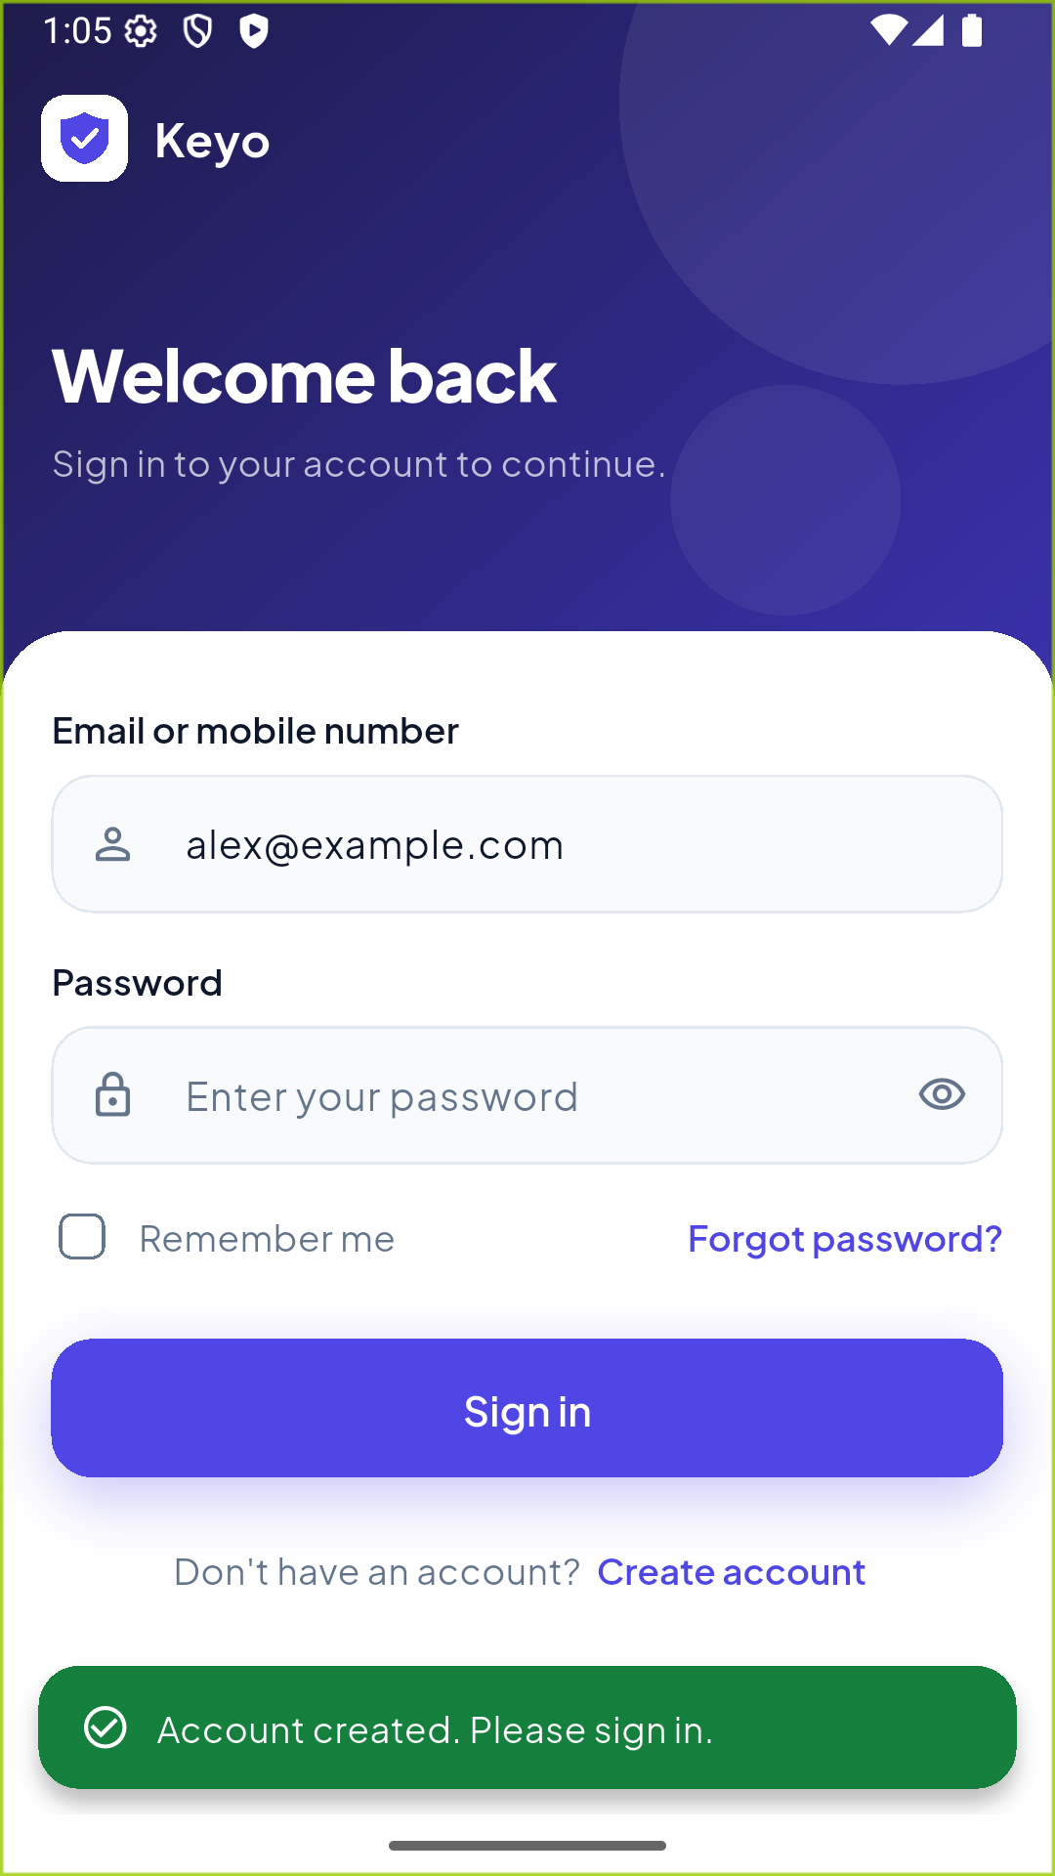
Figure 13. Successful registration (real emulator screenshot).
What the user sees: After registering, the app returns to login with a green message and the new email already filled in.
Functionality shown: Navigator.pop(context, email) and showSuccessSnackBar.

Successful login
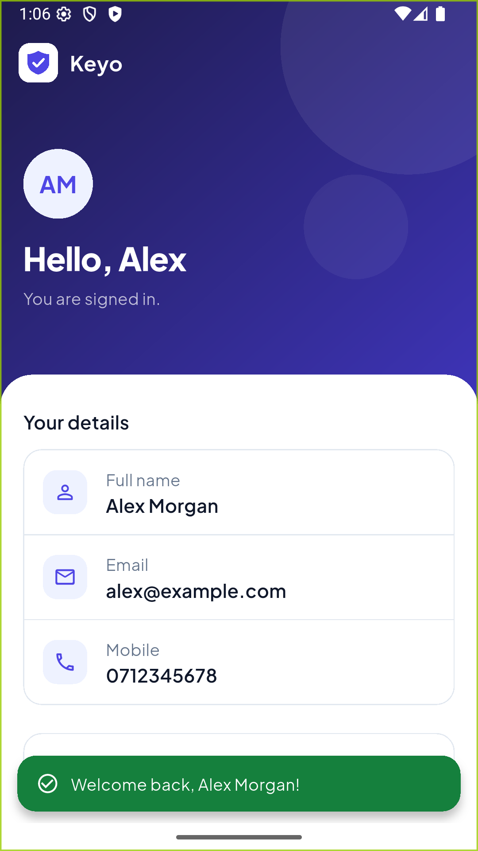
Figure 14. Successful login (real emulator screenshot).
What the user sees: The home screen greets the user and shows their details, with a green welcome message.
Functionality shown: AuthProvider.user read by HomeScreen.

Forgot password screen
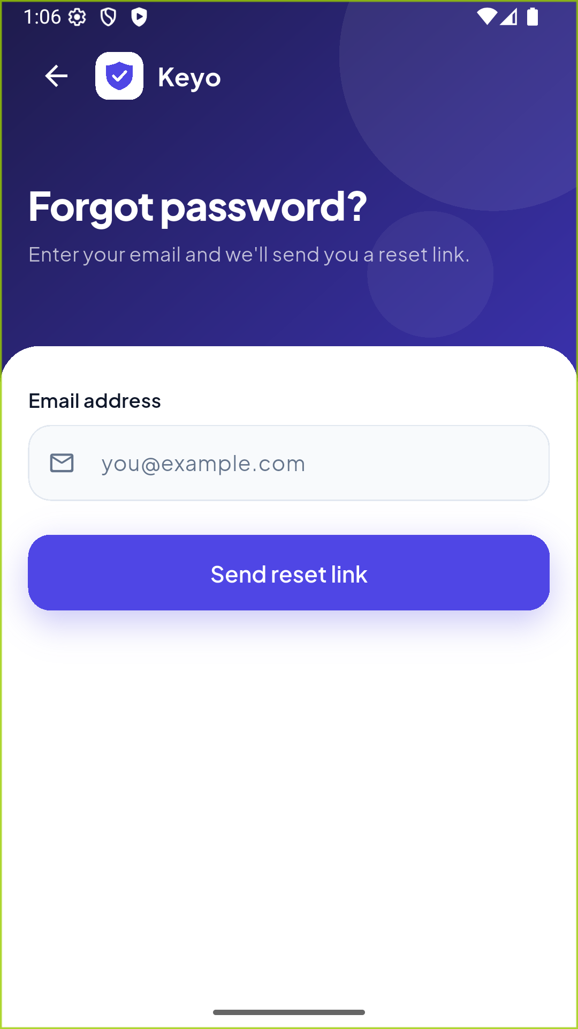
Figure 15. Forgot password screen (real emulator screenshot).
What the user sees: The user enters their email to request a reset link.
Functionality shown: ForgotPasswordScreen form view.

Reset link sent
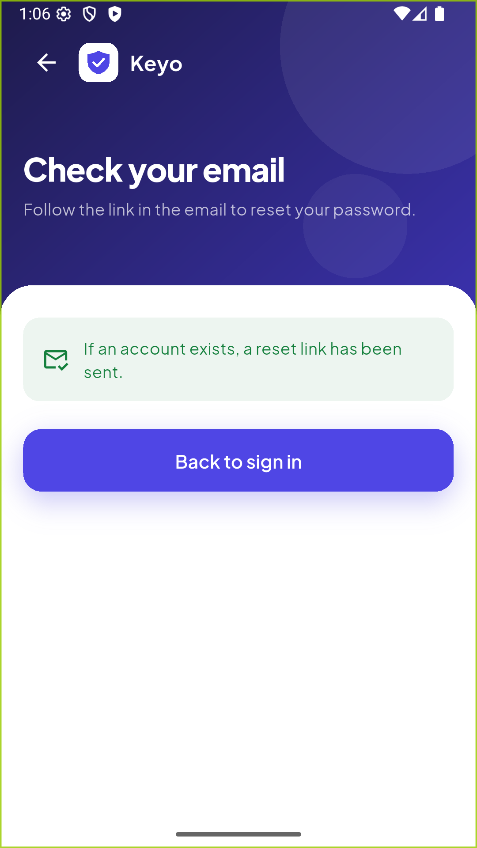
Figure 16. Reset link sent (real emulator screenshot).
What the user sees: The form is replaced by a confirmation, and the title changes to "Check your email".
Functionality shown: AnimatedSwitcher driven by successMessage.

9. Dependencies and pubspec.yaml

9.1 What pubspec.yaml does
pubspec.yaml is the project's configuration file. It sets the package name and version, the Dart SDK version, the packages the app depends on, and the assets and fonts that are bundled into the app. Running flutter pub get downloads the listed packages and writes exact versions to pubspec.lock.
pubspec.yaml — dependencies
dependencies:
flutter:
sdk: flutter

# The following adds the Cupertino Icons font to your application.
# Use with the CupertinoIcons class for iOS style icons.
provider: ^6.1.5+1
shared_preferences: ^2.5.3

dev_dependencies:
flutter_test:
sdk: flutter

dev_dependencies:
flutter_test:
sdk: flutter

# The "flutter_lints" package below contains a set of recommended lints to
# encourage good coding practices. The lint set provided by the package is
# activated in the `analysis_options.yaml` file located at the root of your
# package. See that file for information about deactivating specific lint

9.2 Package details
Package | Purpose | Why it is needed | Where it is used
flutter (SDK) | The Flutter framework. | Everything in the UI. | Every widget file.
provider | State management. | Required by the assignment; shares state and rebuilds widgets. | app.dart, all screens, all providers.
shared_preferences | Simple key-value storage. | Makes Remember me survive an app restart. | login_provider.dart.
flutter_test (dev) | Testing framework. | Unit and widget tests. | test/ and tool/.
flutter_lints (dev) | Recommended code rules. | Keeps code clean; used by flutter analyze. | analysis_options.yaml.
flutter_launcher_icons (dev) | Generates app icons for each platform. | Creates the Keyo icon from one image. | Config in pubspec.yaml; run once.
flutter_native_splash (dev) | Generates the native splash screen. | Shows the logo while Flutter starts. | Config in pubspec.yaml; run once.

dev_dependencies are only used while developing (tests and generators). They are not included in the final app.

10. Interview Preparation
Short answers you can give in an interview. Where possible they point to this project, which makes answers more convincing.

Q1. What is Flutter?
Flutter is Google's UI toolkit for building apps for mobile, web and desktop from one Dart codebase. It draws its own widgets, so the UI looks the same on every platform. In this project the same code runs on Android, iOS and the web.

Q2. What is the difference between StatelessWidget and StatefulWidget?
A StatelessWidget has no changing data of its own; it rebuilds only when its parent gives it new values (for example PrimaryButton). A StatefulWidget has a State object that can change and call setState (for example PasswordField with _isHidden, or LoginScreen, which owns its text controllers and form key).

Q3. What is Provider?
A state management package that gives widgets access to objects higher in the tree and rebuilds them when those objects change. It is built on Flutter's InheritedWidget.

Q4. Why did you use Provider?
The assignment required it, and it suits this app's size. It let me move loading, errors and API calls into providers, so the screens only display state. Each form gets its own provider, and the session lives in AuthProvider.

Q5. What is ChangeNotifier?
A Flutter class that holds a list of listeners and can notify them. My providers extend it, for example AuthProvider extends ChangeNotifier and FormProvider extends ChangeNotifier.

Q6. What does notifyListeners() do?
It tells everything listening that the state changed. With Provider, widgets that used context.watch rebuild. In FormProvider.submit I call it when loading starts and again when it ends. I also override it to do nothing after dispose, so a finished request can't crash a closed screen.

Q7. How does form validation work?
Each TextFormField has a validator function that returns an error string or null. Wrapping the fields in a Form with a GlobalKey<FormState> lets me call validate() to check all of them at once. My rules are in the Validators class, so they are reusable and unit tested.

Q8. What is TextEditingController?
An object that holds and controls the text of a text field. I read values with controller.text, set them (for example filling in the remembered email), and must dispose() them in the State's dispose method to free memory. PasswordStrengthMeter also listens to a controller to update as the user types.

Q9. Why do we separate services and providers?
The service only knows how to talk to the backend. The provider only knows about app state. This makes each part easier to test and lets me swap MockAuthService for a real API without touching providers or screens.

Q10. What is the purpose of a model?
A model gives data a clear, typed structure. UserModel and AuthResponseModel have fromJson constructors, so JSON from an API becomes safe Dart objects, and the compiler catches mistakes such as typos in field names.

Q11. How does the login process work?
Validate the form → LoginProvider.login → FormProvider.submit sets loading → AuthProvider.login → AuthService.login → the response or an exception comes back → AuthProvider stores the user → loading ends → a snack bar shows the result and, on success, the app goes to home. (See Section 5.1.)

Q12. How would you connect a real backend API?
Create ApiAuthService implements AuthService, use the http or dio package to call endpoints such as POST /auth/login, parse the body with AuthResponseModel.fromJson, and map failures to my exceptions (401 → InvalidCredentialsException, 422 → ValidationException, timeouts or socket errors → NetworkException). Then pass it to App in main.dart. No screen needs to change.

Q13. How do you handle API errors?
The service throws typed exceptions. FormProvider.submit catches them in order: ValidationException (field errors), AppException (a known message) and finally any other error, which shows "Something went wrong" and is logged with debugPrint. Loading is always switched off afterwards.

Q14. How do you securely store authentication tokens?
Not in shared_preferences, because it is plain text. I would use flutter_secure_storage, which uses the Android Keystore and iOS Keychain. In this project the mock token is kept only in memory, and Remember me stores just the email or mobile, never the password or token.

Q15. What is async/await?
async marks a function that does work in the background and returns a Future. await pauses that function until the Future completes, without freezing the UI. For example, await provider.login(...) waits for the result while the spinner keeps animating.

Q16. What is a Future?
A value that will be available later, such as the result of a network request. Future<AuthResponseModel> means "an AuthResponseModel will arrive later, or an error". The mock uses Future.delayed to simulate network time.

Q17. What is the difference between GET and POST?
GET asks the server for data and puts parameters in the URL; it should not change anything. POST sends data in the request body to create or change something. Login and registration should use POST, so passwords are not placed in URLs, browser history or server logs.

Q18. How would you improve this application in the future?
Connect a real API with dio; store tokens in secure storage and keep the user signed in; add token refresh; add a real reset-password flow; add localisation and dark mode; add integration tests and CI; and consider a router package such as go_router for deep links.

11. Final Project Summary

11.1 What we implemented
- Login with email or mobile, password visibility toggle, Remember me, forgot password link and full validation.
- Registration with five validated fields, duplicate email and mobile handling and a live strength meter.
- Forgot password flow with a confirmation state.
- Home screen with the user's details and sign out.
- Animated splash, native splash and custom launcher icons.
- Provider-based state with one shared base class for loading, errors and success.
- A mock API with realistic delay, success, validation, network and unexpected errors.
- Responsive layouts for small phones, large phones, landscape, tablets and the web.
- 49 automated tests; flutter analyze reports no issues.

11.2 Main technical concepts learned
- Widgets, StatelessWidget vs StatefulWidget, and the widget tree.
- Forms, validators, GlobalKey<FormState> and TextEditingController.
- Provider: ChangeNotifier, notifyListeners, watch vs read, provider lifetimes.
- Asynchronous code: Future, async/await and error handling with try/catch.
- Named-route navigation, passing results back with pop, and replacing routes.
- Layered architecture: UI → provider → service, and coding against an interface.
- Theming with Material 3 and building reusable widgets.
- Unit and widget testing.

11.3 Important architectural decisions
Decision | Reason
AuthService interface + MockAuthService | The real backend can be added later by changing one line in main.dart.
Errors as typed exceptions | Each failure type gets the right message; successful responses stay simple.
Shared FormProvider base class | Loading, error and duplicate-submit logic is written once and tested once.
Form providers created per route | Each screen starts with clean state and memory is released automatically.
setState for show/hide password | UI-only state belongs in the widget; Provider would be overengineering.
Validators in their own class | Reusable, easy to unit test, and keeps screens short.
Same reply for forgot password | Prevents attackers from discovering registered emails.

11.4 Current limitations
- No real backend: accounts are stored in memory and are lost when the app restarts (except the demo account).
- The user is not kept signed in after restarting the app; Remember me only fills in the email or mobile.
- Forgot password does not send a real email.
- Passwords are stored in plain text inside the mock (acceptable only for demo data).
- English only, light theme only.
- Known small issue: on registration, pressing Next on the keyboard in the Password field moves focus to the show/hide (eye) button instead of the Confirm password field. It was found while taking the screenshots for this document and has not been fixed yet.
- iOS and web builds have not been run on real devices.

11.5 Possible future improvements
- Real REST API with dio, timeouts and retry.
- Secure token storage with flutter_secure_storage and automatic sign-in.
- Token refresh and session expiry handling.
- Email verification and a real reset-password screen.
- Social sign-in (Google, Apple) and biometric login.
- Localisation, dark mode and accessibility review.
- Integration tests and a CI pipeline (for example GitHub Actions) that runs flutter analyze and flutter test.

