Flutter Login & Registration Module
Project Documentation
Prepared for: Flutter Associate Developer - technical assignment
Prepared by: Pasan Sasmika
Date: 2 November 2026
Source code: https://github.com/PasanSasmika/Flutter-Login-Registration-Module.git
Built with: Flutter 3.32, Dart 3.8, Provider, Material 3

1. Introduction
This document describes the login and registration module I built for the Flutter Associate Developer technical assignment. The brief was to build a working, responsive login and registration flow that uses Provider for state management, keeps business logic out of the UI, and talks to a mock API that can be swapped for a real backend later.
I called the app Keyo while building it (the name only appears on the splash screen and app icon). The sections below cover how to run the project, how the code is organised, the main decisions I made and why, how I tested it, and what I would improve with more time.

1.1 Features
- Sign in with either an email address or a mobile number plus a password.
- Show / hide password, Remember me, and a Forgot password screen.
- Registration with full name, email, mobile number, password and confirm password, including a live password strength meter.
- Validation on every form before anything is sent, with live error updates after the first submit attempt.
- Loading state on every request (button spinner, fields disabled, double taps ignored).
- Clear success and error messages for every outcome, including duplicate email/mobile on registration and network errors.
- A simple home screen showing the signed-in user, with sign out.
- Responsive layout: a full-screen sheet on phones and a centred card on tablets and web.
- Native splash screen, an animated splash, and a custom app icon.

1.2 Tech stack
Package / tool | Used for
Flutter 3.32 / Dart 3.8 | UI and application code
Material 3 | Base design system, customised in AppTheme
provider ^6.1.5 | State management (session + per-form state)
shared_preferences ^2.5.3 | Saving the email/mobile for Remember me (the password is never saved)
flutter_test | Unit and widget tests (49 tests)
flutter_lints | Lint rules used by flutter analyze
flutter_launcher_icons, flutter_native_splash | Generating the app icon and native splash from the logo (dev only)

2. Running the Project
git clone https://github.com/PasanSasmika/Flutter-Login-Registration-Module.git
cd Flutter-Login-Registration-Module
flutter pub get
flutter run
flutter test # runs all 49 tests

There is no real backend, so the app uses a mock service with one built-in account and two "trigger" emails I added to test the error paths:
Input | Result
demo@example.com or 0771234567, password Demo@1234 | Successful login as Demo User
Wrong password / unknown account | "Incorrect email/mobile number or password."
Registering an email or mobile that already exists | Error shown under that specific field
network@example.com | Simulated network error ("Unable to connect...")
crash@example.com | Simulated unexpected server error ("Something went wrong. Please try again.")
Every mock request waits about 1.2 seconds so the loading state can actually be seen.

3. Project Structure
I grouped the code by responsibility rather than by feature, since the module is small and every screen shares the same widgets and services. Output of tree lib /F /A:
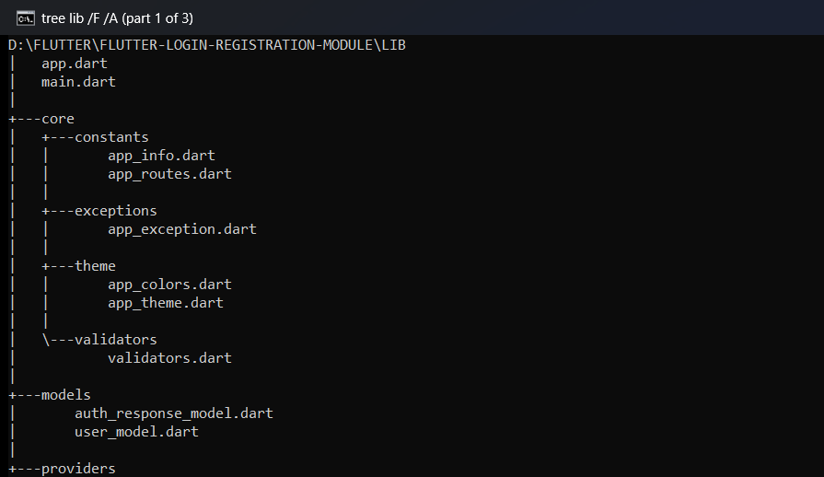
Figure 1: lib folder (1 of 3) - core/ and models/
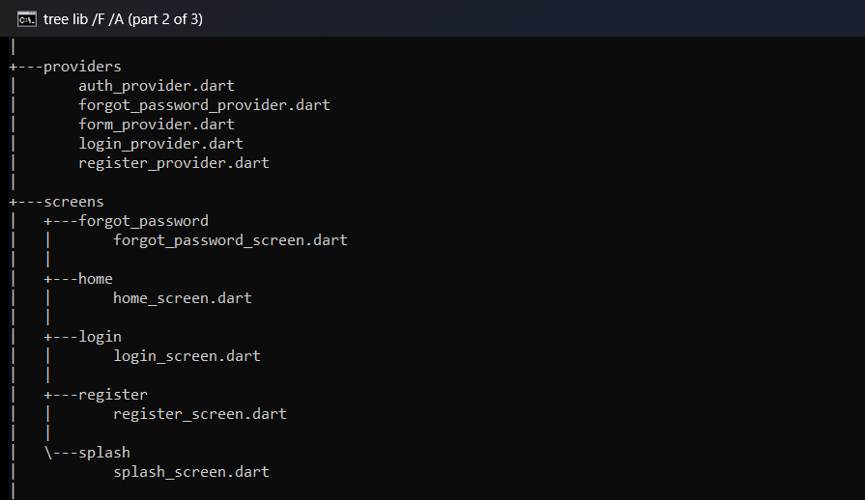
Figure 2: lib folder (2 of 3) - providers/ and screens/
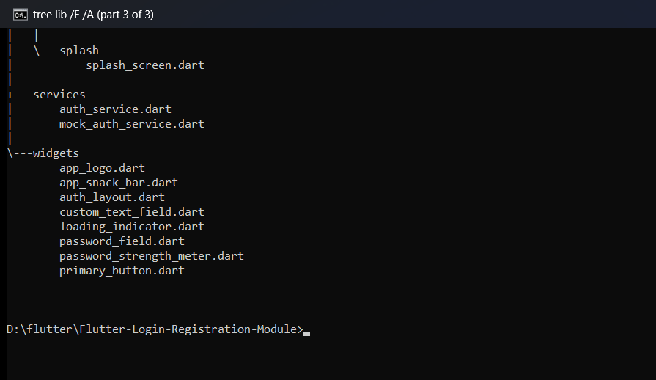
Figure 3: lib folder (3 of 3) - services/ and widgets/
Folder | What goes in it
lib/core/constants | Route names (AppRoutes) and app name/tagline (AppInfo)
lib/core/theme | Colour palette (AppColors) and Material 3 theme (AppTheme)
lib/core/validators | All form validation rules
lib/core/exceptions | AppException and its subclasses thrown by the service layer
lib/models | UserModel and AuthResponseModel (both have fromJson)
lib/services | AuthService (abstract) and MockAuthService
lib/providers | AuthProvider plus one provider per form
lib/screens | splash, login, register, forgot_password, home
lib/widgets | Shared UI: text field, password field, button, layout, logo, snack bars, strength meter
test/ | validators_test, mock_auth_service_test, auth_flow_test
tool/ | Script that renders the logo widget to PNG for the icon and splash

4. Architecture
The app is split into layers, and each layer only talks to the one directly below it:
Screen (LoginScreen, RegisterScreen, ForgotPasswordScreen)
| calls methods / watches state
Form provider (LoginProvider, RegisterProvider, ForgotPasswordProvider)
|
AuthProvider (app-wide session: current user + token)
|
AuthService (abstract contract: login, register, forgotPassword)
|
MockAuthService (today) -> real API client (later)

Calls go down as normal method calls. Results come back up either as an AuthResponseModel (success) or as an AppException (failure). I chose to throw exceptions for failures instead of returning an error object, so if code receives an AuthResponseModel it knows the request worked.

4.1 Swapping the mock for a real API
Screens and providers only depend on the abstract AuthService. The concrete service is created once in main.dart and passed into the app, so moving to a real backend means writing an ApiAuthService implements AuthService and changing one line.
lib/services/auth_service.dart
abstract class AuthService {
/// [identifier] is an email address or mobile number.
Future<AuthResponseModel> login({
required String identifier,
required String password,
});

Future<AuthResponseModel> register({
required String fullName,
required String email,
required String mobile,
required String password,
});

Future<AuthResponseModel> forgotPassword({required String email});
}

lib/main.dart
void main() {
// Replace MockAuthService with a real AuthService to use a live API.
runApp(App(authService: MockAuthService()));
}

4.2 State management with Provider
There are two kinds of providers, with different lifetimes:
Provider | Lifetime | Holds
AuthProvider | Whole app (above MaterialApp) | Signed-in user and token
LoginProvider, RegisterProvider, ForgotPasswordProvider | One screen (created in the route, disposed when it closes) | Loading flag, messages, field errors, Remember me
Creating the form providers per route means an old error message never shows up again when a screen is reopened, and their memory is freed automatically.
lib/app.dart - app-wide provider and per-route form providers
return ChangeNotifierProvider(
create: (_) => AuthProvider(authService),
child: MaterialApp(
title: AppInfo.name,
debugShowCheckedModeBanner: false,
theme: AppTheme.light,
// Form providers are created per route, so their state is reset
// whenever the user leaves a screen.
routes: {
AppRoutes.splash: (_) => const SplashScreen(),
AppRoutes.login: (_) => ChangeNotifierProvider(
create: (context) => LoginProvider(context.read<AuthProvider>()),
child: const LoginScreen(),
),
AppRoutes.register: (_) => ChangeNotifierProvider(
create: (context) => RegisterProvider(context.read<AuthProvider>()),
child: const RegisterScreen(),
),
AppRoutes.forgotPassword: (_) => ChangeNotifierProvider(
create: (context) =>
ForgotPasswordProvider(context.read<AuthProvider>()),
child: const ForgotPasswordScreen(),
),
AppRoutes.home: (_) => const HomeScreen(),
},
),
);

Inside build, screens use context.watch<T>() so they rebuild when the state changes. In button callbacks and initState they use context.read<T>() instead, because they only need to call a method, not listen.
For the show/hide password toggle I used plain setState inside PasswordField. That value only matters to that one widget, so putting it in a provider would have been unnecessary.

4.3 Shared form logic (FormProvider)
Login, registration and forgot password all need the same loading/error/success handling, so I put it in a base class, FormProvider, and the three form providers extend it. Its submit() method wraps any request:
lib/providers/form_provider.dart
Future<bool> submit(Future<String> Function() request) async {
if (_isLoading) return false;

_isLoading = true;
_errorMessage = null;
_successMessage = null;
_fieldErrors = {};
notifyListeners();

var succeeded = false;
try {
_successMessage = await request();
succeeded = true;
} on ValidationException catch (e) {
_fieldErrors = Map.of(e.fieldErrors);
_errorMessage = e.message;
} on AppException catch (e) {
_errorMessage = e.message;
} catch (e, stackTrace) {
debugPrint('Unexpected error: $e\n$stackTrace');
_errorMessage = 'Something went wrong. Please try again.';
}

_isLoading = false;
notifyListeners();
return succeeded;
}

A few things about this method:
- The if (_isLoading) return false; guard blocks double submits. The button is also disabled while loading, but this guard covers pressing Enter on the keyboard too.
- ValidationException must be caught before AppException because it is a subclass.
- The final catch handles anything unexpected, so the app never crashes and the button never gets stuck in the loading state.
FormProvider also overrides notifyListeners() to do nothing after dispose(). Without this, leaving a screen while its request was still running threw an error when the request finished.

5. Implementation Details

5.1 Validation
All rules live in lib/core/validators/validators.dart. Each validator takes String? and returns an error message or null, so it plugs straight into TextFormField.validator and is easy to unit test.
Field | Rule
Full name | Required
Email | Required, trimmed, must match a standard email pattern (name@domain.tld)
Mobile | Spaces, dashes and brackets removed, then optional + followed by 9 to 15 digits
Email or mobile (login) | If the input only contains digits/phone symbols it is checked as a mobile number, otherwise as an email, so the user gets the right message
Password (register) | At least 8 characters, with an uppercase letter, a lowercase letter, a number and a special character
Confirm password | Required and must match the password field
The form is validated with _formKey.currentState!.validate() when the user taps the button. If it fails, I switch the form to AutovalidateMode.onUserInteraction so the errors update live while the user fixes them, instead of showing red text before they have even started typing.
Deciding between email and mobile on the login screen
static String? emailOrMobile(String? value) {
final input = value?.trim() ?? '';
if (input.isEmpty) return 'Email or mobile number is required';
return looksLikeMobile(input) ? mobile(input) : email(input);
}

The password strength meter on the registration screen counts how many of the five rules are met and shows Weak, Fair, Good or Strong. It uses a ValueListenableBuilder on the text controller, so only the meter rebuilds while typing.

5.2 Mock authentication service
MockAuthService keeps the accounts in an in-memory list. Emails are stored in lower case and mobile numbers are normalised, so "Demo@Example.com" and "077 123 4567" still match. On registration it collects duplicate errors into a map and throws a ValidationException, which the screen shows under the matching fields. Each error clears as soon as the user edits that field.
lib/services/mock_auth_service.dart - register
Future<AuthResponseModel> register({
required String fullName,
required String email,
required String mobile,
required String password,
}) async {
await _simulateRequest(email);

final normalizedEmail = email.trim().toLowerCase();
final normalizedMobile = Validators.normalizeMobile(mobile);

final fieldErrors = <String, String>{};
if (_accounts.any((a) => a['email'] == normalizedEmail)) {
fieldErrors['email'] = 'This email is already registered';
}
if (_accounts.any((a) => a['mobile'] == normalizedMobile)) {
fieldErrors['mobile'] = 'This mobile number is already registered';
}
if (fieldErrors.isNotEmpty) throw ValidationException(fieldErrors);

final account = {
'id': '${_accounts.length + 1}',
'fullName': fullName.trim(),
'email': normalizedEmail,
'mobile': normalizedMobile,
'password': password,
};
_accounts.add(account);
return _authResponse(account, 'Account created. Please sign in.');
}

5.3 Remember me
When Remember me is ticked, the email or mobile number is saved with shared_preferences after a successful login and filled in next time. If it is unticked, the saved value is removed. The password is never stored.

5.4 Forgot password
The mock always returns the same message ("If an account exists, a reset link has been sent.") whether or not the email is registered. If it said "no account found", the form could be used to check which emails have accounts. After success, an AnimatedSwitcher replaces the form with a confirmation and the title changes to "Check your email".

5.5 Navigation
- Splash to login, and login to home, use pushReplacementNamed so Back does not return to them.
- Sign out uses pushNamedAndRemoveUntil(..., (route) => false) to clear the whole history.
- After registering, the screen calls Navigator.pop(context, email). The login screen receives the email and fills it in, so the user only needs to type the password.
- While a request is running, PopScope(canPop: false) stops the user leaving the screen mid-request.

5.6 Responsive layout
AuthLayout is shared by all screens. Below 600 px wide it shows an indigo header with a white rounded sheet underneath (phone style). At 600 px and above it shows a centred card instead, so the same screens look right on tablets and in a browser.

6. Testing
The project has 49 tests, split into unit tests for the logic and widget tests that drive the real screens. They run with flutter test.
File | What it covers
validators_test.dart | Every validator, including invalid emails, mobile formats and each password rule
mock_auth_service_test.dart | Login by email and mobile, duplicate registration, forgot password, simulated errors and the delay
auth_flow_test.dart | Widget tests on the real screens: empty forms, invalid input, loading state, double taps, Remember me, registration, forgot password, and layout on five screen sizes

7. Screenshots
Taken on an Android emulator (1080 x 1920, API 36).
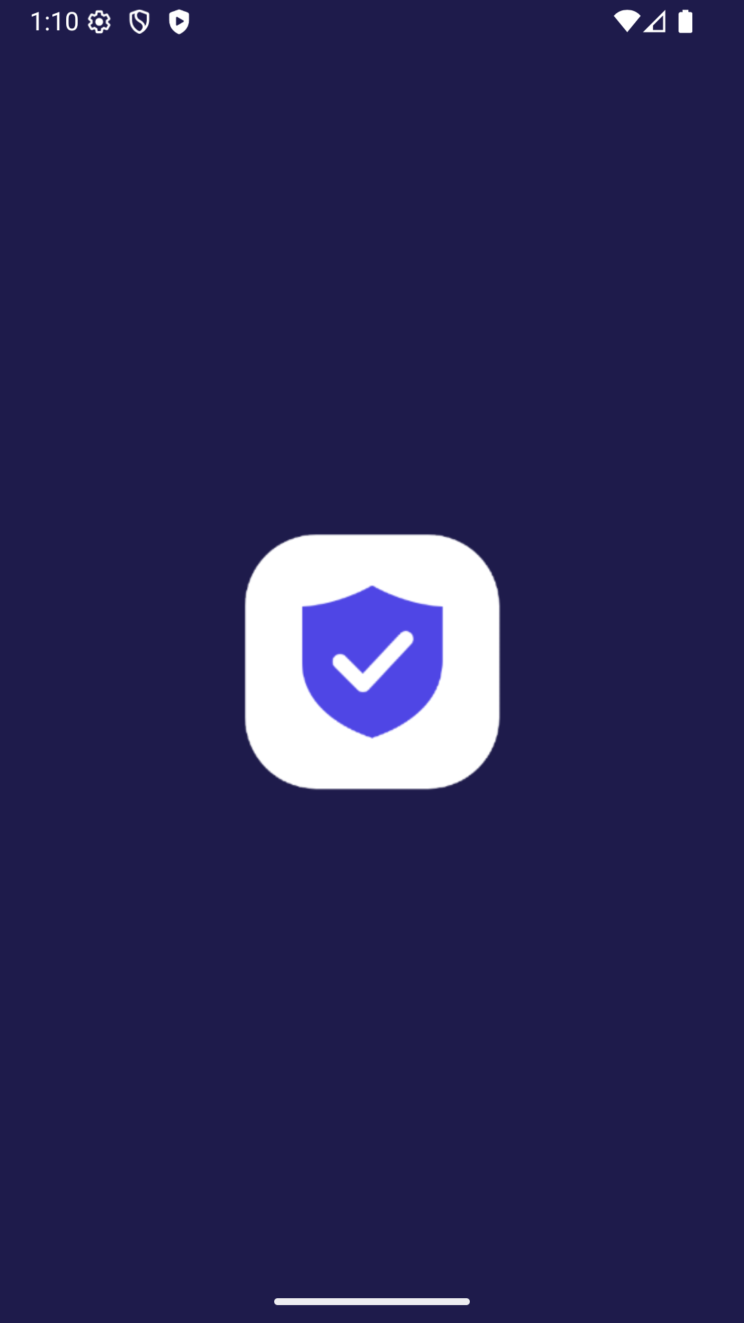  Native splash  Shown while Flutter loads | 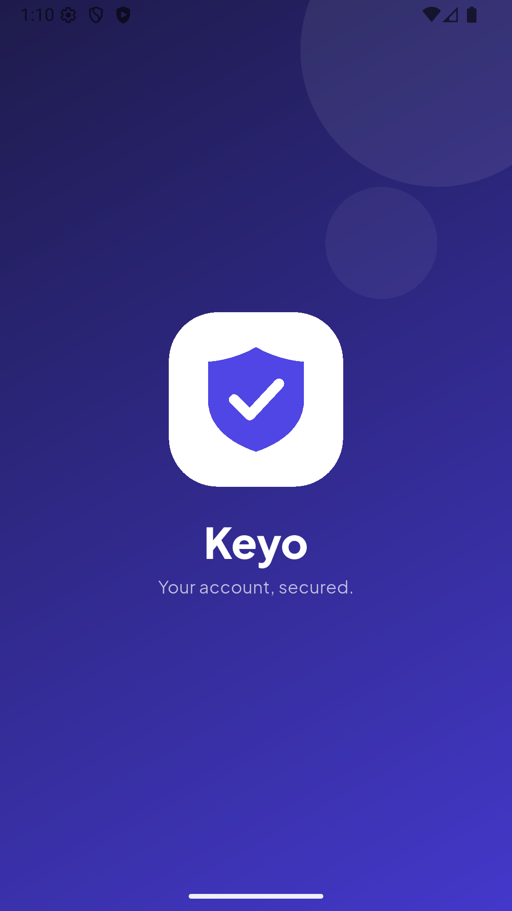  Animated splash  Logo and name animate in, then login opens | 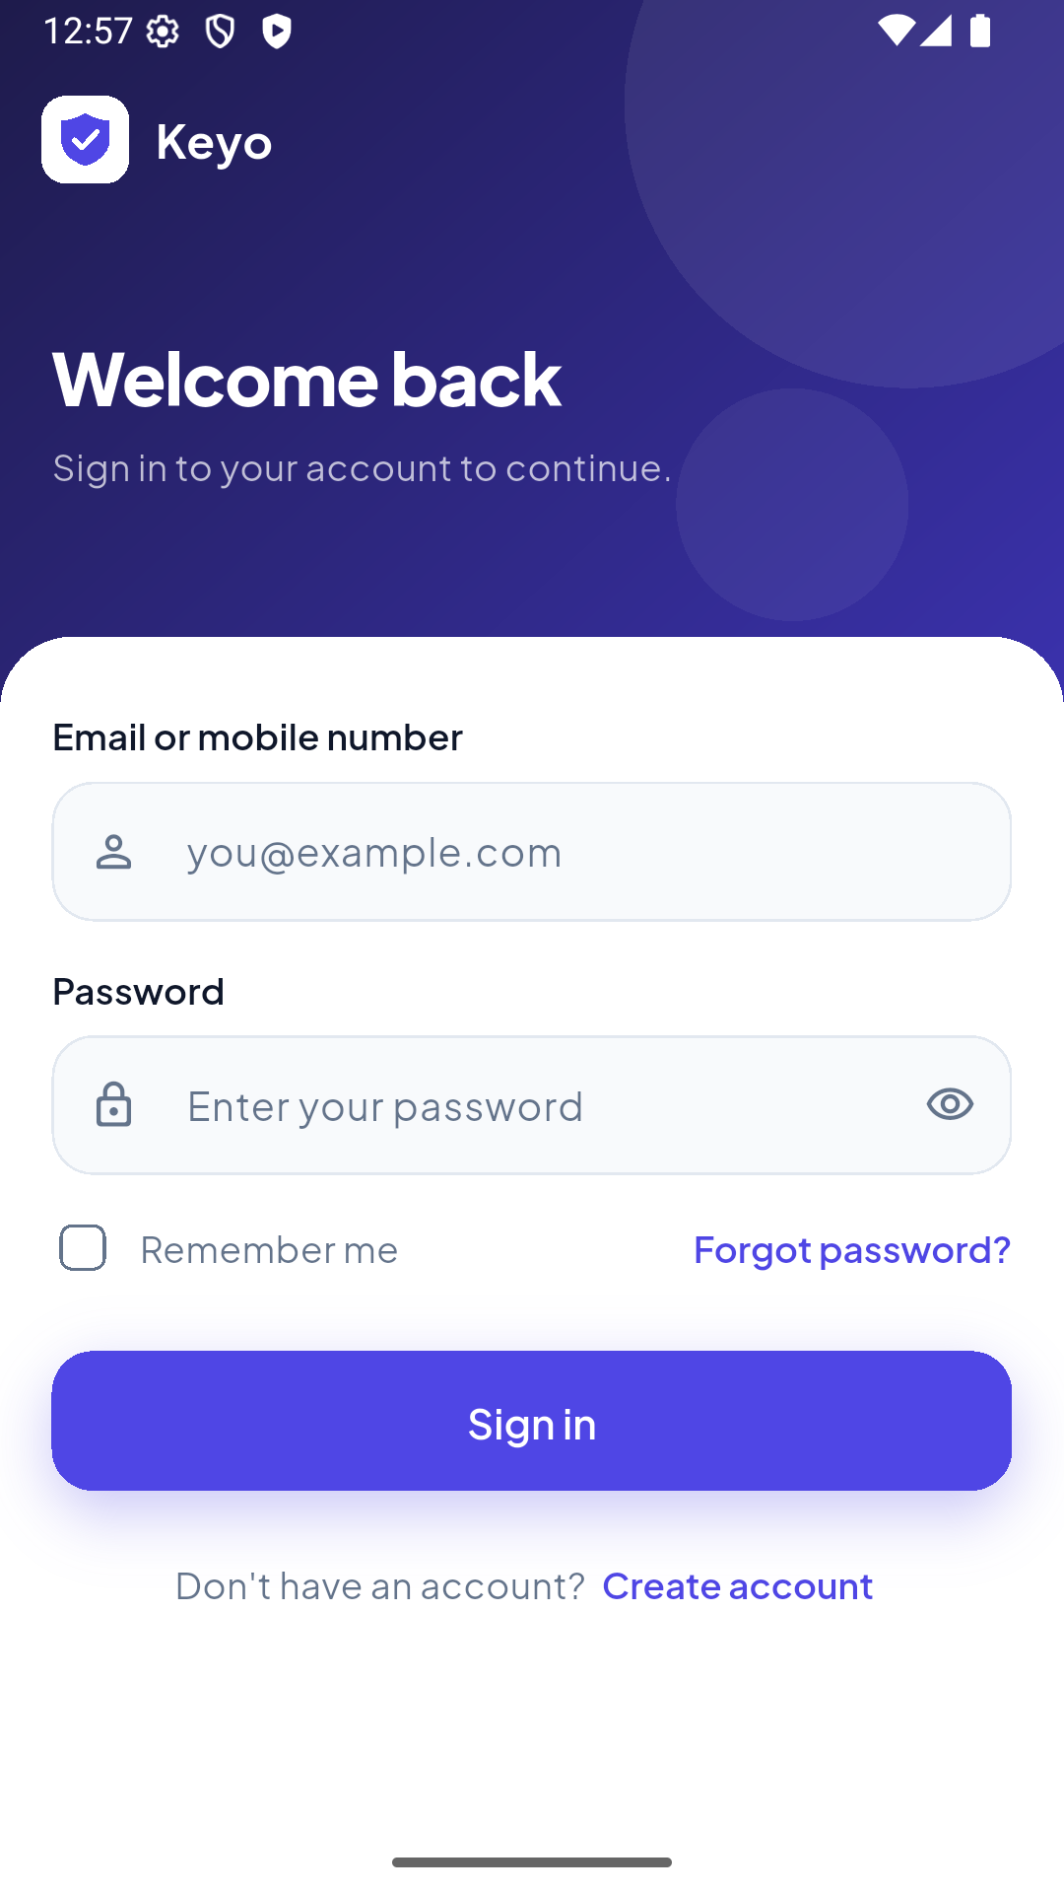  Login  Email/mobile, password, Remember me
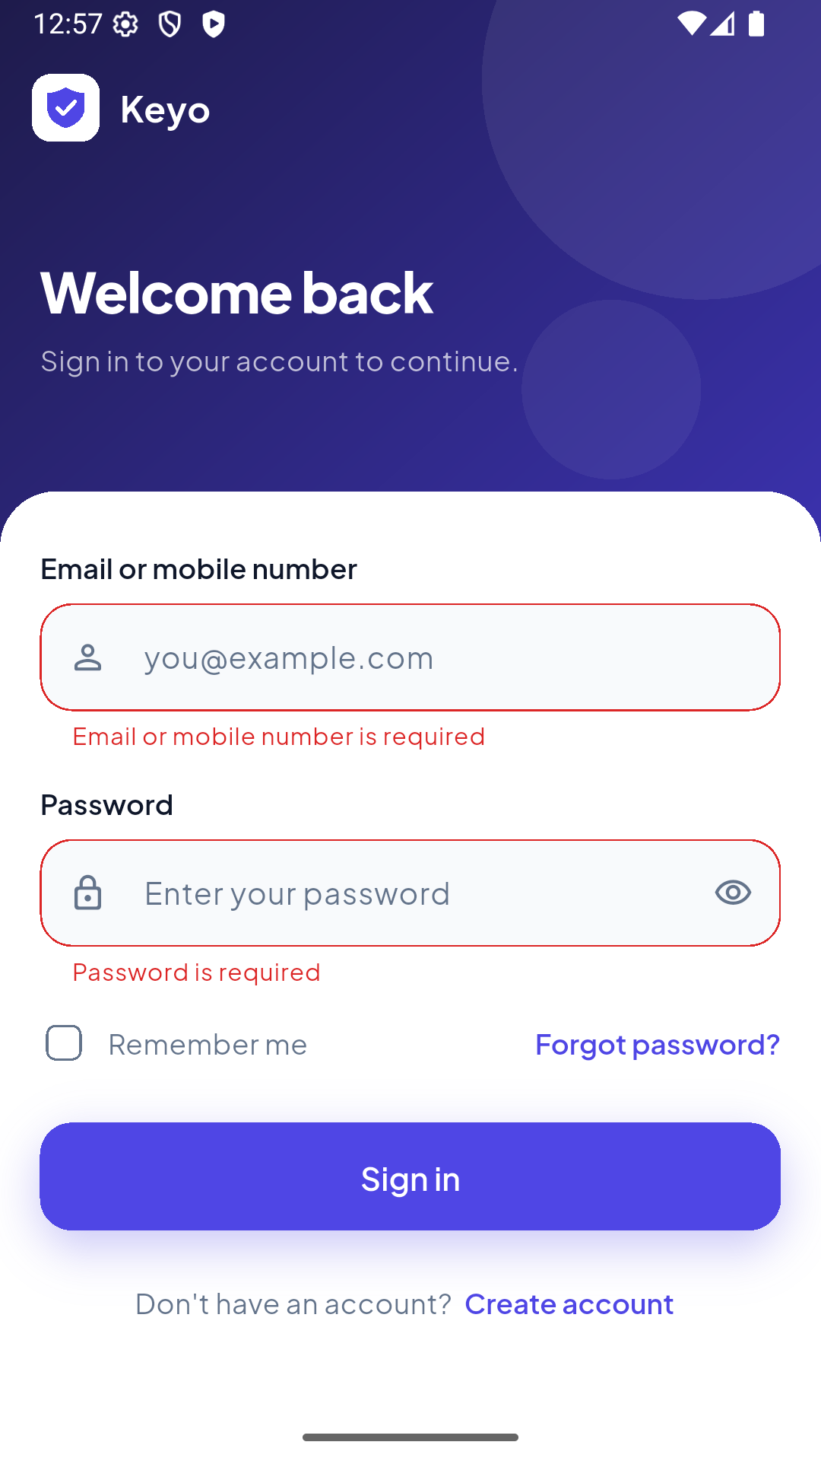  Login validation  Empty fields, nothing is sent | 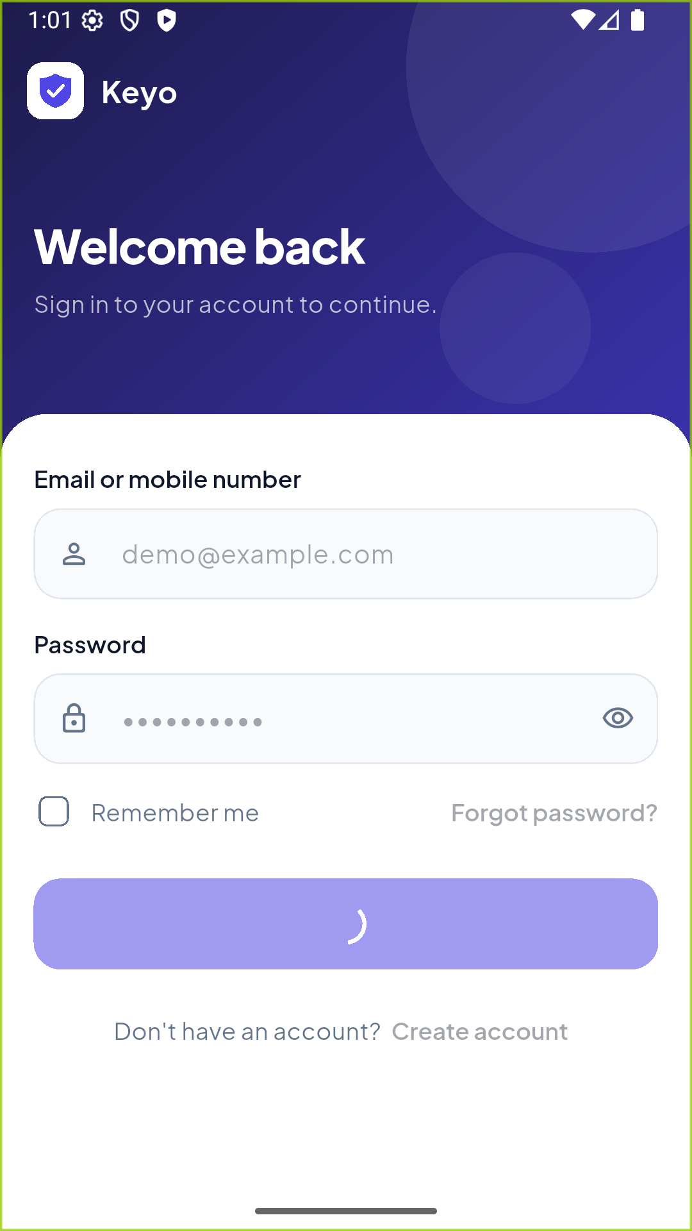  Loading  Spinner on button, fields disabled | 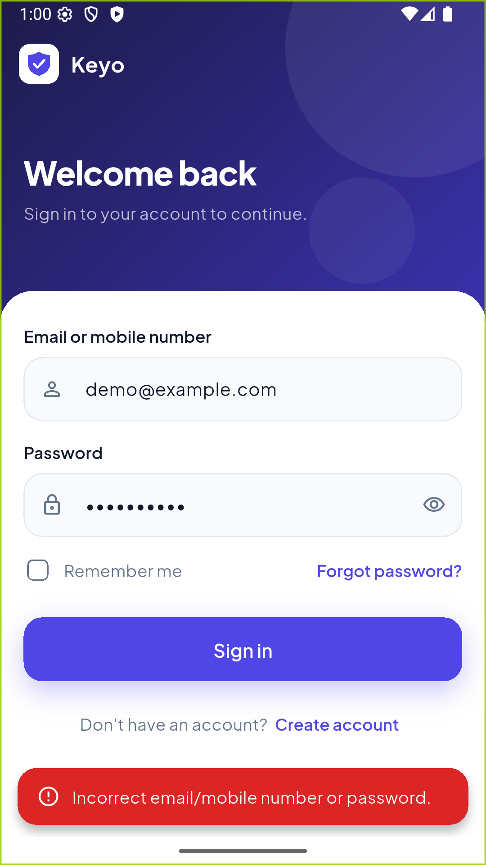  Invalid login  Wrong password, red snack bar
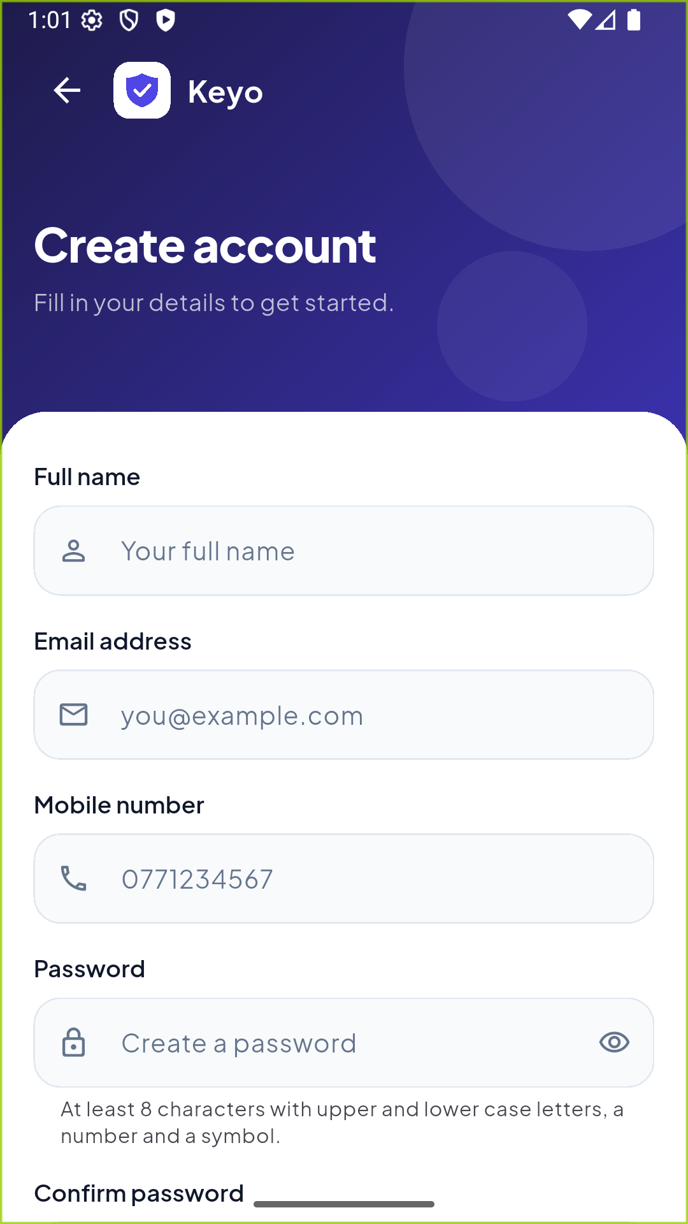  Register  Five fields with suitable keyboards | 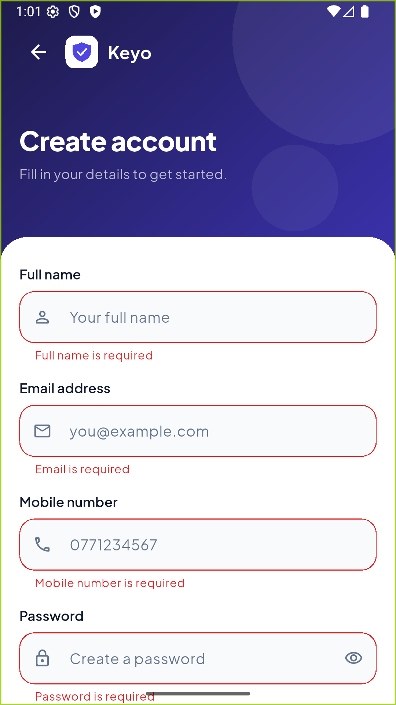  Register validation  Specific message per field | 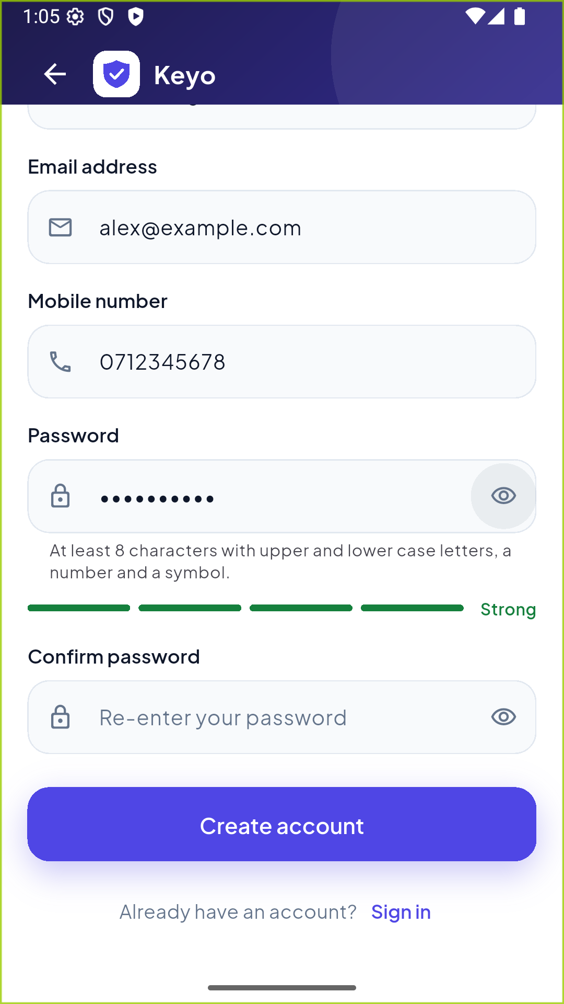  Strength meter  Secret@123 meets all rules
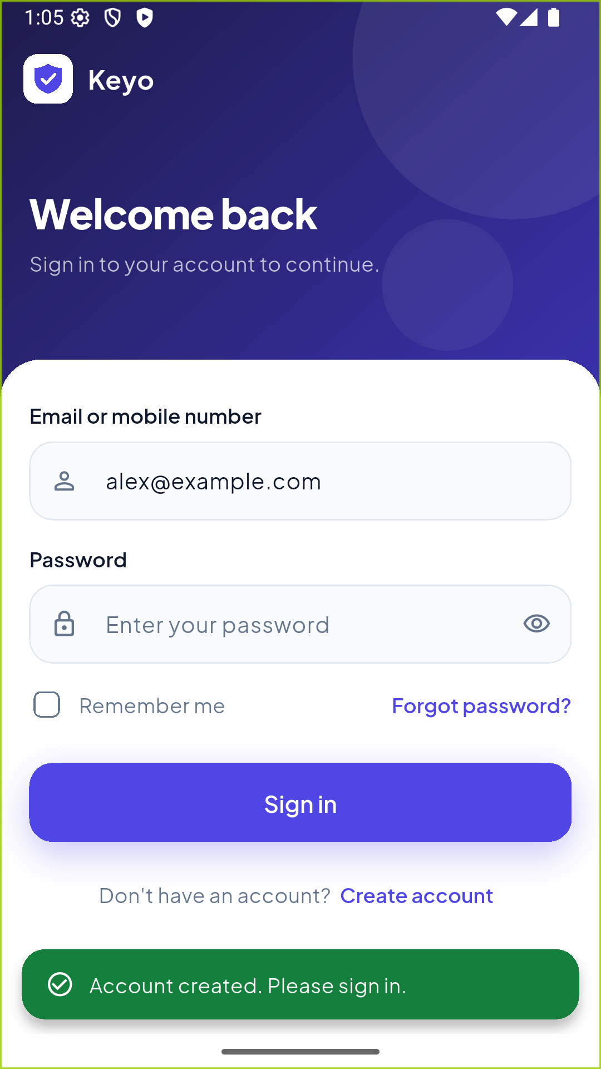  Registered  Back on login, email filled in | 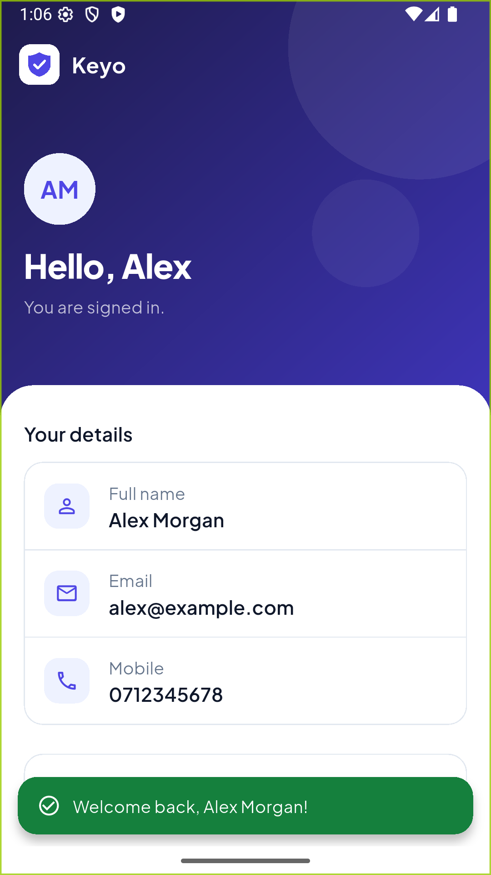  Home  Signed in as Demo User | 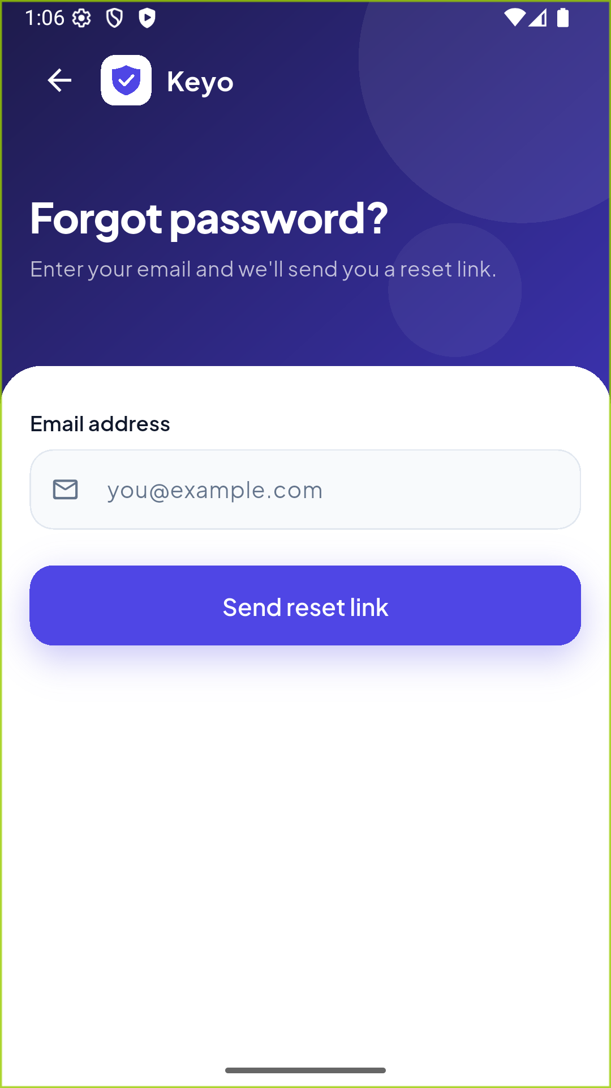  Forgot password  Request a reset link
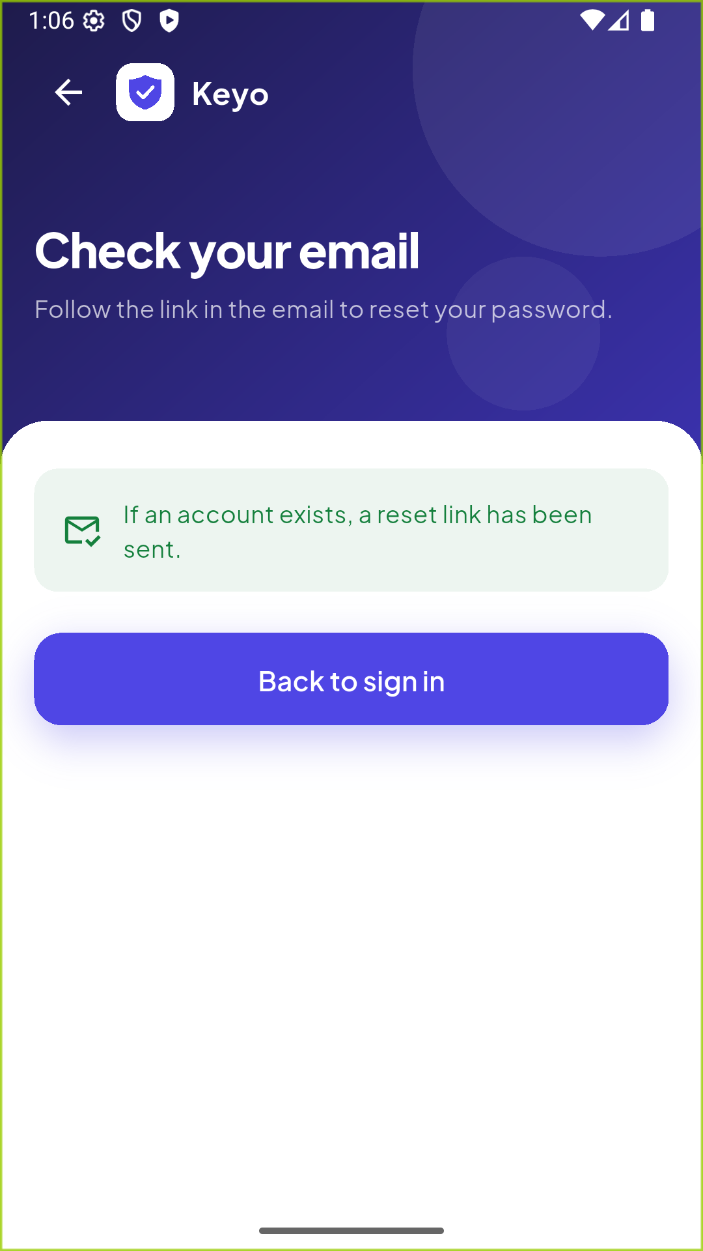
Link sent
Confirmation view

8. Problems I Ran Into
- Crash when returning the email from registration. I first used Navigator.pushNamed<String>(...), but routes defined in a routes: map are MaterialPageRoute<dynamic>, so the typed push crashed. The widget tests caught it. I changed it to an untyped push and check if (result is String) instead.
Future<void> _openRegister() async {
final result = await Navigator.pushNamed(context, AppRoutes.register);
if (result is String) {
_identifierController.text = result;
_passwordController.clear();
}
}

- notifyListeners() after dispose. Pressing Back while a request was running disposed the form provider, and the request then tried to notify it. Fixed with the _isDisposed check in FormProvider.
- Custom font missing on buttons. Setting a button textStyle in the theme replaces the theme text style, so the buttons fell back to the default font. I had to set the font family again in each button theme.
- Android build failure. One of the NDK versions installed on my machine was incomplete, so I pinned the NDK version in android/app/build.gradle.kts.

