[Date]

Ms.AMML Alahakoon

[Company name]

[Company address]

Pandora Green Spot

POINT OF SALES SYSTEM

# Introduction

This is a Point of Sales System (POS) which is built for Pandora Green Spot Juice Bar. There are two users for this Point of Sales System where one user has administrative privilege and other user is a normal user who only can sell the products. The user who has the administrative privilege can add new users to the POS, add new items to the system, delete items from the system, database resetting, can see all the bills since the day that POS had installed in the computer etc. which means this user have the full access to thus Point of Sales System.

In this Point of Sales System there are 5 User Interfaces,

* Login Page
* Main Page
* Pay Screen Page
* Add New Product Page
* Reports Page

# Explanation of the User Interfaces

## Login Page

Here is the User Interface for the Login Page. For a registered user, he/she can login to the system with his/her credentials. But if there is a non-registered user who wants to access the system, he/she can to login as a guest or contact the administrator for register into the system. When login as a guest, he/she can only have the privilege to access the new sales page.

This includes,

1. Place to enter the Username
2. Place to enter the password
3. Button to login into the system
4. Button to cancel the login (closes the whole application)
5. Button to the guest login

## Main Page

Here is the User Interface for the Main Page. This page is for generation a new bill.

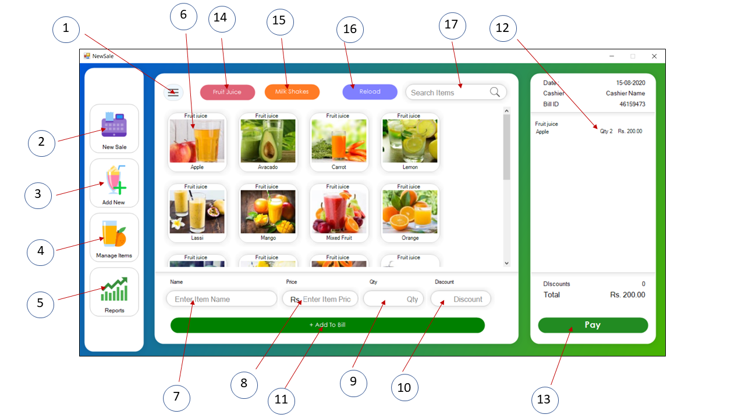

The Main Page includes,

1. Hamburger Menu
2. New Sales
3. Add New
4. Manage Items
5. Report {this includes:

* today’s sales
* weekly sales
* monthly sales
* yearly sales
* revenue
* top sales}

1. Item View
2. Name Of the selected product
3. Price Of the selected product
4. Quantity of the selected product
5. Discount for the selected product
6. Adding the selected item/items to the bill
7. Displaying the selected item’s name, quantity, and the price
8. Pay Button
9. Button to find the fruit juice
10. Button to find the Milk Shake
11. Reload button
12. Search Items

In the Main UI in the left-hand side you can find the navigation bar, which includes navigation for the New Sale page, Add New Item page, Manage Items page and the Report page. And in the middle, you can find buttons for some specific tasks buttons, loading page, place for searching the existing items,

## Pay Screen Page

This is the User Interface for the Pay Screen.

The Pay Screen page includes,

1. Place to display the Total Price
2. Place to display the Cash which Customer has provided
3. Place to display the Balance
4. Complete Button for completing the payment

## Add New Product Page

This is the page for adding a new product to the system.

The Add New Product Page includes,

1. Product Name
2. Product Category
3. Price of the product
4. Place for displaying the selected image for the new product
5. Button for selecting the picture for the new item
6. Button for removing the picture which selected
7. Cancel button for canceling for adding the new product
8. Save button for saving the new product which we newly added

## Reports Page

Below is the User Interface of the Reports Page. In the Reports page you can find the Interfaces for displaying the Sales of the date, weekly sales, monthly sales, yearly sales, revenue, and top selling items.

The Reports Page includes,

1. Today’s Sales Interface
2. Weekly Sales Interface
3. Monthly Sales Interface
4. Yearly Sales Interface
5. Revenue Interface
6. Top Selling Items Interface

## Work