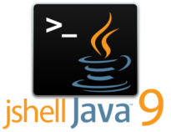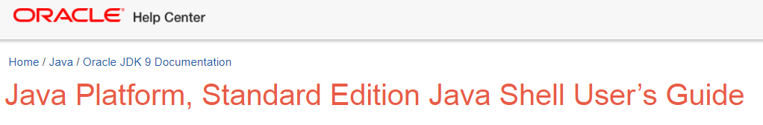----------

-- JShell

----------

The Java Shell tool (JShell) is an interactive tool for learning the Java programming language and prototyping Java code. It was first introduced in the JDK 9 (tracked by JEP 222). JShell is a Read-Evaluate-Print Loop (REPL), which evaluates declarations, statements, and expressions as they are entered and immediately shows the results.

The tool is run from the command line.

Using JShell, you can enter program elements one at a time, immediately see the result, and make adjustments as needed.

Java program development typically involves the following process:

1. Write a complete program.

2. Compile it and fix any errors.

3. Run the program.

4. Figure out what is wrong with it.

5. Edit it.

6. Repeat the process.

**JShell** helps you try out code and easily explore options as you develop your program.

You can test individual statements, try out different variations of a method, and experiment with unfamiliar APIs within the JShell session. JShell doesn’t replace an IDE.

As you develop your program, paste code into JShell to try it out, and then paste working code from JShell into your program editor or IDE.

Useful links:

1. <https://docs.oracle.com/javase/9/jshell/introduction-jshell.htm#JSHEL-GUID-630F27C8-1195-4989-9F6B-2C51D46F52C8>
2. <https://www.infoq.com/articles/jshell-java-repl/>



Snippet: 