**Pascal Mangi**

**PJM 530**

**Prof. Wiseline**

**Fall 2015**

**Using Microsoft Project do the following project schedule and then answer the questions that follow**

* Create a project for developing a website with the following phases
  + Requirements
  + Analysis
  + Development
  + Testing
* Onboard your team
  + Messi (BA) Rate 100 $/hr
  + Rocky (Dev) Rate 125 $/hr + Overtime rate 150$/hr
  + Kate (QA) Rate 80 $/hr
* Create two tasks under each phase and assign resources appropriately
  + For requirements
    - BRD Authoring (Messi – 100%) – 2 weeks
    - BRD Review (Messi – 50%, Rocky 50%) – 3 days
  + Analysis
    - FSD authoring (Messi – 100%) – 2 weeks
    - FSD Review (Messi – 50%, Rocky 50%) – 5 days
  + Development
    - Developing the website (Rocky 100%, Messi 25%) – 5 weeks
    - Unit Testing (Rocky 100%, Messi 25%) – 2 weeks
  + Testing
    - Test case authoring (Kate 100%) – 1 week
    - Test case execution (Kate 75%, Messi 25%, Rocky 75%) – 4 weeks
* Dependencies
  + BRD Review can start half way when Authoring is done
  + FSD Authoring can start in paralles to BRD review
  + Development has to start after analysis is completed
  + Test case authoring can start after BRD review is completed
  + Test case execution has to start after unit testing is completed

Demonstrate the following

1. Develop the project schedule showing dependencies

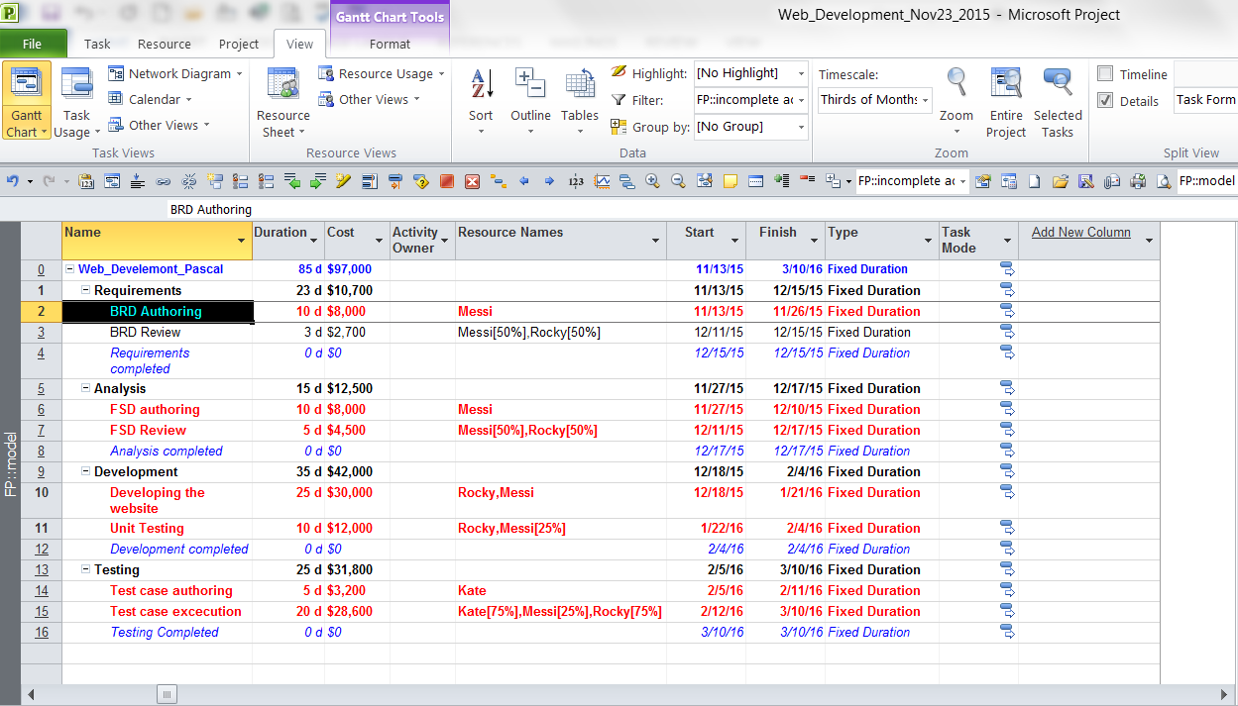

1. Gantt Chart

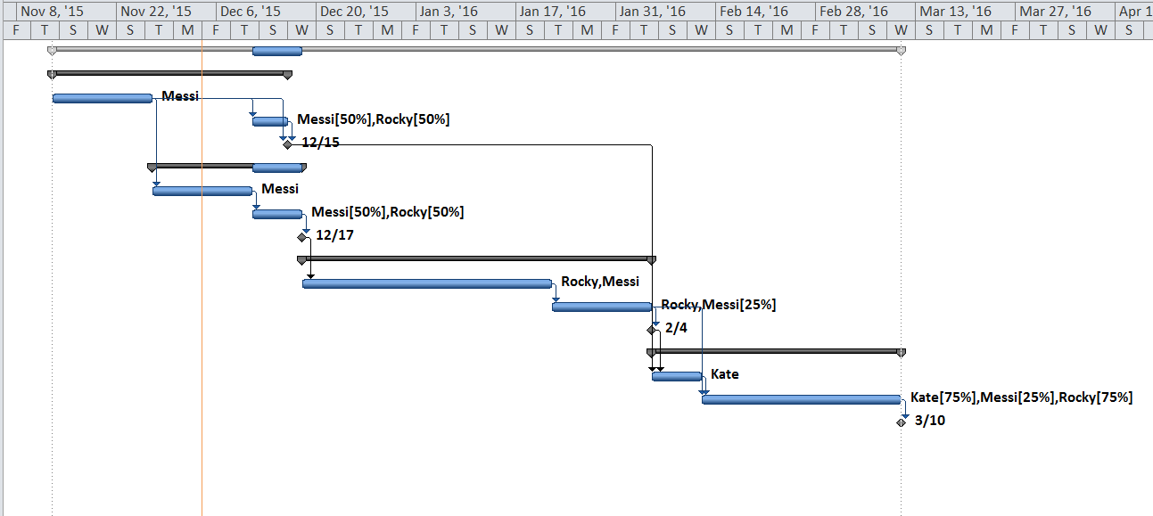

1. Critical path (The longest path of the project and if anything splits on this path the project will therefore get delay)

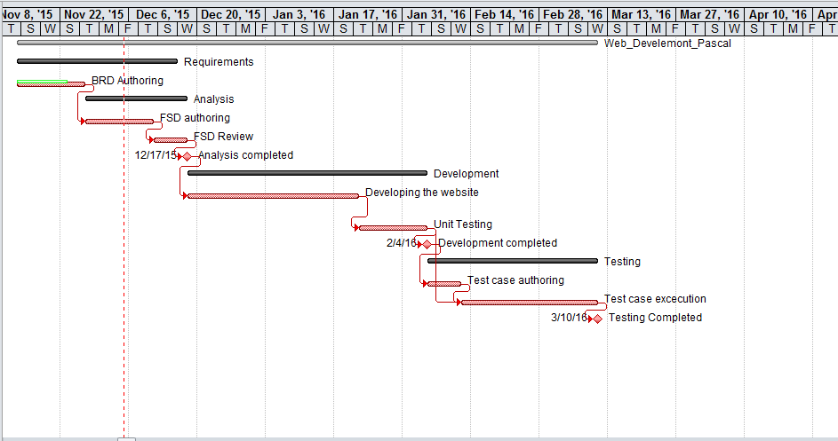

1. Resource Leveling (Resource leveling is a tool used to reduce the workload where there is an indication of employee who are overworked)

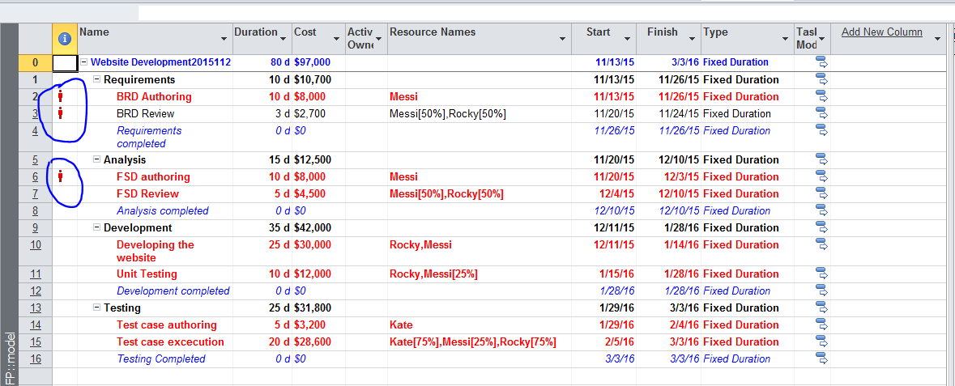

1. Setting project baseline (A baseline is a point of reference.  A baseline is the formal end of project planning and the beginning of project execution and control)

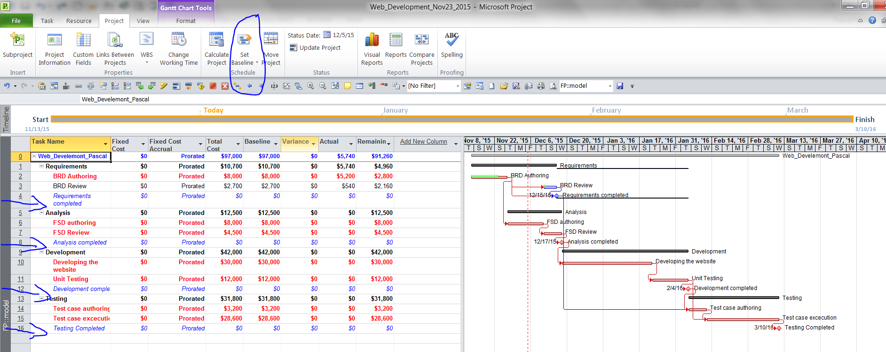

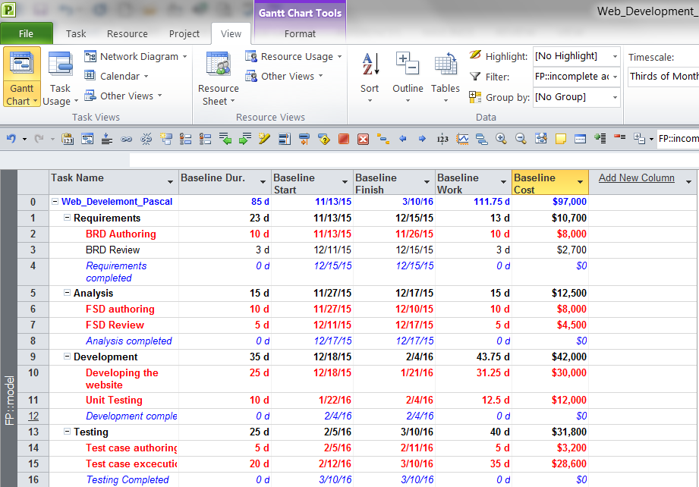

1. Earned value cost indicators (It shows how well the project goes cost wise. CPI value of 1 means the project is performed very well cost wise. A CPI value of less than 1 mean that the project is not going well cost wise)

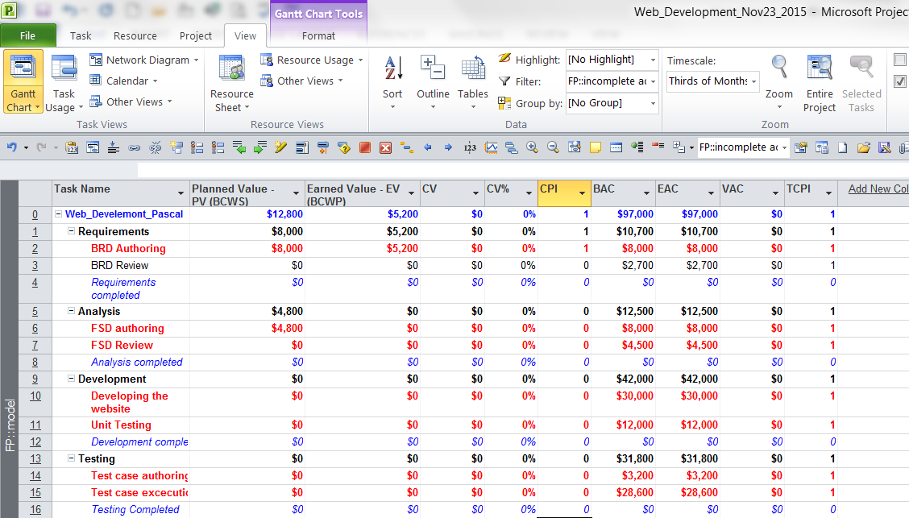

1. Earned value schedule indicators (It shows how well the project goes performance wise. A value of 1 means the project is being well-executed. A value of less than 1 means that the project is not doing well)

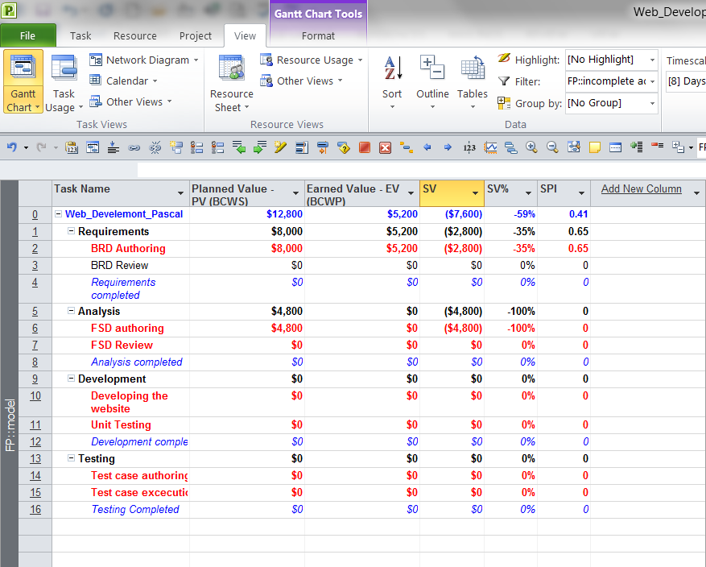

1. Showing slack in the Gantt chart

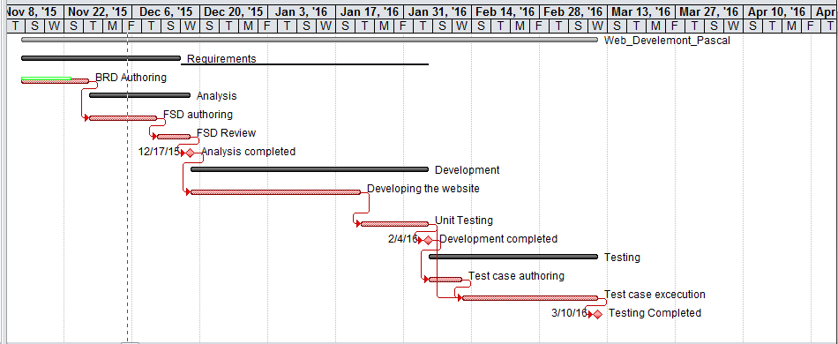

1. Add a milestone (Milestones are the dates with the diamond sign that I circled in bleu. A milestone is an indication of a good progress of the project).

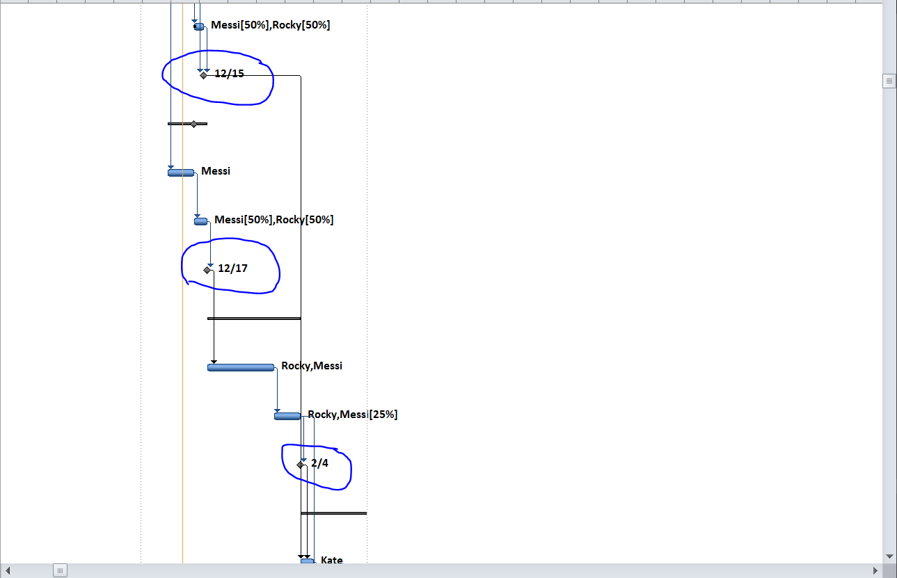

1. Demonstrate a custom report to show resource usage (optional)
2. Timeline to copy into a presentation

Start  
11/13/15

Finish  
3/10/16

January

February

March

1. Calculate Budget (Budget at completion (BAC) is the total anticipated and budgeted spending for the project based on the project estimates and assumptions. The Estimate at Completion (EAC) gives you the forecasted value of the project when it is completed. It tells you how much you may have to spend to complete the project. In other words, you can say that it is the actual amount of money that the project will cost you at the end)

