***HMMer tool***

First the multiple sequences of myoglobin downloaded from the NCBI homologene. Then the sequence txt file is uploaded into the BIN network. The multiple sequence alignment (msa) is generated with clustalO at the same network with the command:



Next a HMMer profile is built with the HMM tool hmmbuild. This tool requires an output <name>.hmm and the msa file, as shown in the next command:



This will generate a hmm profile which can be used for a hmmsearch. The myoglobin.hmm file is downloaded from the BIN network and is uploaded in the HMM search tool of the EBI website. Which gives the following output:

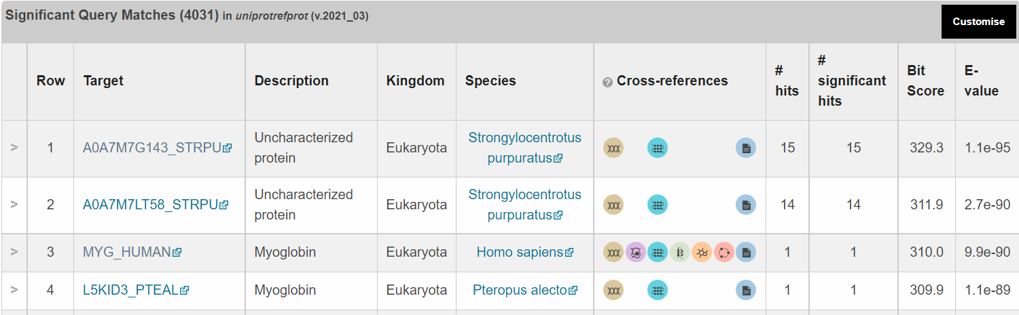

From the standard HMM profile, 4031 significant matches are found. The top 3 matches are used to improve the model. The fasta sequences of these matches are added to the homologene file. Then next a new msa is created:



And a new HMMprofile is made:



With this new profile, at the command line a hmmsearch can be done against a fasta file containg a single protein sequence. The used sequence is retrieved for the msa and three SNPs are introduced. The SNPs on the human myoglobin are based on deleterious entries in the dbSNP/clinvar database.

SNP1 = <https://www.ncbi.nlm.nih.gov/snp/rs1601842249?horizontal_tab=true#variant_details>

SNP2 = <https://www.ncbi.nlm.nih.gov/clinvar/variation/1060608/>

SNP3 = <https://www.ncbi.nlm.nih.gov/clinvar/variation/360269/>

The fasta file is handwritten and SNP are manually implemented.

Hhmsearch against fasta:



Outcome:

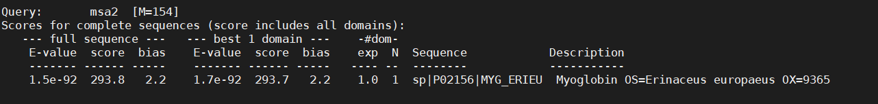

As you can see the score is not bad, but certainly affected.