RISULTATO FINALE JS CODE

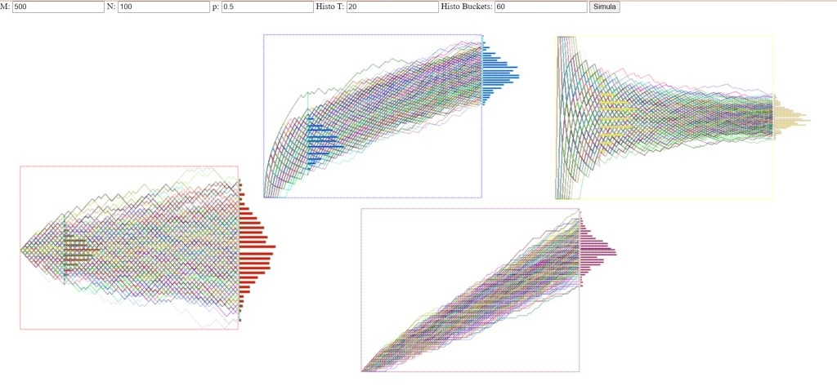

Discussion point:

Is what you see what you expected? What about the averages of the distributions and the shapes of the histograms:

do you see regularities, differences and can you attempt to explain what you see or guessing what are

the "theoretical" limit distribution, when as N increases, and you can make the distribution simulation "more detailed" by increasing M?

As the number of systems (M) and attacks (N) increases in the simulation, we expect certain outcomes:

Expectations from Simulations:

With a large number of systems (M) and a constant penetration probability (p), we anticipate seeing a distribution of security scores centered around a certain value. Fluctuations due to penetration probability should even out with a large number of systems, showing a tendency towards the expected average security score.

Mean of Distributions:

Increasing M should make the average security score approach the expected value, which is given by the penetration probability (p). In other words, as the number of systems increases, we expect the average scores to converge to p.

Shape of Distributions and Differences:

With an increase in N (the number of attacks), the distribution of scores might become more symmetric and Gaussian around the mean. This phenomenon is known as the central limit theorem, stating that the sum of a large number of independent random variables tends to a normal distribution. So, as N increases, we expect the score distributions to be more regular and Gaussian.

Theoretical Limit as N Increases and Detailed Simulation with M:

As N increases, the score distribution is expected to be more concentrated around the expected mean. Furthermore, by increasing M (simulating a larger number of systems), we can get a more accurate representation of random fluctuations in scores. With a large M, simulations should get closer to the theoretical result predicted by the penetration probability p.

In summary, as both M and N increase, we anticipate the security score distributions to become more regular, Gaussian, and converge towards the expected value p. This aligns with the central limit theorem and statistical principles regarding the behavior of averages in large samples.