**Homework 9 (2 weeks from 16/11)**  
  
**Exercise**  
  
Consider a scheme similar to Homework 3  
  
First of all realize that the general scheme that you used so far (random walk and also Poisson process, etc.), can, more in general,  
be used for any stochastic differential equations SDE (see, for instance, Euler–Maruyama method https://en.wikipedia.org/wiki/Euler%E2%80%93Maruyama_method).  
  
In other words, with minor additions to your program you can now generalize this tool to simulate almost any stochastic  
differential equations of interest for many applications  
  
Create a **web only** version where you allow the user to explore (selectable by user) any useful stochastic process.  
  
Do a research on the web and include any SDE that you think its interesting. Some examples of popular processes:  
  
Arithmetic Brownian  
Geometric Brownian (Black–Scholes)  
Ornstein–Uhlenbeck (mean-reverting)  
Vasicek  
Hull–White  
Cox–Ingersoll–Ross  
Black–Karasinski  
Heston  
Chen model  
[... any other interesting ...]

I show different results based on different choices of variables…

**ARITHMETIC BROWNIAN**

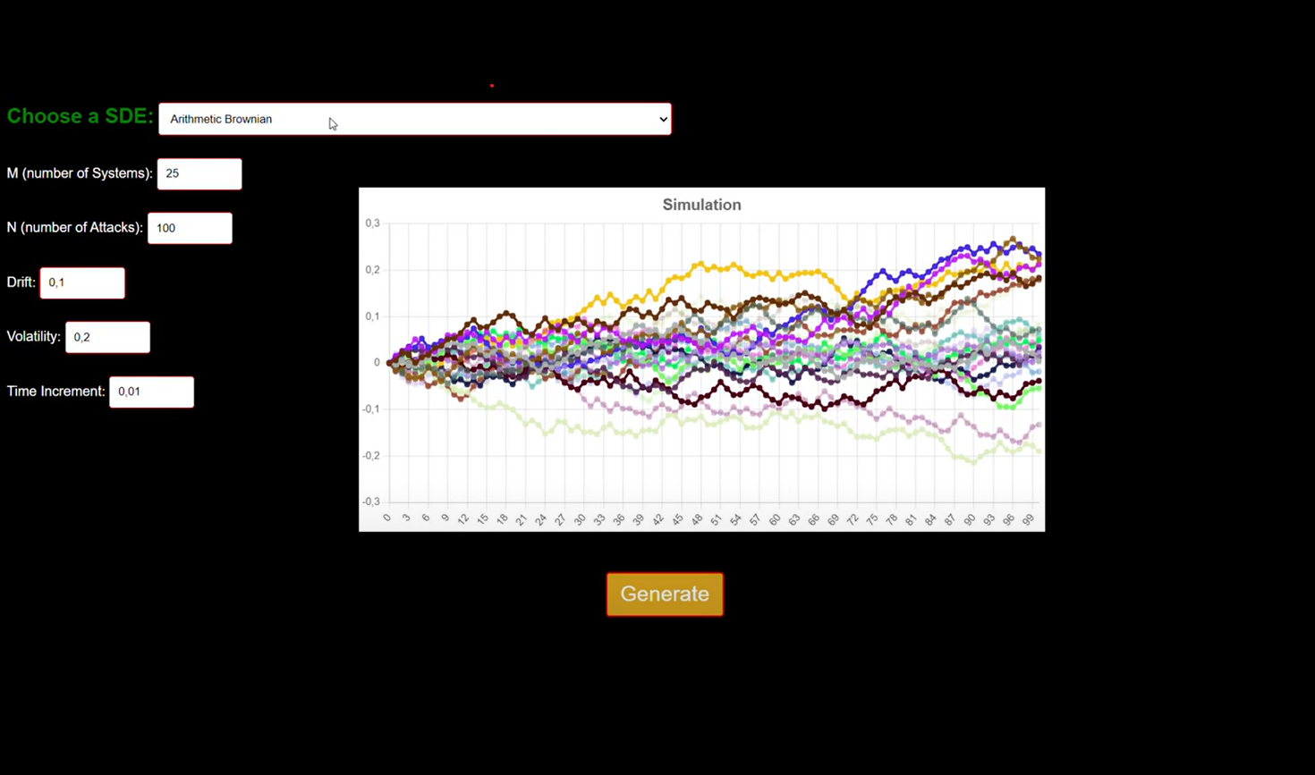

**GEOMETRIC BROWNIAN (BLACK-SCHOLES)**

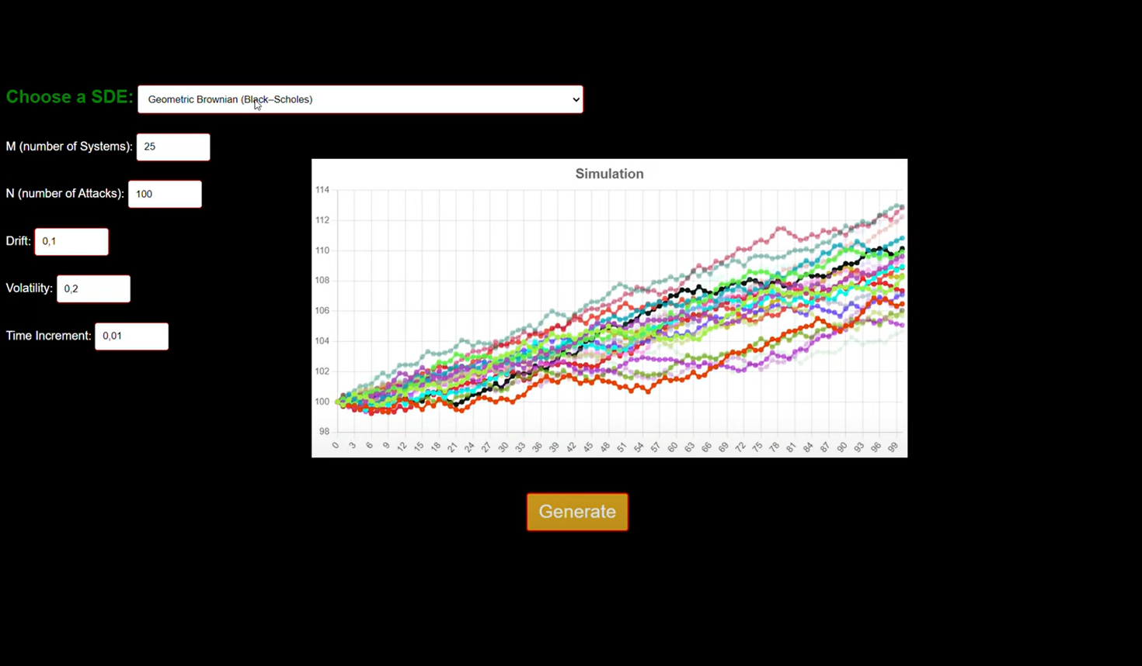

**VESICEK**

