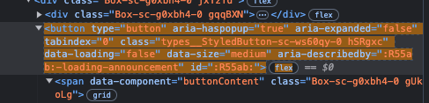

**CSS Locator**#\:R55ab\:

**xPath Locator**

//*[@id=":R55ab:"]





**CSS Locator**

body > div.logged-in.env-production.page-responsive > div.position-relative.js-header-wrapper > header > div.AppHeader-globalBar.pb-2.js-global-bar > div.AppHeader-globalBar-start > deferred-side-panel

**xPath Locator**

/html/body/div[1]/div[1]/header/div[1]/div[1]/deferred-side-panel

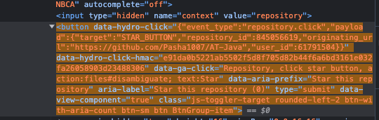

**CSS Locator**

#repository-details-container > ul > li:nth-child(4) > div > div.unstarred.BtnGroup.ml-0.flex-1 > form > button

**xPath Locator**

//*[@id="repository-details-container"]/ul/li[4]/div/div[2]/form/button