**O.O.Gonchar1, I.M. Goncharenko1,2 (Times New Roman, Bold, 10 pt, centered)**

TITLE IN CAPITAL LETTERS (TIMES NEW ROMAN, BOLD, 10 pt, CENTERED, ДО 12 СЛІВ)

*1 S.P. Timoshenko Institute of Mechanics of the National Academy of Sciences,*

*P. Nesterov Str., 3, 03057, Kyiv, Ukraine;*

*e-mail: email@inmech.kyiv.ua (Times New Roman, Italic, 10 pt, centered)*

*2 National Technical University of Ukraine "Igor Sikorsky Kyiv Polytechnic Institute",*

*Beresteyskyi Ave. 37, 03056, Kyiv, Ukraine*

The main text should be typed in Times New Roman font, 10 pt, justified alignment, with indentation of the first line of all paragraphs 0.6 cm. The volume of theses - 1-3 full pages, typed with one interval in a text editor. Formulas that are typed in the MathType editor should use the options of this template

 (1)

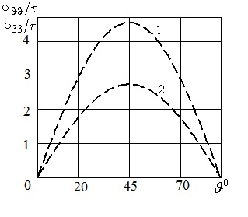 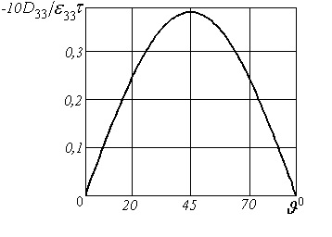

*a b*

*Fig. 1.*

For bitmaps, a resolution of at least 300 dots per inch (dpi) should be used. All explanations to the figures should be included in the text.

KEYWORDS: keywords. (up to 2 lines, Times New Roman, 8,5 pt)

Bibliography should be included at the end alpabetically (Times New Roman, 8,5 pt). References should be given in text in brackets (e.g., [2, 11 – 13]). Examples are shown below.

1. Guz A.N. For the 100th Anniversary of the S. P. Timoshenko Institute of Mechanics of the National Academy of Sciences of Ukraine (NASU) // Int. Appl. Mech. – 2018. – **54**, N 1. – P. 3 – 33.

2. Guz I.A., Rodger A.A., Guz A.N., Rushchitsky J.J. Predicting the properties of nanocomposites with brush-like reinforcement // Carbon Nano Tubes New Engineering Technologies: Abstracts of the Int. Conf. CNTNET 07, University of Cambridge, Trinity College, United Kingdom. (Cambridge, 10-12 September 2007). – Cambridge, 2007. – P.29.

3. Timoshenko S.P., Gere J.M. Mechanics of Materials. – New York: Van Nostrand Reinhold Company, 1972. – 670 p.

**O.O.Gonchar1, I.M. Goncharenko1,2 (Times New Roman, Bold, 9 pt, centered)**

**TITLE IN CAPITAL LETTERS (TIMES NEW ROMAN, BOLD, 9 PT, CENTERED)**

*1 S.P. Timoshenko Institute of Mechanics of the National Academy of Sciences,*

*P. Nesterov Str., 3, 03057, Kyiv, Ukraine;*

*e-mail: email@inmech.kyiv.ua (Times New Roman, Italic, 9 pt, centered)*

*2 National Technical University of Ukraine "Igor Sikorsky Kyiv Polytechnic Institute",*

*Beresteyskyi Ave. 37, 03056, Kyiv, Ukraine*

The text of English annotation should be typed in Times New Roman, 9 pt, with indentation 0.6 cm. The annotation should not exceed 5 lines.