Лабораторна робота №1

Сортування бульбашкою

Мета: Вивчити та застосувати на практиці алгоритм сортування бульбашкою, ознайомитись з нюансами цього методу

Постановка задачі:

- Масив записів, структура якого: кінцева станція, час прибуття, впорядкувати по
направленню.

Блок-схема до алгоритму:

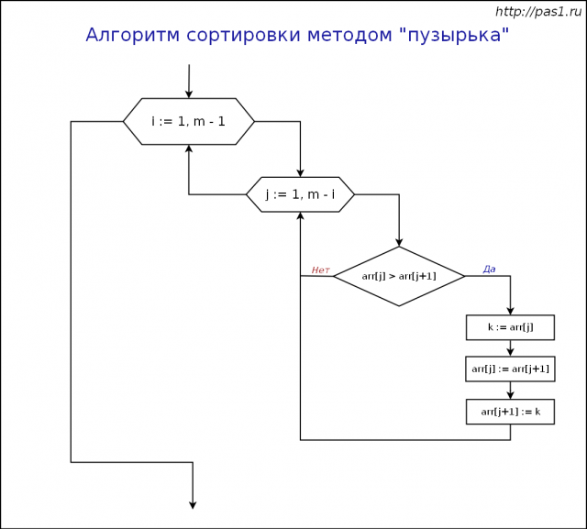

Код:
objectSpawner.py:
### DATA SPAWNER ###
import random
from enum import Enum

###########################################

class Data:
name = "not set"
subject = "not set"
mark = -1

d_Surnames = ("Kolesnyk", "Momot", "Yamborko", "Pelihovskiy", "Savic", "Samoyluk")
d_Names = ("Petya", "Pasha", "Vasya", "Dima", "Egor", "Taras", "Nazar", "Anya", "Dasha", "Nastya", "Katya")
d_Subjects = ("English", "Math", "Programming", "Computer Science", "Physics", "Italian", "Probability Theory", "Literature")

###########################################

print("\n\t!!!***Welcome to obj spawner v -0.1***!!!\n");

try:
ls = []
amt = int(input("What amount of objects: "));
ans = input("You want to spawn " + str(amt) + " objects. \n"
"Every objects by my task has 3 fields: Name, Subject and Mark.\n"
"Do you want to randomly generate objects with all of fields ? (yes/no).. ")

if ans.lower() == "yes":
random.seed()
for i in range(amt):
x = Data()
x.name = d_Surnames[random.randint(0, len(d_Surnames) - 1)] + " " + d_Names[random.randint(0, len(d_Names) - 1)]
x.subject = d_Subjects[random.randint(0, len(d_Subjects) - 1)]
x.mark = random.randint(2, 5)
ls.append(x)

else:
for i in range(amt):
x = Data()
x.name = input("\nEnter name of " + str(i) + " student.. ")
x.subject = input("Enter subject of " + str(i) + " student.. ")
x.mark = input("Enter mark of " + str(i) + " student.. ")
ls.append(x)
print("Data successfully generated")

fileName = str(input("Enter name of the file to finish.. "))
myfile = open("../dataSets/" + str(fileName) + ".txt", "w")
myfile.write(str(amt) + "\n")
for count in ls:
myfile.write(count.name + " | " + count.subject + " | " + str(count.mark) + "\n")

myfile.close()
print("File created. Job done. Now exiting.. See ya. ")
except:
print("Whoooooops.. I think error occured, please restart")

precompile.py:
class Data:
name = "unknown"
subject = "unknown"
mark = -1

ls = []

fileName = input("Enter name of file to set data values.. ")
myfile = open("../dataSets/" + str(fileName) + ".txt", "r")
amt = int(myfile.readline())

for i in range(amt):
temp = Data()
fields = (myfile.readline()).split(" | ")
#print(fields[0] + ", " + fields[1])
temp.name = fields[0] + " " * (17 - len(fields[0]))
temp.subject = fields[1]
temp.mark = int(fields[2])
ls.append(temp)

myfile.close()

def showList(ls):
for i in range(len(ls)):
print("(" + str(i + 1) + ") \t" + str(ls[i].mark) + "\t" + ls[i].name + "\t" + ls[i].subject)
return

bubble_sort.py:
from precompile import *

print("*************** BUBBLE SORT *****************\n\n")

# VARIANT 1
n = 1
while n < len(ls):
for i in range(len(ls) - n):
if ls[i].mark < ls[i + 1].mark:
ls[i], ls[i + 1] = ls[i + 1], ls[i]
n += 1

#VARIANT 2 - sort by 2 name too

n = 1
while n < len(ls):
for i in range(len(ls) - n):
if ls[i].mark < ls[i + 1].mark:
ls[i], ls[i + 1] = ls[i + 1], ls[i]
else:
j = i
while (j < len(ls) and ls[j].mark == ls[j + 1].mark and ls[j].name > ls[j + 1].name):
ls[j], ls[j + 1] = ls[j + 1], ls[j]
j += 1

n += 1
showList(ls)
Результат:

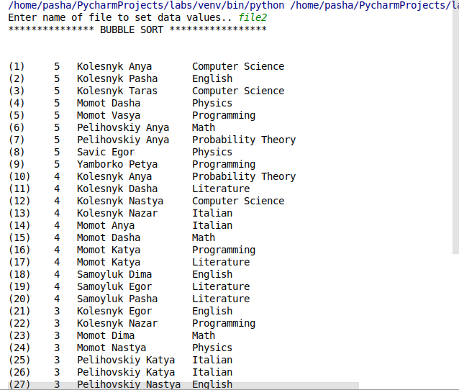

Контрольні питання:

____________________________________________________________________________________________________________________________________________________________________________________________________________________________________________________________________________________________________________________________________________________________________________________________________________________________________________________________________________

Висновок:

На цій лабораторній роботі я навчився працювати з алгоритмом сортування бульбашкою та вивчив його особливості

