ML Classification Project (Task 1)

1. Explanation
This project builds a supervised machine learning classification model to predict whether a breast tumor is malignant or benign based on the Breast Cancer Wisconsin dataset. We evaluated two models: Logistic Regression and Random Forest Classifier. The dataset was split into 80% training data and 20% testing data. We used StandardScaler to normalize the features, which significantly improved the Logistic Regression model's performance.

2. Code Links
The code for this project is contained within this directory. The key files are:
- - Jupyter Notebook: breast_cancer_classification.ipynb
- - Notebook Generator: generate_model_notebook.py
- - Environment Setup: setup.ps1

3. Evaluation Metrics
Metric | Logistic Regression | Random Forest
Accuracy | 98.25% | 95.61%
Precision | 98.61% | 95.89%
Recall | 98.61% | 97.22%
F1 Score | 98.61% | 96.55%
ROC-AUC | 99.54% | 99.37%

4. Screenshots (Visualizations)
ROC Curve:
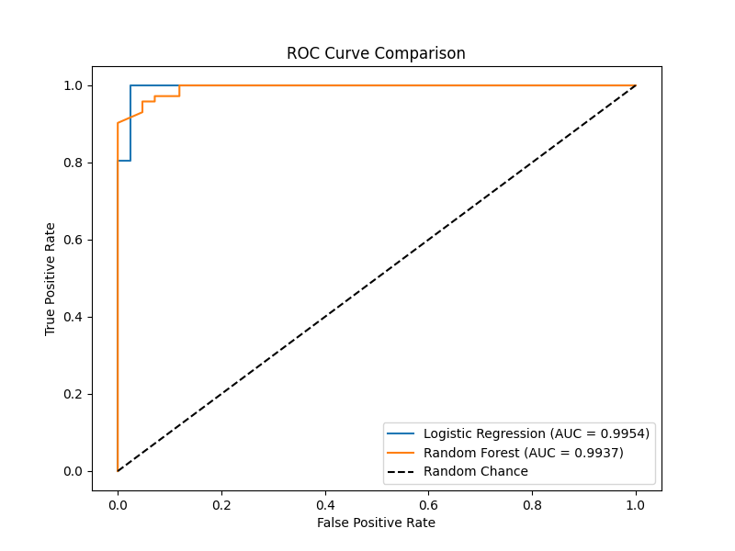
Confusion Matrices:
