Appendix: Key Source Code & Working Prototype
This appendix presents the core implementation excerpts and working prototype screenshots of the MSME Viability Assessment System.

A. Core Source Code Excerpts

A.1 SHAP Explainability Engine
Real-time feature contribution analysis using SHAP TreeExplainer, identifying the top 3 positive and negative factors for each prediction.
File: api/engine.py — SHAP Explainability
def explain(self, app_dict: dict):
X = self._to_array(app_dict)
pred = int(self.primary_model.predict(X)[0])
sv_raw = self.shap_explainer.shap_values(X)

if isinstance(sv_raw, list):
sv = sv_raw[pred][0]
elif isinstance(sv_raw, np.ndarray) and sv_raw.ndim == 3:
sv = sv_raw[0, :, pred]
else:
sv = sv_raw[0]

contributions = {self.feature_names[i]: float(sv[i])
for i in range(len(self.feature_names))}
sorted_feats = sorted(contributions.items(),
key=lambda x: abs(x[1]), reverse=True)
top_pos = [f for f, v in sorted_feats if v > 0][:3]
top_neg = [f for f, v in sorted_feats if v < 0][:3]
return {"predicted_class": pred,
"feature_contributions": contributions,
"top_positive_features": top_pos,
"top_negative_features": top_neg}

A.2 Counterfactual Recommendation Engine
DiCE-inspired deterministic grid-search finding minimum feature changes to upgrade a business to a higher viability class.
File: api/engine.py — Counterfactual Recommendations
FEATURES_TO_VARY = ["Term", "DisbursementGross", "SBA_Appv",
"GrAppv", "CreateJob", "RetainedJob"]

def recommend(self, app_dict, target_class=None):
current_class = int(self.primary_model.predict(
self._to_array(app_dict))[0])
if target_class is None:
target_class = min(current_class + 1, 4)

perturbations = {
"Term": [12, 24, 36, 48, 60, 84, 120, 180, 240],
"CreateJob": list(range(1, 25)),
"DisbursementGross": [0.9, 1.1, 1.2, 1.5, 2.0],
"SBA_Appv": [0.9, 1.1, 1.2, 1.5, 2.0],
}
best_changes, best_dist = [], float("inf")

# Single-feature perturbations first
for feat in FEATURES_TO_VARY:
for delta in perturbations[feat]:
candidate = app_dict.copy()
if feat in ["Term","CreateJob","RetainedJob"]:
candidate[feat] += delta
else:
candidate[feat] *= delta
pred = int(self.primary_model.predict(
self._to_array(candidate))[0])
if pred >= target_class:
dist = abs(candidate[feat] - app_dict[feat])
if dist < best_dist:
best_dist = dist
best_changes = [(feat, app_dict[feat],
candidate[feat])]

return {"current_label": LABEL_NAMES[current_class],
"target_label": LABEL_NAMES[target_class],
"feasible": len(best_changes) > 0,
"changes": best_changes}

A.3 Red-Flag Detection Engine
Rule-based risk detection derived from 899,164 historical loan records.
File: api/optimizer.py — Red-Flag Detection
def detect_red_flags(features, similar_data=None):
flags = []
# New business + large loan (28% default vs 15%)
if (features.get("NewExist") == 2 and
features.get("DisbursementGross", 0) > 100000):
flags.append({"severity": "high",
"flag": "High-value loan for new business",
"explanation": "28% default vs 15% established.",
"suggestion": "Start smaller, scale after 2-3 yrs."})

# Heavy EMI burden
term = features.get("Term", 84)
amount = features.get("DisbursementGross", 0)
if term > 0 and amount/term > 5000 and term < 60:
flags.append({"severity": "high",
"flag": "Heavy monthly EMI burden",
"suggestion": f"Extend to {max(84,term*2)} months."})

# Low guarantee coverage (<50%)
sba = features.get("SBA_Appv", 0)
gr = features.get("GrAppv", 1)
if gr > 0 and sba/gr < 0.5:
flags.append({"severity": "medium",
"flag": f"Low guarantee ({sba/gr*100:.0f}%)",
"suggestion": "Apply for CGTMSE (up to 85%)."})
return sorted(flags, key=lambda x:
{"high":0,"medium":1,"low":2}[x["severity"]])

A.4 Loan Structure Optimizer
Grid-search across 12 term lengths and 10 amount multipliers to find the safest loan configuration via the ML model.
File: api/optimizer.py — Loan Structure Optimizer
class LoanOptimizer:
def __init__(self, prediction_engine):
self.engine = prediction_engine

def find_optimal_term(self, features):
terms = [12,24,36,48,60,72,84,120,180,240,300,360]
results = []
for term in terms:
test = deepcopy(features)
test["Term"] = term
pred = self.engine.predict(test)
results.append({"term": term,
"class": pred["predicted_label"],
"confidence": pred["confidence"]})
best = max(results, key=lambda x:
(x["class"], x["confidence"]))
return {"recommended_term": best["term"],
"best_class": best["class"]}

def find_max_safe_amount(self, features, target=2):
original = features.get("DisbursementGross", 100000)
for mult in [0.1,0.25,0.5,1.0,1.5,2.0,3.0,5.0]:
test = deepcopy(features)
test["DisbursementGross"] = int(original * mult)
pred = self.engine.predict(test)
if pred["predicted_class"] >= target:
max_safe = int(original * mult)
return {"max_safe_amount": max_safe,
"can_take_more": max_safe > original}

B. Model Training Results & Visualizations
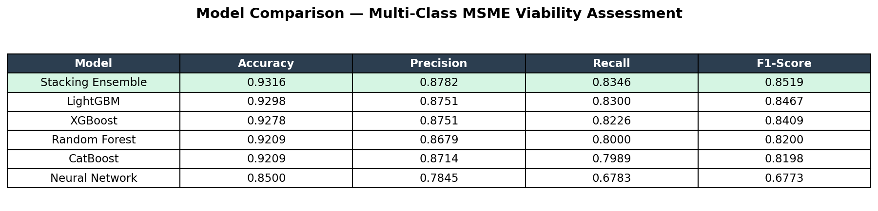
Figure B.1: Comparative performance of all classifiers on the 5-class viability spectrum (test set n=178,385).
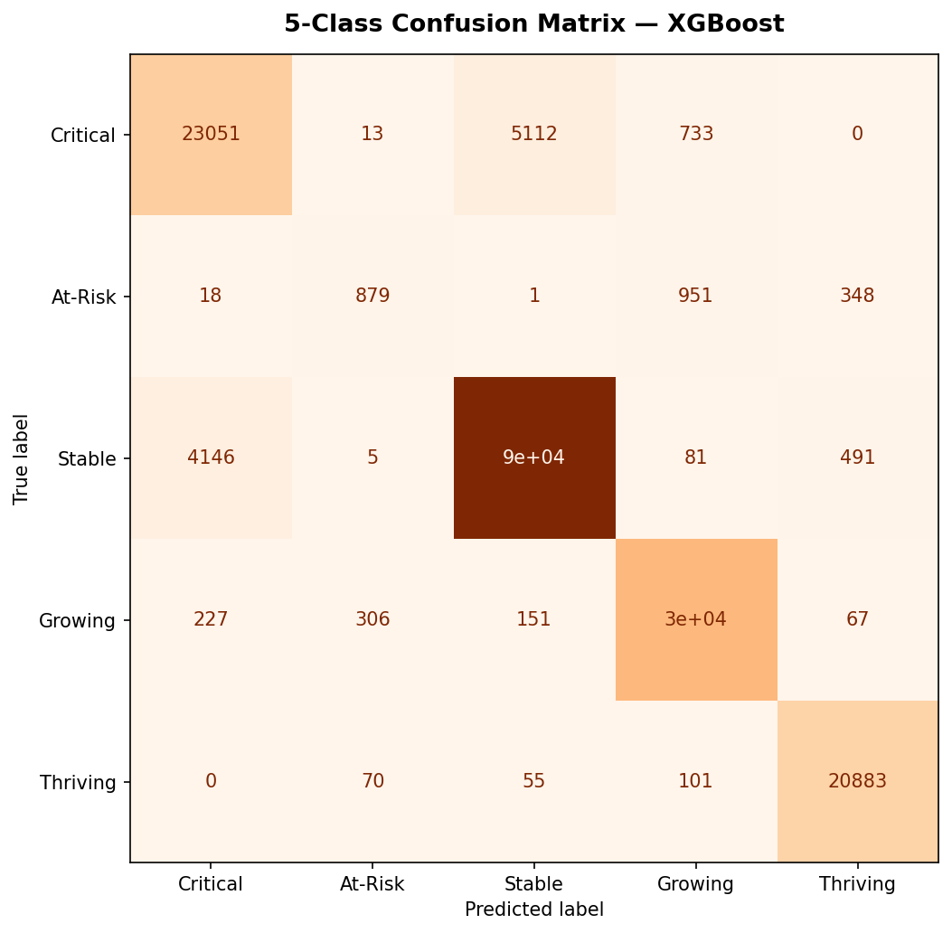
Figure B.2: XGBoost 5-class confusion matrix — 92.78% accuracy.
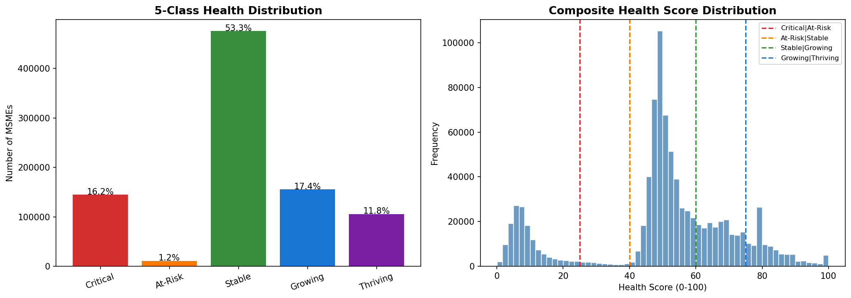
Figure B.3: 5-class health label distribution across 899,164 records.
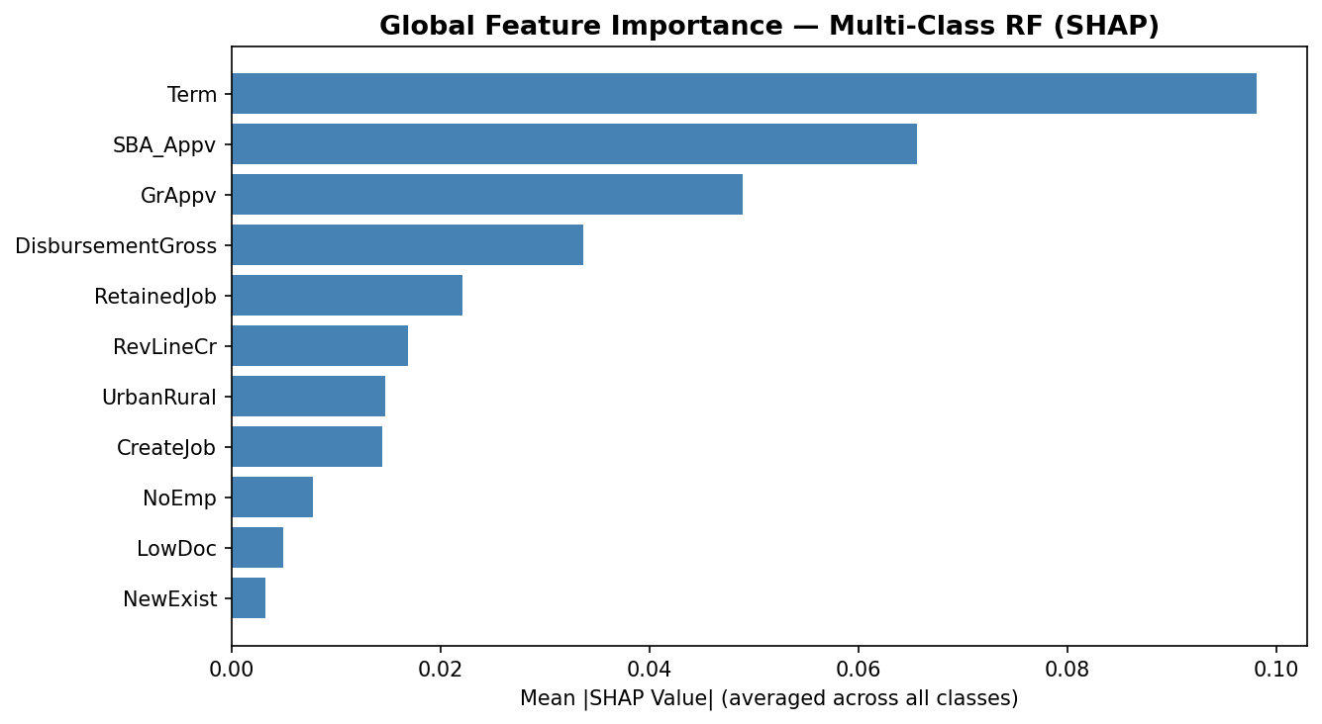
Figure B.4: SHAP global feature importance — Term, DisbursementGross, and SBA_Appv dominate predictions.
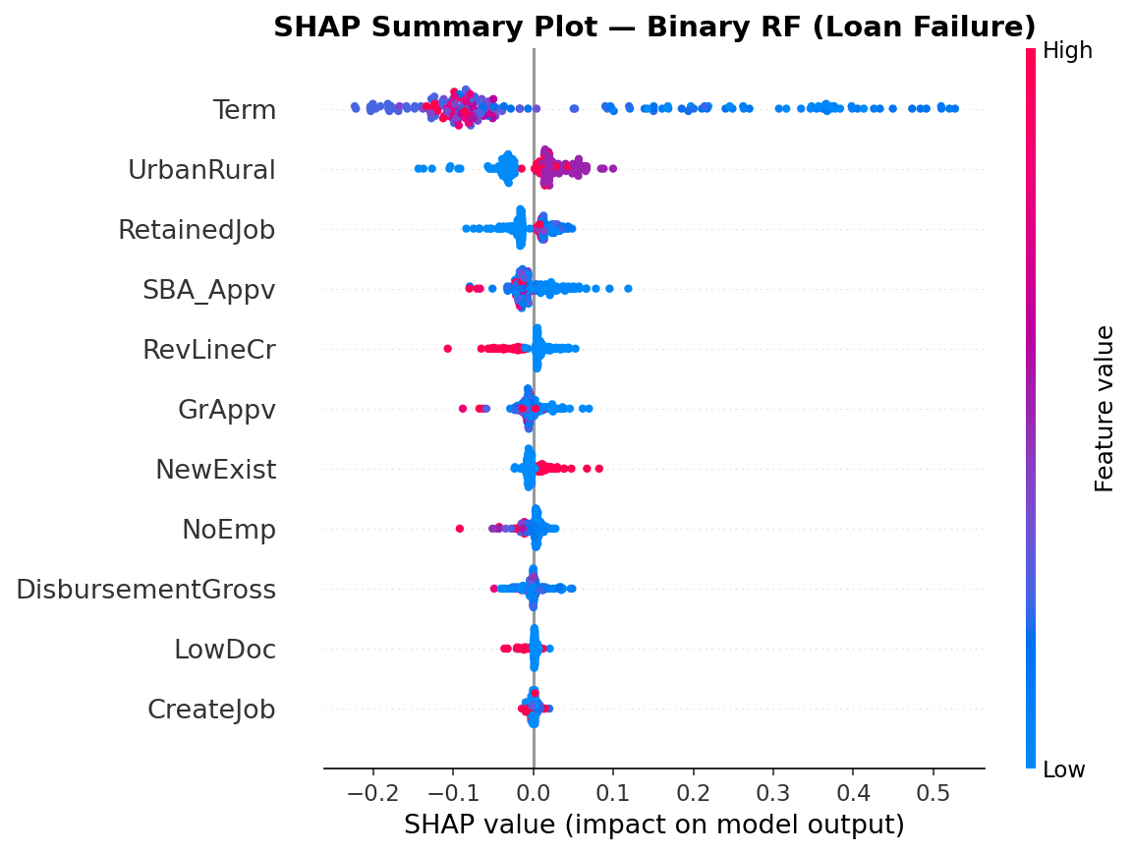
Figure B.5: SHAP beeswarm plot — per-instance feature contributions colored by feature value.

C. Working Prototype Screenshots
The following screenshots demonstrate the complete assessment flow of the deployed MSME Loan Readiness Coach, from parameter input through viability grading, prescriptive recommendations, and government scheme matching.
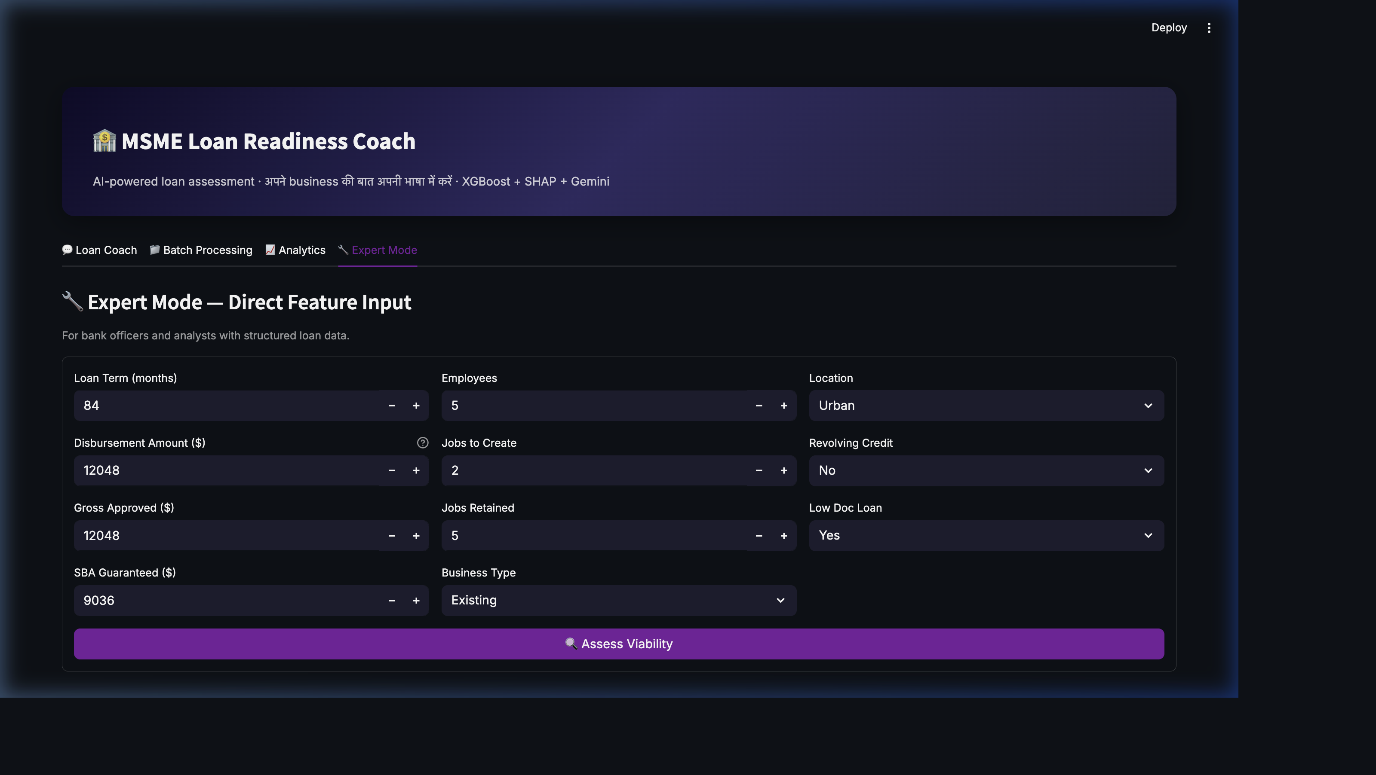
Figure C.1: Expert Mode — loan parameters entered, assessment submitted. Result shows Grade C (Stable) at 99.6% confidence with business radar chart.
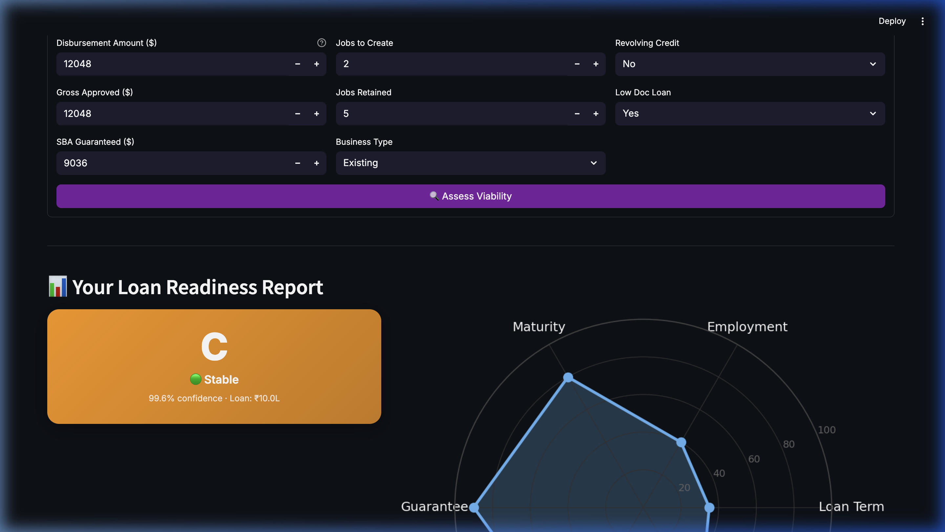
Figure C.2: Viability grade card showing 'C — Stable' with radar chart visualizing the business profile across Maturity, Employment, Loan Term, Documentation, Location, and Guarantee dimensions.
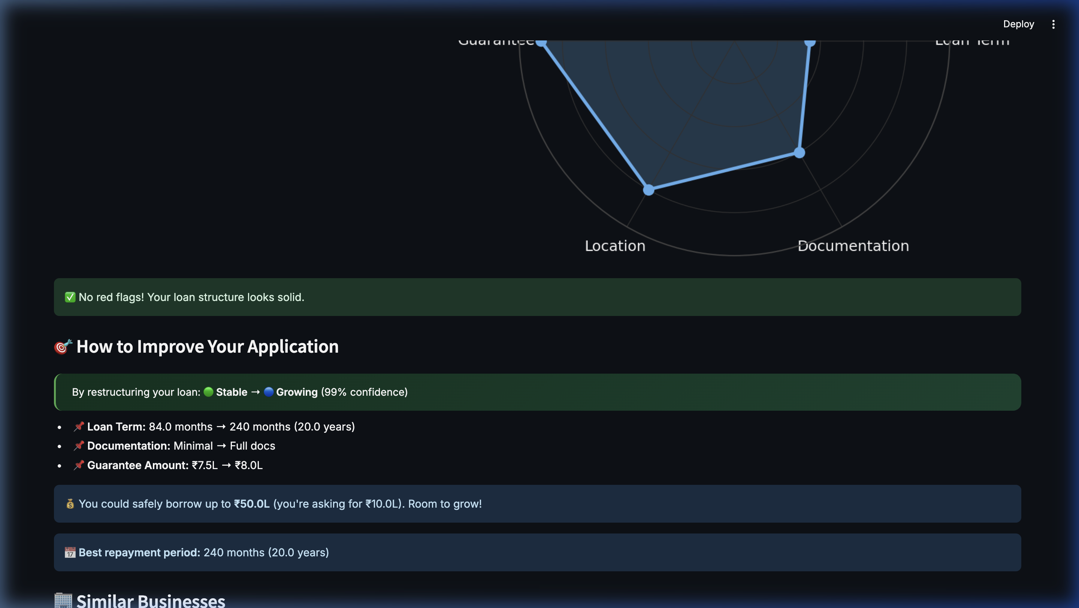
Figure C.3: Prescriptive recommendations — the counterfactual engine suggests extending term from 84 to 240 months, switching to full documentation, and increasing the guarantee amount to upgrade from Stable → Growing (99% confidence).
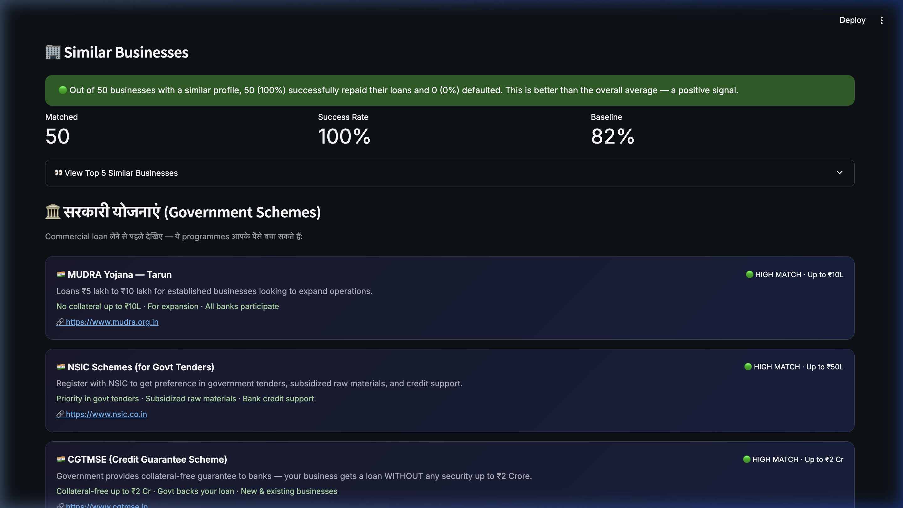
Figure C.4: Peer comparison (50 similar businesses, 100% success rate vs 82% baseline) and auto-matched government schemes — MUDRA Yojana, NSIC, and CGTMSE.
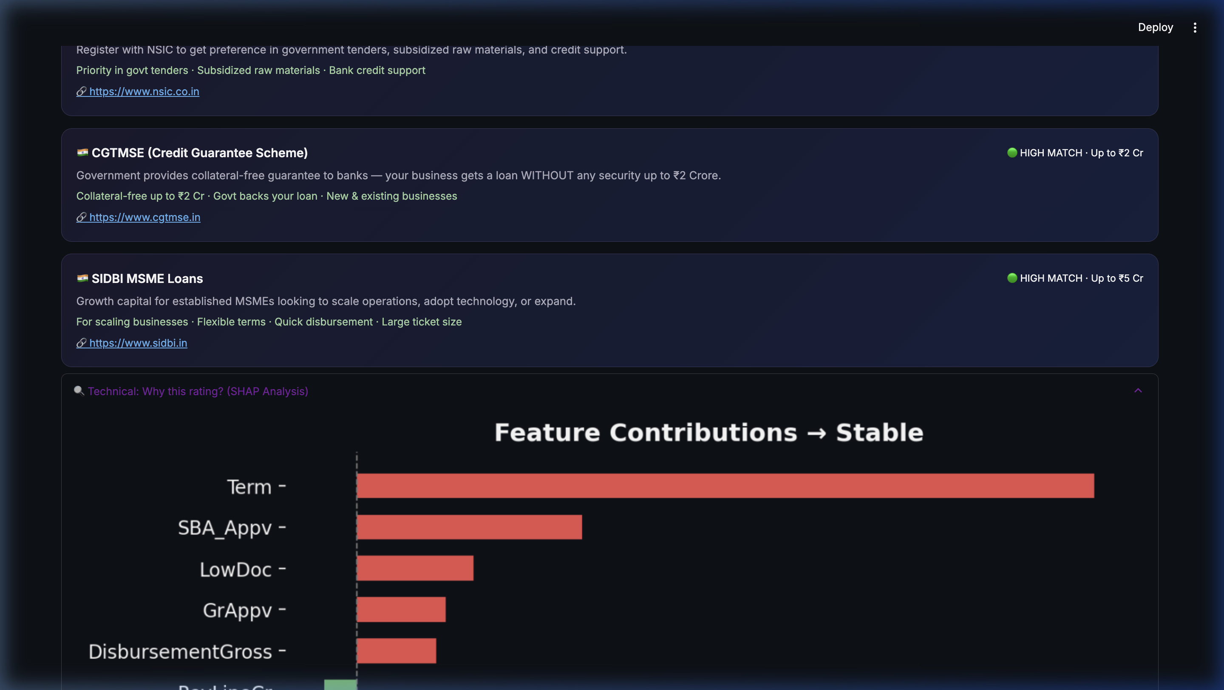
Figure C.5: Real-time SHAP feature contribution chart showing Term and SBA_Appv as the strongest positive contributors to the Stable classification.

Figure C.6: AI Loan Coach — conversational assessment interface with Hindi/English support, voice input capability, and natural language business description.
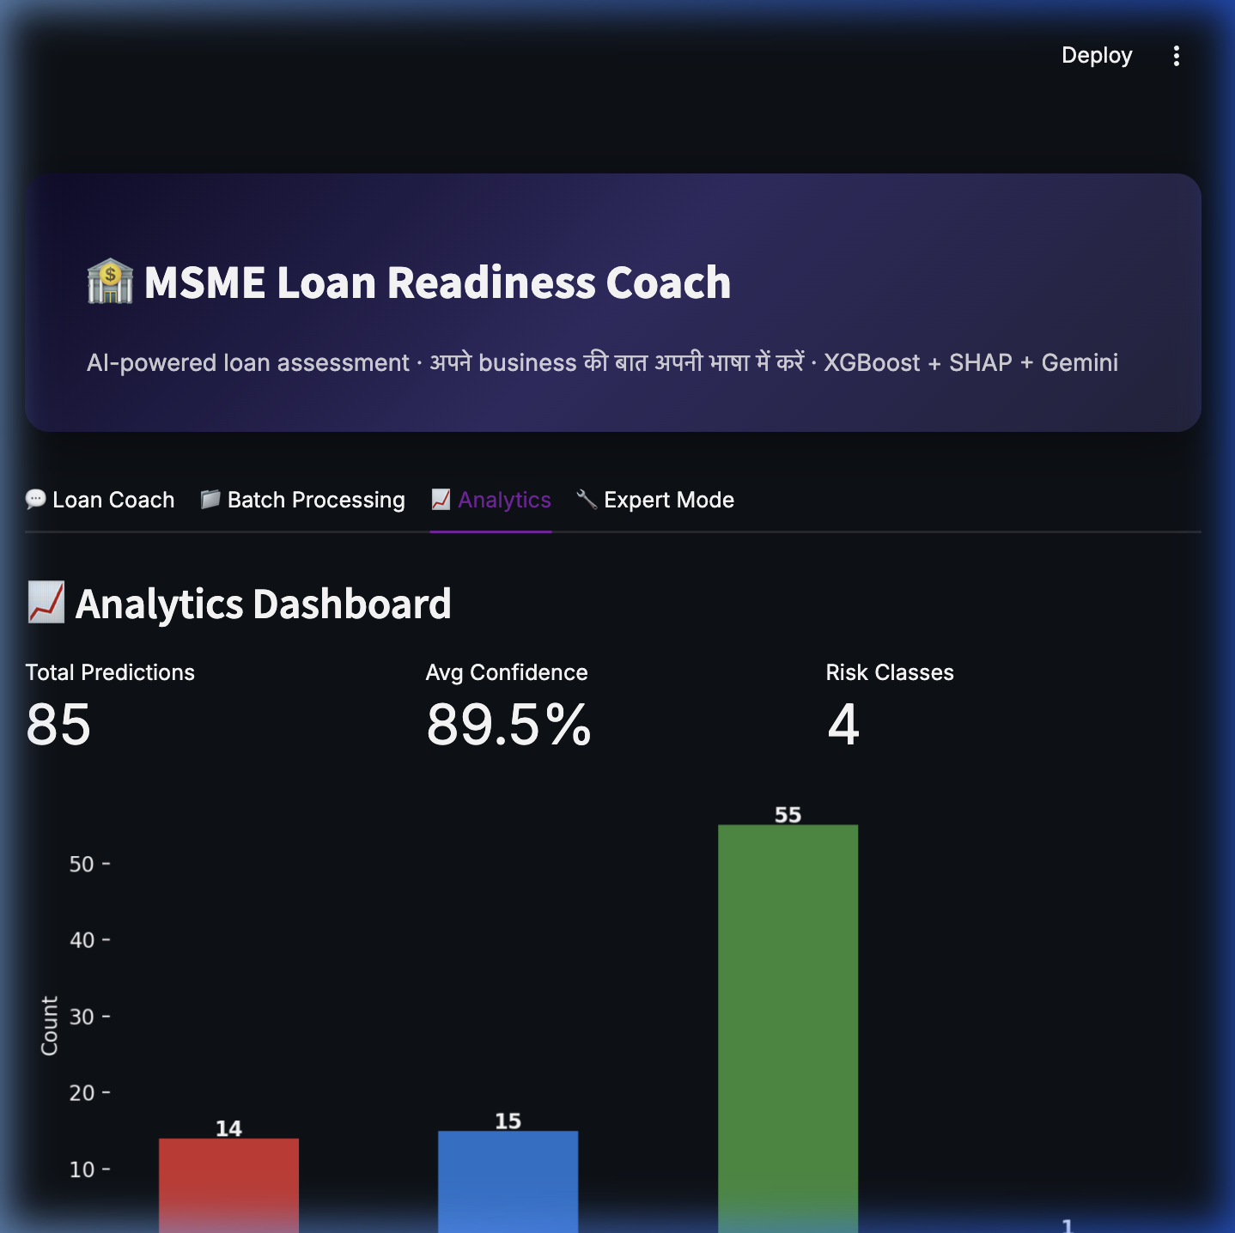
Figure C.7: Analytics Dashboard — 85 predictions logged in SQLite audit trail, 89.5% average confidence, 4 risk classes observed, with distribution histogram.

