**Q1.**

**Code:**

***import javax.swing.*;  
  
public class Q1 {  
 public static void main(String[] args) {  
 JFrame myWindow;  
 myWindow = new JFrame();  
 myWindow.setSize(800, 600);  
 myWindow.setTitle("Welcome To Java");  
 myWindow.setVisible(true);  
 }  
}***

**output:**

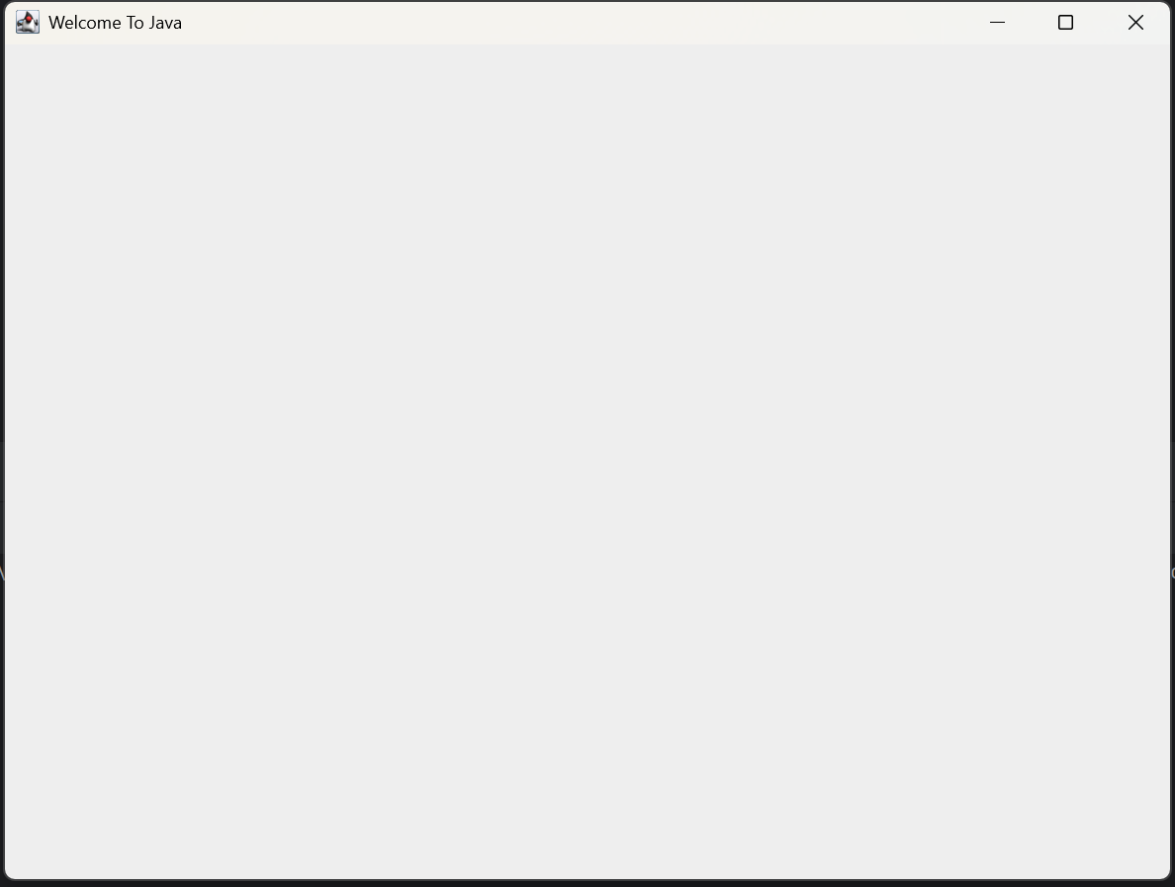

**Q2.**

**Code:**

***import javax.swing.*;  
import java.util.Scanner;  
  
public class Q2{  
 public static void main(String[] args) {  
 Scanner input = new Scanner(System.in);  
 System.out.print("Enter your first name:-");  
 String firstName = input.nextLine();  
  
 System.out.print("Enter your last name:-");  
 String lastName = input.nextLine();  
  
  
 JFrame myWindow;  
 myWindow = new JFrame();  
 myWindow.setSize(800, 600);  
 myWindow.setTitle(firstName + " " + lastName);  
 myWindow.setVisible(true);  
 }  
}***

**output:**

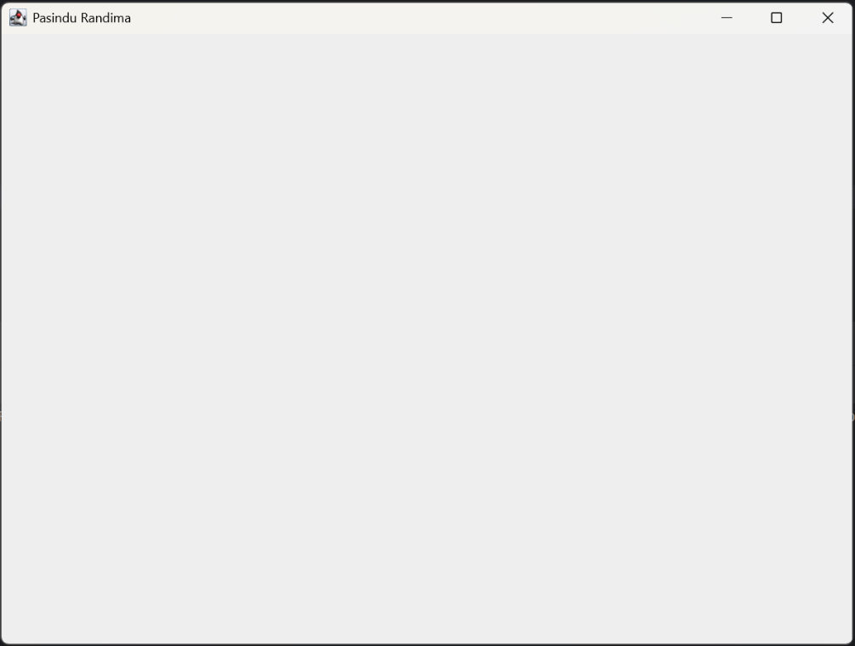

**Q3.**

**Code:**

***import java.util.Scanner;  
  
public class Q3 { public static void main(String[] args) {  
 Scanner input = new Scanner(System.in);  
  
 System.out.print("Enter your first name:-");  
 String firstName = input.nextLine();  
  
 System.out.print("Enter your Middle name:-");  
 String middleName = input.nextLine();  
  
 System.out.print("Enter your last name:-");  
 String lastName = input.nextLine();  
  
 System.out.print(firstName + " " + middleName.charAt(0) + "." + lastName );  
  
}  
}***

**Output:**

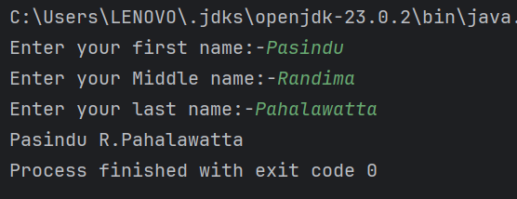

**Q4.**

**Code:**

***import java.util.*;  
import java.text.SimpleDateFormat;  
  
  
public class Q4 {  
 public static void main(String[] args) {  
 Date today = new Date();  
 SimpleDateFormat sdf = new SimpleDateFormat("dd MMMM yyyy");  
 System.out.print(sdf.format(today));  
 }  
}***

**Output:**

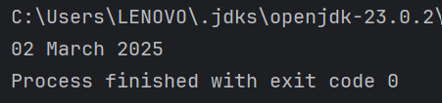

**Q5.**

**Code:**

***import java.text.SimpleDateFormat;  
import java.util.Date;  
  
public class Q5 { public static void main(String[] args) {  
 Date today = new Date();  
 SimpleDateFormat sdf = new SimpleDateFormat("EEEE, MMMM dd, yyyy");  
 System.out.print(sdf.format(today));  
}  
}***

**Output:**

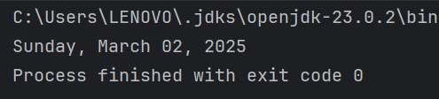

**Q6.**

**Code:**

***import javax.swing.*;  
import java.util.Scanner;  
  
public class Q6{  
 public static void main(String[] args) {  
 Scanner input = new Scanner(System.in);  
 System.out.print("Enter width of the window:-");  
 int width = input.nextInt();  
  
 System.out.print("Enter height of the window:-");  
 int height = input.nextInt();  
  
 input.nextLine();  
  
 System.out.print("Enter the title of the window:-");  
 String title = input.nextLine();  
  
 JFrame myWindow;  
 myWindow = new JFrame();  
 myWindow.setSize(width,height);  
 myWindow.setTitle(title);  
 myWindow.setVisible(true);  
 }  
}***

**Output:**

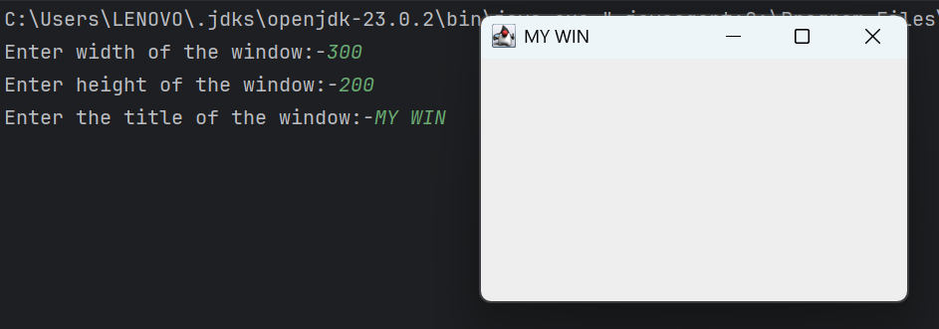

**Q7.**

**Code:**

***import javax.swing.*;  
import java.text.SimpleDateFormat;  
import java.util.Date;  
  
public class Q7 { public static void main(String[] args) {  
 Date today = new Date();  
 SimpleDateFormat sdf = new SimpleDateFormat("hh:mm:ss a");  
  
 JFrame myWindow;  
 myWindow = new JFrame();  
 myWindow.setSize(300, 200);  
 myWindow.setTitle(sdf.format(today));  
 myWindow.setVisible(true);  
}  
}***

output:

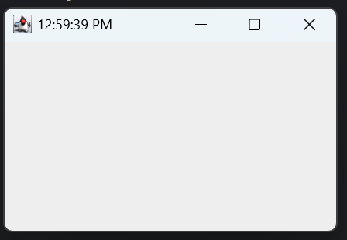

Q8.

Code:

***import java.util.Scanner;  
  
public class Q8 { public static void main(String[] args) {  
  
 Scanner input = new Scanner(System.in);  
  
 System.out.print("Enter text:-");  
 String txt = input.nextLine();  
  
 int index = txt.indexOf("!");  
  
 //System.out.print(index);  
  
 System.out.println(txt.substring(0,index));  
  
 int ln = txt.length();  
  
 //System.out.print(ln);  
  
 String sub = txt.substring(index+1,ln);  
  
 System.out.print(sub.trim());  
  
  
//one potato two potato ! three potato  
}  
}***

output:

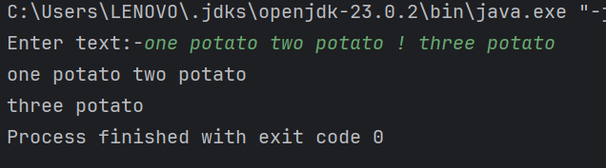

Q9.

Code:

***import java.util.Scanner;  
  
public class Q9 {public static void main(String[] args) {  
  
 Scanner input = new Scanner(System.in);  
  
 System.out.print("Enter text:-");  
 String txt = input.nextLine();  
  
 int ln = txt.length();  
  
 System.out.println(txt.length());  
 System.out.println(txt.charAt(0));  
 System.out.println(txt.charAt(ln-1));  
   
  
}  
}***

output:

: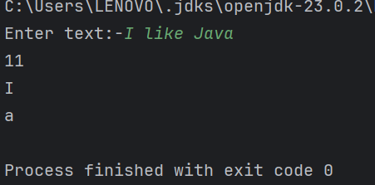

Q10.

Code:

***import java.util.Scanner;  
  
public class Q10 {  
 public static void main(String[] args) {  
  
 Scanner input = new Scanner(System.in);  
  
 System.out.print("Enter text:-");  
 String txt = input.nextLine();  
  
 int len = txt.length();  
  
 if(len % 2 == 1){  
 System.out.print(txt.charAt(len / 2));  
 } else {  
 System.out.print("ENTER odd number word");  
 }  
   
  
 }  
}***

Output:

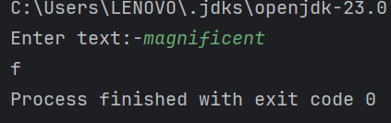

Q11.

Code:

***import java.util.Scanner;  
  
public class Q11 {  
 public static void main(String[] args) {  
 Scanner input = new Scanner(System.in);  
  
 System.out.print("Enter your first name:-");  
 String firstName = input.nextLine();  
  
 System.out.print("Enter your Middle name:-");  
 String middleName = input.nextLine();  
  
 System.out.print("Enter your last name:-");  
 String lastName = input.nextLine();  
  
 System.out.print(lastName + "," + firstName + " " +middleName.charAt(0) + ".");  
  
  
 }  
}***

output:

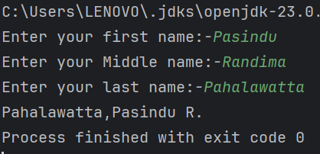

Q12.

Code:

***import javax.swing.*;  
  
public class Q12 {  
 public static void main(String[] args) {  
 JFrame myWindow;  
 myWindow = new JFrame();  
 myWindow.setSize(300, 200);  
 myWindow.setTitle("My First Frame");  
 myWindow.setLocation(100,50);  
 myWindow.setVisible(true);  
 }  
  
}***

Output:

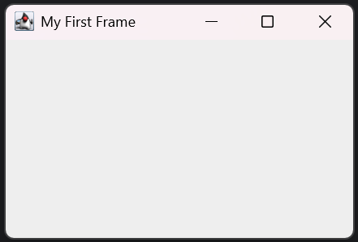

Q13.

Code:

***import javax.swing.*;  
public class Q13 {  
 public static void main(String[] args) {  
 JFrame myWindow;  
 myWindow = new JFrame();  
 myWindow.setSize(500, 250);  
 myWindow.setTitle("UOK");  
 myWindow.setVisible(true);  
 try {  
 Thread.sleep(500);  
 } catch (Exception e) {  
 }  
 myWindow.setVisible(false);  
 try {  
 Thread.sleep(500);  
 } catch (Exception e) {  
 }  
 myWindow.setVisible(true);  
 }  
}***

Output:

