[Date]

CT/2021/056 - PAHALAWATHTHA P.A.P.R.

Lab worksheet 2

**Object Oriented Programming**

**Q1.**

**a.**

**Code:-**

***public class Q1a {  
 public static void main(String[] args) {  
 int B = 5;  
 int A = 2;  
 int C = 3;  
 double result = Math.sqrt(B * B + 4 * A * C);  
 System.out.println(result);  
 }  
}***

**Output:-**

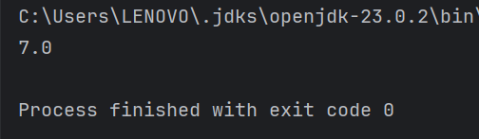

**b.**

**Code:-**

***public class Q1b { public static void main(String[] args) {  
 double X = 10, Y = 2;  
 double result = Math.sqrt(X + 4 * Math.pow(Y, 3));  
 System.out.println(result);  
}  
}***

**Output:-**

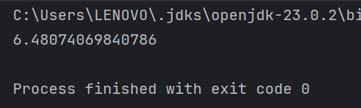

**c.**

**Code:-**

***public class Q1c { public static void main(String[] args) {  
 double X = 8, Y = 4;  
 double result = Math.cbrt(X * Y);  
 System.out.println(result);  
}  
}***

**Output:-**

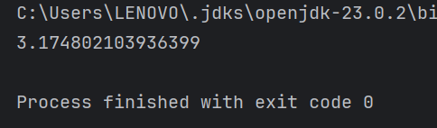

**d.**

**Code:-**

***public class Q1d { public static void main(String[] args) {  
 double radius = 6;  
 double area = Math.PI * radius * radius;  
 System.out.println("Area of the circle: " + area);  
}  
}***

**Output:-**

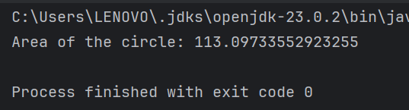

**Q2.**

**Code:-**

***import java.util.Scanner;  
  
public class Q2 {  
 public static void main(String[] args) {  
  
 Scanner input = new Scanner(System.in);  
  
 System.out.print("Enter length in centimeters: ");  
 double cm = input.nextDouble();  
  
 double inches = cm / 2.54;  
 int feet = (int) (inches / 12);  
 double remainingInches = inches % 12;  
  
  
 System.out.printf("%.2f cm is %d feet and %.2f inches.%n", cm, feet, remainingInches);  
  
  
 }  
}***

**Output:-**

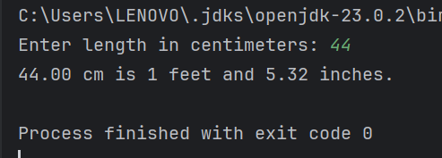

**Q3.**

**Code:-**

***import java.util.Scanner;  
public class Q3 {  
 public static void main(String[] args) {  
 Scanner scanner = new Scanner(System.in);  
  
  
 System.out.print("Enter temperature in Celsius: ");  
 double celsius = scanner.nextDouble();  
  
  
 double fahrenheit = (1.8 * celsius) + 32;  
  
  
 System.out.printf("%.2f C is equal to %.2f F.%n", celsius, fahrenheit);  
  
  
 }  
}***

Output:-

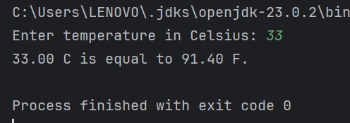

Q4.

Code:-

***import java.util.Scanner;  
  
public class Q4 {  
 public static void main(String[] args) {  
  
 Scanner input = new Scanner(System.in);  
  
 System.out.print("Enter your weight on pounds(lb): ");  
 double pounds = input.nextDouble();  
  
 double calories = pounds * 19;  
 System.out.print("Number of calories you need in one day: " + calories);  
  
  
 }  
}***

Output:-

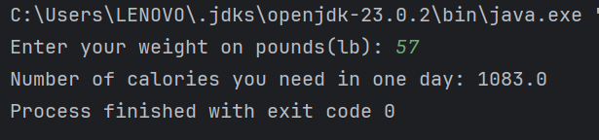

Q5.

Code:-

***mport java.util.Scanner;  
  
public class Q5{  
 public static void main(String[] args) {  
 Scanner scanner = new Scanner(System.in);  
  
  
 System.out.print("Enter temperature in fahrenheit: ");  
 double fahrenheit = scanner.nextDouble();  
  
  
 double Celsius = (5.0 / 9.0) * (fahrenheit - 32);  
  
  
 System.out.printf("%.2f F is equal to %.2f C.%n", fahrenheit,Celsius);  
  
  
 }  
}***

Output:-

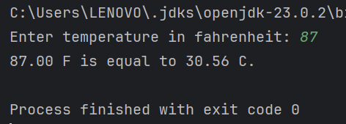

Q6.

Code:-

***import java.util.GregorianCalendar;  
import java.util.Scanner;  
  
public class Q6 {  
 public static void main(String[] args) {  
  
 GregorianCalendar calendar = new GregorianCalendar();  
  
 Scanner scan = new Scanner(System.in);  
  
 System.out.print("Enter your year of birth: ");  
 int birthYear = scan.nextInt();  
  
 int currentYear = calendar.get(GregorianCalendar.YEAR);  
 int age = currentYear - birthYear;  
  
 System.out.printf("You were born in %d and will be %d years old in this year", birthYear, age);  
 }  
}***

Output:-

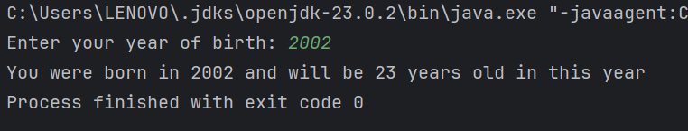

Q7.

Code:-

***import java.util.Scanner;  
  
public class Q7 {  
 public static void main(String[] args) {  
  
 Scanner input = new Scanner(System.in);  
  
 System.out.print("Input your height in cm: ");  
 int H = input.nextInt();  
  
 System.out.print("Input your weight in kg: ");  
 int W = input.nextInt();  
  
 double BMI = W / Math.pow( (H / 100.00), 2);  
 System.out.printf("Your BMI value: %.3f%n",BMI);  
  
 if ( 20 <= BMI || BMI <= 25) {  
 System.out.println("You BMI value is in healthy range (20.0 - 25.0)");  
 } else  
 System.out.println("You BMI value is not in healthy range (20.0 - 25.0)");  
  
  
 }  
}***

Output:-

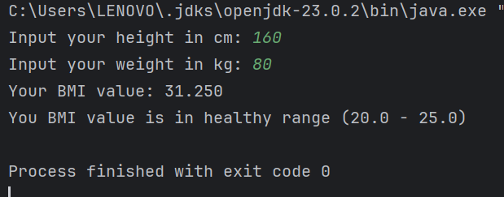

Q8.

Code:-

***import java.util.Scanner;  
  
public class Q8 {  
 public static void main(String[] args) {  
  
 Scanner scan = new Scanner(System.in);  
  
 System.out.print("Input the Radius of the sphere: ");  
 double radius = scan.nextDouble();  
  
 double PI = 3.14;  
 double volume = (4.0 / 3.0) * ( (PI * Math.pow(radius, 3)) );  
  
 System.out.printf("The volume of the sphere: %.2f", volume );  
 }  
}***

Output:-

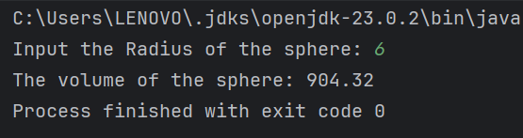

Q9.

Code:-

***import java.util.Scanner;  
  
public class Q9 {  
 public static void main(String[] args) {  
  
 Scanner input = new Scanner(System.in);  
  
 System.out.print("amount of investment: ");  
 double P = input.nextDouble();  
  
 System.out.print("Annual interest rate (in percentage): ");  
 double R = input.nextDouble();  
  
 System.out.print("Investment period (in years): ");  
 int N = input.nextInt();  
  
 double earnings = P * (1 + Math.pow((R / 100), N) );  
 System.out.printf("The amount of money you will be earn after %d years: $ %.2f", N, earnings);  
 }  
}***

Output:-

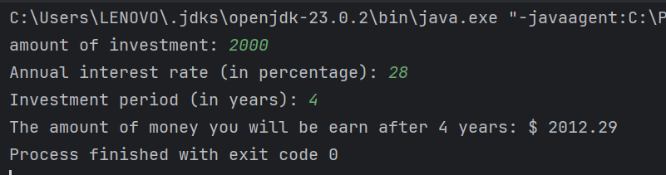

Q10.

Code:-

***import java.util.Scanner;  
  
public class Q10 {  
 public static void main(String[] args) {  
  
 Scanner input = new Scanner(System.in);  
  
 System.out.print("Loan amount: ");  
 double lAmount = input.nextDouble();  
  
 System.out.print("Annual interest rate (in percentage): ");  
 double annual_iR = input.nextDouble();  
  
 System.out.print("Loan period (in years): ");  
 int lPeriod = input.nextInt();  
  
 int months = 12;  
  
 System.out.print("\n");  
  
 double monthly_iR = annual_iR / 100.0 / months;  
 System.out.printf("Monthly interest rate: %.5f %%%n", monthly_iR);  
  
 int no_of_payments = lPeriod * months;  
 System.out.println("Number of payments: " + no_of_payments);  
  
 double monthlyPayment = (lAmount * monthly_iR) / (1 - Math.pow( (1 / ( 1 + monthly_iR)), no_of_payments) );  
 System.out.printf("Monthly payment: $ %.2f%n", monthlyPayment);  
  
 System.out.printf("Total payment: $ %.2f%n", (monthlyPayment * no_of_payments) );  
 }  
}***

Output:-

