4/1/2025

CT/2021/056 - PAHALAWATHTHA P.A.P.R.

**Lab worksheet 3**

Object Oriented Programming

Q1.

Code:-

**Temperature.java**

***public class Temperature {  
 private double celsius;  
  
 // No-arg constructor  
 public Temperature() {  
 this.celsius = 0.0;  
 }  
  
 // Parameterized constructor  
 public Temperature(double celsius) {  
 this.celsius = celsius;  
 }  
  
 // Getter for Fahrenheit  
 public double toFahrenheit() {  
 return this.celsius * 9 / 5 + 32;  
 }  
  
 // Getter for Celsius  
 public double toCelsius() {  
 return this.celsius;  
 }  
  
 // Setter for Celsius  
 public void setCelsius(double celsius) {  
 this.celsius = celsius;  
 }  
  
 // Setter for Fahrenheit  
 public void setFahrenheit(double Fahrenheit) {  
 this.celsius = (Fahrenheit - 32) * 5 / 9;;  
 }  
  
  
  
}***

**Main.java**

***import java.util.Scanner;  
  
public class Main {  
 public static void main(String[] args) {  
  
 Scanner input = new Scanner(System.in);  
  
 System.out.print("Enter Temperature in celsius: ");  
  
 double celsius = input.nextDouble();  
  
 Temperature temp = new Temperature();  
  
 temp.setCelsius(celsius);  
  
 System.out.print("Temperature in Fahrenheit: " + temp.toFahrenheit() );  
  
  
  
  
 }  
}***

Output:-

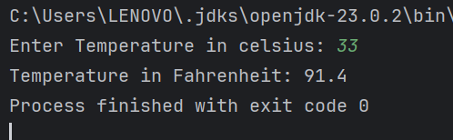

Q2.

Code:-

**Main.java**

***import java.util.Scanner;  
  
public class Main {  
  
 public static void main(String[] args) {  
  
 Scanner input = new Scanner(System.in);  
  
 System.out.print("Enter Temperature in Fahrenheit: ");  
  
 double Fahrenheit = input.nextDouble();  
  
 Temperature temp = new Temperature();  
  
 temp.setFahrenheit(Fahrenheit);  
  
 System.out.print("Temperature in celsius: " + temp.toCelsius());  
  
 }  
}***

Output:-

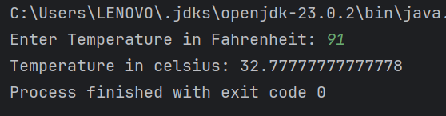

Q3.

Code:-

**Circle.java**

***public class Circle {  
  
 private double ri;  
 private double ro;  
  
   
 public Circle() {  
 this.ri = 0.0;  
 this.ro = 0.0;  
 }  
  
   
 public Circle(double ri, double ro) {  
 this.ri = ri;  
 this.ro = ro;  
 }  
  
 public void setRadius(double ri, double ro) {  
 this.ri = ri;  
 this.ro = ro;  
 }  
  
 public double computeArea(){  
 return ( (Math.PI * Math.pow(ro, 2)) - (Math.PI*Math.pow(ri,2)) );  
 }  
  
  
 public void computeCircumference(){  
 System.out.println("Circumference of the inner circle: " + ( 2 * Math.PI * ri ) );  
 System.out.print("Circumference of the outer circle: " + ( 2 * Math.PI * ro ) );  
 }  
  
  
}***

**Main.java**

***import java.util.Scanner;  
  
public class Main {  
 public static void main(String[] args) {  
  
 Scanner input = new Scanner(System.in);  
  
 System.out.print("Enter the radius of inner circle: ");  
 double ri = input.nextDouble();  
  
 System.out.print("Enter the radius of outer circle: ");  
 double ro = input.nextDouble();  
  
 Circle rad = new Circle();  
  
 rad.setRadius(ri , ro);  
  
 System.out.println("Shaded Area of the circle : " + rad.computeArea());  
  
 rad.computeCircumference();  
  
  
 }  
}***

Output:-

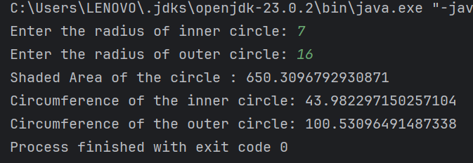

Q4.

Code:-

**Owner.java**

***public class Owner {  
  
 private String ownerName;  
 private String phoneNo;  
  
 public Owner(){  
 ownerName = "Not Assign";  
 phoneNo = "Not Assign" ;  
 }  
  
 public Owner(String ownerName, String phoneNo){  
 this.ownerName = ownerName;  
 this.phoneNo = phoneNo ;  
 }  
  
 public String getownerName() {  
 return ownerName;  
 }  
  
 public void setOwnerName(String ownerName) {  
 this.ownerName = ownerName;  
 }  
  
 public String getphoneNo(){  
 return phoneNo;  
 }  
  
 public void setphoneNo(String phoneNo){  
 this.phoneNo = phoneNo;  
  
 }  
  
}***

**Bicycle.java**

***public class Bicycle {  
  
 private Owner owner;  
  
 public Bicycle(){  
 this.owner = new Owner();  
 }  
  
 public Bicycle(String ownerName, String phoneNo){  
 this.owner = new Owner(ownerName,phoneNo);  
 }  
  
 public String getBicycleowner(){  
 return this.owner.getownerName();  
 }  
  
 public void setBicycleowner(String ownerName){  
 this.owner.setOwnerName(ownerName);  
 }  
  
 public String getBicyclephoneno(){  
 return this.owner.getphoneNo();  
 }  
  
 public void setBicyclephoneno(String phoneNo) {  
 this.owner.setphoneNo(phoneNo);  
 }  
  
}***

**Main.java**

***import java.util.Scanner;  
  
public class Main {  
  
 public static void main(String[] args) {  
  
 Scanner input = new Scanner(System.in);  
  
 System.out.print("Enter the name of the Owner: ");  
 String ownerName = input.next();  
  
 System.out.print("Enter the phone number: ");  
 String phoneNo = input.next();  
  
 Bicycle bic = new Bicycle();  
  
 bic.setBicycleowner( ownerName );  
 bic.setBicyclephoneno( phoneNo );  
  
 System.out.println("Name of the Bicycle owner: " + bic.getBicycleowner());  
 System.out.print("Phone number is: " + bic.getBicyclephoneno());  
  
 }  
}***

Output:-

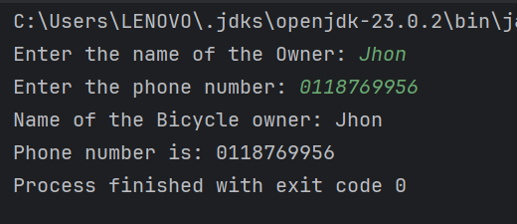

Q5.

Code:-

**Course.java**

***public class Course {  
 private String courseName;  
 private String courseCode;  
 private Lecturer lecturer;  
  
  
 public Course(String courseName, String courseCode, Lecturer lecturer) {  
 this.courseName = courseName;  
 this.courseCode = courseCode;  
 this.lecturer = lecturer;  
 }  
  
  
 public String getCourseName() {  
 return courseName;  
 }  
  
 public void setCourseName(String courseName) {  
 this.courseName = courseName;  
 }  
  
 public String getCourseCode() {  
 return courseCode;  
 }  
  
 public void setCourseCode(String courseCode) {  
 this.courseCode = courseCode;  
 }  
  
 public Lecturer getLecturer() {  
 return lecturer;  
 }  
  
 public void setLecturer(Lecturer lecturer) {  
 this.lecturer = lecturer;  
 }  
}***

**Lecturer.java**

***public class Lecturer {  
 private String lecturerName;  
 private String courseTeaching;  
  
  
 public Lecturer(String lecturerName, String courseTeaching) {  
 this.lecturerName = lecturerName;  
 this.courseTeaching = courseTeaching;  
 }  
  
  
 public String getLecturerName() {  
 return lecturerName;  
 }  
  
 public void setLecturerName(String lecturerName) {  
 this.lecturerName = lecturerName;  
 }  
  
 public String getCourseTeaching() {  
 return courseTeaching;  
 }  
  
 public void setCourseTeaching(String courseTeaching) {  
 this.courseTeaching = courseTeaching;  
 }  
}***

**Student.java**

***public class Student {  
 private String studentName;  
 private String degreeName;  
 private String courseFollowing;  
  
  
 public Student(String studentName, String degreeName, String courseFollowing) {  
 this.studentName = studentName;  
 this.degreeName = degreeName;  
 this.courseFollowing = courseFollowing;  
 }  
  
  
 public String getStudentName() {  
 return studentName;  
 }  
  
 public void setStudentName(String studentName) {  
 this.studentName = studentName;  
 }  
  
 public String getDegreeName() {  
 return degreeName;  
 }  
  
 public void setDegreeName(String degreeName) {  
 this.degreeName = degreeName;  
 }  
  
 public String getCourseFollowing() {  
 return courseFollowing;  
 }  
  
 public void setCourseFollowing(String courseFollowing) {  
 this.courseFollowing = courseFollowing;  
 }  
}***

**Main.java**

***import java.util.Scanner;  
  
public class Main {  
 public static void main(String[] args) {  
  
 Scanner input = new Scanner(System.in);  
 System.out.print("Enter the lecturer name:- ");  
 String lecturerName = input.next();  
 System.out.print("Enter the teaching course:- ");  
 String courseTeaching = input.next();  
  
 Lecturer lecturer = new Lecturer(lecturerName , courseTeaching);  
  
 System.out.print("Enter the course name:- ");  
 String courseName = input.next();  
 System.out.print("Enter the course code:- ");  
 String courseCode= input.next();  
  
 Course course = new Course(courseName,courseCode, lecturer);  
  
 System.out.print("Enter the student name:- ");  
 String studentName = input.next();  
 System.out.print("Enter the degree name:- ");  
 String degreeName= input.next();  
  
 Student student = new Student(studentName , degreeName , course.getCourseName());  
  
  
 System.out.println("=== Course Registration System ===");  
 System.out.println("\nCourse Information:");  
 System.out.println("Course Name: " + course.getCourseName());  
 System.out.println("Course Code: " + course.getCourseCode());  
 System.out.println("Lecturer: " + course.getLecturer().getLecturerName());  
  
 System.out.println("\nStudent Information:");  
 System.out.println("Student Name: " + student.getStudentName());  
 System.out.println("Degree Program: " + student.getDegreeName());  
 System.out.println("Registered Course: " + student.getCourseFollowing());  
  
 System.out.println("\nLecturer Information:");  
 System.out.println("Lecturer Name: " + lecturer.getLecturerName());  
 System.out.println("Teaching Course: " + lecturer.getCourseTeaching());  
 }  
}***

Output:-

