[Date]

CT/2021/056 - PAHALAWATHTHA P.A.P.R.

**Lab worksheet 04**

**Object Oriented Programming**

Q 01.

Code:-

***package Q1;  
  
import java.util.Scanner;  
  
public class Q_01 {  
 public static void main(String[] args) {  
 Scanner scanner = new Scanner(System.in);  
 System.out.println("Enter three integers:");  
 int a = scanner.nextInt();  
 int b = scanner.nextInt();  
 int c = scanner.nextInt();  
  
 int smallest = a;  
 if (b < smallest) smallest = b;  
 if (c < smallest) smallest = c;  
  
 System.out.println("The smallest number is: " + smallest);  
 }  
}***

Output:-

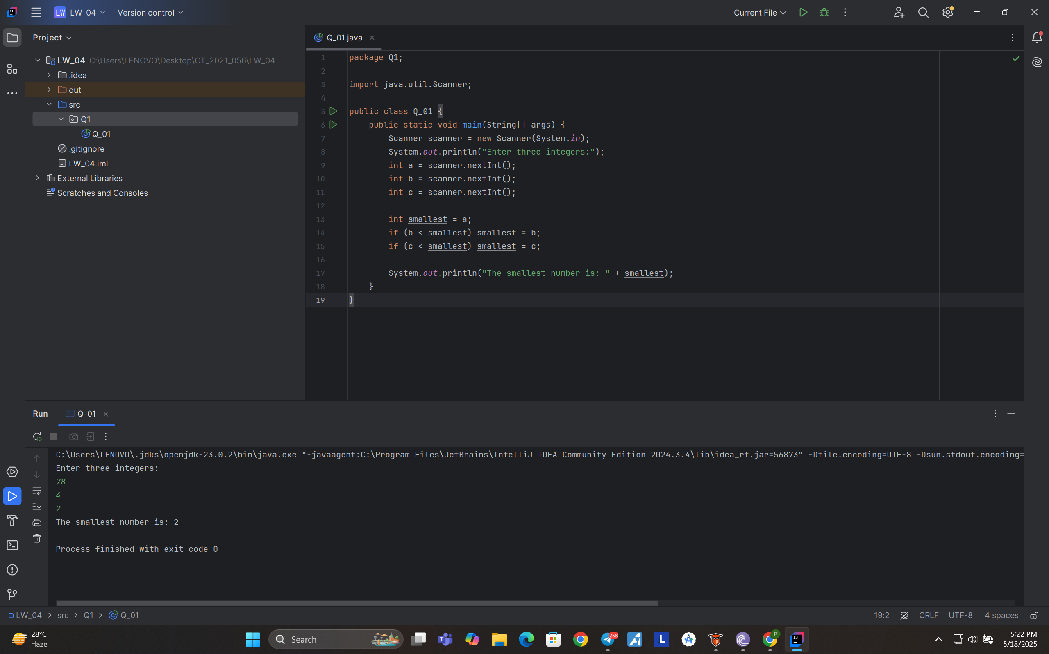

Q 02.

Code:-

***package Q2;  
  
import java.util.Scanner;  
  
public class Q_02 {  
 public static void main(String[] args) {  
 Scanner scanner = new Scanner(System.in);  
 System.out.println("0.Magenta");  
 System.out.println("1.Cyan");  
 System.out.println("2.Red");  
 System.out.println("3.Blue");  
 System.out.println("4.Green");  
 System.out.println("Select one color from the above list:");  
 int selection = scanner.nextInt();  
  
 switch (selection) {  
 case 0: System.out.println("You selected Magenta"); break;  
 case 1: System.out.println("You selected Cyan"); break;  
 case 2: System.out.println("You selected Red"); break;  
 case 3: System.out.println("You selected Blue"); break;  
 case 4: System.out.println("You selected Green"); break;  
 default: System.out.println("Invalid selection");  
 }  
 }  
}***

Output:-

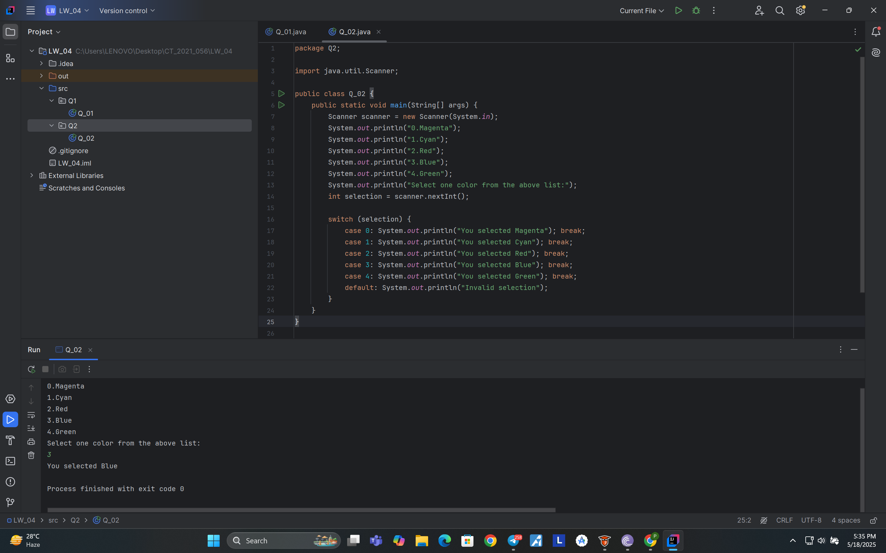

Q 03.

Code:-

***package Q3;  
  
import java.util.Scanner;  
  
public class Q_03 {  
 public static void main(String[] args) {  
 Scanner scanner = new Scanner(System.in);  
 System.out.println("Enter a power of 10 (e.g., 6, 9, 12):");  
 int power = scanner.nextInt();  
  
 switch (power) {  
 case 6: System.out.println("Million"); break;  
 case 9: System.out.println("Billion"); break;  
 case 12: System.out.println("Trillion"); break;  
 case 15: System.out.println("Quadrillion"); break;  
 case 18: System.out.println("Quintillion"); break;  
 case 21: System.out.println("Sextillion"); break;  
 case 30: System.out.println("Nonillion"); break;  
 case 100: System.out.println("Googol"); break;  
 default: System.out.println("No corresponding word for this power.");  
 }  
 }  
}***

Output:-

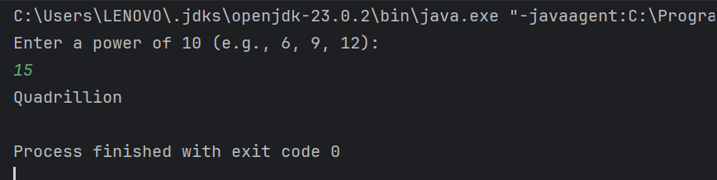

Q 04:-

Code:-

***package Q4;  
  
import java.util.Scanner;  
  
public class Q_04 {  
 public static void main(String[] args) {  
 Scanner scanner = new Scanner(System.in);  
 System.out.println("Enter a year:");  
 int year = scanner.nextInt();  
  
 boolean LeapYear = (year % 4 == 0 && year % 100 != 0) || (year % 400 == 0);  
  
 if (LeapYear) {  
 System.out.println("Leap Year");  
 } else {  
 System.out.println("Not a Leap Year");  
 }  
 }  
}***

Output:-

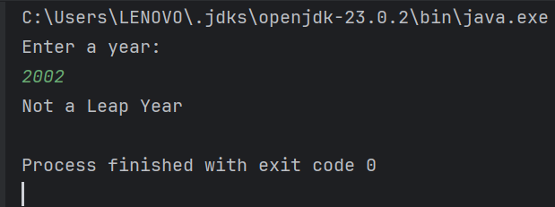

Q 05.

Code:-

***package Q5;  
  
import java.util.Scanner;  
  
public class Q_05 {  
 public static void main(String[] args) {  
 Scanner scanner = new Scanner(System.in);  
 System.out.println("Menu Categories:");  
 System.out.println("1. Entree");  
 System.out.println("2. Side Dish");  
 System.out.println("3. Drink");  
 System.out.println("Select a category (1-3):");  
 int category = scanner.nextInt();  
  
 switch (category) {  
 case 1:  
 System.out.println("Entree Options:");  
 System.out.println("Tofu Burger - $3.49");  
 System.out.println("Cajun Chicken - $4.59");  
 System.out.println("Buffalo Wings - $3.99");  
 System.out.println("Rainbow Fillet - $2.99");  
 break;  
 case 2:  
 System.out.println("Side Dish Options:");  
 System.out.println("Rice Cracker - $0.79");  
 System.out.println("No-Salt Fries - $0.69");  
 System.out.println("Zucchini - $1.09");  
 System.out.println("Brown Rice - $0.59");  
 break;  
 case 3:  
 System.out.println("Drink Options:");  
 System.out.println("Cafe Mocha - $1.99");  
 System.out.println("Cafe Latte - $1.90");  
 System.out.println("Espresso - $2.49");  
 System.out.println("Oolong Tea - $0.99");  
 break;  
 default:  
 System.out.println("Invalid category.");  
 }  
 }  
}***

Output:-

