[Date]

CT/2021/056 - PAHALAWATHTHA P.A.P.R.

**Lab worksheet 05**

**Object Oriented Programming**

Q1.

package Q1;  
  
public class PrintNumbers {  
 public static void main(String[] args) {  
 for (int i = 10; i <= 49; i++) {  
 System.*out*.print( i + " ");  
 if ((i + 1) % 10 == 0) {  
 System.*out*.println();  
 }  
 }  
 }  
}

Output:-

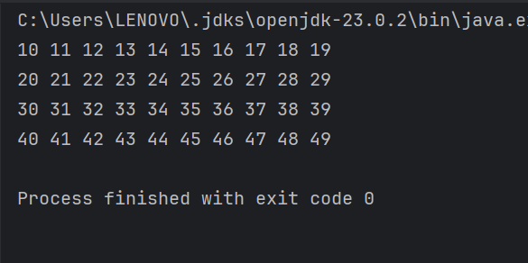

Q2.

package Q2;  
  
  
  
import java.util.Scanner;  
  
public class Q2 {  
 public static int countDigits(int num) {  
 if (num == 0) return 1;  
 int count = 0;  
 while (num != 0) {  
 num /= 10;  
 count++;  
 }  
 return count;  
 }  
  
 public static void main(String[] args) {  
 Scanner scanner = new Scanner(System.*in*);  
 int input;  
 do {  
 System.*out*.print("Enter an integer (negative to stop): ");  
 input = scanner.nextInt();  
 if (input >= 0) {  
 System.*out*.println("Number of digits: " + *countDigits*(input));  
 }  
 } while (input >= 0);  
 scanner.close();  
 }  
}

Output:-

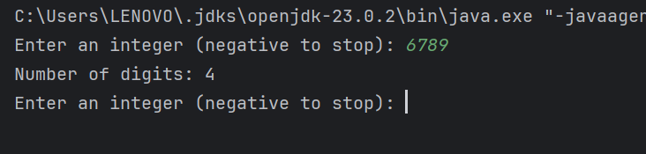

Q3.

package Q3;  
  
  
  
import java.util.Scanner;  
  
public class Q3{  
 public static void main(String[] args) {  
 Scanner scanner = new Scanner(System.*in*);  
 System.*out*.print("Enter a number: ");  
 int N = scanner.nextInt();  
 for (int i = 1; i <= 10; i++) {  
 System.*out*.println(N + " x " + i + " = " + (N * i));  
 }  
  
 }  
}

Output:-

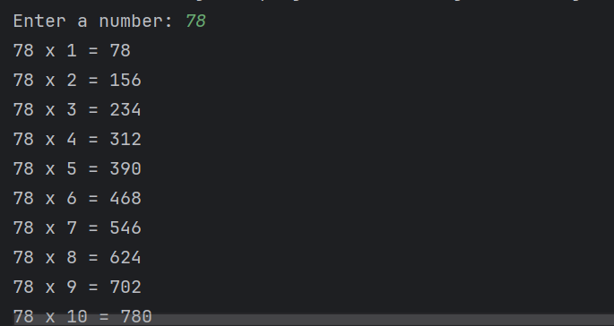

Q4.

package Q4;  
  
import java.util.Scanner;  
  
public class Q4 {  
 public static void main(String[] args) {  
 Scanner scanner = new Scanner(System.*in*);  
 System.*out*.print("Enter the number of rows: ");  
 int rows = scanner.nextInt();  
 for (int i = 1; i <= rows; i++) {  
 for (int j = 1; j <= rows - i; j++) {  
 System.*out*.print(" ");  
 }  
 for (int k = 1; k <= 2 * i - 1; k++) {  
 System.*out*.print("*");  
 }  
 System.*out*.println();  
 }  
  
 }  
}

Output:-

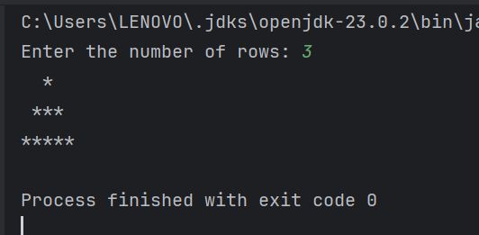

Q5.

package Q5;  
  
  
  
import java.util.Scanner;  
  
public class Q5 {  
 public static void main(String[] args) {  
 Scanner scanner = new Scanner(System.*in*);  
 System.*out*.print("Enter a word or phrase: ");  
 String input = scanner.nextLine().replaceAll("[^a-zA-Z0-9]", "").toLowerCase();  
 String reversed = new StringBuilder(input).reverse().toString();  
 if (input.equals(reversed)) {  
 System.*out*.println("It is a palindrome!");  
 } else {  
 System.*out*.println("It is not a palindrome.");  
 }  
  
 }  
}

Output:-

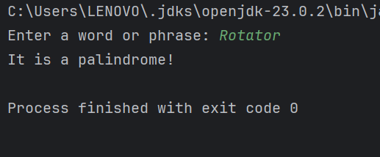

Q6.

package Q6;  
  
import java.util.Scanner;  
import java.util.Random;  
  
public class Q6{  
 public static void main(String[] args) {  
 Random random = new Random();  
 int target = random.nextInt(100) + 1;  
 Scanner scanner = new Scanner(System.*in*);  
 int guess;  
 do {  
 System.*out*.print("Guess the number (1-100): ");  
 guess = scanner.nextInt();  
 if (guess < target) {  
 System.*out*.println("Higher!");  
 } else if (guess > target) {  
 System.*out*.println("Lower!");  
 }  
 } while (guess != target);  
 System.*out*.println("Correct! The number was " + target);  
  
 }  
}

Output:-

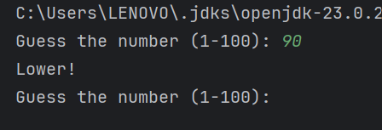

Q7.

package Q7;  
  
import java.util.Scanner;  
  
public class Q7 {  
 public static void main(String[] args) {  
 Scanner scanner = new Scanner(System.*in*);  
 System.*out*.print("Enter a sentence: ");  
 String sentence = scanner.nextLine();  
 System.*out*.print("Enter the word to replace: ");  
 String oldWord = scanner.next();  
 System.*out*.print("Enter the replacement word: ");  
 String newWord = scanner.next();  
 String replaced = sentence.replaceAll(oldWord, newWord);  
 System.*out*.println("Modified sentence: " + replaced);  
  
 }  
}

Output:-

