**6MMCS009W1 Usability Testing & Evaluation**

**Individual Coursework**

**Student: Pasindu Manodya (2018484)**

Degree: BSc (Hons) in Computer Science

School of Computer Science & Engineering

College of Design, Creative and Digital Industries

University of Westminster

Date

Contents

1 Introduction 3

2 Hypothesis testing 3

2.1 Independent-sample-test 3

2.1.1 Hypothesis testing for Independent-sample-test 3

2.1.2 Data organisation 4

2.1.3 Descriptive statistics and discussion of results 8

2.1.4 Conducting independent sample t-test, interpret and report the results 11

2.1.5 Independent sample t-test files 11

2.2 Paired-sample-test 12

2.2.1 Hypothesis testing for paired-sample-test 12

2.2.2 Data organisation 13

2.2.3 Descriptive statistics and discussion of results 15

2.2.4 Conducting paired sample t-test, interpret and report the results 18

2.2.5 Paired sample t-test files 19

2.3 Correlation Analysis 20

2.3.1 Hypothesis testing for Correlation Coefficient 20

2.3.2 Data organisation 21

2.3.3 Descriptive statistics and discussion of results 23

2.3.4 Conducting Correlation Coefficient test, interpret and report the results 25

2.3.5 Correlation Coefficient test files 26

3 Conclusions 26

# Introduction

This is the extended document on the “Westminster Navigation Game” used by Westminster University. For this document the “Guides and Policies” section was chosen from the Westminster navigation game. Research questions and hypothesises were created in align with independent sample, paired sample, and Pearson correlation tests. The gathered data using the online questionnaire were used for this document when answering the questions.

# Hypothesis testing

*This section contains three subsections that present how data collected from experimental design aiming to test whether the formed hypotheses from the CW1 are valid or not in regard to the research questions is being organised and analysed statistically with the following methods:*

* *independent-sample-test*
* *paired-sample t-test*
* *Pearson correlation r-test.*

## 2.1 Independent-sample-test

*This section is in regard to the independent-sample-test of the document. In this section research questions, hypothesis testing, data organizing, and statistical results are discussed.*

### 2.1.1 Hypothesis testing for Independent-sample-test

|  |  |
| --- | --- |
| **Research question** | Is there a tendency which level 6 students are scoring more points than level 4 students in the Guides and Policies quiz room? |
| **Hypothesis statement** | *Ho:* There is no significant difference between the overall points scored by level 6 students compared to the overall points scored by level 4 students in the guides and policies quiz room. |
| *Ha:* There is a significant difference between the overall points scored by level 6 students compared to the overall points scored by level 4 students in the guides and policies quiz room. |
| **Mathematical expression of the Hypothesis** | *Ho:* μLevelSixStudent – μLevelFourStudent = 0 |
| *Ha:* μLevelSixStudent ≠ μLevelFourStudent |
| **Dependent variable** | Overall points |
| **Dependent variable data type** | *Ratio* |
| **Independent variable** | level 6 or level 4 student |
| **Independent variable type** | *Nominal* |
| **Experimental design** | Between Group |
| **Study method** | independent-sample-test |

### 2.1.2 Data organisation

**RAW DATA**

Above snapshot shows the data gathered for this experimental design to calculate the mean, median and mode.

**RAW DATA FOR T TEST**

Above snapshot shows the data gathered for this experimental design for the independent sample t test.

**SNAPSHOTS OF ORGANIZED DATA SHOWED IN PSPP**

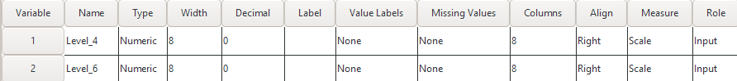

Above snapshots show the tables which are used to calculate the mean, median and mode values using pspp.

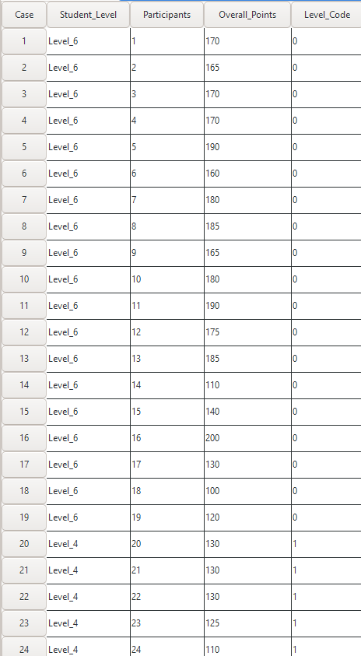

*Above snapshots show the variable and data view in the pspp which is used to calculate the t values.*

### 2.1.3 Descriptive statistics and discussion of results

*Above snapshot shows the calculated values for the mean, median and mode variables which belongs to the between group independent sample t test. According to the above snapshot the mean of the overall points scored by the level 6 students is 162.37 and for the level 4 students is 146.58. When it comes to the median of the overall points, level 6 students’ median is 170 and level 4 students’ median is 145. Considering the above stated means, we can come to a conclusion that level 6 students have scored more points in overall than level 4 students who took part in this test.*

*Above snapshots shows the calculated values for standard deviation, variance, skewness, and range variables which belongs to the between group independent sample t test. Standard deviation is used to calculate the spread of the data from the mean. When it comes to level 4 standard deviation score it is shown as 29.86 and in level 6 standard deviation it is shown as 28.79. Since the level 4 students’ standard deviation score is higher than level 6 students’ standard deviation score, we can state that level 6 student overall points data are spread around the mean and level 4 students’ overall points data are spread out away from the mean value. Using the variance variable, we can calculate the variability of the data. The variance of level 4 students’ overall points is 891.81 and level 6 students’ variance is 828.80. Considering the given variance scores, we can come to the conclusion that level 4 overall points have a higher data spread than level 6 overall points. The skewness scores of the level 4 overall points and level 6 overall points is stated as – 0.50 and – 0.97 respectively.*

***HISTOGRAM OF LEVEL 4 OVERALL POINTS***

This histogram shows the overall points scored by the level 4 students who participated in this study. According to the above table this diagram has a skewness of – 0.50. Since the skewness is between -0.50 and +0.50 the distribution is approximately skewed. Since the distribution is approximately skewed this can be considered as a normal distribution.

**HISTOGRAM OF LEVEL 6 OVERALL POINTS**

This histogram shows the overall points scored by the level 6 students who participated in this study. According to the above table this diagram has a skewness of – 0.97. If the skewness is between +1 and 0.5 or -1 and -0.5 the skewness is moderately skewed. Since the skewness falls under this category this is a moderately skewed distribution. Since this is a moderately skewed this cannot be considered as a normal distribution.

***What can you tell about the means you are studying?***

*Two variables were selected for this study. The means of the selected level 4 and level 6 are 146.5 and 162.3 respectively. Level 6 has a higher mean than level 4.*

***Can you proceed to parametric statistics to study the significance of the results?***

*If the data is normally distributed, we can proceed with a parametric test. Since the data is not normally distributed the answer is no. Cannot proceed with parametric tests.*

***If you cannot conduct parametric statistics, what would be the equivalent non-parametric test that you would have to conduct?***

*If not mann-whitney test has to be used to proceed.*

### 2.1.4 Conducting independent sample t-test, interpret and report the results

***What is the p and t values you get?***

*P value = 0.10*

*T value = 1.66*

***Report the results:***

* ***Provide a short recap of method***

*Between group independent sample t test is done by comparing the two means which is level 4 overall points and level 6 overall points as show in the above snapshots. The aim of this test is to identify whether if there is significant difference between the means or not. In this test the level 4 overall points skewness is – 0.50 and it is between* -0.50 and +0.50*. Hence it is a normal distribution. Also, in the level 6 overall points the skewness is – 0.97 and it is between* +1 and 0.5 or -1 and -0.5.  *Since it is between the designated values it is not a normal distribution. Since this cannot be a parametric test.*

* ***Descriptive recap with standard deviations***

*There are two standard deviations in this independent sample t test. Level 4 overall points and level 6 overall points and their standard deviations are 29.86 and 28.79 respectively. Since level 6 standard deviation is closer to 0 than the level 4 standard deviation it is safe to say that level 6 data points are spread around the mean and level 4 data points are spread out of the mean.*

* ***Significant test (with t-statistics and p-value)***

*We can calculate both t value and p values using this independent sample t-test. In this test calculated t-value is 1.66 and the calculated p-value is 0.10. When doing these tests, the confidence level was taken as 95%. The estimated p-value of 0.10 is larger than 0.05 for the degree of freedom 37. Since this result can be considered as an insignificant result.*

* ***Hypothesis test recap***

*After conducting this independent sample t-test the returned p-value is 0.10. Since 0.10 is larger than the selected 0.05 value, the significance value is lower than the p-value. Hence the author is able to come to the conclusion that the null hypotheses will be accepted.*

### 2.1.5 Independent sample t-test files

[*PSPP files and output files*](https://drive.google.com/drive/folders/1M9neKmm8aBTUvFtgPn-HaBjf7L76_lg2?usp=sharing)

## 2.2 Paired-sample-test

*This section is in regard to the paired-sample-test of the document. In this section research questions, hypothesis testing, data organizing, and statistical results are discussed which relates to the within group study.*

### 2.2.1 Hypothesis testing for paired-sample-test

|  |  |
| --- | --- |
| **Research question** | Is there an effect on the average time taken by students to complete the guides and policies quiz room? |
| **Hypothesis statement** | *Ho:* There is no significant difference between the time, students complete the guides quiz room in higher time and students complete the policies quiz in lesser time |
| *Ha:* There is a significant difference between the time, students complete the guides quiz room in higher time and students complete the policies quiz in lesser time |
| **Mathematical expression of the Hypothesis** | *Ho:* μTimeTakenToCompleteTheGuidesQuiz – μTimeTakenToCompleteThePoliciesQuiz = 0 |
| *Ha:* μTimeTakenToCompleteTheGuidesQuiz ≠ μTimeTakenToCompleteThePoliciesQuiz |
| **Dependent variable** | average time taken by a student |
| **Dependent variable data type** | *Ratio* |
| **Independent variable** | guides and policies quiz room |
| **Independent variable type** | *Nominal* |
| **Experimental design** | Within Group |
| **Study method** | paired-sample-test |

### 

### 2.2.2 Data organisation

***RAW DATA***

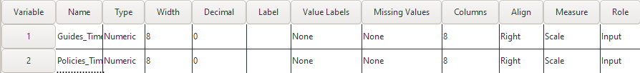

*The above snapshots show the raw data which belongs to the within group test. And also, pspp variable view and data view snapshots. Two variables were taken as guides time and policies time because these are mentioned in the above hypotheses.*

### 2.2.3 Descriptive statistics and discussion of results

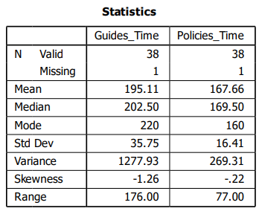

*Above snapshot shows the calculated values for the mean, median and mode variables which belongs to the within group paired sample test. According to the above snapshot the mean of the guides time is 195.11 and for the policies time is 167.66. When it comes to the median of the completion time, guides time median is 202.50 and policies time median is 169.50. Considering the above stated means, we can come to a conclusion that students have spent more time complete guides quiz game than the time they spent on policies quiz game.*

*Above snapshots shows the calculated values for standard deviation, variance, skewness, and range variables which belongs to the within group paired sample test. Standard deviation is used to calculate the spread of the data from the mean. When it comes to guides time standard deviation score is shown as 35.75 and in policies time standard deviation is shown as 16.41. Since the guides time standard deviation score is higher than policies time standard deviation score, we can state that policies time data are spread around the mean and guides time data are spread out away from the mean value. Using the variance variable, we can calculate the variability of the data. The variance of guides time is 1277.93 and policies time variance is 269.31. Considering the given variance scores, we can come to the conclusion that guides time have a higher data spread than policies time. The skewness scores of the guides time and policies time are stated as – 1.26 and – 0.22 respectively.*

**GUIDES TIME HISTOGRAM**

This histogram shows the overall time spent by students to complete the guides game. According to the above table this diagram has a skewness of – 1.26. If the skewness is higher tha +1 or lesser than -1 it is a highly skewed distribution. According to the above stated facts the author can state that this diagram does not presents a normal distribution because this is a highly skewed distribution and parametric test cannot be used.

***POLICIES TIME HISTOGRAM***

This histogram shows the overall time spent by students to complete the policies game. According to the above table this diagram has a skewness of – 0.22. If the skewness is between +0.5 and -0.5 it is an approximately skewed distribution. Since this fall under this category we can consider a diagram presents a normal distribution.

***What can you tell about the means you are studying?***

*Two variables were selected for this study. The means of the selected guides time and policies time are 195.1 and 167.6 respectively. Guides time has a higher mean than policies time.*

***Can you proceed to parametric statistics to study the significance of the results?***

*If the data is normally distributed, we can proceed with a parametric test. Since the data is not normally distributed the answer is no. Cannot proceed with parametric tests.*

***If you cannot conduct parametric statistics, what would be the equivalent non-parametric test that you would have to conduct?***

*Wilcoxon test is needed.*

### 2.2.4 Conducting paired sample t-test, interpret and report the results

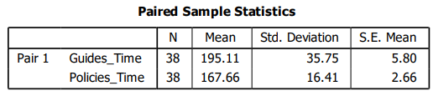

***What is the p and t values you get?***

*P value = 0.00001*

*T value = 4.99*

***Report the results:***

* ***Provide a short recap of method***

*Within group paired sample test is done by comparing the two means which is guides game completion time and policies game completion time as show in the above snapshots. The aim of this test is to identify whether if there is significant difference between the means or not. In this test the guides time skewness is – 1.26 and it is not a normal distribution since it is is a highly skewed distribution. But in the policies time the skewness is – 0.22 and it falls under approximately skewed and it ia normal distribution. Since parametric test cannot be used.*

* ***Descriptive recap with standard deviations***

*There are two standard deviations in this paired sample test. Guides time and policies time and their standard deviations are 35.75 and 16.41 respectively. Since policies time standard deviation is closer to 0 than the guides time standard deviation it is safe to say that policies time data points are spread around the mean and guides time data points are spread out of the mean.*

* ***Significant test (with t-statistics and p-value)***

*We can calculate both t value and p values using this paired sample test. In this test calculated t-value is 4.99 and the calculated p-value is 0.00001. When doing these tests, the confidence level was taken as 95%. The estimated p-value of 0.00001 is lower than 0.05 for the degree of freedom 37. Since this result can be considered as a significant result.*

* ***Hypothesis test recap***

*After conducting this paired sample test the returned p-value is 0.00001. Since 0.00001 is lower than the selected 0.05 value the significance value is higher than the p-value. Hence the author is able to come to the conclusion that the null hypotheses will be rejected.*

***In case the data is not normally distributed is this analysis reliable?***

### 2.2.5 Paired sample t-test files

[*PSPP files and output files*](https://drive.google.com/drive/folders/1I9qFnaflZlKqEwxmQbUVVgnB8smBSMSO?usp=share_link)

## 2.3 Correlation Analysis

*This section is in regard to the pearson-correlation-test of the document. In this section research questions, hypothesis testing, data organizing, and statistical results are discussed.*

### 2.3.1 Hypothesis testing for Correlation Coefficient

|  |  |
| --- | --- |
| **Research question** | Is there a leniency towards the age and, guides and policies quiz satisfaction of students who completed the guides and policies quiz room? |
| **Hypothesis statement** | *Ho:* There is no relationship between age and the students’ satisfaction on policies and guides quiz room |
| *Ha:* There is a relationship between age and the students’ satisfaction on policies and guides quiz room |
| **Variables studied** | Independent variable - students’ age  Dependent variable – satisfaction on the quiz |
| **Variables studied data type** | Independent variable - Ratio  Dependent variable - Ordinal |
| **Study method** | Pearson correlation r-test |

### 2.3.2 Data organisation

***RAW DATA***

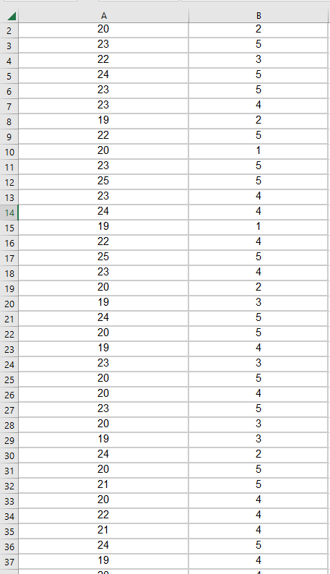

***PSPP DATA***

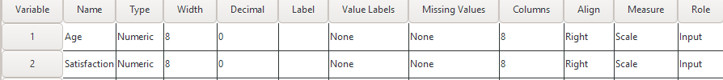

*The gathered data using the questionnaire were put into a excel for first and then they were migrated to the pspp. After that they were arranged according to the pearson correlation r test.*

### 2.3.3 Descriptive statistics and discussion of results

Above snapshot shows the mean values and the standard deviation values which relates to the pearson correlation r test. Mean of the age of the participants who took part in this study is calculated as 21.61 and mean of their satisfaction is calculated as 3.89. And the standard deviation is calculated as 1.92 and 1.20 respectively for age and satisfaction.

This histogram shows the age of the participants who took part in this study. This diagram has a skewness level of 0.09. If the skewness is between 0.5 and -0.5 it is a approximately skewed. Since we can consider a diagram presents a normal distribution.

This histogram shows the satisfaction level of the participants who took part in this study. This diagram has a skewness level of – 0.97. If the skewness is between +1 or 0.5 and -1 or -0.5 moderately skewed distribution, since we can consider a diagram does not present a normal distribution.

***What can you tell about the means you are studying?***

*Two variables were selected for this study. The means of the selected guides time and policies time are 195.1 and 167.6 respectively. Guides time has a higher mean than policies time.*

***Can you proceed to parametric statistics to study the correlation coefficient?***

*If the data is normally distributed, we can proceed with a parametric test. Since the data is normally distributed the answer is yes.*

***If you cannot conduct parametric statistics, what would be the equivalent non-parametric test that you would have to conduct for correlation coefficient?***

***the Spearman correlation is needed.***

### 2.3.4 Conducting Correlation Coefficient test, interpret and report the results

***What is the p and r values you get.***

*P = 0.003*

*R = 0.472*

***Report the results:***

* ***Provide a short recap of method***

*Pearson correlation r test is used to measure the statistical relationship between two selected variables. In this test those two variables are Age and Satisfaction. In this test the age skewness is 0.09 and it is between +0.5 and -0.5 it is a moderately skewed distribution.Also, in the satisfaction the skewness is – 0.97 and it is between +1 or 0.5 and -1 or -0.5 is it moderately skewed distribution.*

* ***Descriptive recap with standard deviations***

*There are two standard deviations in this pearson correlation r test. Age and satisfaction and their standard deviations are 1.92 and 1.20 respectively. Since satisfaction standard deviation is closer to 0 than the age standard deviation it is safe to say that satisfaction data points are spread around the mean and age data points are spread out of the mean.*

* ***Significant test (with t-statistics and p-value)***

*We can calculate both the r value and p values using this paired sample test. In this test calculated r-value is 0.472 and the calculated p-value is 0.003. When doing these tests, the confidence level was taken as 95%. The estimated p-value of 0.003 is lower than 0.05 for the degree of freedom 37. Since this result can be considered as a significant result.*

* ***Hypothesis test recap***

*After conducting this pearson correlation r test the returned p-value is 0.003. Since 0.003 is lower than the selected 0.05 value the significance value is higher than the p-value. Hence the author is able to come to the conclusion that the null hypothesis will be rejected.*

### 2.3.5 Correlation Coefficient test files

[*PSPP files and output files*](https://drive.google.com/drive/folders/1ioRdu-zaEATVedo0jc-U6i3RSTAyqzPV?usp=share_link)

# Conclusions

This is the extended document on the “Westminster Navigation Game” used by Westminster University. For this document the “Guides and Policies” section was chosen from the Westminster navigation game. Testing the hypotheses which were created previously was done in this document. Independent sample t test, paired sample t test and pearson correlation r test were used when investigating the hypothesis. Using those tests p values, t values, and r values were identified according to the appropriate tests, and they were explained.