## **Lab 05**

**Question 07**

**Why there are 1783 boxes?** – ‘yolo_filter_boxes’ function filters the boxes using the confidence threshold to filter out the low-confidence boxes. This reduces the total number of boxes to 1783 which have confidence scores greater than or equal to 0.5. Also the mean and the stddev can effect the box_confidence , increasing the mean or decreasing the standard deviation will result in higher confidence scores. Also adjusting those will also affect class probability distribution. If we increase the threshold the number of retained boxes will be decreased as the confidence requirement is higher. I changed those values and observed the changes of the number of boxes.

**Maximum number of boxes** – 1805, maximum number of boxes is determined by the grid size and number of anchors per cell. For a grid with 19 * 19 cels with 5 anchors each the number of boxes can be calculated by, 19 * 19 * 5 =1805.

**Minimum number of boxes** – 0, minimum number theoretically can be low as 0 if none of the boxes meet the confidence threshold.

**Question 08**

**advantage of using such anchor boxes** –

* Anchor boxes improve the efficiency of the YOLO model by reducing the complexity of predicting bounding boxes directly.
* The use of anchor boxes enables the detection of multiple objects in the same grid cell.
* Detect objects with various dimensions by multiple aspect ratios of anchor boxes.

**Method used -** K-Means clustering

**Question 10**

Original Image :

Output Image:

In here bus has been correctly identified but traffic lights , truck and jeep have not been correctly identified.

Original Image:

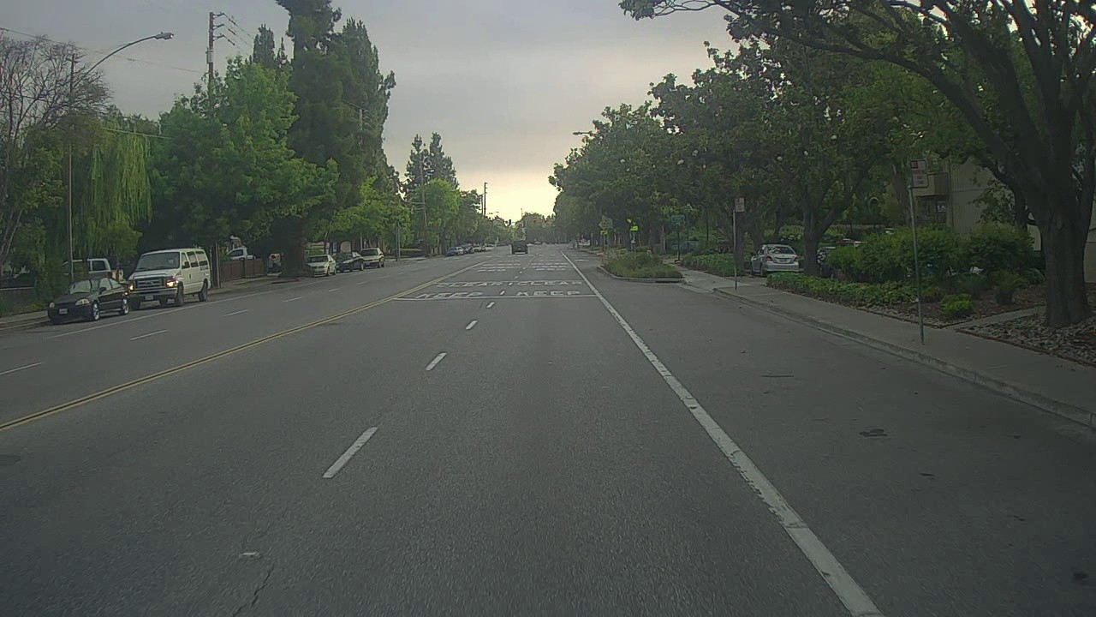

Output Image:

In here cars and other vehicles are not identified.

Question 11

Adjusting parameters like max_boxes, score_threshold, and iou_threshold of the yolo_eval

Before changing values:

After changing values:

After changing values

Before changing values:

