Scenario:

TechNova Ltd. is a leading software and consulting company expanding its network infrastructure. The company is divided into several departments, each with its own subnetwork and connectivity requirements.

Here are the number of computers in each subnetwork:

a. Finance Department - 60 computers
b. Research Department - 40 computers
c. Administration Department - 15 computers
d. Sales Department - 25 computers
e. Logistics Department - 12 computers

The network is structured as follows:

- Router X is connected to Router Y and Router Z
- The Finance Department LAN is connected to Router X.
- The Research Department LAN is connected to Router Y.
- The Administration Department LAN is connected to Router Z.
- The Sales Department LAN is connected to Router Z as well.
- The Logistics Department LAN is connected to Router W, which is also connected to Router Y.
- The company’s Intranet Application Server is connected to the Finance Department LAN.

You have been provided with the IP Address Block of 10.10.0.0/24 for LAN connections and 192.168.50.0/24 for inter-router connections.

Set up the network using Cisco Packet Tracer with appropriate cables to establish connectivity between relevant devices, ensuring that all department LANs are connected as per the given scenario.

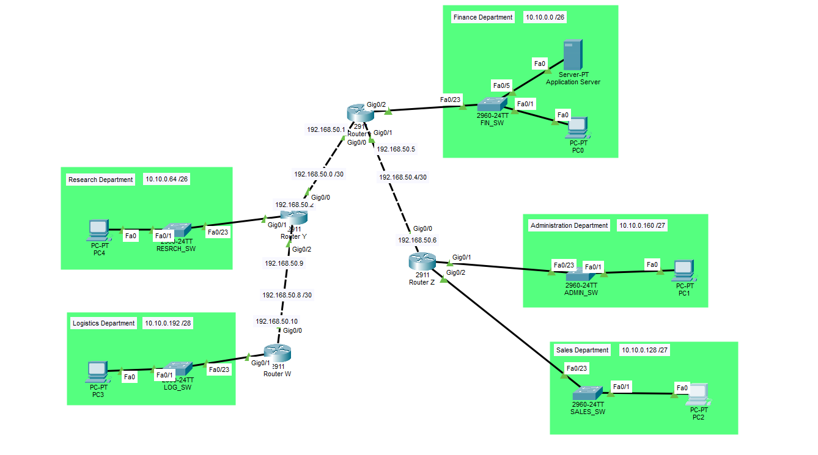
Configure the hostname and assign IP addresses. Set up default gateways on the relevant router interfaces and end devices based on the scenario details. Use VLSM to assign subnetworks and IP addresses for each department LAN to minimize IP address wastage.

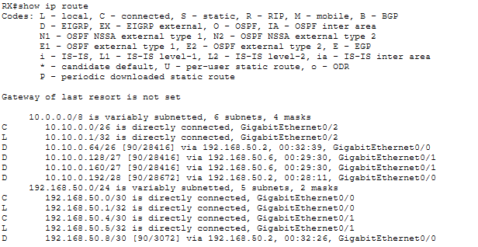
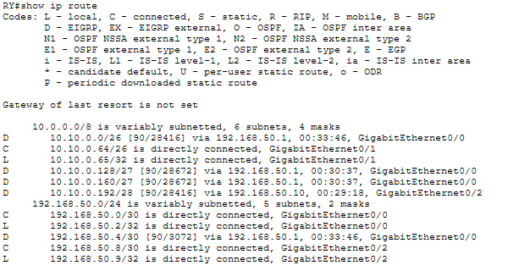

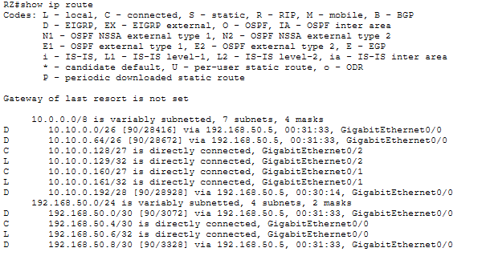

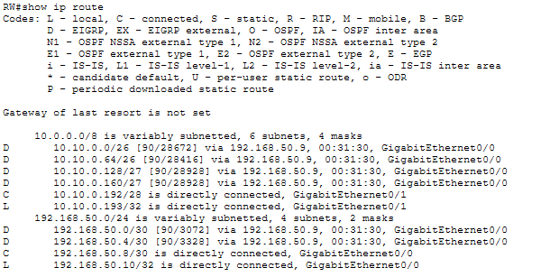
Configure EIGRP on all routers to enable dynamic routing and establish inter-subnetwork connectivity so that all department LANs can communicate with each other.

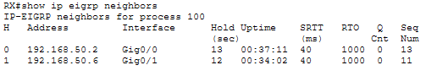

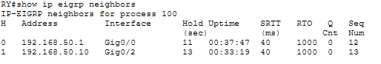

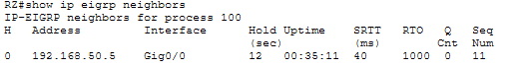

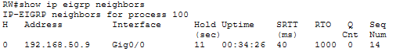

Configure DHCP on the relevant routers to automatically assign IP addresses to end devices in each department. Ensure the correct DHCP pools, default gateways, and excluded addresses are implemented.

