**Q1:**

package Q_01;  
import java.util.Scanner;  
  
public class Q_01 {  
 public static void main(String[] args) {  
 Scanner scanner = new Scanner(System.*in*);  
  
 System.*out*.print("Enter first number: ");  
 int num1 = scanner.nextInt();  
  
 System.*out*.print("Enter second number: ");  
 int num2 = scanner.nextInt();  
  
 System.*out*.print("Enter third number: ");  
 int num3 = scanner.nextInt();  
  
 int smallest = num1;  
  
 if (num2 < smallest) {  
 smallest = num2;  
 }  
 if (num3 < smallest) {  
 smallest = num3;  
 }  
  
 System.*out*.println("The smallest number is: " + smallest);  
 }  
}

**Output:**

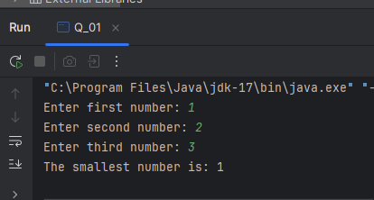

**Q2:**

public class Q_02 {  
 public static void main(String[] args) {  
 Scanner scanner = new Scanner(System.*in*);  
  
 System.*out*.println("0. Magenta");  
 System.*out*.println("1. Cyan");  
 System.*out*.println("2. Red");  
 System.*out*.println("3. Blue");  
 System.*out*.println("4. Green");  
 System.*out*.println("Select one color from the above list:");  
  
 int selection = scanner.nextInt();  
 switch (selection) {  
 case 0:  
 System.*out*.println("You selected Magenta");  
 break;  
 case 1:  
 System.*out*.println("You selected Cyan");  
 break;  
 case 2:  
 System.*out*.println("You selected Red");  
 break;  
 case 3:  
 System.*out*.println("You selected Blue");  
 break;  
 case 4:  
 System.*out*.println("You selected Green");  
 break;  
 default:  
 System.*out*.println("Invalid selection");  
 break;  
 }  
 }  
}

**Q3:**package Q_03;  
import java.util.Scanner;  
  
public class Q_03 {  
 public static void main(String[] args) {  
 Scanner scanner = new Scanner(System.*in*);  
  
 System.*out*.print("Enter the power of 10: ");  
 int power = scanner.nextInt();  
  
 switch (power) {  
 case 6:  
 System.*out*.println("Million");  
 break;  
 case 9:  
 System.*out*.println("Billion");  
 break;  
 case 12:  
 System.*out*.println("Trillion");  
 break;  
 case 15:  
 System.*out*.println("Quadrillion");  
 break;  
 case 18:  
 System.*out*.println("Quintillion");  
 break;  
 case 21:  
 System.*out*.println("Sextillion");  
 break;  
 case 30:  
 System.*out*.println("Nonillion");  
 break;  
 case 100:  
 System.*out*.println("Googol");  
 break;  
 default:  
 System.*out*.println("No corresponding word for this value.");  
 break;  
 }  
 }  
}

**Output:**

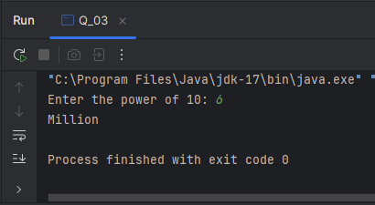

**Q4:**

package Q_04;  
import java.util.Scanner;  
  
public class Q_04 {  
 public static void main(String[] args) {  
 Scanner scanner = new Scanner(System.*in*);  
  
 System.*out*.print("Enter a year: ");  
 int year = scanner.nextInt();  
  
 if ((year % 4 == 0 && year % 100 != 0) || (year % 400 == 0)) {  
 System.*out*.println("Leap Year");  
 } else {  
 System.*out*.println("Not a Leap Year");  
 }  
 }  
}

**Output:**

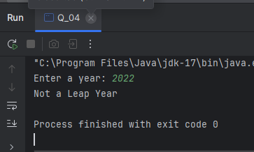

**Q5:**

package Q_05;  
import java.util.Scanner;  
  
public class Q_05 {  
 public static void main(String[] args) {  
 Scanner scanner = new Scanner(System.*in*);  
  
 // Entree  
 System.*out*.println("Select Entree:");  
 System.*out*.println("1. Tofu Burger - $3.49");  
 System.*out*.println("2. Cajun Chicken - $4.59");  
 System.*out*.println("3. Buffalo Wings - $3.99");  
 System.*out*.println("4. Rainbow Fillet - $2.99");  
 int entreeChoice = scanner.nextInt();  
 double entreePrice = 0;  
  
 switch (entreeChoice) {  
 case 1:  
 entreePrice = 3.49;  
 break;  
 case 2:  
 entreePrice = 4.59;  
 break;  
 case 3:  
 entreePrice = 3.99;  
 break;  
 case 4:  
 entreePrice = 2.99;  
 break;  
 default:  
 System.*out*.println("Invalid entree selection.");  
 return;  
 }  
  
 // Side Dish  
 System.*out*.println("Select Side Dish:");  
 System.*out*.println("1. Rice Cracker - $0.79");  
 System.*out*.println("2. No-Salt Fries - $0.69");  
 System.*out*.println("3. Zucchini - $1.09");  
 System.*out*.println("4. Brown Rice - $0.59");  
 int sideChoice = scanner.nextInt();  
 double sidePrice = 0;  
  
 switch (sideChoice) {  
 case 1:  
 sidePrice = 0.79;  
 break;  
 case 2:  
 sidePrice = 0.69;  
 break;  
 case 3:  
 sidePrice = 1.09;  
 break;  
 case 4:  
 sidePrice = 0.59;  
 break;  
 default:  
 System.*out*.println("Invalid side dish selection.");  
 return;  
 }  
  
 // Drink  
 System.*out*.println("Select Drink:");  
 System.*out*.println("1. Cafe Mocha - $1.99");  
 System.*out*.println("2. Cafe Latte - $1.90");  
 System.*out*.println("3. Espresso - $2.49");  
 System.*out*.println("4. Oolong Tea - $0.99");  
 int drinkChoice = scanner.nextInt();  
 double drinkPrice = 0;  
  
 switch (drinkChoice) {  
 case 1:  
 drinkPrice = 1.99;  
 break;  
 case 2:  
 drinkPrice = 1.90;  
 break;  
 case 3:  
 drinkPrice = 2.49;  
 break;  
 case 4:  
 drinkPrice = 0.99;  
 break;  
 default:  
 System.*out*.println("Invalid drink selection.");  
 return;  
 }  
  
 double total = entreePrice + sidePrice + drinkPrice;  
 System.*out*.printf("Total price: $%.2f%n", total);  
 }  
}

**Output:**

