**Q1:**

package Q_01;  
  
public class Q_01 {  
 // Q_01/Pet.java  
 public class Pet {  
 private String name;  
  
 public String getName() {  
 return name;  
 }  
  
 public void setName(String petName) {  
 name = petName;  
 }  
  
 public String speak() {  
 return "I'm your cuddly little pet.";  
 }  
 }  
  
 // Q_01/Dog.java  
 public class Dog extends Pet {  
 @Override  
 public String speak() {  
 return "Woof!";  
 }  
 }  
  
 // Q_01/Cat.java  
 public class Cat extends Pet {  
 @Override  
 public String speak() {  
 return "Meow!";  
 }  
 }  
  
}

**Q2:**

package Q_02;  
  
import java.util.ArrayList;  
import java.util.Scanner;  
  
// Base class Pet  
class Pet {  
 private String name;  
  
 public String getName() {  
 return name;  
 }  
  
 public void setName(String petName) {  
 this.name = petName;  
 }  
  
 public String getType() {  
 return "Pet";  
 }  
}  
  
// Cat subclass  
class Cat extends Pet {  
 @Override  
 public String getType() {  
 return "Cat";  
 }  
}  
  
// Dog subclass  
class Dog extends Pet {  
 @Override  
 public String getType() {  
 return "Dog";  
 }  
}  
  
  
public class Q_02 {  
 public static void main(String[] args) {  
 ArrayList<Pet> pets = new ArrayList<>();  
 Scanner scanner = new Scanner(System.*in*);  
  
 while (true) {  
 System.*out*.print("Enter pet name (or STOP to finish): ");  
 String name = scanner.nextLine();  
 if (name.equalsIgnoreCase("STOP")) break;  
  
 System.*out*.print("Enter type (c for Cat, d for Dog): ");  
 String type = scanner.nextLine().trim().toLowerCase();  
  
 Pet pet;  
 if (type.equals("c")) {  
 pet = new Cat();  
 } else if (type.equals("d")) {  
 pet = new Dog();  
 } else {  
 System.*out*.println("Invalid type. Please enter 'c' or 'd'.");  
 continue;  
 }  
  
 pet.setName(name);  
 pets.add(pet);  
 }  
  
 System.*out*.println("\nPet List:");  
 for (Pet p : pets) {  
 System.*out*.println("Name: " + p.getName() + ", Type: " + p.getType());  
 }  
  
 scanner.close();  
 }  
}

**Output:**

**Q3:**

package Q_03;  
import java.util.ArrayList;  
import java.util.Scanner;  
  
// Base class Pet  
class Pet {  
 private String name;  
  
 public String getName() {  
 return name;  
 }  
  
 public void setName(String petName) {  
 this.name = petName;  
 }  
  
 public String getType() {  
 return "Pet";  
 }  
}  
  
// Cat subclass  
class Cat extends Pet {  
 @Override  
 public String getType() {  
 return "Cat";  
 }  
}  
  
// Dog subclass  
class Dog extends Pet {  
 @Override  
 public String getType() {  
 return "Dog";  
 }  
}  
  
public class Q_03 {  
 public static void main(String[] args) {  
 ArrayList<Pet> pets = new ArrayList<>();  
 Scanner scanner = new Scanner(System.*in*);  
  
 while (true) {  
 System.*out*.print("Enter pet name (or STOP to finish): ");  
 String name = scanner.nextLine();  
 if (name.equalsIgnoreCase("STOP")) break;  
  
 System.*out*.print("Enter type (c for Cat, d for Dog): ");  
 String type = scanner.nextLine().trim().toLowerCase();  
  
 Pet pet;  
 if (type.equals("c")) {  
 pet = new Cat();  
 } else if (type.equals("d")) {  
 pet = new Dog();  
 } else {  
 System.*out*.println("Invalid type. Please enter 'c' or 'd'.");  
 continue;  
 }  
  
 pet.setName(name);  
 pets.add(pet);  
 }  
  
 // Group and display pets  
 System.*out*.println("\nCat Names:");  
 for (Pet p : pets) {  
 if (p instanceof Cat) {  
 System.*out*.println("- " + p.getName());  
 }  
 }  
  
 System.*out*.println("\nDog Names:");  
 for (Pet p : pets) {  
 if (p instanceof Dog) {  
 System.*out*.println("- " + p.getName());  
 }  
 }  
  
 scanner.close();  
 }  
}

**Output:**

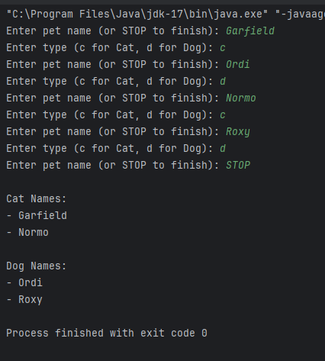

**Q4:**

//Class Pet

package Q_04;  
  
public class Pet {  
 private String name;  
  
 public String getName() {  
 return name;  
 }  
  
 public void setName(String petName) {  
 this.name = petName;  
 }  
  
 public String getType() {  
 return "Pet";  
 }  
}

//Class Cat

package Q_04;  
  
public class Cat extends Pet {  
 private String coatColor;  
  
 public String getCoatColor() {  
 return coatColor;  
 }  
  
 public void setCoatColor(String coatColor) {  
 this.coatColor = coatColor;  
 }  
  
 @Override  
 public String getType() {  
 return "Cat";  
 }  
}

//Class Dog

package Q_04;  
  
public class Dog extends Pet {  
 private double weight;  
  
 public double getWeight() {  
 return weight;  
 }  
  
 public void setWeight(double weight) {  
 this.weight = weight;  
 }  
  
 @Override  
 public String getType() {  
 return "Dog";  
 }  
}

Class Q_04

package Q_04;  
  
import java.util.ArrayList;  
import java.util.Scanner;  
  
public class Q_04 {  
 public static void main(String[] args) {  
 ArrayList<Pet> pets = new ArrayList<>();  
 Scanner scanner = new Scanner(System.*in*);  
  
 while (true) {  
 System.*out*.print("Enter pet name (or STOP to finish): ");  
 String name = scanner.nextLine();  
 if (name.equalsIgnoreCase("STOP")) break;  
  
 System.*out*.print("Enter type (c for Cat, d for Dog): ");  
 String type = scanner.nextLine().trim().toLowerCase();  
  
 if (type.equals("c")) {  
 Cat cat = new Cat();  
 cat.setName(name);  
 System.*out*.print("Enter coat color: ");  
 cat.setCoatColor(scanner.nextLine());  
 pets.add(cat);  
  
 } else if (type.equals("d")) {  
 Dog dog = new Dog();  
 dog.setName(name);  
 System.*out*.print("Enter weight: ");  
 try {  
 dog.setWeight(Double.*parseDouble*(scanner.nextLine()));  
 pets.add(dog);  
 } catch (NumberFormatException e) {  
 System.*out*.println("Invalid weight entered. Skipping this dog.");  
 }  
  
 } else {  
 System.*out*.println("Invalid type. Please enter 'c' or 'd'.");  
 }  
 }  
  
 // Display cats  
 System.*out*.println("\nCat List:");  
 for (Pet p : pets) {  
 if (p instanceof Cat) {  
 Cat cat = (Cat) p;  
 System.*out*.println("Name: " + cat.getName() + ", Type: Cat, Coat Color: " + cat.getCoatColor());  
 }  
 }  
  
 // Display dogs  
 System.*out*.println("\nDog List:");  
 for (Pet p : pets) {  
 if (p instanceof Dog) {  
 Dog dog = (Dog) p;  
 System.*out*.println("Name: " + dog.getName() + ", Type: Dog, Weight: " + dog.getWeight() + " kg");  
 }  
 }  
  
 scanner.close();  
 }  
}

**Output:**

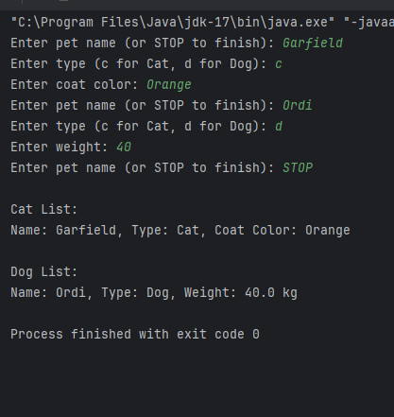

**Q5:**

package Q_05;  
  
import Q_04.Dog;  
import Q_04.Cat;  
import Q_04.Pet;  
  
import java.util.ArrayList;  
import java.util.Scanner;  
  
public class Q_05 {  
 public static void main(String[] args) {  
 ArrayList<Pet> pets = new ArrayList<>();  
 ArrayList<Dog> dogList = new ArrayList<>();  
 Scanner scanner = new Scanner(System.*in*);  
  
 //Input section (reused from Q_04)  
 while (true) {  
 System.*out*.print("Enter pet name (or STOP to finish): ");  
 String name = scanner.nextLine();  
 if (name.equalsIgnoreCase("STOP")) break;  
  
 System.*out*.print("Enter type (c for Cat, d for Dog): ");  
 String type = scanner.nextLine().trim().toLowerCase();  
  
 if (type.equals("c")) {  
 Cat cat = new Cat();  
 cat.setName(name);  
 System.*out*.print("Enter coat color: ");  
 cat.setCoatColor(scanner.nextLine());  
 pets.add(cat);  
 } else if (type.equals("d")) {  
 Dog dog = new Dog();  
 dog.setName(name);  
 System.*out*.print("Enter weight: ");  
 try {  
 dog.setWeight(Double.*parseDouble*(scanner.nextLine()));  
 pets.add(dog);  
 dogList.add(dog); //add only Dog references here  
 } catch (NumberFormatException e) {  
 System.*out*.println("Invalid weight. Skipping dog entry.");  
 }  
 } else {  
 System.*out*.println("Invalid type. Please enter 'c' or 'd'.");  
 }  
 }  
  
 //Process only Dog list  
 if (dogList.isEmpty()) {  
 System.*out*.println("\nNo dogs in the list.");  
 } else {  
 double total = 0;  
 double min = dogList.get(0).getWeight();  
 double max = min;  
  
 for (Dog d : dogList) {  
 double w = d.getWeight();  
 total += w;  
 if (w < min) min = w;  
 if (w > max) max = w;  
 }  
  
 double avg = total / dogList.size();  
  
 System.*out*.println("\nDog Weight Statistics:");  
 System.*out*.printf("Average: %.2f kg%n", avg);  
 System.*out*.printf("Minimum: %.2f kg%n", min);  
 System.*out*.printf("Maximum: %.2f kg%n", max);  
 }  
  
 scanner.close();  
 }  
}

**Output:**

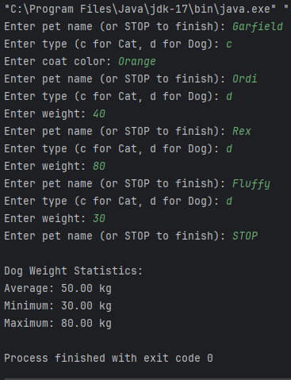

**Q6:**

package Q_06;  
  
import Q_04.Cat;  
import Q_04.Dog;  
import Q_04.Pet;  
  
import java.util.ArrayList;  
import java.util.Scanner;  
  
public class Q_06 {  
 public static void main(String[] args) {  
 ArrayList<Pet> pets = new ArrayList<>();  
  
 ArrayList<Cat> catList = new ArrayList<>();  
 ArrayList<Dog> dogList = new ArrayList<>();  
 Scanner scanner = new Scanner(System.*in*);  
  
 int choice = -1;  
  
 do {  
 //Display Menu  
 System.*out*.println("\n--- Pet Management Menu ---");  
 System.*out*.println("1. Add Cat");  
 System.*out*.println("2. Add Dog");  
 System.*out*.println("3. Remove Cat");  
 System.*out*.println("4. Remove Dog");  
 System.*out*.println("5. Display All Pets");  
 System.*out*.println("0. Quit");  
 System.*out*.print("Enter your choice: ");  
  
 try {  
 choice = Integer.*parseInt*(scanner.nextLine());  
 } catch (NumberFormatException e) {  
 System.*out*.println("Invalid input. Try again.");  
 continue;  
 }  
  
 switch (choice) {  
 case 1 -> {  
 Cat cat = new Cat();  
 System.*out*.print("Enter cat name: ");  
 String name = scanner.nextLine();  
 cat.setName(name);  
 System.*out*.print("Enter coat color: ");  
 String coatColor = scanner.nextLine();  
 cat.setCoatColor(coatColor);  
  
 catList.add(cat);  
 pets.add(cat);  
 System.*out*.println("Cat added successfully.");  
 }  
  
 case 2 -> {  
 Dog dog = new Dog();  
 System.*out*.print("Enter dog name: ");  
 String name = scanner.nextLine();  
 dog.setName(name);  
 System.*out*.print("Enter weight: ");  
 try {  
 double weight = Double.*parseDouble*(scanner.nextLine());  
 dog.setWeight(weight);  
 dogList.add(dog);  
 pets.add(dog);  
 System.*out*.println("Dog added successfully.");  
 } catch (NumberFormatException e) {  
 System.*out*.println("Invalid weight. Dog not added.");  
 }  
 }  
  
 case 3 -> {  
 System.*out*.print("Enter cat name to remove: ");  
 String name = scanner.nextLine();  
 boolean removed = false;  
  
 for (int i = 0; i < catList.size(); i++) {  
 if (catList.get(i).getName().equalsIgnoreCase(name)) {  
 catList.remove(i);  
 removed = true;  
 break;  
 }  
 }  
  
 pets.removeIf(p -> p instanceof Cat && p.getName().equalsIgnoreCase(name));  
  
 if (removed) System.*out*.println("Cat removed successfully.");  
 else System.*out*.println("Cat not found.");  
 }  
  
 case 4 -> {  
 System.*out*.print("Enter dog name to remove: ");  
 String name = scanner.nextLine();  
 boolean removed = false;  
  
 for (int i = 0; i < dogList.size(); i++) {  
 if (dogList.get(i).getName().equalsIgnoreCase(name)) {  
 dogList.remove(i);  
 removed = true;  
 break;  
 }  
 }  
  
 pets.removeIf(p -> p instanceof Dog && p.getName().equalsIgnoreCase(name));  
  
 if (removed) System.*out*.println("Dog removed successfully.");  
 else System.*out*.println("Dog not found.");  
 }  
  
 case 5 -> {  
 if (pets.isEmpty()) {  
 System.*out*.println("No pets available.");  
 } else {  
 System.*out*.println("\n--- All Pets ---");  
 for (Pet p : pets) {  
 if (p instanceof Cat cat) {  
 System.*out*.println("Cat - Name: " + cat.getName() + ", Coat Color: " + cat.getCoatColor());  
 } else if (p instanceof Dog dog) {  
 System.*out*.println("Dog - Name: " + dog.getName() + ", Weight: " + dog.getWeight() + " kg");  
 }  
 }  
 }  
 }  
  
 case 0 -> System.*out*.println("Exiting program. Goodbye!");  
  
 default -> System.*out*.println("Invalid choice. Try again.");  
 }  
  
 } while (choice != 0);  
  
 scanner.close();  
 }  
}

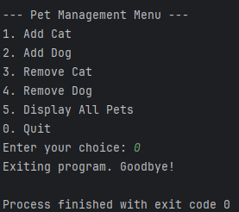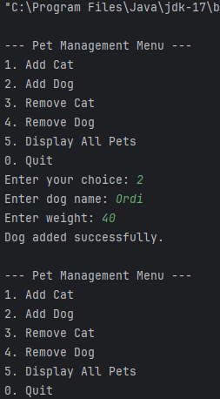**Output:**