**Q1:**

package Q_01;  
import javax.swing.*;  
  
public class Q_01 {  
 public static void main(String[] args) {  
 int num1 = Integer.*parseInt*(JOptionPane.*showInputDialog*("Enter first integer:"));  
 int num2 = Integer.*parseInt*(JOptionPane.*showInputDialog*("Enter second integer:"));  
 int num3 = Integer.*parseInt*(JOptionPane.*showInputDialog*("Enter third integer:"));  
  
 int sum = num1 + num2 + num3;  
  
 JOptionPane.*showMessageDialog*(null, "The sum is: " + sum);  
 }  
}

**Output:**

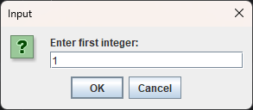

**Q_02:**

package Q_02;  
  
import javax.swing.*;  
import java.awt.*;  
  
public class MyFrame extends JFrame {  
  
 public MyFrame() {  
 setTitle("My Frame");  
 setSize(400, 450);  
 setDefaultCloseOperation(JFrame.*EXIT_ON_CLOSE*);  
 getContentPane().setBackground(Color.*BLUE*);  
 setLocationRelativeTo(null);  
 setVisible(true);  
 }  
}

package Q_02;  
  
public class Q_02 {  
 public static void main(String[] args) {  
 // Create and show the frame  
 new MyFrame();  
 }  
}

**Output:**

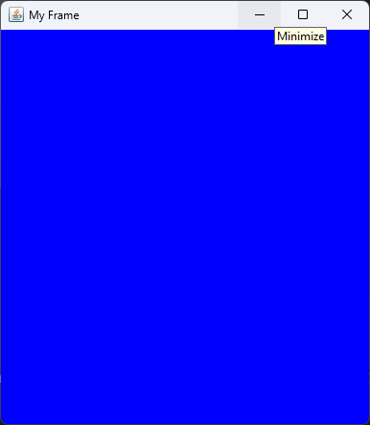

**Q3:**

package Q_03;  
  
import javax.swing.*;  
import java.awt.event.*;  
  
public class ButtonClickMessage extends JFrame {  
 public ButtonClickMessage() {  
 JButton button = new JButton("Click Me");  
 button.addActionListener(e -> JOptionPane.*showMessageDialog*(this, "You clicked!"));  
  
 add(button);  
 setSize(300, 200);  
 setDefaultCloseOperation(JFrame.*EXIT_ON_CLOSE*);  
 setTitle("Click Button");  
 setVisible(true);  
 }  
}

package Q_03;  
  
public class Q_03 {  
 public static void main(String[] args) {  
 new ButtonClickMessage();  
 }  
}

**Output:**

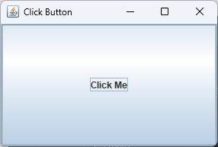

**Q4:**

package Q_04;  
  
import javax.swing.*;  
import java.awt.*;  
import java.awt.event.*;  
  
public class TitleChanger extends JFrame {  
 public TitleChanger() {  
 JTextField textField = new JTextField(20);  
 JButton button = new JButton("Set Title");  
  
 button.addActionListener(e -> setTitle(textField.getText()));  
  
 setLayout(new FlowLayout());  
 add(textField);  
 add(button);  
  
 setSize(400, 150);  
 setDefaultCloseOperation(JFrame.*EXIT_ON_CLOSE*);  
 setVisible(true);  
 }  
}

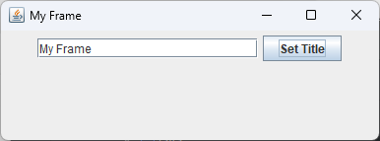package Q_04;  
  
public class Q_04 {  
 public static void main(String[] args) {  
 new TitleChanger();  
 }  
}

**Output:**

**Q5:**

package Q_05;  
  
import javax.swing.*;  
import java.awt.*;  
  
public class ToggleFrame extends JFrame {  
 private boolean isOn = false; // To track toggle state  
 private final JButton toggleButton;  
  
 public ToggleFrame() {  
 // Set title, size, and close behavior  
 setTitle("Toggle Frame");  
 setSize(300, 200);  
 setDefaultCloseOperation(JFrame.*EXIT_ON_CLOSE*);  
  
 // Set layout to null to directly control positions  
 setLayout(null);  
  
 // Create the button  
 toggleButton = new JButton("OFF");  
 toggleButton.setBounds(100, 70, 100, 40); // Position and size  
  
 // Set initial background color to Green  
 getContentPane().setBackground(Color.*GREEN*);  
  
 // Add action listener to toggle color and text  
 toggleButton.addActionListener(e -> toggleState());  
  
 // Add button to the frame  
 add(toggleButton);  
  
 // Center and show the frame  
 setLocationRelativeTo(null);  
 setVisible(true);  
 }  
  
 private void toggleState() {  
 isOn = !isOn;  
  
 // Update button text and background color  
 if (isOn) {  
 toggleButton.setText("ON");  
 getContentPane().setBackground(Color.*RED*);  
 } else {  
 toggleButton.setText("OFF");  
 getContentPane().setBackground(Color.*GREEN*);  
 }  
 }  
  
 public static void main(String[] args) {  
 new ToggleFrame();  
 }  
}

package Q_05;  
  
public class Q_05 {  
 public static void main(String[] args) {  
 new ToggleFrame(); // This should now resolve correctly  
 }  
}

**Output:**

