**Lab worksheet 04(CT-2021-031)**

**01)** **package Q_01;  
  
import java.util.*;  
  
public class Q_01 {  
 public static void main(String[] args) {  
  
 Scanner s;  
 s=new Scanner(System.*in*);  
  
 System.*out*.print("input first number:");  
 int a=s.nextInt();  
  
 System.*out*.print("input second number:");  
 int b=s.nextInt();  
  
 System.*out*.print("input third number:");  
 int c=s.nextInt();  
  
 if(a<b)  
 {  
 if(a<c)  
 {  
 System.*out*.println("The minimum Number is "+a);  
 }else{  
 System.*out*.println("The minimum Number is "+c);  
 }  
 }else  
 {  
 if(b<c)  
 {  
 System.*out*.println("the minimum Number is "+b);  
 }else  
 {  
 System.*out*.println("the minimum Number is "+c);  
 }  
 }  
  
 }  
}**

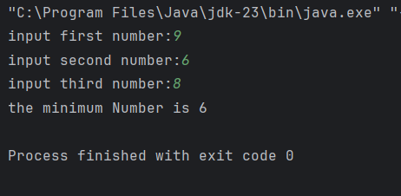

**02)** **package Q_02;  
  
import java.util.*;  
public class Q_02 {  
 public static void main(String[] args) {  
  
 System.*out*.println("0.Magenta");  
 System.*out*.println("1.Cyan");  
 System.*out*.println("2.Red");  
 System.*out*.println("3.Blue");  
 System.*out*.println("4.Green");  
 System.*out*.println("Select one color from the above list:");  
  
 Scanner s;  
 s=new Scanner(System.*in*);  
  
 int n=s.nextInt();  
  
 switch(n)  
 {  
 case 0:  
 System.*out*.println("You selected Magenta");  
 break;  
  
 case 1:  
 System.*out*.println("You selected Cyan");  
 break;  
  
 case 2:  
 System.*out*.println("You selected Red");  
 break;  
  
 case 3:  
 System.*out*.println("You selected Blue");  
 break;  
  
 case 4:  
 System.*out*.println("You selected Green");  
 break;  
  
 default:  
 System.*out*.println("Invalid selection");  
 break;  
  
  
  
  
  
 }  
  
 }  
}**

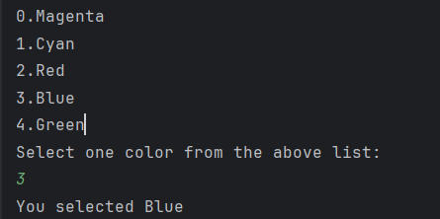

**03)** **package Q_03;  
  
import java.util.*;  
  
public class Q_03 {  
 public static void main(String[] args) {  
  
 System.*out*.println("input power:");  
  
 Scanner s;  
 s=new Scanner(System.*in*);  
  
 int p=s.nextInt();  
  
 int x=(10^p);  
  
 if(x==(10^6))  
 {  
 System.*out*.println("Million");  
 }else{  
 if(x==(10^9))  
 {  
 System.*out*.println("Billion");  
 }else{  
 if(x==(10^12))  
 {  
 System.*out*.println("Trillion");  
 }else{  
 if(x==(10^15))  
 {  
 System.*out*.println("Quadrillion");  
 }else{  
 if(x==(10^18))  
 {  
 System.*out*.println("Quintillion");  
 }else{  
 if(x==(10^21))  
 {  
 System.*out*.println("Sextillion");  
 }else{  
 if(x==(10^30))  
 {  
 System.*out*.println("Nonillion");  
 }else{  
 if(x==(10^100))  
 {  
 System.*out*.println("Googol");  
 }else{  
 System.*out*.println("invalid");  
 }  
  
 }  
 }  
 }  
 }  
 }  
 }  
 }  
  
  
  
 }  
}**

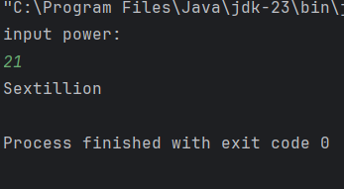

**04)** **package Q_04;  
  
import java.util.*;  
  
public class Q_04 {  
 public static void main(String[] args) {  
  
 Scanner s;  
 s=new Scanner(System.*in*);  
  
 System.*out*.print("input year:");  
  
 int year=s.nextInt();  
  
 if((year/4==0)&&(year/100==0))  
 {  
 if(year/400==0)  
 {  
 System.*out*.println("Leap year");  
 }else  
 {  
 System.*out*.println("Not a Leap Year");  
 }  
 }else  
 {  
 if(year/4==0)  
 {  
 System.*out*.println("Leap Year");  
 }else  
 {  
 System.*out*.println("Not a Leap year");  
 }  
 }  
 }  
}**

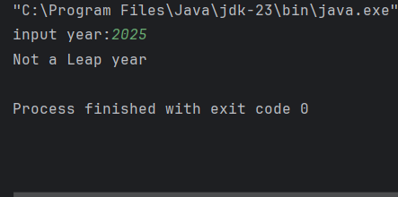

**05)** **package Q_05;  
  
import java.util.*;  
  
public class Q_05 {  
 public static void main(String[] args) {  
  
 Scanner s;  
 s=new Scanner(System.*in*);  
  
 System.*out*.println("Welcome to MyJava Lo-Fat Burgers!\n");  
  
 System.*out*.println("Choose an Entree:");  
 System.*out*.println("1. Tofu Burger - $3.49");  
 System.*out*.println("2. Cajun Chicken - $4.59");  
 System.*out*.println("3. Buffalo Wings - $3.99");  
 System.*out*.println("4. Rainbow Fillet - $2.99");  
 System.*out*.print("enter your choice (1-4):");  
  
 int a=s.nextInt();  
  
 System.*out*.println("\n\n");  
  
 System.*out*.println("Choose a Side Dish:");  
 System.*out*.println("1. Rice Cracker - $0.79");  
 System.*out*.println("2. No-Salt Fries - $0.69");  
 System.*out*.println("3. Zucchini - $1.09");  
 System.*out*.println("4. Brown Rice - $0.59");  
 System.*out*.print("Enter your choice (1-4):");  
  
 int b=s.nextInt();  
  
 System.*out*.println("\n\n");  
  
 System.*out*.println("Choose a Drink:");  
 System.*out*.println("1. Cafe Mocha - $1.99");  
 System.*out*.println("2. Cafe Latte - $1.90");  
 System.*out*.println("3. Espresso - $2.49");  
 System.*out*.println("4. Oolong Tea - $0.99");  
 System.*out*.print("Enter your choice (1-4):");  
  
 int c=s.nextInt();  
  
 System.*out*.println("\n\n");  
  
 System.*out*.println("your order summary:");  
  
  
 switch(a)  
 {  
 case 1:  
 System.*out*.println("Tofu Burger - $3.49");  
 break;  
  
 case 2:  
 System.*out*.println("Cajun Chicken - $4.59");  
 break;  
  
 case 3:  
 System.*out*.println("Buffalo Wings - $3.99");  
 break;  
  
 case 4:  
 System.*out*.println("Rainbow Fillet - $2.99");  
 break;  
  
 default:  
 System.*out*.println("enter valid number");  
 break;  
 }**

