**Lab worksheet 05(CT-2021-031)**

**01) package Q_01;  
  
  
public class Q_01 {  
 public static void main(String[] args) {  
  
 int N=10;  
  
 while((N>=10) && (N<=49))  
 {  
 System.*out*.print(N+",");  
 N=N+1;  
 }  
  
 }  
}**

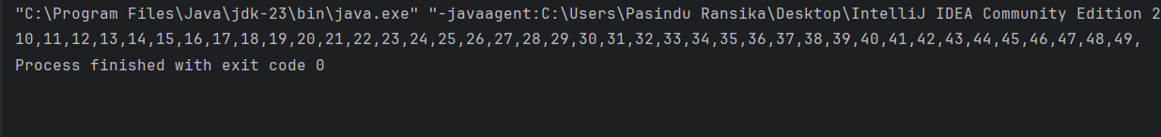

**02)**

**03)** **package Q_03;  
  
import java.util.*;  
  
public class Q_03 {  
 public static void main(String[] args) {  
  
 Scanner s;  
 s=new Scanner(System.*in*);  
  
 System.*out*.print("enter Number: ");  
 int N;  
 N=s.nextInt();  
  
 int multiplication;  
  
 for(int x=1; (x<=10); x=x+1)  
 {  
 multiplication=N*x;  
 System.*out*.println(multiplication);  
  
 }  
 }  
}**

**04)** **package Q_04;  
  
import java.util.*;  
  
public class Q_04 {  
 public static void main(String[] args) {  
  
 Scanner s;  
 s=new Scanner(System.*in*);  
  
 System.*out*.print("enter Number:");  
 int N;  
 N=s.nextInt();  
  
 for(int x=1; (x<=N); x=x+1)  
 {  
 for(int j=1; (j<=x); j=j+1)  
 {  
 System.*out*.print("*");  
 }  
 System.*out*.print("\n");  
 }  
 }  
}**

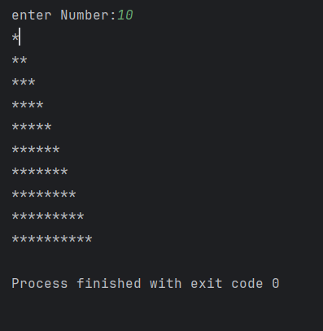

**05)** **package Q_05;  
  
import java.util.*;  
  
public class Q_05 {  
 public static void main(String[] args) {  
  
 Scanner s;  
 s= new Scanner(System.*in*);  
  
 System.*out*.print("Input a word or phrase: ");  
 String Word;  
 Word= s.next();  
  
 String cleaned = Word.replaceAll("[^a-zA-Z0-9]", "").toLowerCase();  
 String reversed = new StringBuilder(cleaned).reverse().toString();  
  
 if (cleaned.equals(reversed)) {  
 System.*out*.println("It's a palindrome!");  
 } else {  
 System.*out*.println("It's not a palindrome.");  
 }  
  
  
 }  
}**

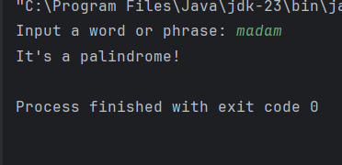

**06) package Q_06;  
  
import java.util.*;  
  
public class Q_06 {  
 public static void main(String[] args) {  
  
 int x=(int)(Math.*random*()*100);  
  
 if(x<=50)  
 {  
 System.*out*.println("Lower");  
 }else  
 {  
 System.*out*.println("higher");  
 }  
  
 Scanner s;  
 s=new Scanner(System.*in*);  
 System.*out*.print("input a number:");  
 int Number;  
 Number=s.nextInt();  
  
 System.*out*.println("random Number is: "+x);  
 }  
}**

**7)** **package Q_07;  
  
import java.util.*;  
  
public class Q_07 {  
 public static void main(String[] args) {  
  
 Scanner s;  
 s= new Scanner(System.*in*);  
  
 System.*out*.println("Enter a sentence: ");  
 String sentence = s.nextLine();   
  
 System.*out*.println("Enter the word to replace: ");  
 String oldWord = s.nextLine();   
  
 System.*out*.println("Enter the replacement word: ");  
 String newWord = s.nextLine();   
  
 String updatedSentence = sentence.replaceAll("\\b" + oldWord + "\\b", newWord);  
  
 System.*out*.println("Updated sentence: " + updatedSentence);  
  
 }  
}**

