**Lab worksheet 01**

Q1) **code**

import javax.swing.JFrame;  
 public class Q_1 {  
 public static void main(String[] args) {  
  
 JFrame frame = new JFrame("Welcome to Java");  
 frame.setSize(800, 600);  
 frame.setVisible(true);  
  
 }  
 }

**output**

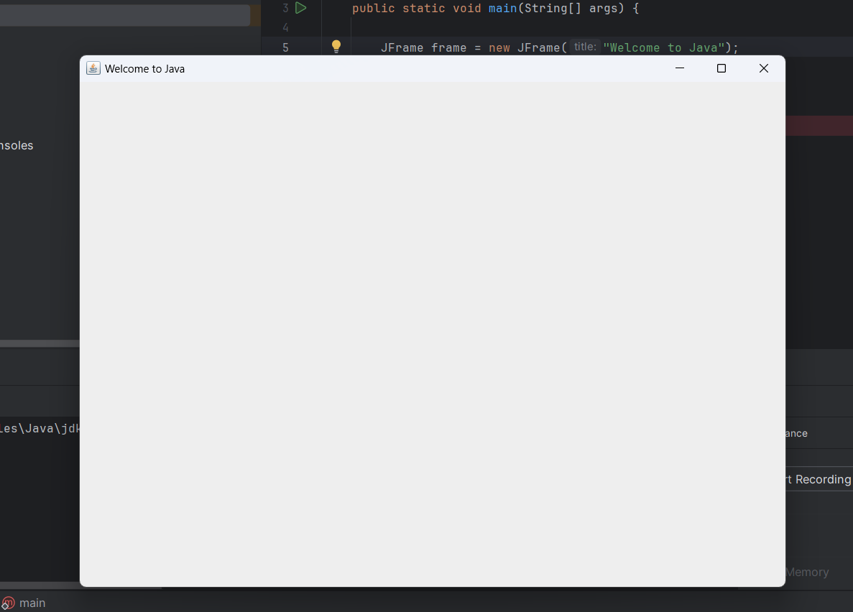

Q2) **code**

import javax.swing.*;  
import java.util.*;  
  
public class Q_2 {  
 public static void main(String[] args) {  
 Scanner scanner = new Scanner(System.*in*);  
 String firstName;  
 String lastName;  
 System.*out*.print("Enter your first name: ");  
 firstName = scanner.next();  
 System.*out*.print("Enter your last name: ");  
 lastName = scanner.next();  
 JFrame frame = new JFrame();  
 frame.setSize(300,200);  
 frame.setVisible(true);  
 System.*out*.print(firstName+" "+lastName);

frame.setTitle(firstName+" "+lastName);

}  
}

**output**

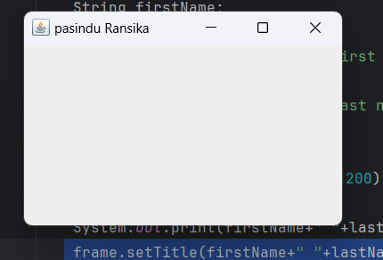

Q3)**code**

public class Q_3 {  
 public static void main(String[] args) {  
 Scanner scanner = new Scanner(System.*in*);  
 String firstName;  
 String secondName;  
 String lastName;  
  
 System.*out*.print("Enter your first name: ");  
 firstName = scanner.next();  
 System.*out*.print("Enter your second name: ");  
 secondName = scanner.next();  
 System.*out*.print("Enter your last name: ");  
 lastName = scanner.next();  
  
 JFrame frame = new JFrame();  
 frame.setSize(300,200);  
 frame.setVisible(true);  
 System.*out*.print(firstName+" "+secondName.charAt(0)+"."+lastName);  
 }  
}

**output**

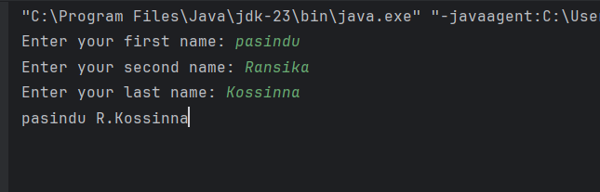

**Q4) code**

import java.text.SimpleDateFormat;  
import java.util.*;  
  
public class Q_4 {  
 public static void main(String[] args) {  
 Date D = new Date();  
 SimpleDateFormat sdf = new SimpleDateFormat("dd MMM yyyy");  
 System.*out*.println(sdf.format(D));  
 }  
}

**output**

**Q5)code**

import java.text.SimpleDateFormat;  
import java.util.*;  
  
public class Q_5 {  
 public static void main(String[] args) {  
 Date D = new Date();  
 SimpleDateFormat sdf = new SimpleDateFormat("EEEE, MMM dd, yyyy");  
 System.*out*.println(sdf.format(D));  
 }  
}

output

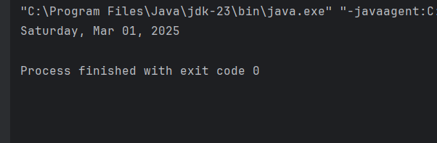

**Q6) code**

import javax.swing.*;  
import java.util.Scanner;  
  
public class Q_6 {  
 public static void main(String[] args) {  
 Scanner s=new Scanner(System.*in*);  
  
 System.*out*.print("Enter width:");  
 int width =s.nextInt();  
  
 System.*out*.print("Enter height:");  
 int height =s.nextInt();  
  
 s.nextLine();  
  
 System.*out*.print("Enter title:");  
 String title =s.nextLine();  
  
 JFrame frame = new JFrame(title);  
 frame.setSize(width, height);  
 frame.setDefaultCloseOperation(JFrame.*EXIT_ON_CLOSE*);  
 frame.setVisible(true);  
 }  
}

**output**

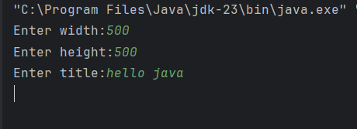

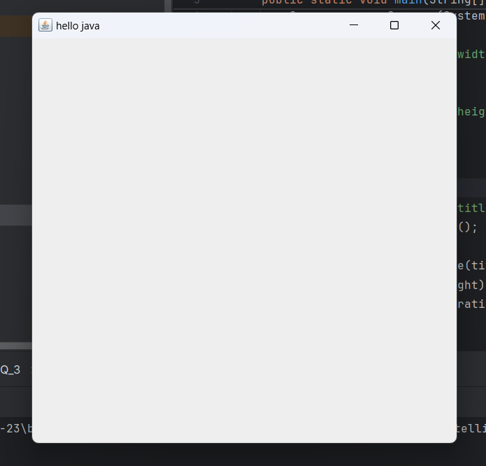

**Q7) code**

import javax.swing.*;  
import java.text.SimpleDateFormat;  
import java.util.Date;  
  
public class Q_7 {  
 public static void main(String[] args) {  
 String time = new SimpleDateFormat("hh:mm:ss a").format(new Date());  
  
 JFrame frame = new JFrame(time);  
 frame.setSize(600, 500);  
 frame.setDefaultCloseOperation(JFrame.*EXIT_ON_CLOSE*);  
 frame.setVisible(true);  
 }  
}

**output**

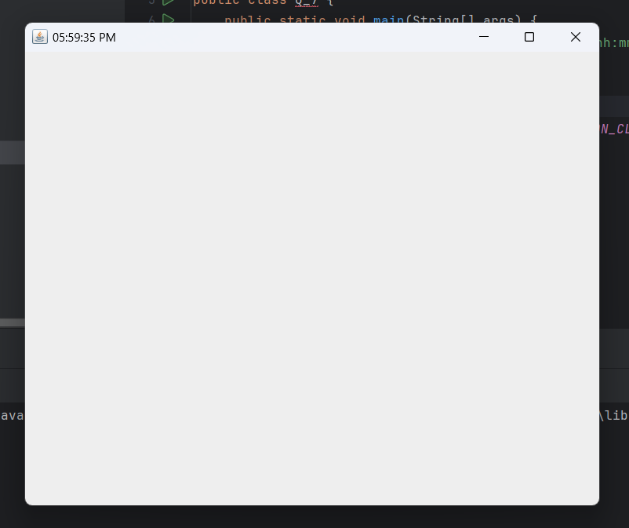

**Q8) code**

import java.util.Scanner;  
  
public class Q_8 {  
 public static void main(String[] args) {  
 Scanner sc=new Scanner(System.*in*);  
 System.*out*.print("input string value:");  
 String I=sc.nextLine();  
 String[] parts=I.split("!");  
 System.*out*.println(parts[0].trim());  
 System.*out*.println(parts[1].trim());  
 }  
}

**output**

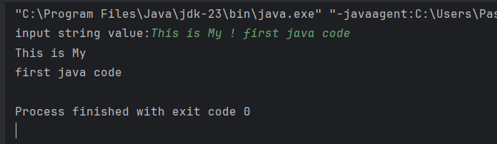

**Q9)code**

import java.util.Scanner;  
  
public class Q_9{  
 public static void main(String[] args) {  
 System.*out*.print("input number or text:");  
 Scanner s=new Scanner(System.*in*);  
 String i=s.nextLine();  
  
 System.*out*.println(i.length());  
 System.*out*.println(i.charAt(0));  
 System.*out*.println(i.charAt(i.length() - 1));  
 }  
}

**output**

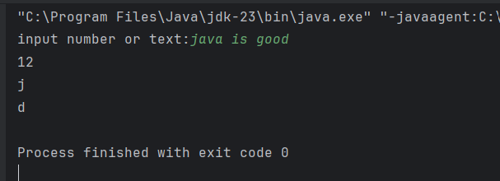

**Q10) code**

import java.util.Scanner;  
public class Q10 {  
 public static void main(String[] args) {  
 System.*out*.print("input word:");  
 Scanner s=new Scanner(System.*in*);  
 String word=s.nextLine();  
 int middleIndex = word.length()/2;  
 System.*out*.println(word.charAt(middleIndex));  
 }  
}

**output**

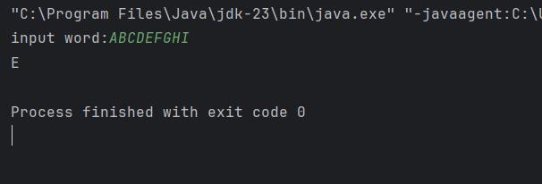

**Q11) code**

import java.util.Scanner;  
public class Q11 {  
 public static void main(String[] args) {  
 Scanner s=new Scanner(System.*in*);  
 System.*out*.print("Enter your full name:");  
 String first = s.next();  
 String middle = s.next();  
 String last = s.next();  
 System.*out*.println(last+","+first+" "+ middle.charAt(0)+".");  
 s.close();  
 }  
}

**output**

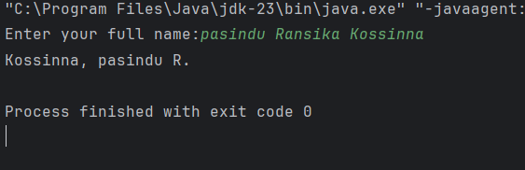

**Q12)code**

import javax.swing.JFrame;  
public class Q12 {  
 public static void main(String[] args) {  
 JFrame FR=new JFrame("My First Frame");  
 FR.setSize(300,200);  
 FR.setLocation(100, 50);  
 FR.setDefaultCloseOperation(JFrame.*EXIT_ON_CLOSE*);  
 FR.setVisible(true);  
 }  
}

**output**

