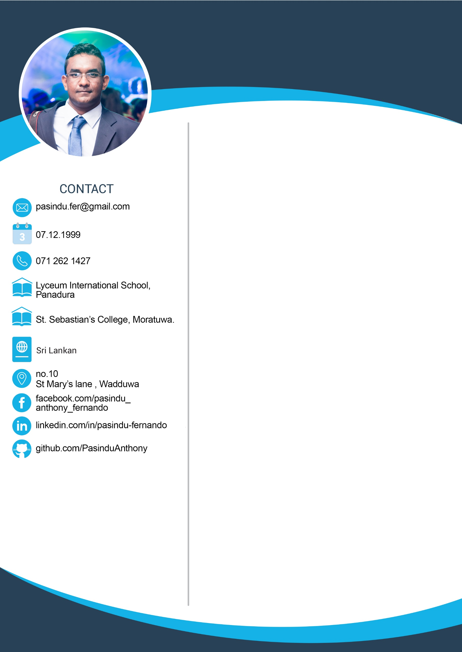­



PROFILE

Undergraduate, in the field of Software Engineering, with sound knowledge and expertise in programing skills (Machine learning, Frontend development, backend development, database management), and up to date with innovative technologies. Strong desire and profound ability in quick-grasping, and independently working in an efficient manner with minimal supervision.

<pasindu.fer@gmail.com>



(+94) 71 262 1427

ACADEMICS

VISION

To be part of an esteemed organization, a truly Global player in the Industry of Information Technology that offers equal opportunities and progressive career development, willing to lend a hand to an Apprentice (currently at an Internship level), to make inroads into a lasting career.

Panadura, Sri Lanka

Lyceum International School

St. Sebastian’s College

Moratuwa, Sri Lanka

[ImageGallery](https://pasinduanthony.github.io/ImageGallery/)

2018-2022

**BEng Software Engineering**(**University of Westminster)** affiliated with the **Informatics Institute of Technology**(Level 5) - Object Oriented Programming Pending - Database Systems Pending - Software Development Group Project Pending - Client Server Architecture Pending - Server-side Web Development Pending - Algorithms Pending(Level 4) - Programming Principles I B - Programming Principles II B - Web Design and Development B - Computer Science Practice C - Computer Systems Fundamentals S - Mathematics for Computing S

**Secondary Education** (Cambridge International Examinations)Lyceum International School Panadura, Sri Lanka - Math B - Computer B - Physics C

Wadduwa, Sri Lanka

No: 10, St Mary’s Lane

[@PasinduAnthonyFernando](https://www.facebook.com/people/Pasindu-Anthony-Fernando/100011713651790)

[@pasindu-anthony](https://www.linkedin.com/in/pasindu-anthony-80b489180/)

[@PasinduAnthony](https://github.com/PasinduAnthony)

[@pasindu_anthony](https://www.instagram.com/Pasindu_Anthony/)

2016-2018



2004-2015

SKILLS

HTML/CSS

PHP

Java

JavaScript

My SQL

Python

Photoshop

Lightroom

React-Native

C#

Flutter

Git

JSON

Google API

SpringBoot

NodeJS

ML

LANGUAGES

Sinhala

English

HOBBIES

**Primary Education** (GCE Ordinary level)St. Sebastian’s College, Moratuwa, Sri Lanka - Math A - Computer A - History A - Art A - Religion A - Commerce B - English B - Sinhala B - Science B

**C# Course** (Microsoft Net Assist)

**C++ & Core Java Course**

(Jurassic Institute of Management and Technology, Sharjah, UAE)

**Cambridge ICT Starters**

(University of Cambridge International Examinations) through Gateway, Sri Lanka.

**English Language Course**

British Council, Colombo, Sri Lanka

2019



2016

2009-2014

2008-2011



**13th Young Computer Scientist Competition**

**(Federation of information Technology Industry Sri Lanka)**

**~ Merit Award**

**Schools Educational Software Provincial Competition** (**Ministry of Education** **Sri Lanka)** and (**Microsoft Sri Lanka)** **~ Merit Award**

2010

2014

ACHIEVEMENTS

**Lyceum International School, Panadura**

* Toastmasters club. (2018-2016)
* Western Band (2018-2016)
* Sinhala drama. (2017)

**St. Sebastian’s College, Moratuwa**

* Swimming club (2010-2008)
* Karate club (2012-2008)

**Volunteering**

* IEEE Yesist 12 Designing posters

(04.2019-05.2019)

**Negombo Photographers’ association (Negpho LK)**

**Negombo Photographers’ Association**



**XploreLanka Project**

Mobile based Trip planning application. Which predicts and tells the user the ideal day to visit a certain place in Sri Lanka.

BEYOND CURRICULAR

REFREES

**Mr. A.U. JAYAKODY**

**Superintendent of Customs**

30, Minuwanpitiya Cross Road,

Walana, Panadura.

Sri Lanka.

Telephone: (+94) 112 214 3434

Mobile: (+94) 71 864 0640

**Mr. Sudharshan Welihinda**

**Director – Operations of Informatics**

**Institute of Technology**

57, Ramakrishna Road, Colombo 06

Sri Lanka.

Telephone: (+94) 112 360 212

Mobile: (+94) 726 868192,

(+94) 768 209669

E-mail: [weli@iit.ac.lk](mailto:weli@iit.ac.lk)