As our group project our team decided to create a website for a “Flower Plant saling shop” I was appointed to create customer registration form.To buy flowers user need to register in our system as a customer.

First I create the table for customer as follows.

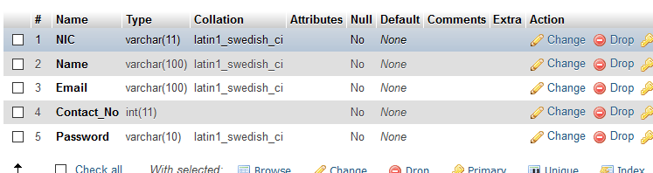

To get the customer details I created a simple user interface.

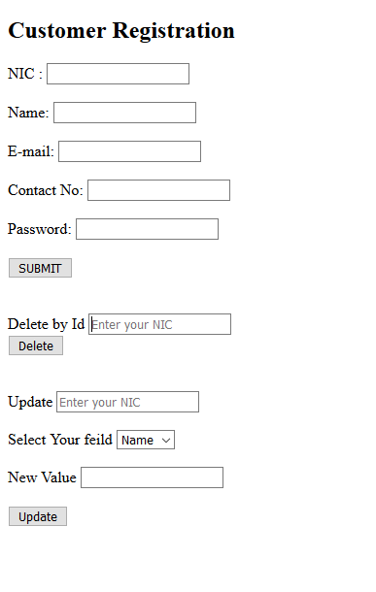

After that I started doing my php coding by connecting the database .Here is the code I wrote.

Then ,when customer add details in the form the details should be inserted in to the database.

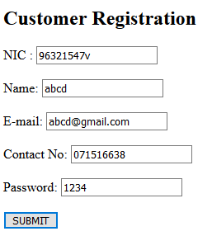

When I click the submit button data has inserted as follows.

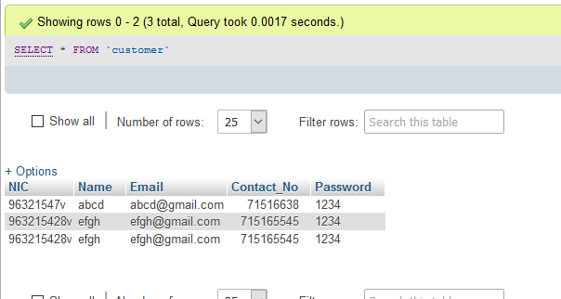

Here is the code for insertion .

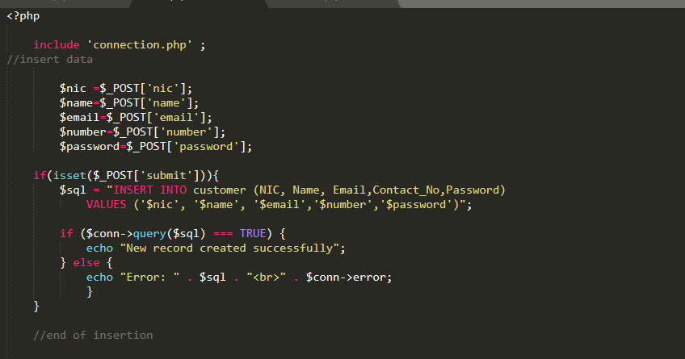

There are some situations which admin may need to delete a record. So I created delete option for it.

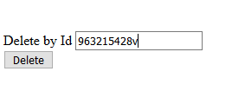

This is the code for deletion.

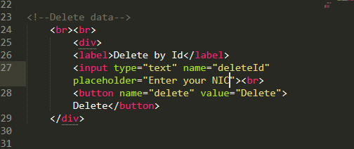

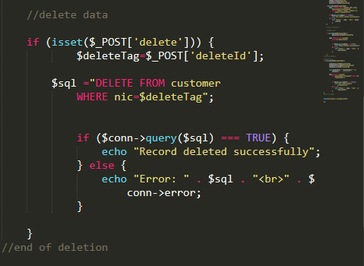

After the operation done the corresponding record is deleted in the database.

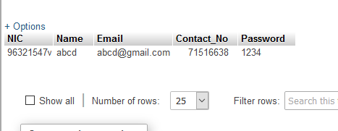

I add another option if the customer need to update any detail.

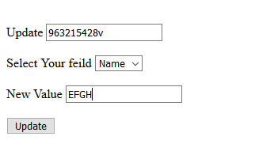

After doing the update operation the database has been updated.

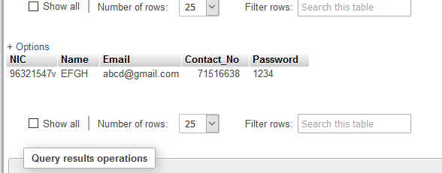

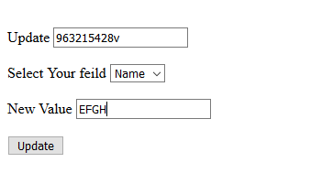

This is my code for the update operation.

