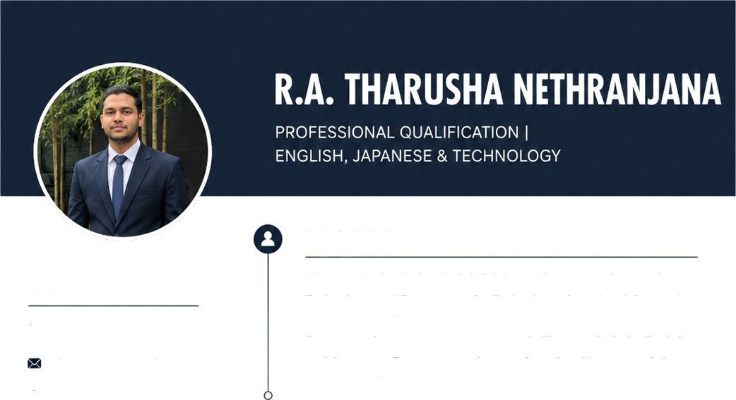

CONTACT

U 078 118 5335
tharutozzy@gmail.com

@ 339/01/A, Dadigampura, Angampitiya, Padukka
ID Number
200427702823

Date of Birth
2004.10.03

SKILLS

- Languages- Sinha!a (Native), English (Fluent), Japanese
- Technical: Vehicle Emission Testing, MS Office
- Soft Skills: Teamwork, Communication, Learning Ability

REFERENCE

K.S. Sakuni Gaya
Undergraduate I BSc (Hons) Geographical Information Science University of Peradeniya I Sri Lanka

C 076 263 7756
£g ID: 200453312746

PROFI LE
Motivated individual with G.C.E A/L qualifications in Science for Technology and Engineering for Technology. Completed Cambridge British Council English course and Vehicle Emission Testing Program. Experienced in government sector work. Fluent in Sinhala, English, and Japanese. Eager to contribute technical and language skills to a dynamic work environment.


WORK EXPERIENCE

Government Printing (Incorporated) Corporation - Meegoda
Work Experience


EDUCATION

G.C.E Advanced Level - Siri Piyarathana National School, Padukka
- Science for Technology - S
- Engineering for Technology - 5
- Home Economics Science - C

G.C.E Ordinary Level - Siri Piyarathana National School, Padukka
- Buddhism - C | English - S | Science - C | Mathematics - S
- History — S | Drama — C | Sinhala — | Commerce — C


COURSES 6 CERTIFICATIONS

- Cambridge British Council English Course - 6 Months Completed
- Vehicle Emission Testing Program
- Japanese Language Course

