

Programming Applications and Frameworks

(IT3030)

3rd Year, 1st Semester

Assignment

**ElectroGrid**

Submitted to

Sri Lanka Institute of Information Technology

Group – Y3.S1.WE.IT.02.01

Group ID – 220

IT20219598 – S.L.D.P Pramodya

IT20257040 – A.M.K.A.P Amarasingha

IT20235260 - D.R.N. Samarawila

IT20141356 - A.N Upathissa

In partial fulfillment of the requirements for the

Bachelor of Science Special Honors Degree in Information Technology

2022.04.26

GitHub Link – <https://github.com/PasinduPramodya/PAF_Electro.Grid.git>

Contents

Software Engineering Methodology (SE Methodology)………………………. 3

Gantt Chart…………………………………………………………………….. 4

Onion Diagram………………………………………………………………… 5

Requirements analysis…………………………………………………………. 6

Requirement Modelling……………………………………………………….. 7

Use case diagram……………………………………………………….. 7

Activity Diagram……………………………………………………….. 8

ER Diagram…………………………………………………………….. 9

Overall Architecture Diagram………………………………………………… 10

Requirement categorization…………………………………………………… 11

Individual contribution…………………………………………………… 12-28

Software Engineering methodology

Introduction

The ElectroGrid company which supplies power to the country is in need of a more

scalable system in order to maintain their users. The ElectroGrid system is a system

that our team has developed a highly scalable online platform to monitor the power

usages, generate bills and let their users make online payments.

The main functions that we have taken to implement are Customer management,

power consumption management, Generate Bill which is a part of financial management

and let the customers make online payments which is also function of financial

management, Employment management where details about the existing staff is managed.

Also, we have implemented a customer care where the users can lodge

complaints regarding the breakdowns, inquiries regarding bill payment and other

issues that may face, it is a part of the customer management.

To develop this system, we have chosen the Software Engineering methodology of

Agile development because this company already has its system and need

an extended version of the existing system in order to match the competition.

Also, there is a fixed set of requirements that they need implemented.

The main stakeholders that we have identified are: -

Customers

Power consumption manager

Electrical Engineer

Customer service manager

Financial manager

Staff manager

After identifying the main stakeholders, we have gathered all the necessary requirements needed for this system and analysed them to fix the most essential requirements.

Also we have categorised the requirements as functional, non-functional and technical to finalise the most important requirements and get a clear understanding about the logic.

**IDE Used** - Eclipse EE

**Database –** phpMyAdmin (MySQL)

**Server** - Tomcat

Gantt chart

|  |  |  |  |  |  |  |  |  |  |  |  |
| --- | --- | --- | --- | --- | --- | --- | --- | --- | --- | --- | --- |
| **09 April-24 April** |  |  |  |  |  |  |  |  |  |  |  |
| **07 April-08 April** |  |  |  |  |  |  |  |  |  |  |  |
| **04 April-06 April** |  |  |  |  |  |  |  |  |  |  |  |
| **01 April-03 April** |  |  |  |  |  |  |  |  |  |  |  |
| **14 March-31 March** |  |  |  |  |  |  |  |  |  |  |  |
| **12 March-13 March** |  |  |  |  |  |  |  |  |  |  |  |
| **11 March-12 March** |  |  |  |  |  |  |  |  |  |  |  |
| **08 March-10 March** |  |  |  |  |  |  |  |  |  |  |  |
| **05 March-07 March** |  |  |  |  |  |  |  |  |  |  |  |
| **03 March-04 March** |  |  |  |  |  |  |  |  |  |  |  |
| **01 March-02 March** |  |  |  |  |  |  |  |  |  |  |  |
|  | Stockholder Determination | Gather requirement | Analyzing requirements | Drawing UML | Drawing ER | Creating GitHub repository | Create individual functions | Create database | Connecting DB to individual part | Integrating the system | Report |

Onion Diagram

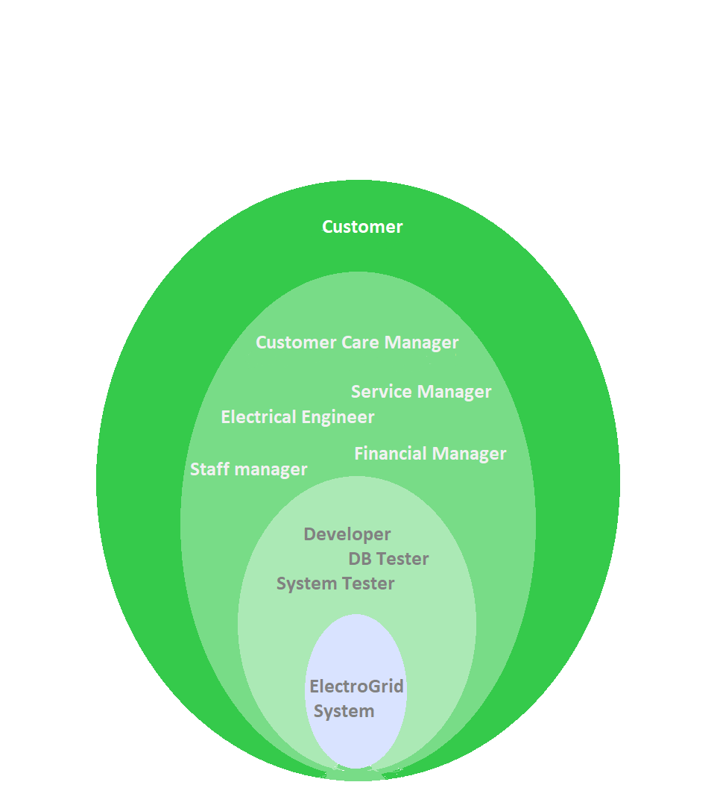

Requirement analysis

1. Customer management

Customer Registration

Customer login

Customer profile update

Customer profile delete

1. Customer care management

Customer lodge a complaint regarding an issue they faced.

1. Power consumption management

Determine power usage of each customer

Send the power usage details to financial management

Have a table with units and their rates in the database

1. Finance management

Get the necessary details from power consumption

Get customer details

Generate a bill regarding the usage

Allow customer to make online payments.

1. Employee management

Employee Registration

Employee login

Employee profile update

Employee profile delete

Engage in power management

Engage in billing management

Requirements modelling

Usecase Diagram

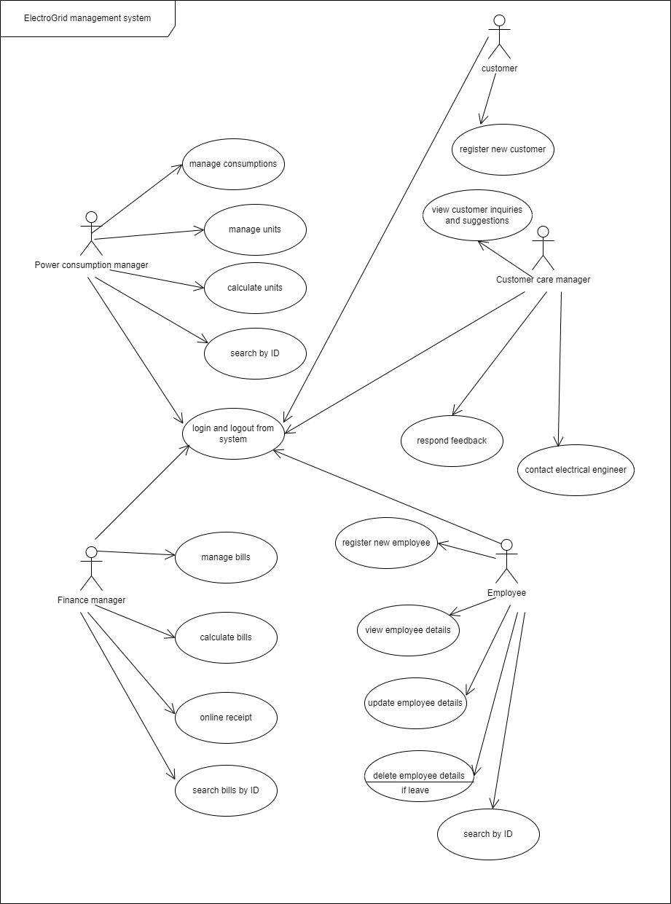

Overall Activity Diagram

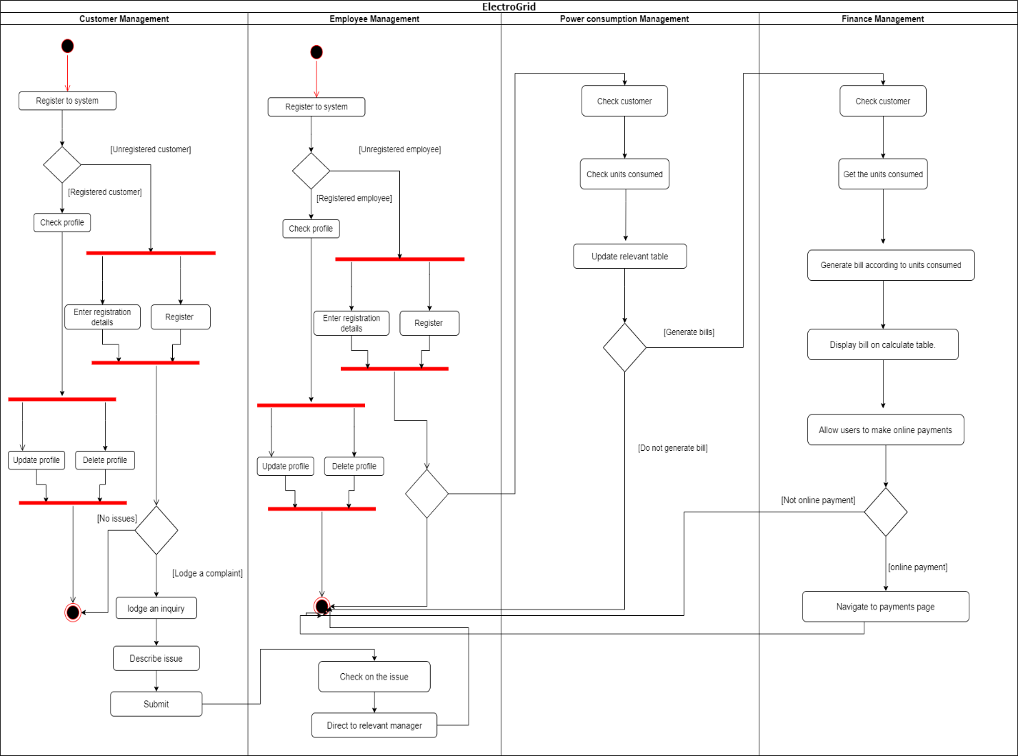

Overall Entity Relationship Diagram

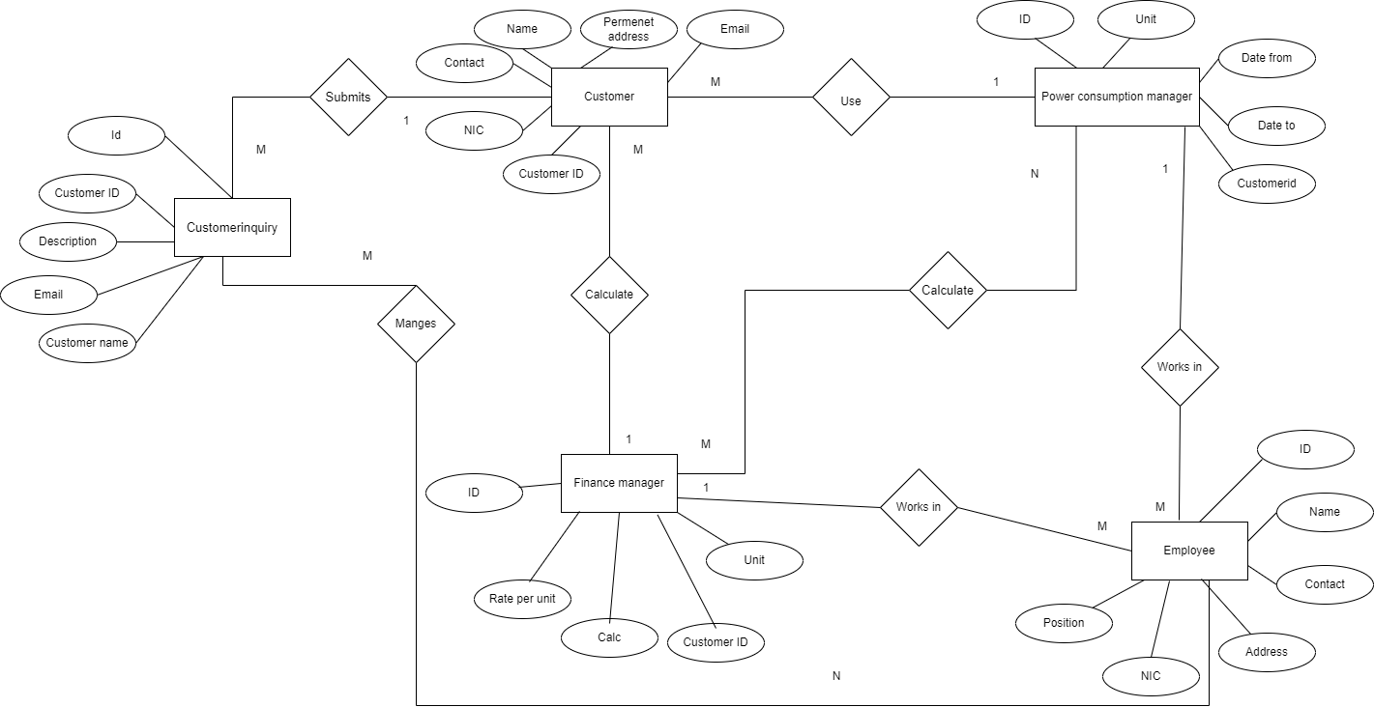

**Entity Relationship Diagram**

The main entities that we have identified are

Customer

Power consumption manager

Financial manager

Employee.

According to these entities we have identified the main tables in our Database

after all normalisation processes and schema refinements as

Customer table (id, name, permanent address, NIC, Email)

Customer_contact (id, cusid, contact)

Power consumption (id, unit, date _to, date_from, customerid)

Finance (id, rate_per_unit, calc, units, customerid)

Employee (id, Name, address, nic, position)

Employee_contact (id, eid, contact)

Calculate (id, customerid, powerid, financeid, bill)

Customerinquiry (id. customerid, Description, email, customername)

Overall Architecture

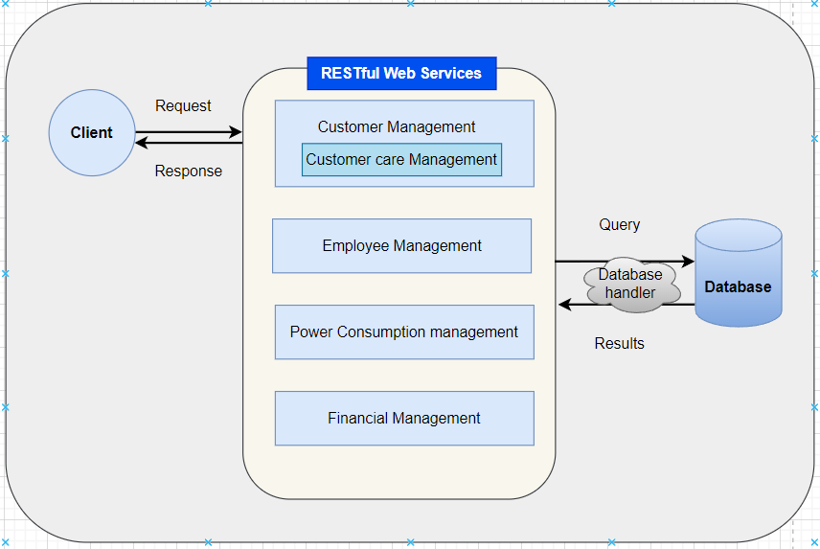

This Explains the overall architecture of our RESTful web services. The client request using the PUT,GET,POST and DELETE methods, then the web services manage the request with the relevant web service and database handler.

The database handler executes the query and obtain the relevant results from the Database

And the results are returned to the client as a response made to his/her request.

**Main web services:** -

Customer Management

Employee Management

Power consumption Management

Financial Management

Requirements Categorization

|  |  |  |  |
| --- | --- | --- | --- |
| **Functionality** | **Function Requirements** | **Non-functional Requirements** | **Technical Requirements** |
| Customer Management | * Customer can sign in or log in to the system * The system should allow a customer to check his or her monthly electricity bill. * The customer should be able to use the system to file a complaint   .  . | • Reliability  • Efficiency  • Security  • Usability  • Privacy | * Customer can directly register to the system using the Customer management |
| Customer Care Management | * Should be able to view customer’s inquiries and suggestions. * Should be able to contact electrical engineer to resolve power consumption issues. * Should be able to read and respond to feedback. * Should be able to delete outdated feedback and irrelevant remarks. | • Reliability  • Efficiency  • Security  • Usability  • Privacy | * Customer’s inquiry is directed to all management sections. |
| Power consumption management  (Service manager and Electrical engineer) | * Should be to view complaints logged by the client * Should be able to update the statuses of ongoing complaints * Working on the power consumption issues * Calculate the monthly consumption units | • Reliability  • Efficiency  • Security  • Usability  • Privacy | * Connecting with electrical engineers to solve issues. |
| Financial Management | * Should be able to manage bills. * Should be able to Calculate the bills by using monthly consumption power units and update the bills * Generate the online receipt | • Reliability  • Efficiency  • Security  • Usability  • Privacy | * Should be able to communicate with power consumption management and generate user’s bills. |
| Employee Management | * All employee information should be visible. * New employees should be able to be added to the system, and current employees should be able to be removed if they depart. | • Reliability  • Efficiency  • Security  • Usability  • Privacy | * Employees who have been verified have access to the personnel management feature. |

Use Case Diagrams - Individual

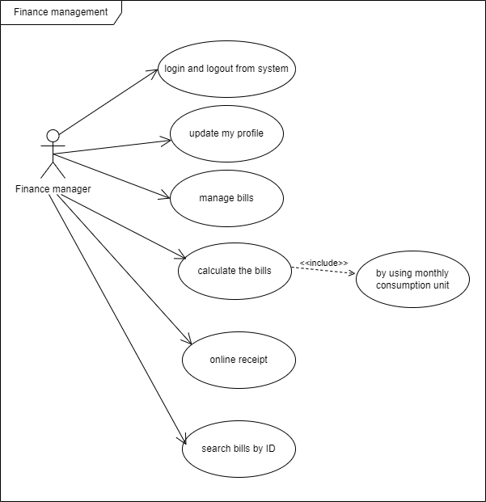 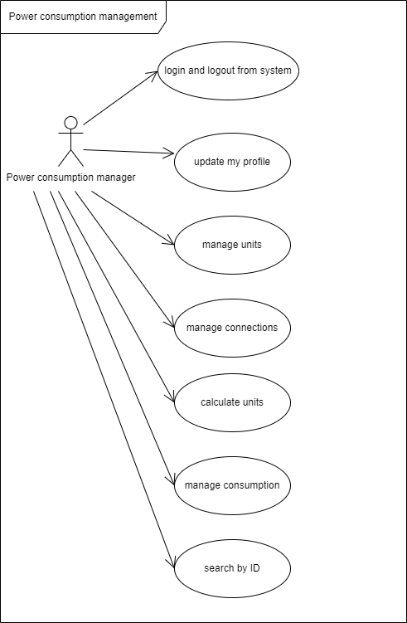

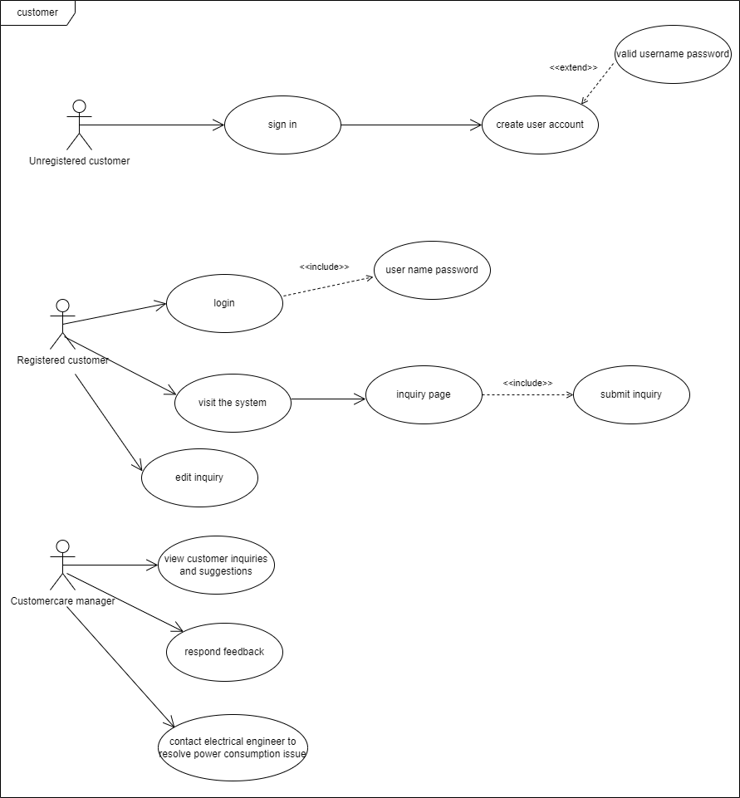 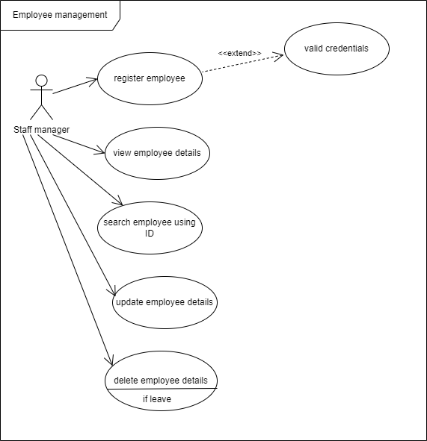

Individual Contribution

**S.L.D.P Pramodya - IT20219598**

**Web service -** Power Consumption Management

**Purpose** - The main purpose of this web service is to get the details of power usage of each individual registered in the system and send those details to Billing section in order to generate a bill on monthly basis. Here the rates are entered for each unit that the customers consume and the bill is generated using those details.

**Main stakeholders** - Electrical manager

Power consumption manager

Financial manager

**Logic used** - The power consumption manager gathers the relevant details of customer such as units consumed, date form, date to and enter them in the power consumption table along with customer’s ID. Here data is passed from powerconsumption.jsp to powerconsumptionservice.java and finally to powerconsumption.java which sends the data database using the relevant inserting query and updating and deletion are performed accordingly.

|  |
| --- |
| **Code** |
|  |
| **User Interface - Before inserting** |
|  |

|  |
| --- |
| **User Interface – After inserting** |
|  |
| **User Interface – After deletion** |
|  |

**A.M.K.A.P Amarasingha -IT20257040**

**Web service** - Financial Management

**Purpose -** The main purpose of this web service is to get the details of power usage of each individual registered in the system generate a bill according their usage. on monthly basis. Here the rates which are entered in the power consumption management tables are used to calculate the monthly bills of the customers.

**Main stakeholders** - Electrical manager

Power consumption manager

Financial manager

**Logic used** - The finance manager gathers the relevant details such as id, rate per unit and units so that the calculation happens and enter them in the finance table along with ID. Here data is passed from finance.jsp to financeservice.java and finally to finance.java which sends the data database using the relevant inserting query and updating and deletion are performed accordingly.

|  |
| --- |
| **Code** |
|  |
| **User Interface - Before inserting** |
|  |

|  |
| --- |
| **User Interface – After inserting** |
|  |
| **User Interface – After deletion** |
|  |

**D.R.N Samarawila – IT20235260**

**Web service** - Customer Management and Customer care Management

**Purpose** - The main purpose of this web service is to register new customers to the company and maintain a user profile of those customers. The customers can register themselves to the system and they can update and delete their profiles as they need. Also, these details are taken by the billing section and power consumption section to calculate the bills on a monthly basis. Also, there is a customer care management web service where it allows the customers to lodge he complaints regarding the service, breakdowns or any other interruptions that thy face.

**Main stakeholders** - Customer

Customer service manager

**Logic used** – The customer can register himself by entering name, address, nic, email and those details taken through customer.jsp are sent to customerservice.java, then those are taken to customer.java and inserted, viewed, updated and deleted according to customer’s request.

|  |
| --- |
| **Code** |
|  |
| **User Interface - Before inserting** |
|  |

|  |
| --- |
| **User Interface – After inserting** |
|  |
| **User Interface – After deletion** |
|  |

**A.N Upathissa – IT20141356**

**Web service** - Employee Management

**Purpose** - The main purpose of this web service is to register new Employees to the company and maintain a user profile of those employees. The employees are registered by the staff manager. The main details id, name, address, nic, position and their contact number are taken in-order to register an employee to the system.

**Main stakeholders** - Staff manager

**Logic used** – The employee can register by entering id, name, contact, address, nic, position through the employee management and those details taken through employee.jsp are sent to employeeservice.java, then those are taken to employee.java and inserted, viewed, updated and deleted according to each employee.

|  |
| --- |
| **Code** |
|  |
| **User Interface - Before inserting** |
|  |

|  |
| --- |
| **User Interface – After inserting** |
|  |
| **User Interface – After deletion** |
|  |

**Customer Care Management**

|  |
| --- |
| **Code** |
|  |
| **User Interface - Before inserting** |
|  |

|  |
| --- |
| **User Interface – After inserting** |
|  |
| **User Interface – After deletion** |
|  |

Thank You !