Source Image



Bi-linear interpolation method

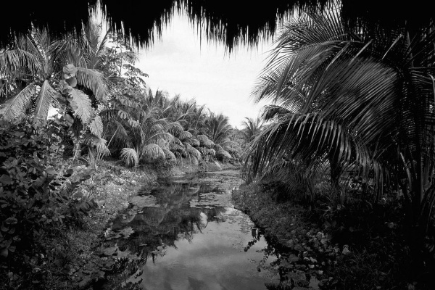

Nearest neighbor method

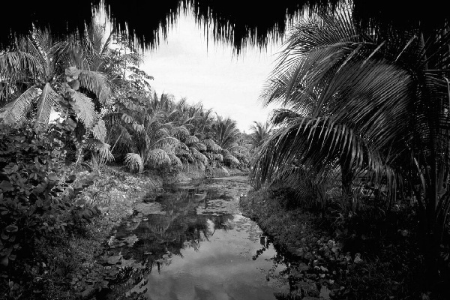

In nearest neighbor method more noise was visible than the bi-linear interpolation method

Further resampled image size of nearest neighbor method (134 KB) is larger than the resampled image size of bi-linear interpolation method (127 KB).