## Task 5.1c

### News App

GitHub Link repo link: <https://github.com/Pasindufdo98/sit708/tree/main/task5_1c>

Video Link: <https://youtu.be/_B6rMe6ySV4>  
  
**Screenshots**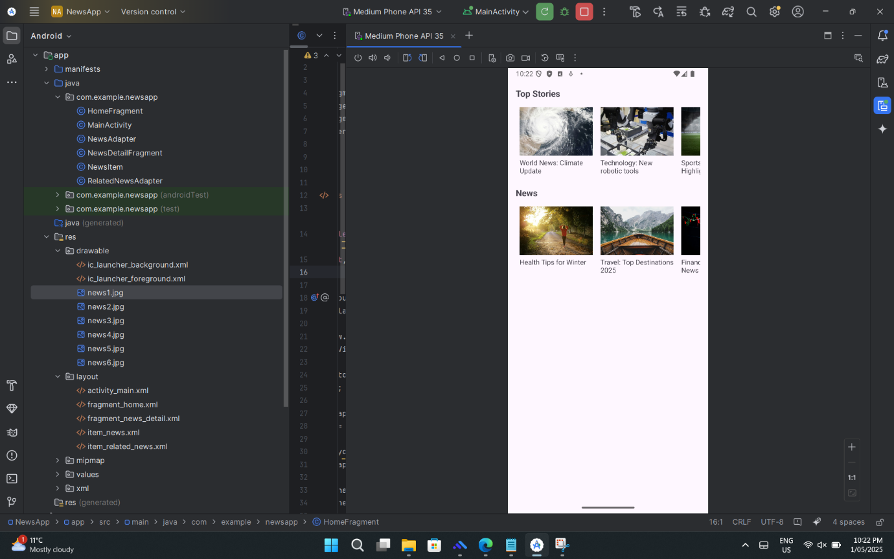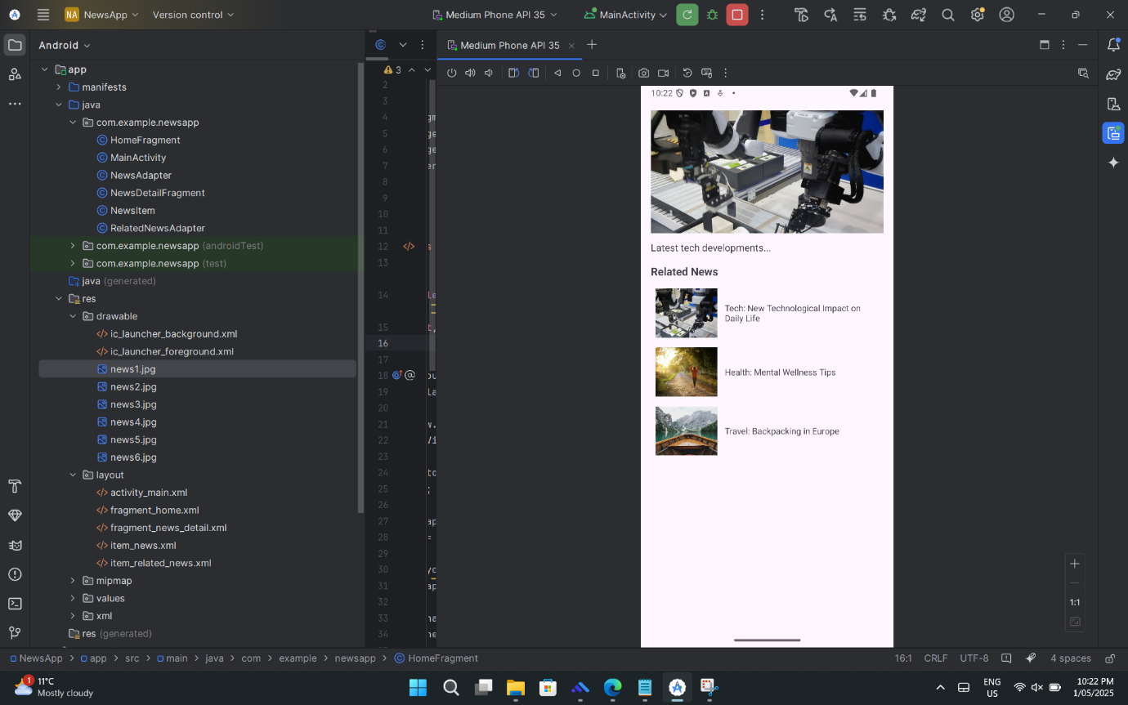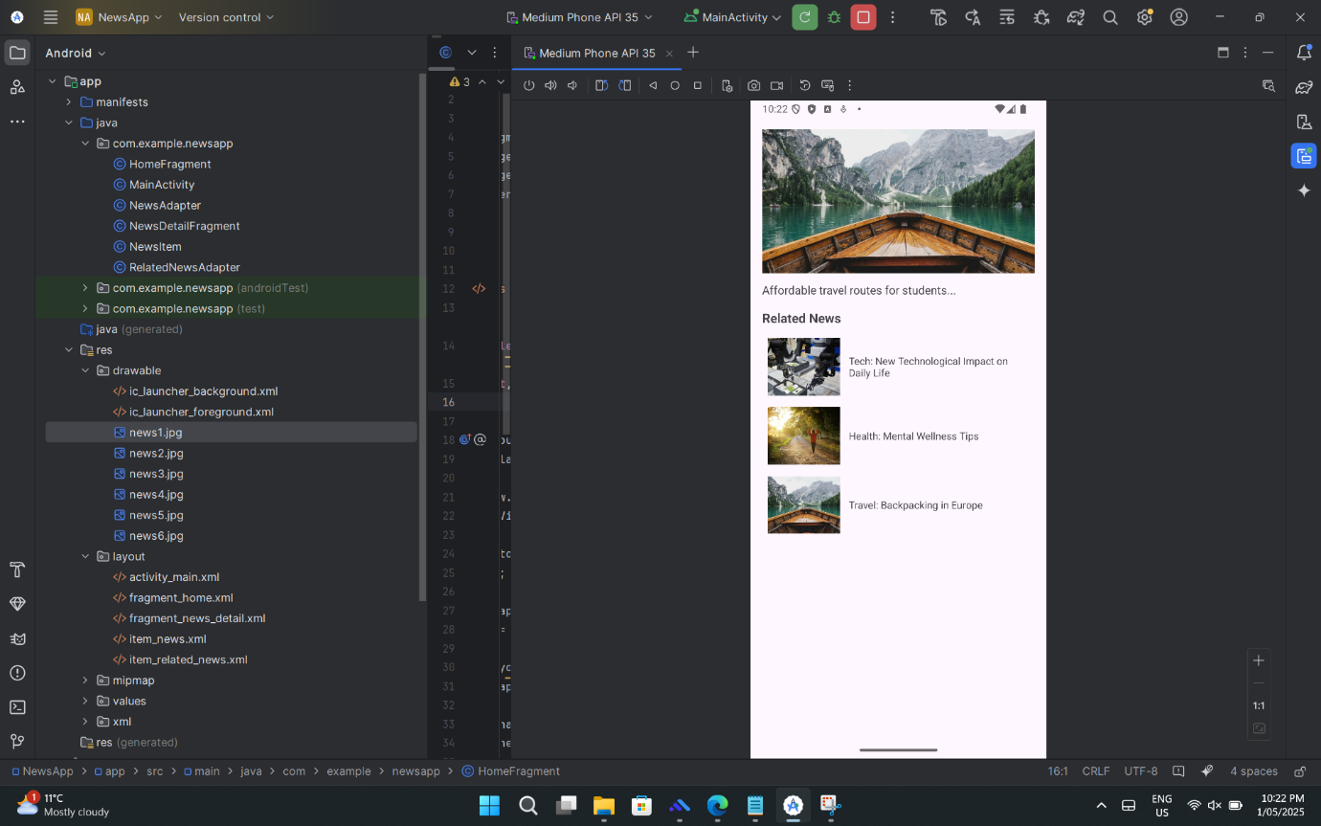

### iTube App

Video Link : <https://youtu.be/4BemGMGMG84>  
  
