IT3051 – Fundamentals of Data Mining
Comprehensive Viva Defense & Progress Evaluation Report
Automobile Loan Default Prediction Project (Stages 1 to 5)
1. Business Understanding & Problem Formulation (Stage 1)
The objective is to predict whether an automobile loan applicant will default on their credit obligation. This prediction is made at application submission time, strictly prior to loan approval or disbursement, allowing the financial institution to reject high-risk loans or price risk accordingly.
- Why Binary Classification: The target variable Default is binary (0 = Repaid, 1 = Defaulted).
- Prediction Point: Predicting after loan disbursement is useless; risk evaluation must happen before capital loss occurs.
2. Data Understanding & Initial Inspection (Stage 2)
The raw dataset (Train_Dataset.csv) contains 121,856 rows and 40 raw attributes. 33 columns contain missing values (e.g. Score_Source_1 is missing in 56% of applicants).
- Rogue Text Symbols: Client_Income, Credit_Amount, and Loan_Annuity contained '$' symbols and '#VALUE!' strings.
- Sentinel Value: Employed_Days contained the sentinel value 365,243 in 21,098 rows (17.31%).
- Identifier: The ID column is an arbitrary database key with no predictive value.
3. Exploratory Data Analysis & Visualizations (Stage 3)
A. Target Distribution & Severe Class Imbalance
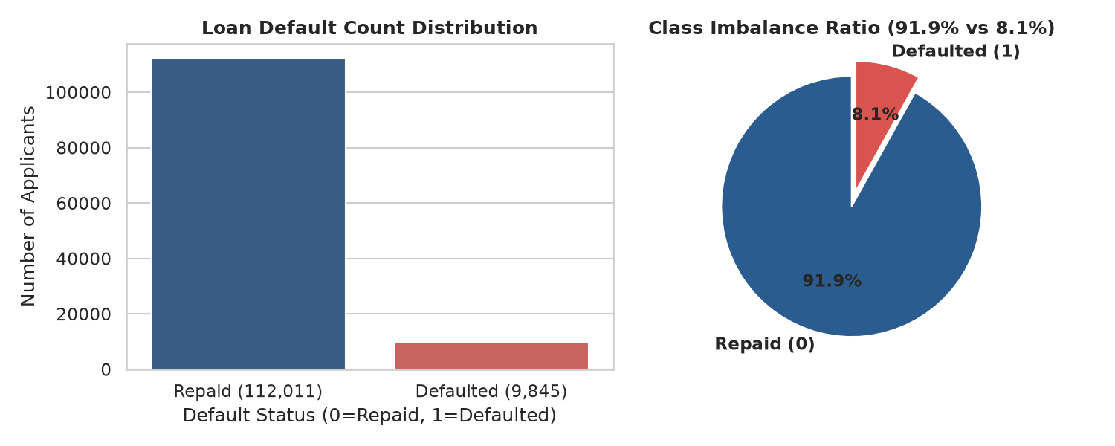
Figure: Class Imbalance (91.9% Repaid vs 8.1% Defaulted)
Only 8.1% of applicants defaulted (11.4:1 ratio). A naive baseline predicting all 0 gets 91.9% accuracy with zero utility. Therefore, models must be evaluated using ROC-AUC, Recall, Precision, and F1-score.
B. The 365,243 Employment Sentinel
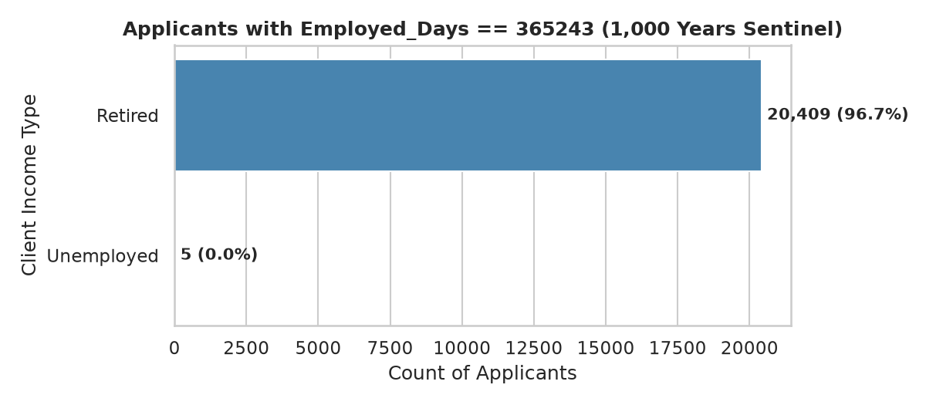
Figure: Distribution of Client Income Types for Employed_Days == 365243
365,243 days equals ~1,000 years. Cross-tabulation proves that 96.7% (20,409 rows) are Retired. Leaving 365,243 raw distorts linear and tree models. We flagged them as Is_Retired_Unemployed and set days to NaN.
C. Financial Risk Profiles (Boxplots)
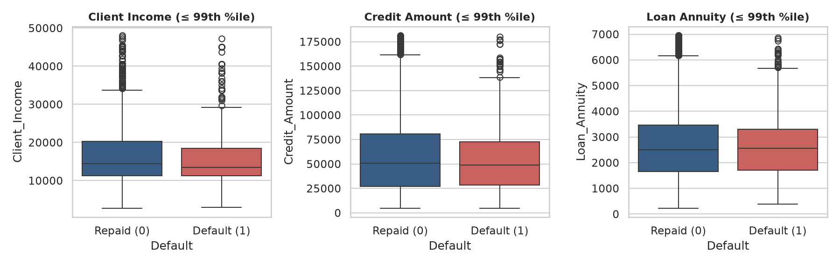
Figure: Boxplots of Income, Credit Amount, and Annuity Across Default Status
Defaulters have lower median income ($13,500 vs $14,850) but pay nearly identical monthly annuities ($2,528 vs $2,497), creating debt service stress.
D. External Credit Bureau Scores
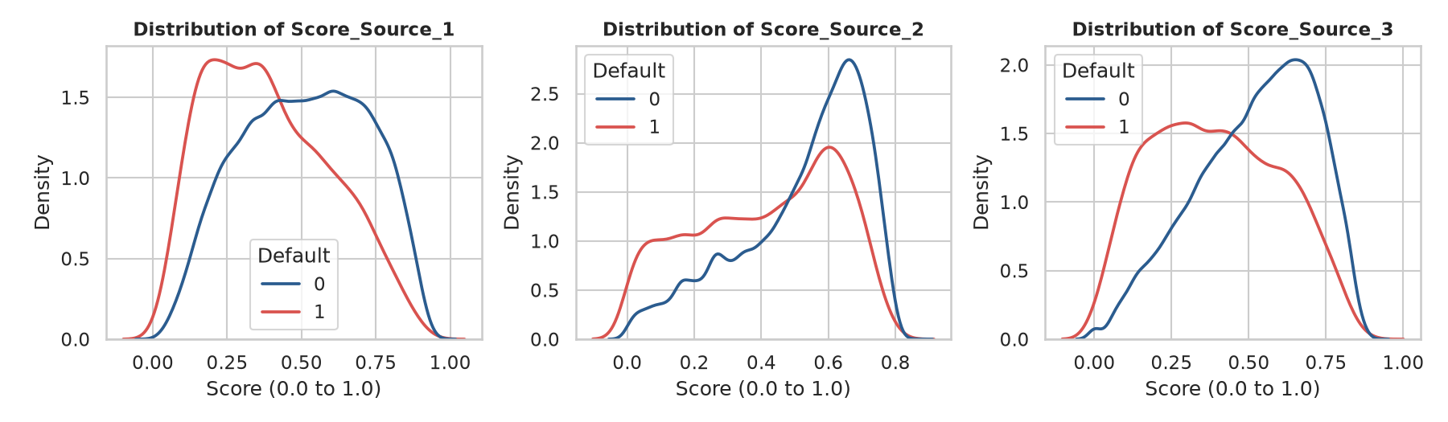
Figure: KDE Distributions for Credit Bureau Scores (Score 1, 2, 3)
Defaulters have 20% to 30% lower median scores across all bureaus. These credit bureau ratings are the strongest individual predictors in the dataset.
E. Correlation Heatmap
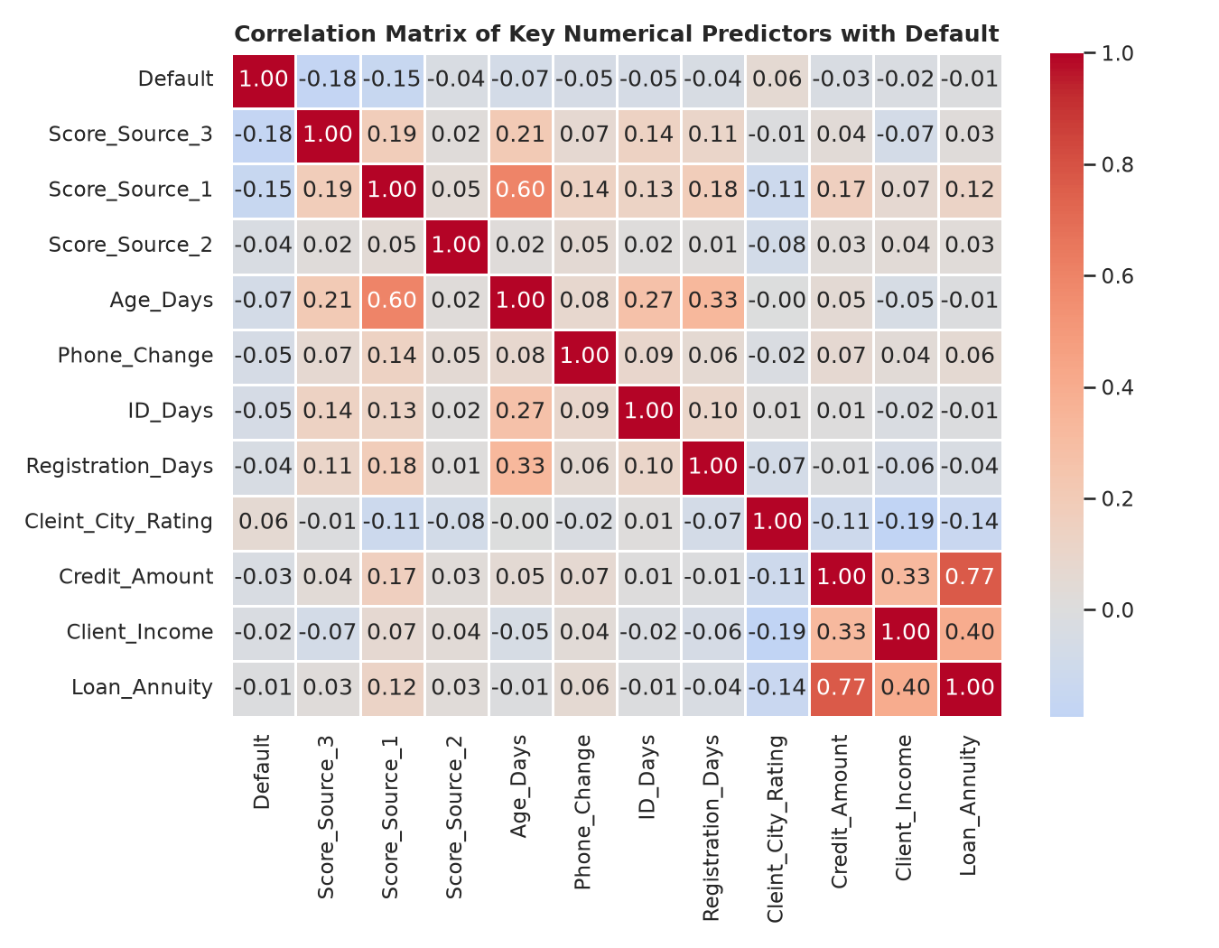
Figure: Correlation Matrix of Core Numerical Features with Default
Score_Source_3 (r = -0.18) and Score_Source_1 (r = -0.15) have the strongest negative correlation with default. Credit_Amount and Loan_Annuity share high collinearity (r = 0.77).
4. Data Cleaning Implementation (src/data/data_cleaning.py)
Encapsulates raw data cleaning into clean_corrupted_numerical_columns, handle_employed_sentinel, and remove_identifiers.
5. Domain Feature Engineering (src/preprocessing/feature_engineering.py)
Creates 7 domain features: Age_Years, Employed_Years, Annuity_to_Income_Ratio, Credit_to_Income_Ratio, Credit_to_Annuity_Ratio, Mean_Bureau_Score, and Bureau_Scores_Count. Adding '+ 1' prevents division by zero.
6. Machine Learning Preprocessing & Data Leakage Prevention
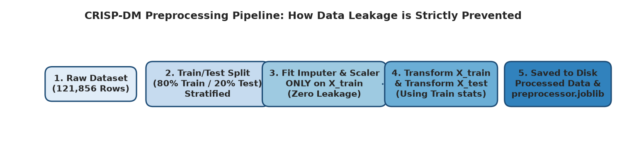
Figure: Data Leakage Prevention: Stratified Split-First Pipeline
Data leakage is prevented by splitting 80/20 train/test FIRST. SimpleImputer (median for numeric, mode for categorical) and StandardScaler are fit strictly on X_train and applied to X_test via .transform() only. Produces 150 clean features with 0 missing values.
7. Master Viva Cheat-Sheet: Top Questions & Confident Answers
Topic | Examiner Question | Confident Viva Answer
Prediction Point | When does the model predict? | At application submission time, strictly prior to loan approval, so the lender can avoid disbursing funds to high-risk borrowers.
Class Imbalance | Why is accuracy misleading? | Because 91.9% of loans are repaid. A naive dummy model predicting 'repaid' for everyone achieves 91.9% accuracy with 0% recall.
Sentinel Value | What does Employed_Days == 365243 mean? | 365,243 days equals ~1,000 years, an artificial legacy placeholder for non-employed applicants (96.7% retired). We flagged them as Is_Retired_Unemployed and set days to NaN.
Data Leakage | How was data leakage strictly prevented? | We performed the 80/20 train-test split BEFORE any imputation or scaling. All transformers were fit strictly on X_train and only applied to X_test via transform().
Stratified Split | Why stratified split? | Because the 8.1% minority class is sensitive to sampling drift. Stratification guarantees that both train (97,484) and test (24,372) have identical 8.08% default rates.

