Lambda-class T-4a shuttle

|  |  |
| --- | --- |
| Manufacturer | Sienar Fleet Systems |
| Class | Multi-purpose transport |
| Cost | 140,000 credits |
| Length | 20 meters |
| Maximum speed | 850 kph |
| Hyperdrive system | Class 1 |
| Shielding | Deflector shield |
| Sensor systems | Short-ranged sensors |
| Navigation system | Navcon 1 |
| Armament | * Forward-facing double laser cannons * Forward-facing wing-mounted double laser cannons * Retractable rear-mounted double laser cannon |
| Crew | 1 Pilot |
| Passengers | 20 |
| Cargo capacity | 80 metric tons |
| Usage | Transport |

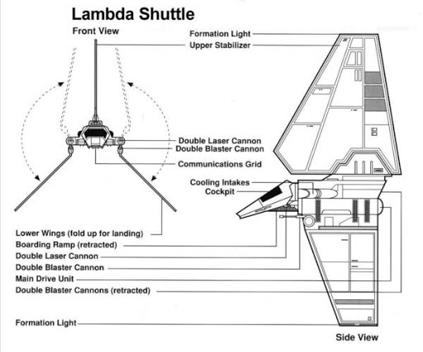

The Lambda-class T-4a shuttle, also known as the Lambda-class shuttle, Imperial Lambda, Imperial Transport or the Imperial Shuttle, was a multi-purpose transport with a trihedral foil design used by the Galactic Empire during the Galactic Civil War, and was considered an elegant departure from the standards of brutish Imperial engineering. The shuttles were often used by high-ranking Imperial officers and such dignitaries as Darth Vader and Emperor Sheev Palpatine, but were more commonly found ferrying stormtroopers or cargo.

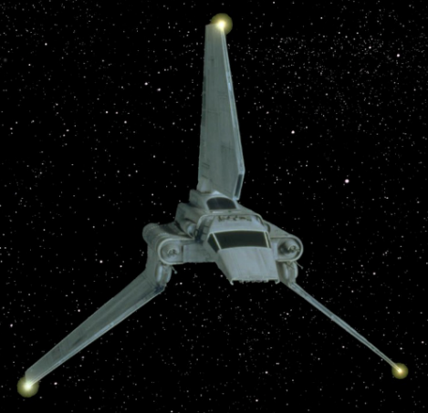A hyperdrive-equipped multi-purpose transport, the Lambda-class T-4a shuttle was developed by Sienar Fleet Systems for use in the Imperial Navy. Measuring 20 meters in length, the Lambda-class could attain a max speed of 850 kph, and was one of the more common Imperial ships found throughout the galaxy—along with its nearly-identical counterpart, the Sentinel-class landing craft. It had three wings: one tall, dorsal stabilizer that remained stationary, and two lower articulated flanking wings. While in flight, the wings folded outwards for greater stabilization, while during landing procedures the wings folded inward, reducing the vessel's silhouette. This triangular shape was considered elegant and a departure from the Empire's usually crude designs.

Although Lambda-class craft could be flown by a single pilot, the presence of a copilot/navigator made it much easier, especially when traveling through hyperspace. Additionally, in order to prove that the shuttle crew was working for the Empire, Lambda-class T-4a shuttles utilized special transponders to transmit secret codes to Star Destroyers.

Despite the elegance of the Lambda-class's outer design, the inside of many shuttles often reeked of stale sweat owing to the numerous perspiring stormtroopers they hauled across the galaxy. Moreover, bored troopers were known to scratch their operating numbers on every available surface.

A well-armed vessel, the Lambda-class T-4a shuttle was equipped with two forward-facing double laser cannons, two forward-facing wing-mounted double cannons, and a retractable rear-mounted double laser