Tie-Advanced

|  |  |
| --- | --- |
| Manufacturer | Sienar Fleet Systems |
| Class | StarFighter |
| Cost | 90,000 credits |
| Length | 9,2 meters |
| Maximum speed | 1200 kph |
| Hyperdrive system | Class 4.0 |
| Shielding | None |
| Sensor systems | Short Range sensors |
| Navigation system | N-s6 Navcon |
| Armament | * L-s9.3 laser cannons * Cluster missile launch equipment |
| Crew | 1Pilot |
| Passengers | None |
| Cargo capacity | 150 Kg |
| Usage | Space superiority fighter |

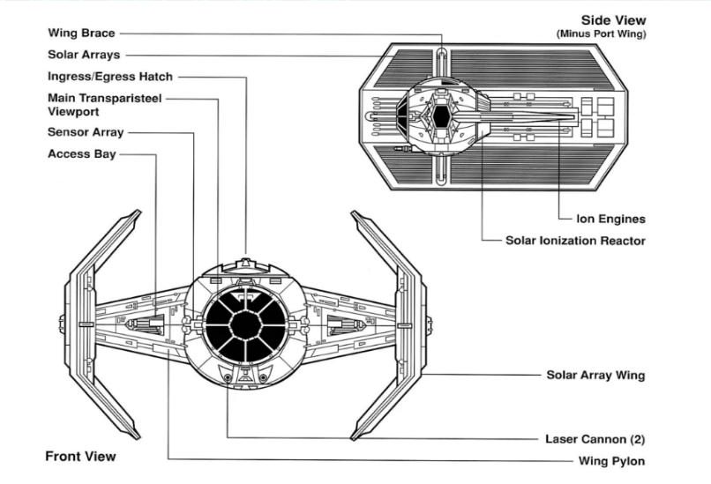

The TIE Advanced x1 featured a Sienar Fleet Systems I-s3a solar ionization reactor and paired P-s5.6 twin ion engines like the original TIE Fighter. However, the x1 had an original spaceframe, with an elongated rear deck and reinforced durasteel-alloy hull. The x1's most important innovation was the use of "bent-wing" solar array wings, like those used on the TIE/sa bomber, which had the advantages of increased surface area for more power while also reducing the craft's profile, compared to the TIE/LN starfighter's hexagonal panel wings.

Speed was only slightly improved due to the added mass of the vessel; a good deal of the extra power was bled off to the deflector shield generators. While less maneuverable than standard TIE fighters, it was more resilient in battle.

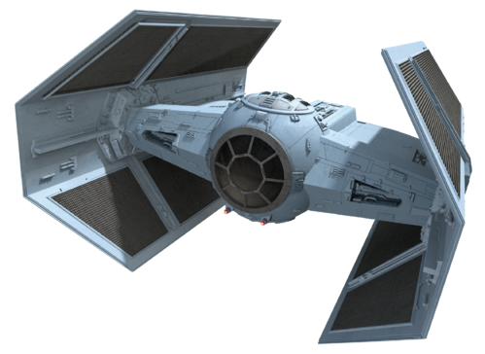

The 9.2 meter-long craft had twin heavy L-s9.3 laser cannons in a gimballed, front-mounted position, as well as a cluster missile launcher. In addition to its shields, it had a modest Class 4.0 hyperdrive but no life support systems. The target tracking system was also more sophisticated than the already formidable advanced targeting system on standard TIE craft, used to overcome the extremely powerful electronic jamming used by all combat craft to defeat target lock in battle. For best performance, the targeting system of the x1 required frequent adjustment in combat.

Only the most elite Imperial pilots flew the TIE Advanced, and the starfighter was capable of fighting a T-65 X-wing starfighter to a draw.