Tie-Bomber

|  |  |
| --- | --- |
| Manufacturer | Sienar Fleet Systems |
| Class | Space bomber |
| Cost | 110,000 credits |
| Length | 7,8 meters |
| Maximum speed | 850 kph |
| Hyperdrive system | None |
| Shielding | None |
| Sensor systems | S-c3.4 multi-range TAG |
| Navigation system | N-s4 Navcon |
| Armament | * L-s1 laser cannons * T-s5 proton torpedo launchers * M-s3 concussion missile launchers * Bomb bay   + ArmaTek SJ-62/68 orbital mines   + ArmaTek VL-61/79 proton bombs   + Thermal detonators |
| Crew | 1 Pilot |
| Passengers | 20 |
| Cargo capacity | 15 metric tons in bomb bay |
| Usage | Light space bomber |

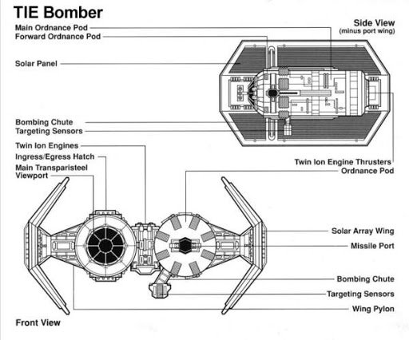

The TIE/sa bomber, simply known as the TIE bomber was a larger, less maneuverable TIE starfighter used for destroying large starships and pinpoint-precision bombing. The "sa" in the TIE bomber's designation stood for "surface assault."

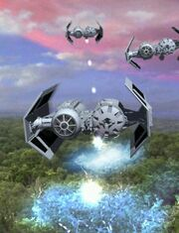Due to their distinctive dual-hull shape, TIE bombers came to be referred to occasionally as "dupes" or (albeit indirectly) "sitting ducks" by enemy pilots. The latter nickname was due to its bulky structure making it much slower and far less maneuverable than other TIE craft.

The TIE/sa bomber had two hulls next to each other; the starboard hull carried the pilot and the port carried a pair of general purpose warhead launchers, enabling them to carry a variety of weapons tailored for the mission. The bomber was much more heavily built-up than the "fighter"-series of TIEs; it carried more sophisticated sensors to penetrate capital ship jamming and SFS P-s4 twin ion engines powered by a SFS I-a2b solar ionization reactor to allow a full payload to be carried at a reasonable speed. The ordnance hull could also be swapped for a passenger cabin instead of heavy weapons.

An Imperial Star Destroyer generally carried a squadron of 12 bombers. The TIE bomber was capable of carrying at least one of the following payloads, for a total of 15 metric tons: sixteen concussion missiles, twelve proton torpedoes, eight proton rockets, six space mines, four proton bombs, sixty-four thermal detonators, thousands of propaganda pamphlets, or supply canisters. Guided concussion missiles/proton torpedoes were generally carried nearing the inside of the second hull, orbital mines were placed in a rack above the missile rack, while proton bombs and orbital mines were generally near the exterior of the hull, near the bomb-drop chute. In addition, the second hull also possessed an ordnance maneuvering arm that retrieves and loads armaments. Its fixed armament was two wing-mounted laser cannons.

The bomber was agile enough to deliver devastating strikes with surgical precision; as shown by a mission when a group of these craft destroyed a Rebel-occupied tower in the middle of a crowded city while leaving the surroundings untouched.