Tie-Fighter

|  |  |
| --- | --- |
| Manufacturer | Sienar Fleet Systems |
| Class | StarFighter |
| Cost | 60,000 credits |
| Length | 6,3 meters |
| Maximum speed | 1200 kph |
| Hyperdrive system | None |
| Shielding | None |
| Sensor systems | Fabritech Sensor Arrays |
| Navigation system | N-s6 Navcon |
| Armament | L-s1 laser cannons |
| Crew | 1Pilot |
| Passengers | None |
| Cargo capacity | 120 Kg |
| Usage | Military |

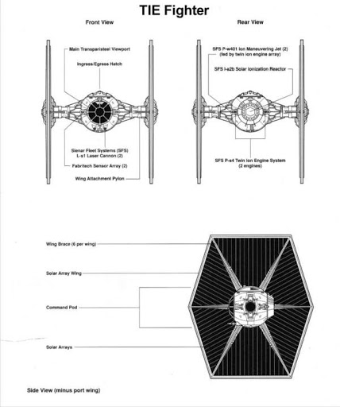

The TIE/Ln's engine was one of the most precisely manufactured propulsion systems in the galaxy and, with no moving parts, was low-maintenance. Unlike the TIE before it, the TIE/Ln sported independent generators for the engine and the weapons. The lack of combat shields, hyperdrive, and life-support systems, in concert with the advanced engine design, reduced the mass of the fighter and conferred exceptional maneuverability. This also made them both inexpensive and quick to replace.

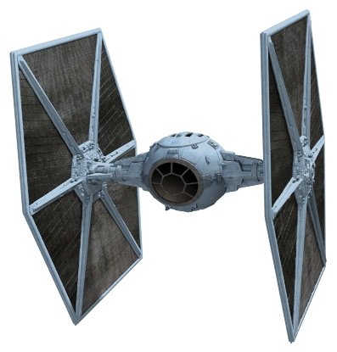Primary armament was a pair of L-s1 laser cannons, coupled with a powerful sensor suite. The cannons were relatively powerful, and a well-placed hit on a starfighter or medium transport could damage or destroy it. It did not carry missile tubes, but such weapons could be added if necessary.

Due to the lack of life-support systems, each TIE pilot had a fully sealed flight suit superior to their Rebel counterparts. The absence of a hyperdrive also rendered the fighter totally dependent on carrier ships when deployed in enemy systems. TIE/Lns also lacked landing gear, another mass-reducing measure. While the ships were structurally capable of "sitting" on their wings, they were not designed to land or disembark their pilots without special support. On Imperial ships, TIEs were launched from racks in the hangar bays.

Power conduits were attached between the engine system and the solar arrays.

TIEs were designed to attack in large numbers, overwhelming the enemy craft. Standard attack squadrons consisted of 12 fighters while full attack wings were made up of six squadrons. The Imperials used so many that they came to be considered symbols of the Empire and its might. They were also very cheap to produce, reflecting the Imperial philosophy of quantity over quality.

Contrary to popular belief, the ships did possess ejection seats, but the nature of space warfare often resulted in pilots riding their craft down to a swift end rather than ejecting and risking slow death by heat loss and oxygen starvation in the vacuum of space. The ejection system was more a formality than anything else - given the delicacy of the craft, by the time enough damage was done to require the pilot ejecting, it would likely have already destroyed itself.