Tie-Interceptor

|  |  |
| --- | --- |
| Manufacturer | Sienar Fleet Systems |
| Class | StarFighter |
| Cost | 90,000 credits |
| Length | 9,6 meters |
| Maximum speed | 1250 kph |
| Hyperdrive system | None |
| Shielding | None |
| Sensor systems | S-c4.1 multi-range TAG |
| Navigation system | N-s6 Navcon |
| Armament | * L-s9.3 laser cannons * Blaster cannons (4) * Multipurpose Warhead Launchers with optionally varying payload |
| Crew | 1Pilot |
| Passengers | None |
| Cargo capacity | 150 Kg |
| Usage | Space superiority fighter |

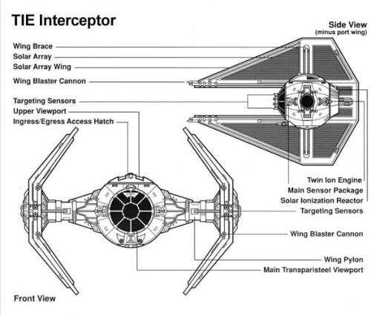

The TIE/IN starfighter, simply known as the TIE Interceptor or T/I, was a TIE Series starfighter used by the Galactic Empire. The TIE Interceptor was identifiable by its arrow-shaped solar collection panels, a distinct difference from the hexagonal solar arrays of its predecessor, the TIE Fighter. The Interceptor was one of the fastest starfighters in the galaxy at its prime, nearly rivaling the Alliance's RZ-1 A-wing interceptor.

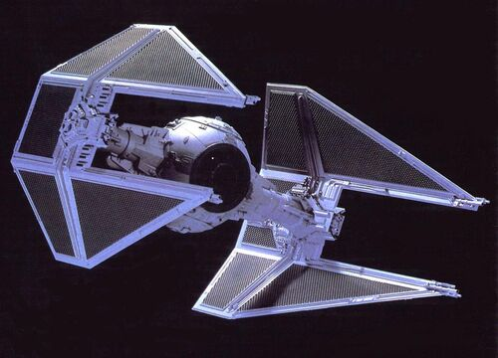Like most TIE models, the TIE Interceptor shared nearly identical cockpits, drive pods, and wing brace designs with the TIE Fighter. The solar collector panels were lengthened and angled, and the forward center section was removed. This new solar array design gave the Interceptor its unmistakable dagger-like appearance and shrinking its profile to make targeting more frustrating for enemy gunners. This wing design gave the craft a more menacing visage, continuing the Empire's reputation of ruling through fear.

The original production model came equipped with four L-s9.3 laser cannons, one installed on each wingtip. New targeting software was installed in the TIE Interceptor, and the SFS T-s9a targeting computer offered greater accuracy during complex flight maneuvers. Twin laser cannon hardpoints still remained on the "chin" portion of the cockpit module. Provided that technicians could find room for additional power generators, these cannons could also be utilized. Further upgrades, including hyperdrives and advanced shielding made them equal to the Rebellion's X-wing starfighters. Their weapons were equipped with safeties.

Later TIE Interceptor models were modified to carry four blaster cannons, replacing the original wingtip laser cannons. The twin chin-mounted laser cannons remained. The new model also came equipped with multi-purpose warhead launchers. These upgrades made the new model more of a multi-purpose fighter rather than an Interceptor.

The TIE Interceptor's primary role was as its title suggested. Like its predecessors, the Interceptor lacked heavier armor, deflector shields, a hyperdrive, and life support. Interceptor pilots were forced to rely on speed, maneuverability, superior numbers, and advanced weapon systems to prevail in its primary role of space superiority. The craft's drawbacks meant that any pilot who survived more than a few missions was considered to be a "top gun" in the Imperial fleet.

With no hyperdrive, the TIE Interceptor was reliant on a capital ship for an operations base. Star Destroyers and prominent shipyards such as Kuat and Fondor were common staging areas for Interceptor squadrons; however, smaller vessels and more remote locations had to rely on aging TIE/ln fighters.