**HOTELS**

____________________________________________________

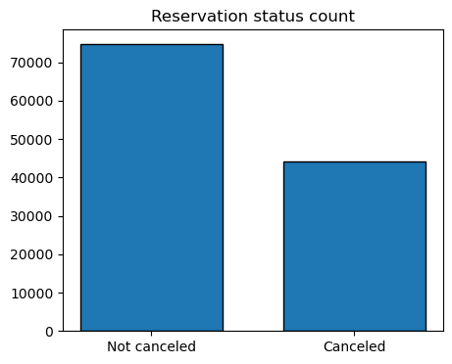

Cancelation percentage in both hotels

1. 0.628648
2. 0.371352

Majority of bookings were not cancelled, still some half of the bookings were cancelled.

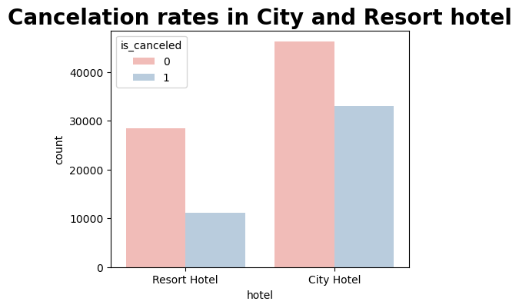Most bookings were in city hotels. Cancellations in resort hotels are less frequent compared to city hotels. City hotels have more bookings than resort hotels, possibly because resort hotels are more expensive than those in cities.

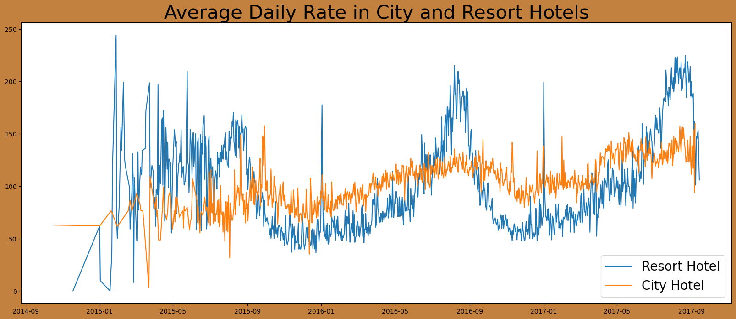

Prices of resort hotel are much higher. Prices of city hotel don’t fluctuate that much.

The line graph shows that resort hotel prices are much higher and change more than city hotel prices. Sometimes, city hotel rates are lower than resort hotel rates, and other times, they are even lower. Resort hotel prices often go up on weekends and holidays, while city hotel prices stay mostly the same.

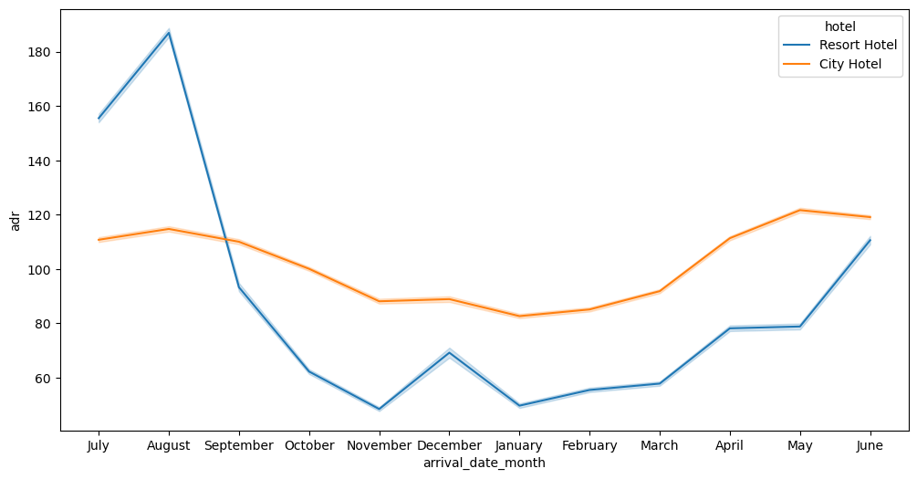

The Resort Hotel has higher room rates in July, August, and September, while the City Hotel's rates are slightly higher in March, April, and May.

Most bookings were made in May, June, July, and August.

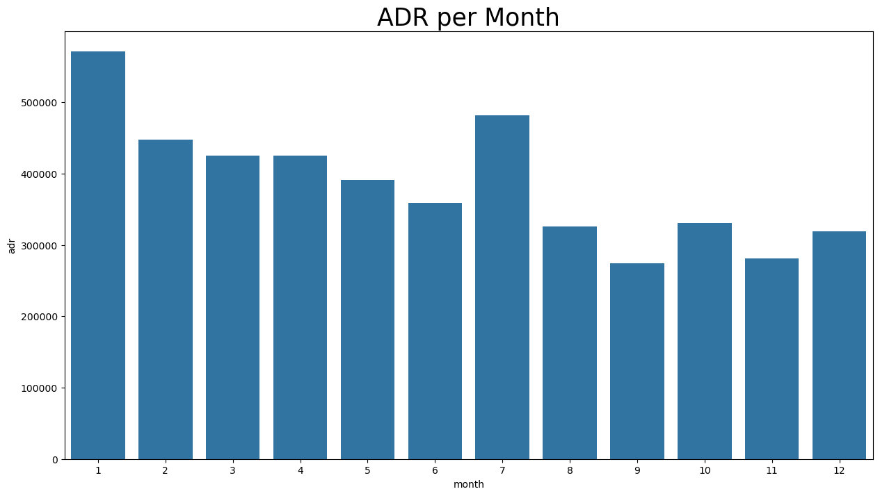Our grouped bar graph shows that August has the most confirmed and canceled reservations, while January has the fewest confirmed reservations but the most cancellations.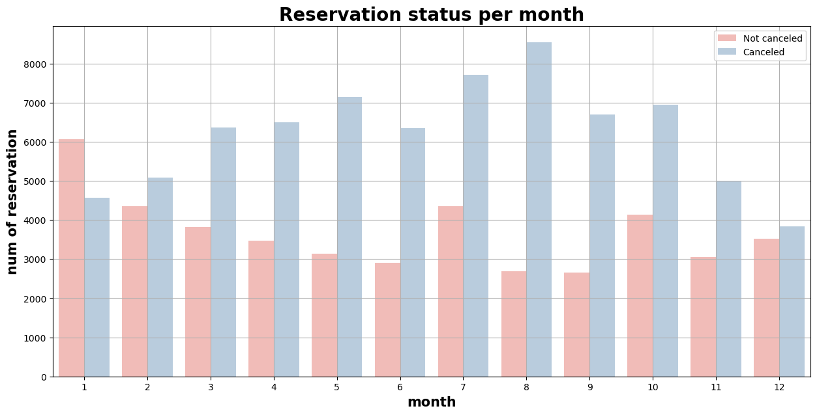

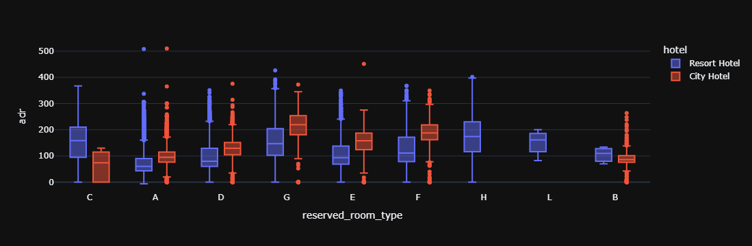The bar graph shows that cancellations are highest when prices are high and lowest when prices are low. This suggests that accommodation prices are the main factor influencing cancellations.

Both hotels offer different room types and meal arrangements. Seasonal factors also play a role, leading to significant price variations.

___________________________________________________

Let's examine which country experiences the highest number of canceled reservations. Portugal stands out as the top country with the most cancellations.

Here are the top 10 countries with the highest number of canceled reservations:

